NEW for this year!

Join REMIND and get simple text reminders periodically about upcoming events and meetings right to your smartphone. This is to help strengthen the home-school connection.

(For example: Back to School bash tonight at 5pm)

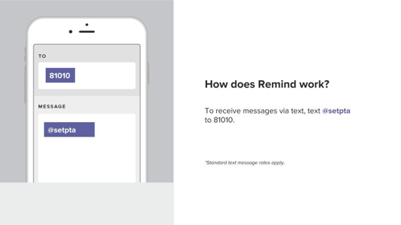

Rest assured you will not receive advertisement texts and your phone number will remain private.

If you have any questions, please contact
jamiesileo@hotmail.com

