Copy/Paste Organization Provider Intro

Hello and nice to meet you! Below is a screenshot of what CMS alone says this typical provider is currently missing and being penalized for not taking. NOW, we will go and get it for you, with no upfront or out-of-pocket costs, no new technology to learn and zero operational changes. We get paid if and only when you get paid and we even do the billing for our services for you. See your Program Options HERE!

Penalized? YES! On one sample code, a compliant provider is getting $352, and a noncompliant provider is getting $179, or 42 other payment levels between those two and you never even see it. We can launch in 72 hours! How much are you missing in your entire patient population? Find out today!

This real provider is missing $333,901 where medical necessity was found and he failed to act!

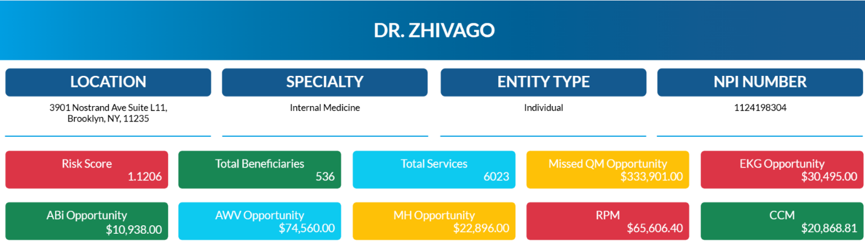

Now let’s help you to help your staff and patients! To begin the program, we do an electronic billable encounter or the entire patient population. The link to our AI Embedded Health Risk Assessment is required to give you insights into current medical necessities and to give control of their own health records to consumers and patients.

By simply sharing our 501(3)(c) Nonprofit’s Public Service Announcement regarding patients’ rights to control health records, you qualify to be paid $1 per subscriber per month. Our Precision Health Records app download and records storage is always free, OR they can subscribe to real-time updates through our relationship with Milliman.”

What's the Message?
“The best life, health, and travel assurance or you and your family is to have your health records in one place on your device instead of spread across many password protected portals.

The My Health Access device app download and personal records storage is and will always be free, OR for less than the cost of TV streaming services you can have real time updates. If you had 10 services in 10 states it would update your records automatically.”

Do you have your own personal Health & Wellness app branded for your practice name? ALL of our providers and Strategic Partners get these for free! This is a great way to keep your patients in touch with links to programs, products and/or services that you offer. Most important, it allows us to connect data directly to serve your patients as you have directed. Let's get together and get started!

