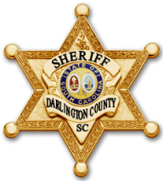
DARLINGTON COUNTY SHERIFF’S OFFICE
Sheriff Michael B. August
www.darcosc.com
WE GOT YOUR 6

Senior Citizen Welfare Check Program
This form is to be filled out by Darlington County Resident who would like weekly welfare checks conducted by the Darlington County Sheriff’s Office. Requesting citizens must be aware these checks are not guaranteed and should not replace any regular family check-in, care or any other steps to ensure your safety and well-being. If you suspect there is an emergency, please dial 911.

NAME: _______________________________________________________

ADDRESS: ____________________________________________________

TELEPHONE: __________________________________________________

VEHICLE: _____________________________________________________

DO THEY LIVE ALONE? YES NO

IF NO, WHO LIVES IN THE HOME? ___________________________________

EMERGENCY CONTACT: __________________________________________

ADDRESS: _____________________________________________________

TELEPHONE: ___________________________________________________

HIDDEN KEY (OPTIONAL):

________________________________________________________________

________________________________________________________________

