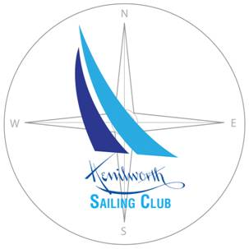

**Directors and Officers**

**Commodore**

Tom Nodine

312-504-6466

thnodine@gmail.com

**Treasurer**

Ned Forsberg

847-256-1303

[e.forsberg@att.net](mailto:e.forsberg@att.net)

**Harbor Master**

Eric Britton

847-421-8486

[eric@ericbritton.com](mailto:eric@ericbritton.com)

**Membership Director**

Cindy Baur

847-612-6925

[cindybaur@harperbaur.com](mailto:cindybaur@harperbaur.com)

**Camp Directors**

Debbie Zelten

630-248-0565

[debbiezelten@comcast.net](mailto:debbiezelten@comcast.net)

Lee Ann Shay

202-341-1424

[leeannshay2@gmail.com](mailto:leeannshay2@gmail.com)

**Associate Director**

Chris Ottsen

702-525-6759

[christopher.ottsen@stantec.com](mailto:christopher.ottsen@stantec.com)

**2022 KENILWORTH SAILING CLUB CALENDAR**

*Dates Subject to Change*

April 31 **Dues Due (for Members with Rack Spaces)**  
May 31 **Dues Due (for those without Rack Spaces)**

Friday, June 10 **Camp registration deadline**Saturday, June 11 **Sailing Beach Opens** Daily 9- 6pm (Weather Permitting)

(Camps have prior claim on Club equipment)

Sunday, August 21 **Last Day of Club is Open Daily**

Aug. 27-28 **Open Weekend** Sept. 3-5 **Open Labor Day Weekend**

**2022 KSC CAMP SCHEDULE**

*Dates subject to change*

Ages: 4th-9th graders (as of Fall 2022)  
$150 per Week

**Morning Camps, 9:30-11:30 and separate Afternoon Camps (1:30-3:30)**

**Week 1: June 20-24  
Week 2: June 27 – July 1  
Week 3: July 5-8 (Tu-F only)  
Week 4: July 11-15  
Week 5: July 18-22  
Week 6: July 25-29  
Week 7: August 1-5**

To register, go to www.kenilworthsailingclub.org