St. John Lutheran Church—News June, 2021
13045 Fremont Ave./Zimmerman
763-856-4561
Summer 2021

Worship at
9 a.m.
in person & online

“Brush off your Sunday Shoes”
You know how good it feels when you begin your week with worship? During COVID-19, many people got out of the habit of coming to worship on a regular basis. Worship is essential for growing our faith. And, did you know---scientific research shows that being a part of a worship community is good for your health? If you are out of the habit of coming to church for worship, it is time to get back into the habit. Brush off your Sunday shoes [or sandals]. We miss seeing you. In person attendance at worship has been very light. But, now—all COVID restrictions on churches have been lifted!
Masks are optional. We are singing together and celebrating Holy Communion. We are enjoying seeing each other and having great fellowship after worship. It is not the same without you. As the old saying goes:

Have you heard the GREAT news?!

All Covid-19 mandates have been lifted for churches. We have been waiting some 14 months to be able to announce this great news. Thank you for your cooperation during this time of trial. You cared for one another, you followed our Lord’s command to always do that which helps others, especially those most vulnerable. You lived out the Christian mandate to live for one another, not for yourself. Because of that, our Preschoolers were able to stay in school, and once it was safe, we were able to worship in person, without having a breakout.
Was it easy?
NO
Was it trying?
YES
The decisions which had to be made very quickly throughout the changes that Covid-19 brought were never easy but were always made with the best of intentions and with direction from the medical community and our Bishop. All throughout this time, our congregation and staff have continued the ministry of St. John, and St. John has never been “closed”. We have remained deeply committed to our mission and our call from Christ to love and care for all. Three priorities carried us through the decisions of Covid-19
1/ Care for the most vulnerable.
2/ Commitment to follow the best medical advice available to us.
3/ Taking no unnecessary risks.
A HUGE thank you goes to the members of St. John who faithfully served on the Covid-19 Safety Team. Thinking through never-before-seen scenarios while trying to care for the future of St. John and the people of St. John was an enormous task.
This journey has not been easy and is not over. We weep with those who have lost loved ones. We lament with those who suffer long-term health issues because of Covid, have lost jobs and endured the challenges of distance learning and social isolation.
We remain thankful to God for our staff and church leadership who waded through unchartered waters with energy, creativity, and love for the people of St. John and the ministry we do together. We are concerned for those who have not reconnected with our faith community. We all need to be a part of inviting each other back to worship, engaging in the ministry of St. John, and caring for our community and God’s world.
God has been and continues to be with us through all that we have gone through and is guiding us into a grace-filled future. We remain, St. John strong, because of God’s faithfulness! We are thankful for PPP funds which allowed us to continue paying staff salaries, our utility bills, and loan payments throughout the difficult months.

What we are doing moving forward—
- Masks & Social distancing are now optional at all St. John worship services and events.
- It is no longer necessary to sign-in when you enter the building.
- The congregation is invited to sing and respond corporately in worship.
- We will have fellowship [coffee and treats if people sign up to host!] after worship.
- We will continue to follow the guidance of our local school district and the Minnesota Department of Health when ministering directly to children and youth.
- We will continue to offer a live stream broadcast of our 10 AM worship services [and on demand thereafter] on our Facebook page: greenchurch1897.
We continue now as we always have—as people of God who are in the community for good! May we continue to be a beacon of hope and bring to the world that which is needed so much now days—patience with one another, kindness, and love for one another. –Pastor Bahe
Fall at St. John 2021-22
Better Together!
The St. John Council, Staff, and Ministry Teams are so excited for this Fall. We are planning and ready to be TOGETHER. Fall kickoff day will be Sunday, September 12th. Sunday School students will meet their teachers [of course, we need YOU to volunteer to be teachers first!], we will have all kinds of adventure events outside, a traditional St. John BBQ, and a wonderful day of worship and fellowship.
We will kickoff Bible Studies, Adult Education opportunities, book study opportunities and our Mid-week Wednesday worship.
Plan Ahead for these Sunday School & Confirmation Dates
- Sunday School Meet your Teacher Day 9/12.
- Sunday School Classroom time begins 9/19.
- Confirmation Orientation for 10th graders and parents will be Wednesday, 9/22 at 6:00 PM.
- Confirmation Orientation for 7-9th graders and parents will be Wednesday, 10/13 at 6:00 PM.
- Confirmation Day [Affirmation of Baptism] for 10th Graders will be Sunday, 10/31—Reformation Sunday, at 1:00 PM.

Get Ready for a St. John Garage Sale!
It began as a “what if…” in one of our members’ minds. Now, this “what if” is going to be a reality that will help St. John financially---as well as socially. We have all missed being able to gather with our St. John family, but a summer mission garage sale gives us the perfect chance to see one another, make new friends, reconnect, and raise money for our ministries.
Do you have nice, gently used items sitting around that need a new home? Gather them together to be placed on the St. John Garage Sale this summer!
We will announce the date for drop-off soon. We are asking those who are going to take advantage of selling their items to also donate 2 hours of their time for helping with the garage sale. All proceeds from the sale will go to St. John’s General Fund.
Children’s clothing, toys, and books sell well at garage sales. No TV’s or computers will be accepted. Of course we cannot accept mattresses either. Nothing that is broken or soiled will be accepted. We ask that you use good judgement on which things you bring---we do not want to end up paying for disposal of items at the end of the day.
There will be appointment times for dropping off your items. We will not be able to accept any items outside of those appointment times. Please do not bring your items in without an appointment. We will announce appointment times shortly.
The items that do not sell will either be recycled or brought to a charitable organization after the sale.
The date for the sale will be early July. Most likely July 10th. If you work the sale, you will also have opportunity to purchase items at the early/pre-view sale.
Gather up all those items that are cluttering up your home---well, maybe not all of them---please remember, in order for this to be a benefit to St. John Church, we want only nice, gently used items!
First Communion
On May 16th, four St. John fifth graders celebrated their First Communion at a special 11 o’clock worship service. We are thankful for this next step in their journey of faith. They have gone through instruction with Pastor Bahe and were so eager to fully join the celebration of Communion.
The students baked their own unleavened bread for their First Communion. Using unleavened bread is an early church tradition that honors the Old Testament narrative of our faith ancestors’ hasty escape from Egypt.
It was a special day and a memorable faith milestone for these students, their families, and St. John Church. Please hold them in prayer as they continue their growing and learning in the faith.

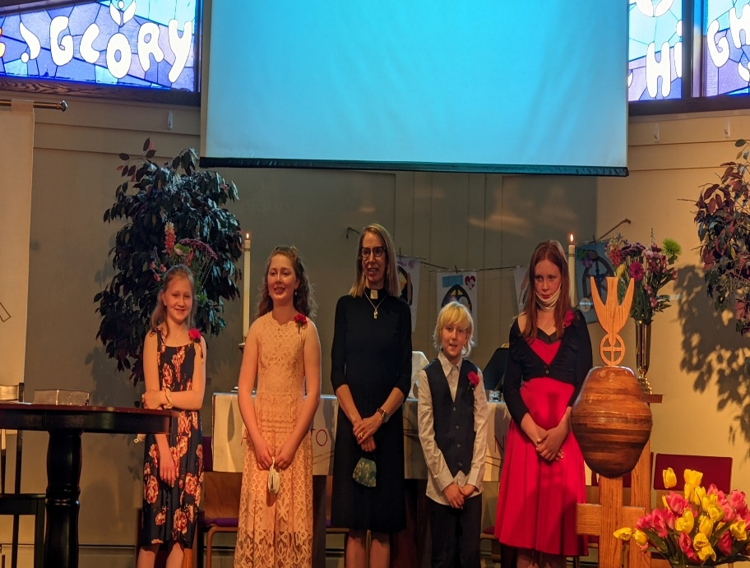

VBS—Vacation Bible School at St. John this summer
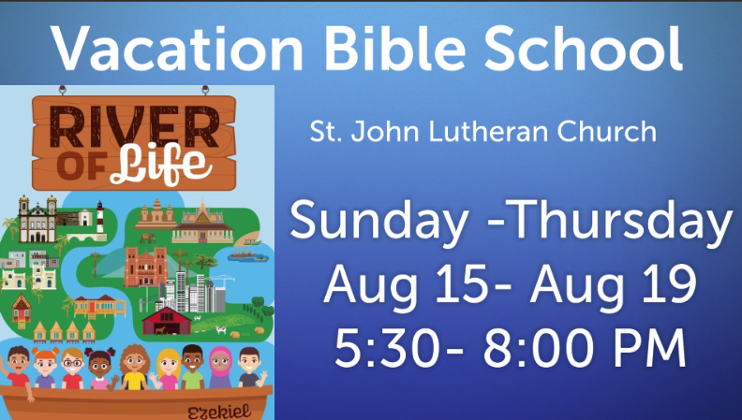
Registration is online at www.stjohnlc.org
K-4th grade in Fall 2021-22 School year.
We need 20 volunteers to help make this important ministry a success for our community. We have 2 so far. We will not be able to provide this ministry without help from congregation members---young and old!
Confirmation students are eligible to volunteer and will receive service hours/acts of kindness credit and great experience.
Our theme this year is “River of Life”. We will be learning through Scripture, story, games, art, and science about the importance of clean water and the need to care for the hungry here in our area and around the world. Lutheran World Relief [which St. John is a part of] helps us fulfill Jesus’ mandate to care for one another.
We will learn more about Lutheran World Relief efforts and how being a part of those efforts helps us put our faith into action. We will “travel” to places like Central Africa, Cambodia, Papua New Guinea, El Salvador, and Milwaukee.
Our ship, the EZEKIEL will help us explore how people of Lutheran faith are helping with water and hunger needs in our own country and across the globe.
VBS—Vacation Bible School—River of Life, continued
Water is an important part of our faith. From the waters of creation, to the waters of baptism, and the waters of life, God graciously provides enough and we are asked to share with all.
We are going to have so much fun and learn so much. We know you will enjoy being a part of this adventure. Please either email churchoffice@green-church.org or call 763-856-4561 if you are willing to help us bring this experience to life for our community! We want it to be epic and you can help with that, no matter what your experience level or interest is. We will find the perfect fit for your skills and we will help each other along the way. Training, resources, fun, and prayer provided!

“God has you in His keeping, we have you in our Hearts.”
Memorial Services at St. John Lutheran
Sunday, June 20, 2021 at 1:30 PM Everrett Snetsinger
Sunday, August 15, 2021 at 1:00 PM Jarl [Bud] Knutson

We pray for the sure and certain hope given in the promise of Jesus Christ. May the promise of Christ be the hope and peace of all who mourn.
Amen.

