August
13045 Fremont Ave. Zimmerman, MN
763-856-4561
August
St. John Messenger
2021
Help Spread the word!

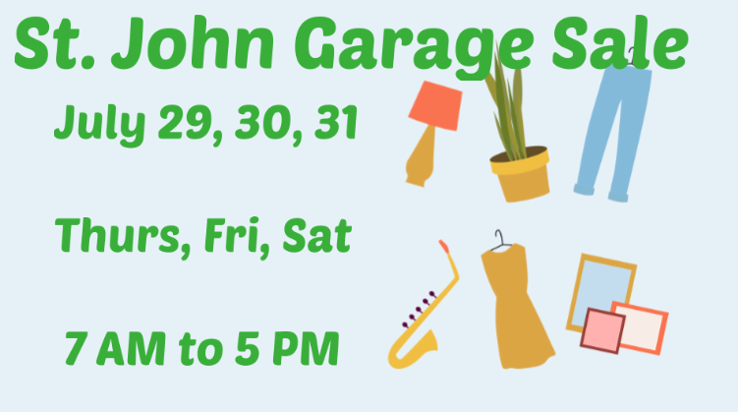
_______________________________________________________________________________________________
Thank you!
St. John Tuesday Evening Men’s Bible Study Group!
Thank you for leading worship on the weekend of July 11th. You inspired us to think about the truth that “it all starts right here”---with US. Thanks for reminding us that we are the church and without our engagement and participation---the community misses out. Our faith doesn’t have a chance to grow when we aren’t engaged with serving in the congregation.
Your message, leadership, music, and Scripture readings were impactful and meaningful.
Thanks for saying “yes”! Thanks for giving our pastor an opportunity to have a vacation over a Sunday. Thanks for making a difference and thanks for taking what you’ve done in Bible study and acting on it. A good reminder for all of us that faith is heart, head, and hands.
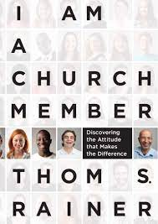
Here is the link to the Casting Crowns song the group used: “It Starts Here”
It Starts Here
This is the book the Men’s Bible Study group referred to.

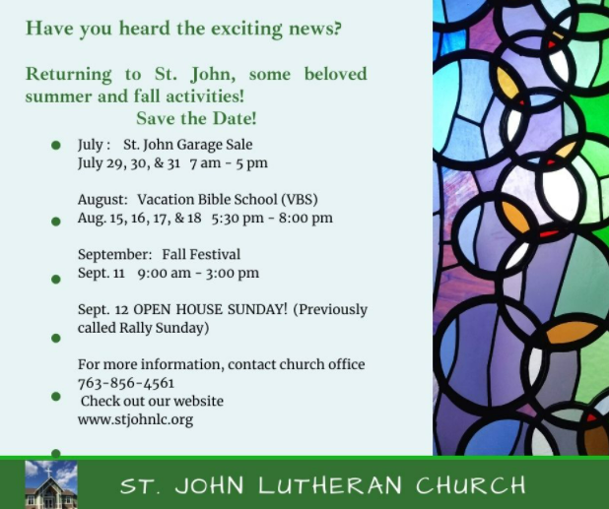
________________________________________________________________________________________________
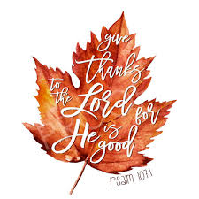

St. John Missions/Outreach Team Announces that we are a part of a new ministry in town!
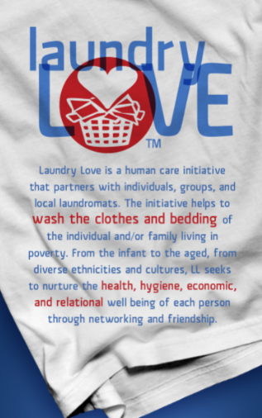
St. John will sponsor October. If you are interested in helping with this simple yet highly impactful way of being the hands and feet of Jesus right here in Zimmerman, please email churchoffice@green-church.org so we can let you know more about this ministry.

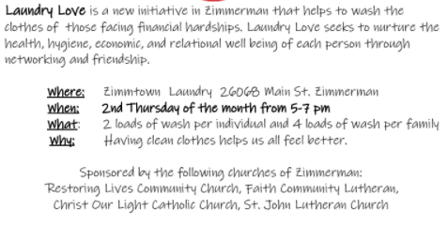

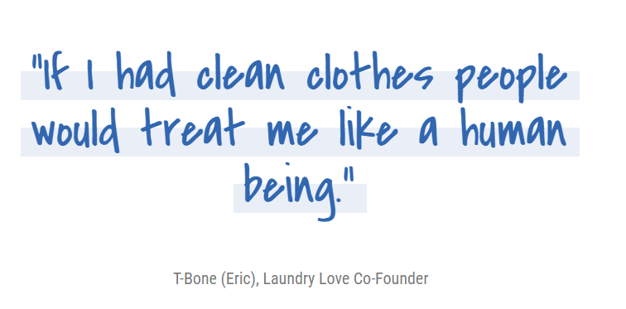
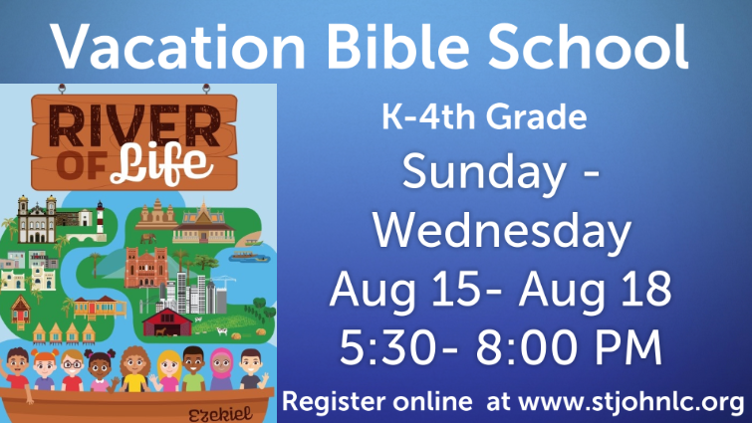
__________________________________________________________________________________

_________________________________________________________________________________________

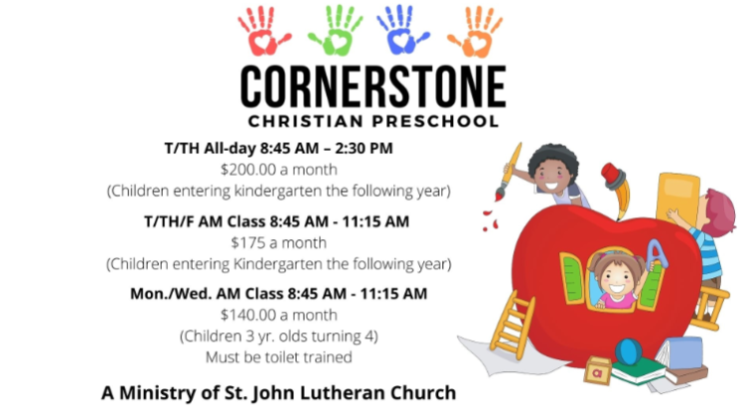
_________________________________________________________________________
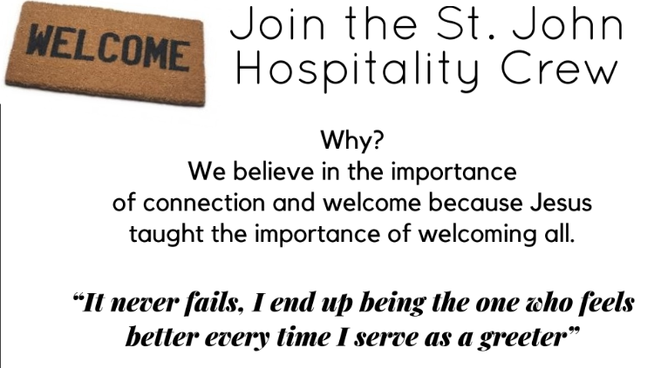

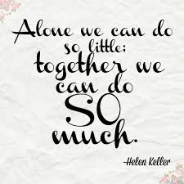
Helen Keller was so right when she said: "Alone, we can do so little; together we can do SO much"! We are so excited to be able to offer some outreach opportunities for you coming up in August!
We hope you'll consider giving some of your time to St. John so we can make these ministries a great success this Summer. We need you!
Vacation Bible School: We are hoping that you can help us out! It is August 15 (Sunday) through August 18 ( Wednesday) from 5:30 PM to 8:00 PM.
We need “Crew Leaders” - that would be you - to bring a small group to each of their stations. You may know some of the kids and may not. But by the end of the week, you will know them all and they will know you! It will be fun! The stations are all around the building, so each of you will have your own group's schedule. Your role is important! You will learn all of their names, and get to know them a bit.
The kids love their VBS leaders! If they don’t get what the station leader said, you become a teacher. If they get hurt, you become their nurse [don't worry, we'll be here to help!] When they are doing activities that are difficult, you are their encourager and cheerleader. If their behavior gets a bit inappropriate, you redirect them to pay attention. You might want to sit near somebody who is a bit antsy.
Expectations: Be here a 5:15 PM , ready to greet the kids. Bring them as a group into the sanctuary, and sit amongst them.
Watch the clock, which helps the station leader. Be ready to bring the students to the next station
Hang with the kids! Help redirect them when behavior choices need to change.
Bring them back to the sanctuary for closing at 7:45 PM.
Stay with the group until parents come and pick them up.

This is an important ministry for children to learn about Our Creator, HIs Son, and how much He loves us.
Remember you are God’s Love to them.

Contact the church office if you are interested as soon as possible
Sincerely,
St. John VBS Ministry Team
Mr. Nelson Mandela reminds us:

We believe that God wants us to be his love in the world by helping others. St. John has gathered supplies to make personal care kits for people all over the world. This is a huge ministry of the Lutheran Church that is run through Lutheran World Relief Check it out! see all the amazing things the Lutheran Church [that's us!] is helping people all over the world.

Here is a video about Personal Care Kits: Lutherans help change the world for BETTER

We will assembly the kits next week: Wednesday, July 28th from 1-2:30 PM at church. We hope you can come and help. We'll have fun making the world a better place TOGETHER!

Questions? Call 763-856-4561. We are here to help!

Fall at St. John 2021-22

Better Together!
The St. John Council, Staff, and Ministry Teams are so excited for this Fall. We are planning a big Fall kickoff---an Open House! We are ready to celebrate TOGETHER. Fall kickoff day will be Sunday, September 12th. Sunday School students will meet their teachers [of course, we need YOU to volunteer to be teachers first!], we will have all kinds of adventure events outside, a traditional St. John BBQ, and a wonderful day of worship and fellowship.
We will kickoff Confirmation, Sunday School, Bible Studies, Adult Education, book study opportunities and our Mid-week Wednesday worship.

Plan Ahead for these Sunday School & Confirmation Dates
- Sunday School Meet your Teacher Day 9/12.
- Sunday School Classroom time begins 9/19.
- Confirmation Orientation for 10th graders and parents will be Wednesday, 9/22 at 6:00 PM.
- Confirmation Orientation for 7-9th graders and parents will be Wednesday, 10/13 at 6:00 PM.
- Confirmation Day [Affirmation of Baptism] for 10th Graders

Memorial Services at St. John Lutheran

“God has you in His keeping, we have you in our Hearts.”

Sunday, August 15, 2021 at 1:00 PM Jarl [Bud] Knutson

We pray for the sure and certain hope given in the promise of Jesus Christ. May the promise of Christ be the hope and peace of all who mourn.
Amen.

13045 Fremont Ave. Zimmerman, MN 55398
763-856-4561 Facebook: greenchurch/1897
www.stjohnlc.org
churchoffice@green-church.org
revkbahe@green-church.org
financeoffice@green-church.org
custodian@green-church.org
music@green-church.org
Worship every Sunday at 9 AM on-line or in person.
All are Welcome Here.

St. John is a member of the ELCA Evangelical Lutheran Church in America
www.elca.org

St. John Lutheran Church is a member of the ELCA Evangelical Lutheran Church in America.

