New! Updated! Worship Information
Beginning next week
Sunday, April 18th
Worship will be held at 9 AM on Sundays
With no reservations required!
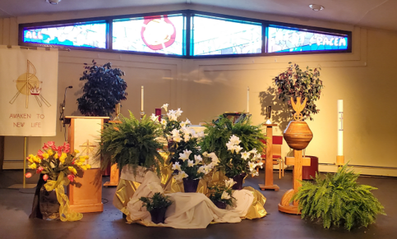

Masks, Social Distancing, and Limited Capacity protocols will be followed. Over-flow seating will be available in The Gathering Space if we reach capacity*. If we consistently reach capacity, an additional service time will be added to accommodate all! We need your help---ushers and greeters needed!
Of course, services will continue to be offered live, online as well.

*seating will be on a first come first serve basis, once over-flow capacity is reached, we will take names of those who will not be able to stay, so that they can be assured a spot the next week*

