Register online for Sunday School and Confirmation at www.stjohnlc.org
Please help us out by registering today.
We need to know how many students to plan for!
See more specific information about each program in this newsletter.

Fall 2021

Fall Worship Schedule Returns on September 12th!
Rally Day Open House
Worship at 8 and 10:30 AM
BBQ, Games, Fun
See inside for more exciting details!
Worship at 8 & 10:30 returns on
September 12th
Thank You to all who made this event a huge success at St. John! We raised $3900!
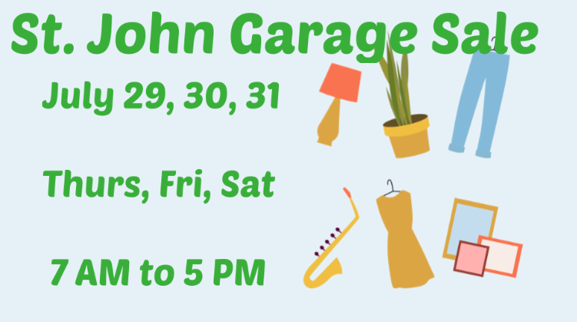

A special thanks to Sharon Kriesel who got us started with her generous donation of estate items. These items made up the majority of what we sold at the Garage Sale. Thank you, Sharon!
Will a garage sale be an annual St. John event? That is up to you, St. John! We will need a Task Force to make it happen. Are you interested in making this happen? It is a fundraiser, social & outreach, recycling & helping families in our community event all in one! Let us know at: churchoffice@green-church.org

_______________________________________________________________________________________________

And Today?
“Today, if you hear His voice, do not harden your hearts…” Hebrews 3:15 NIV
Are we living in God’s presence today, this moment? Are we drawing from His strength?
Are we seeking to know Him and the power of His resurrection today?
Leave the past and the future with the Lord and resolve
to cling to Him and dwell in His presence today. He truly has the whole world in His
hands, and His strength is perfect—moment by moment.
Devotion by Kathrine Hannon
www.christianperspectives.net

We continue to feel in person worship is the best way to connect as a church family. In keeping with CDC guidelines for indoor gatherings, we recommend that our members wear a mask during worship. However, they are not required at this time. We will continue to offer online worship at 10:30 am. Worship returns to 8 & 10:30 am on September 12th!

________________________________________________________________________________________________
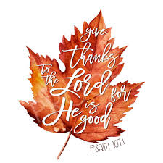

St. John Missions/Outreach Team Announces that we are a part of a new ministry in town!
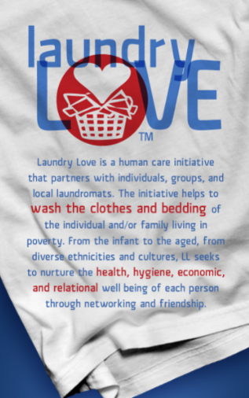
Laundry Love is a new initiative in Zimmerman that helps to wash the clothes of
those facing financial challenges. Laundry Love seeks to nurture the health, hygiene, economic, and relational well-being of each person through networking and friendship.
Where: Zimmtown Laundry 26068 Main St. Zimmerman
When: 2nd Thursday of the month from 5-7 pm
What: 2 louds of wash per individual and 4 loads of wash per family
Sponsored by the following churches of Zimmerman:
Restoring Lives Community church, Faith Community Lutheran, Christ Our Light Catholic Church, St. John Lutheran Church.

St. John will sponsor October. If you are interested in helping with this simple yet highly impactful way of being the hands and feet of Jesus right here in Zimmerman, please email churchoffice@green-church.org so we can let you know more about this ministry.

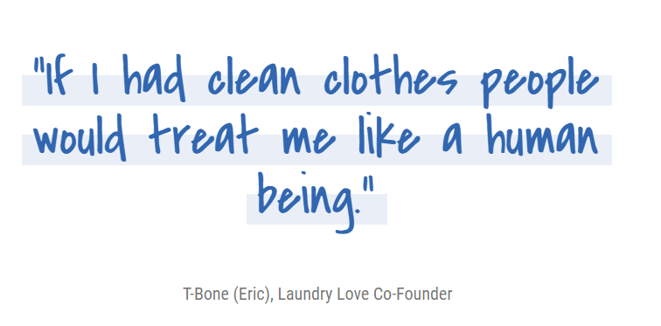
TBone [Eric], Laundry Love Co-Founder

__________________________________________________________________________________

We need baked goods and craft items to sell! Are you willing to donate for St. John? It will help us donate more dollars to missions and ministry here at St. John and in the community! Please call 763-856-4561, sign up after worship in the Gathering Space, or email churchoffice@green-church.org. Don’t delay!

Have you purchased your Raffle Tickets yet?
Be a part of the fun!
Available after worship in the Gathering Space, or by contacting the church office [see above].
This is going to be such a fun day!
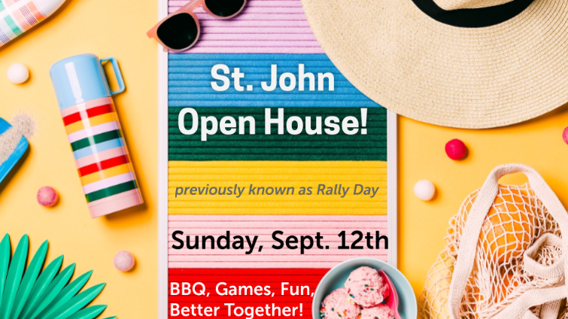
Sunday September 12
St John Open House - - “Better Together”
(Formerly Rally Sunday)

This is for EVERYONE! Services return to 8:00 and 10:30 AM. We would love to see worship filled with kids!! Kids time with the Pastor & activities bags are always favorites during worship; we love the giggles, the squiggles, the noise, and seeing families together for worship. Come see the new activity table for kids in the Gathering Space! Find out what a noisy offering is!
Between services we will have Sunday School sign-up in the Gathering Space [upstairs, just outside of the Sanctuary]. At 11:30 there will be games, a fishpond, a silly photo op, lots of smiles and a
St. John BBQ---all free! We are Better Together!
Help us fill our classrooms, spread the word that St. John is open for Preschool. We offer an excellent Preschool in a Christian setting. Fun, learning, friends, music, and of course, Jesus!
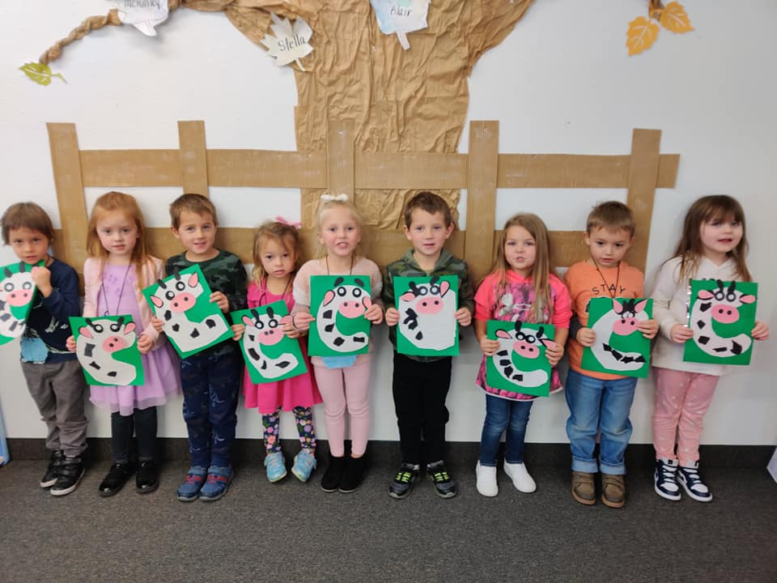
“C” is for Cornerstone
Christian
Preschool!
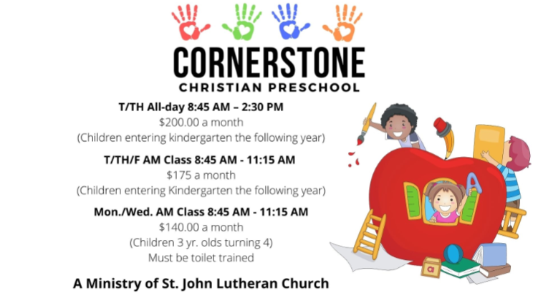

We believe that God wants us to be his love in the world by helping others. St. John made 36 personal care kits for Lutheran World Relief. These kits will be sent to people all over the world. This is a huge ministry of our Lutheran Church Check it out! see all the amazing things the Lutheran Church [that's us!] is doing to help share God’s love by helping people all over the world.
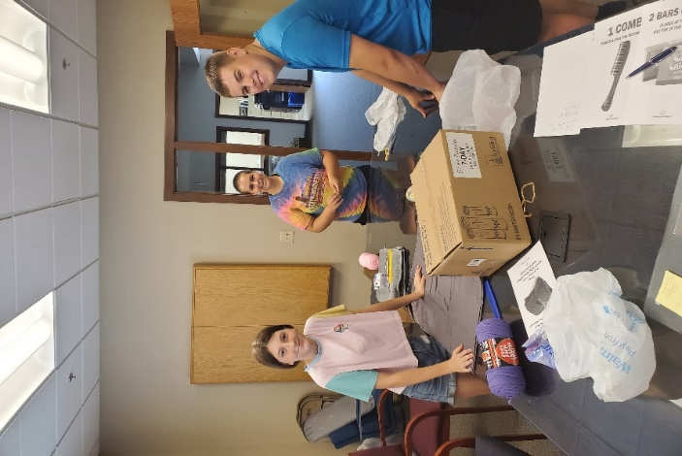
Here is a video about Personal Care Kits: Lutherans help change the world for BETTER We had such fun making the world a better place TOGETHER! Thank you to one special donation that helped us buy additional items and helped pay for shipping---wow! That was generous

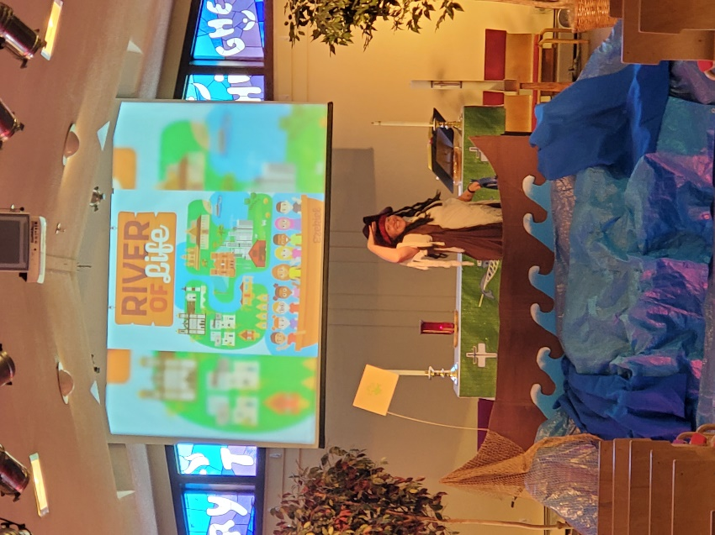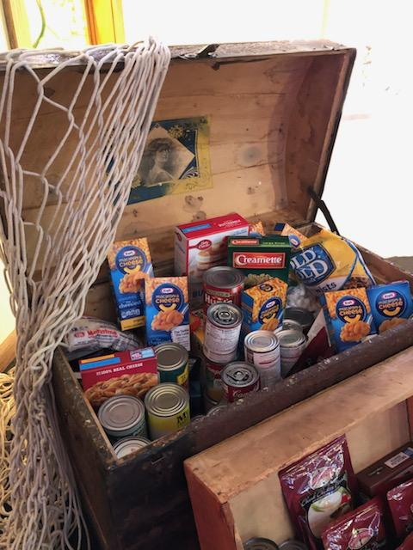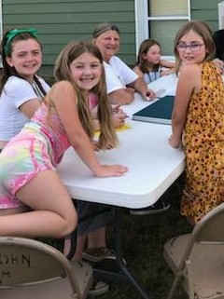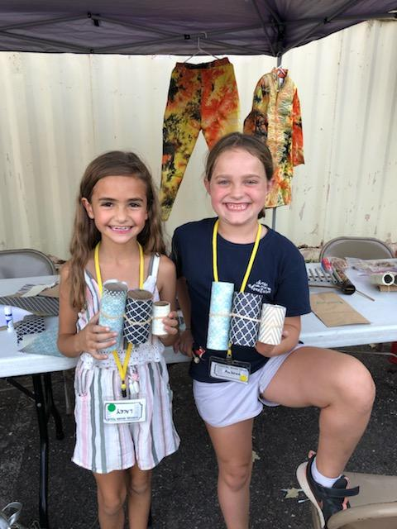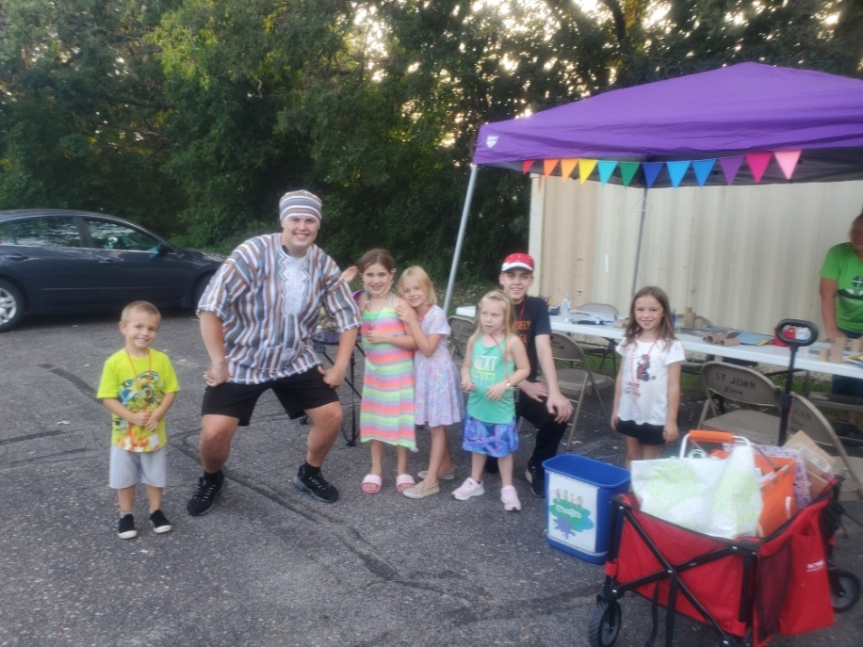
Vacation Bible School was a great event! Thank You volunteers! Carrie Stevens & Janie Wegleitner, our co-leaders, were AMAZING!

137 pounds of FOOD donated to CAER from VBS! Way to GIVE, Kids!
Confirmation students & others from St. John helped share God’s love, we had crafts, story tellers, fun snacks, water balloons, and just a whole lot of fun together.
THANK YOU to ALL who made VBS so special.

Fall at St. John 2021-22

Better Together!
The St. John Council, Staff, and Ministry Teams are so excited for this Fall.

Get ready for our Better Together Open House Rally Day!!
We are ready to celebrate TOGETHER. Fall kickoff day will be Sunday,
September 12th and it is for EVERYONE!
It’ll be a wonderful day together!

Worship at 8 & 10:30 am returns.

At 11:30 am we continue the celebration with a traditional St. John BBQ, outdoor games, a silly photo op, and of course smiles and laughter

Plan now for these Sunday School & Confirmation Dates

- Sunday School Register if you haven’t already and 9/12​ [Rally Day/Open House]​
- Sunday School Classroom Sunday School begins 9/19.
- Confirmation Orientation for 10th graders and parents ​on ​Wednesday, 10/06 at 6:00 PM.
- Confirmation class for 10th graders on 10/06 at 7:00 PM [one hour class on Faith Packets].
- Confirmation ​10th Grade ​Faith Packets DUE 10/20.
- Confirmation Orientation for 7-9th graders and parents​ on Wednesday, 10/13 at 6:00 PM.
- Confirmation classes begin for 7-9th graders on Wednesday, 10/20.
- ​Fall ​Confirmation Day [Affirmation of Baptism] for ​students who have completed all requirements, is ​October 31, 2021​​ at 1 PM.
- Spring Confirmation Day [Affirmation of Baptism] for ​students who have completed all requirements, is May 22, 2022 at 1 PM. ​

.
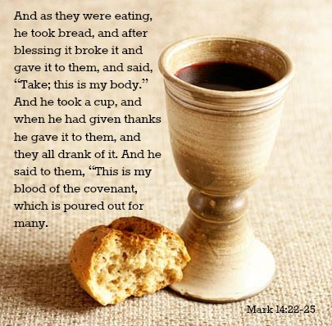
Your child’s first Holy Communion is such a special moment for them, and for you.
FIRST COMMUNION FAMILIES
With the news of Pastor moving to a different congregation, you may be wondering: “What about First Communion?”
First of all, let us assure you that your child will receive both instruction & their First Communion. We do, however, need to postpone it until we have our Interim Pastor in place.
We are working with the Synod Office to secure an Interim Pastor to serve at St. John. An Interim Pastor can be thought of as a “bridge” for congregations. Interim Pastor’s serve in a congregation through the transition from one Pastor to the next. They work with congregations while a Call Committee is formed, candidates interviewed, and a settled Call is extended to our next Pastor. Your St. John Council is meeting this Tuesday with Pastor Craig Pederson from our Synod Office to learn about the timing for this process. Be assured that we will keep the entire congregation informed about next steps.
Your child will receive a wonderful opportunity to learn more about the gift of Holy Communion and will have a special day to celebrate their First Holy Communion and we are so excited to be a part of that journey with you! Watch for updates in our newsletter, on the website at www.stjohnlc.org and through Sunday School emails. Be sure your child is registered for Sunday School [open now, on the website—register today!]
Plan to be at St. John on September 12th for the “Better Together Open House” Rally Day celebration.
September 12th--St John Open House - - “Better Together” (formerly Rally Sunday)
This is for EVERYONE! Services return to 8:00 and 10:30 AM. Between services we will have Sunday School sign-up in the Gathering Space [upstairs, just outside of the Sanctuary]. At 11:30 there will be games, a fishpond, a silly photo op, lots of smiles and a St. John BBQ---all free! We are Better Together!

If you have any questions or concerns about First Communion or anything else during this transition time, , please call the church office at 763-856-4561 or email at churchoffice@gmail.com we will get you in touch with the right person to talk with.

Sincerely,
Pastor Kari Bahe
Shane Steinbrecher, Council President

With the news of Pastor moving to a different congregation, you may be wondering: “What about Confirmation?”
CONFIRMATION FAMILIES
First of all, let us assure you that your child will have the opportunity to take part in a wonderful Confirmation year at St. John! We are especially excited to be offering in-person Confirmation this year!! Please add the dates below to your family schedule.
If your child is in 10th grade or in their 3rd year of Confirmation and if they complete all the requirements, they will be able to take part in a wonderful Confirmation Sunday celebration as they Affirm their Baptism at one of two Confirmation Services. We offer that worship service both in the Fall and the Spring—see below.
We are working with the Synod Office to secure an Interim Pastor to serve at St. John. An Interim Pastor can be thought of as a “bridge” for congregations. Interim Pastor’s serve in a congregation through the transition from one Pastor to the next. They work with congregations while a Call Committee is formed, candidates interviewed, and a settled Call is extended to our next Pastor. Your St. John Council is meeting this Tuesday with Pastor Craig Pederson from our Synod Office to learn about the timing for this process. Be assured that we will keep the entire congregation informed about next steps.
We are so excited to be a part of this journey with you! Watch for updates in our newsletter, on the website at www.stjohnlc.org and through emails. Be sure your child is registered for Confirmation [open now, on the website—register today!]
Plan to be at St. John on September 12th for the “Better Together Open House” Rally Day celebration.
September 12th--St John Open House - - “Better Together” (formerly Rally Sunday)
This is for EVERYONE! Services return to 8:00 and 10:30 AM. Between services we will have Sunday School sign-up in the Gathering Space [upstairs, just outside of the Sanctuary]. At 11:30 there will be games, a fishpond, a silly photo op, lots of smiles and a St. John BBQ---all free! We are Better Together!

If you have any questions or concerns about Confirmation or anything else during this transition time, , please call the church office at 763-856-4561 or email at churchoffice@gmail.com we will get you in touch with the right person to talk with.

Sincerely,
Pastor Kari Bahe
Shane Steinbrecher, Council President

* We are excited to see our confirmation students back in person this year! We believe that our teens grow in their faith best when they can connect and learn in person. In keeping with CDC and American Academy of Pediatric guidelines, we recommend that our students wear a mask when they gather for confirmation. However, they are not required at this time.
Requirements to be eligible as a candidate for
Affirmation of Baptism/Confirmation Day
- Participation in 3 years of confirmation instruction.
- All sermon notes, and acts of kindness forms complete and turned in.
- Confirmation readiness discussion with Pastor during the final year of confirmation.
- Faith Packet complete and turned in—found on the St. John website. More complete information about these requirements, the forms for sermon notes and acts of kindness & the Faith Packet are located here:
Confirmation Info and Faith Packet
SUNDAY SCHOOL FAMILIES----

Fall is just around the corner, and that means a return to Sunday School! St. John is ready for a wonderful year!

New Curriculum---SPARK! Written especially for Lutheran kids and geared toward each age group specifically, with resources for home too!

Are you joining in for this Fall? We need to know who is coming! Registration is currently open on our website - stjohnlc.org. Sign up today.

Sunday September 12 - St John Open House - - “Better Together” (formerly Rally Sunday)
This is for EVERYONE! Services return to 8:00 and 10:30 AM. We would love to see worship filled with kids!! Kids time with the Pastor & activities bags are always favorites during worship; we love the giggles, the squiggles, the noise, and seeing families together for worship. Come see the new activity table for kids in the Gathering Space! Find out what a noisy offering is!
Between services we will have Sunday School sign-up in the Gathering Space [upstairs, just outside of the Sanctuary]. At 11:30 there will be games, a fishpond, a silly photo op, lots of smiles and a St. John BBQ---all free! We are Better Together!

September 19 - First official day of Sunday School - We will start at 9:15 with music and be done with class at 10:15. We have a new curriculum this year that the kids will love. We would love to see the kids in worship!!! Come to worship and get a new magazine especially made for kids!

September 19 is also for Moms/Dads/Aunts/Uncles/ALL adults because it is also the First Day of Adult Education. Gather and learn together about our faith, each other, and God’s Word. Please grab a cup of coffee and join us in the conference room [upstairs] for fellowship and learning, while the kids are in Sunday School.

October 3 – WOW! Are we ever excited about October 3rd--Dr Roland Martinson—a nationally known and loved man of deep faith will be at St. John! This is BIG. Dr. Martinson [known as “Rollie”] is a Lutheran gem and expert on faith & home & congregation and how to put it all together in today’s demanding, busy world. He is funny, engaging, and you will leave with practical ways of truly living in your faith! You will want to be here for this! Drop your child/children at Sunday School and come up to the Sanctuary and absorb all he has to share.

More Information
- We are excited to see our Sunday School students back in person this year!
We believe that our children grow in their faith best when they can connect and learn in person. Knowing that our youngest church members are not yet able to be vaccinated against COVID, and in keeping with CDC and American Academy of Pediatric guidelines, we recommend that our students wear a mask when they gather for Sunday School. However, though encouraged, masks are not required at this time.

- We continue to feel in person worship is the best way to connect as a church family. In keeping with CDC guidelines for indoor gatherings, we recommend that our members wear a mask during worship. However, masks are not required at this time. Online worship will continue to be offered on the St. John Facebook page at 10:30 am.

We are still in need of teachers. It is going to be a great year with new curriculum that is ready to teach [podcasts available for 3-minute prep on those weeks when you are running late!] You can team teach, so you don’t have to be here every Sunday. Believe us when we say: you get WAY more out of teaching then you realize. It is a great experience. Plus---it is what we need to do to help pass on the faith. As the saying goes: If not you…then who?!
Please contact Jane Wegleitner at 952-913-7949, or at wegjm1@gmail.com; or Michelle Strom, Sunday School Superintendent at sundayschool@green-church.org or call the church office at 763-856-4561 and find out more about teaching.

Remember---Register your child/children for Sunday School today, so we are ready for them on day one! www.stjohnlc.org
September 12th is the day,
St. John!
We are Better Together!

We are sincerely looking forward to having your children in Sunday School. See you at the Open House on the 12th! Thanks for your time.

Keep the Faith,
--Your St. John Education Ministry Team
_____________________________________________________________________________________________
Adult Education for the Fall
September 19 is the First Day of Adult Education. Gather and learn together about our faith, each other, and God’s Word. Please grab a cup of coffee and join us in the conference room [upstairs] for fellowship and learning, while the kids are in Sunday School. We will be learning about how Lutheran’s approach the study of the Bible.

September 26 we continue our intro to the Bible, we look specifically at how Lutheran’s read the Bible.

October 3 – WOW! Are we ever excited about October 3rd--Dr Roland Martinson—a nationally known and loved man of deep faith will be at St. John! This is BIG. Dr. Martinson [known as “Rollie”] is a Lutheran gem and expert on faith & home & congregation and how to put it all together in today’s demanding, busy world. He is funny, engaging, and you will leave with practical ways of truly living in your faith! You will want to be here for this! Drop your child/children at Sunday School and come up to the Sanctuary and absorb all he has to share.

October 10- we will build on what Dr. Martinson shared with us and talk together about practical ways to have faith discussions at home.

October 17- How to raise a Spiritual Child/Grandchild.
October 24- We will continue to explore ways to support children in the faith.
October 31-Intergenerational learning event! This is for EVERYONE. Let’s join together as the faith family we are and learn from each other!

MINISTRY is filled with

“hello” & “goodbye”

Much of ministry is learning how to say “hello” and “goodbye” well, and helping others to do the same. When one of my favorite professors shared this with me, I thought it was a strange thing to say. But, over my 27 years of ministry, I have experienced how true it is. And, within the hellos and goodbyes there is God’s presence with those coming, those staying, those going, and those in between. The goodbye part is never easy, but new chapters can be a catalyst for opening up to the Holy Spirit in new and creative ways.
Russ Crabtree, a consultant with Holy Cow! Church Consultants says something about this “opening up” in a new way to the Holy Spirit, I have shared it previously, but it is well worth repeating:
Christians are constantly moving forward and reacting to the world around them through their faith and trust in God to work in the process of transition. Since the ministry in a congregation includes the entire congregation, the bulk of their strength and potential does not change as their pastor leaves. Congregations need to recognize and celebrate their inherent strength and potential even as they give thanks to God for the ministry and leadership their pastor provided during his or her tenure.

St. John, you are blessed by an abundant God. You have much to offer each other, to be sure, but more importantly for a faith community; you have much to offer the world! My prayers are with you as you do so. I get kidded about writing long articles for our newsletter---so maybe this is my chance to keep it short and sweet as I say, Dear St. John Family---[from Genesis 12]
You are Blessed to be a Blessing. You are God’s people. Fill the world with hope!
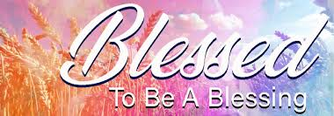
--Pastor Kari Bahe

THE LIFE HE PROMISES WILL PREVAIL
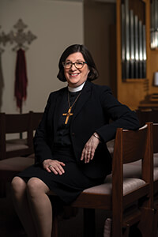
A word of hope from the Presiding Bishop of the ELCA, Rev. Elizabeth Eaton
I planted a garden last summer during the pandemic. Here in Chicago, March and April 2020 were cold and dreary. And it snowed. All around us was the oppressive reality of COVID-19: the lockdown, the fear, the daily grim statistics of rising cases and deaths, the isolation. I longed for a project that would look to the future and be life-giving. A garden would be just the thing.
I planted green beans and tomatoes, basil and lavender. I even planted raspberry canes, which turned out to be a challenge because there was a run on them—everybody must have been planting their own patch of Eden. I also planted petunias for a splash of color. When all was in, I admired the colors and waited for vegetables to grow.
With human beings in quarantine, the rest of creation had a chance to breathe and thrive. The smog had abated so much in India that people could see the Himalayas for the first time in decades. Penguins roamed the streets of Cape Town, South Africa, and mountain goats strolled through towns in Wales. I heard coyotes howling at night in my urban neighborhood. Rabbits and squirrels had the run of the place. At first this was a welcome sign of life flourishing despite the pandemic. But soon the rabbits and squirrels became brazen, and they turned their attention to my garden.
The squirrels chewed the raspberry canes down to a nub. The rabbits treated my petunia bed and green beans like an all-you-can-eat salad bar. Just as the tomatoes were beginning to ripen, the squirrels took them right off the vine. It was maddening. I tried all kinds of deterrents—Tabasco sauce mixed with dish soap, chunks of Irish Spring soap tied to stakes, constant vigilance—all to no avail. I even considered the possibility of an air rifle, but I’m pretty sure that there is an ordinance prohibiting the discharge of weapons in the city limits.
Eventually I came to believe that the rabbits and squirrels had formed an unholy alliance and were organizing against me. My suspicions were confirmed when I found tiny copies of Watership Down (the rabbit liberation manifesto) tucked in the bushes. All that was standing by the end of the season was the lavender, which I found remarkable because I was sure they would have taken the opportunity to fashion little wreathes to adorn their burrows and nests. To add insult to injury, the rabbits kept producing more little bunnies. They were adorable! Darn it!
I planted a garden this summer. Green beans, tomatoes, lavender, basil, zucchini, sage, rosemary and thyme. Flowers will follow soon. The rabbit and squirrel populations are robust, and it doesn’t help that my husband feeds the squirrels and has given them names. I thought about constructing a garden compound topped with razor wire, but I’m not going to do that. I will try the traditional methods of Tabasco sauce, dish soap, Irish Spring soap and vigilance. I will also place some fencing around the green beans and tomatoes. And I will hope.
Legend has it that Martin Luther once said: “If I knew that the world were to come to an end tomorrow I would plant an apple tree today.” This is a powerful statement of faith in the God who brought again from the dead our Lord Jesus Christ. This is the confidence that, when “he will come again in glory to judge the living and the dead, and his kingdom will have no end” (Nicene Creed), God will restore all of creation and this will be a good end.
This is the faith which declares that through pandemics, droughts, floods, famine, deadly bigotry, war, all the death-dealing things in nature and the human heart, life—the abundant life that Jesus promises—will prevail.

Info about Masks From your St. John Covid Safety Team—
For worship:
We continue to feel in person worship is the best way to connect as a church family. In keeping with CDC guidelines for indoor gatherings, we recommend that our members wear a mask during worship. However, they are not required at this time. We continue to offer online worship on the St. John Facebook page.

For confirmation:
We are excited to see our confirmation students back in person this year! We believe that our teens grow in their faith best when they can connect and learn in person. In keeping with CDC and American Academy of Pediatric guidelines, we recommend that our students wear a mask when they gather for confirmation. However, they are not required at this time.

For Sunday School:
We are excited to see our Sunday School students back in person this year! We believe that our children grow in their faith best when they can connect and learn in person. Knowing that our youngest church members are not yet able to be vaccinated against COVID, and in keeping with CDC and American Academy of Pediatric guidelines, we recommend that our students wear a mask when they gather for Sunday School. However, though encouraged, masks are not required at this time.

For Preschool:
We are excited to welcome our preschool students back! We followed COVID guidelines all last year and were able to continue our program through COVID. We continue to believe that our preschool students do best when they can connect and learn in person. Knowing that our preschool students are not yet able to be vaccinated against COVID, and in keeping with CDC and American Academy of Pediatric guidelines, we recommend that our students wear a mask when they are participating in indoor activities at preschool. However, though encouraged, masks are not required at this time. CCP continues to monitor information from the Minnesota Department of Health every day and will keep parents informed of any changes to this recommendation. Thank you for your cooperation!

13045 Fremont Ave. Zimmerman, MN 55398
763-856-4561 Facebook: greenchurch/1897 St. John is a member of the ELCA Evangelical Lutheran Church in America
www.elca.org
www.stjohnlc.org
churchoffice@green-church.org
pastor@green-church.org
financeoffice@green-church.org
custodian@green-church.org
music@green-church.org
Beginning Sept. 12th:
Worship every Sunday at 8 & 10:30 AM in person. Online at 10:30 AM on the St. John Facebook page.

St. John Lutheran Church is a member of the ELCA Evangelical Lutheran Church in America.

