I SCREAM YOU SCREAM

WHO WILL EAT THE MOST

ICE CREAM

2023 HOG CHALLENGE

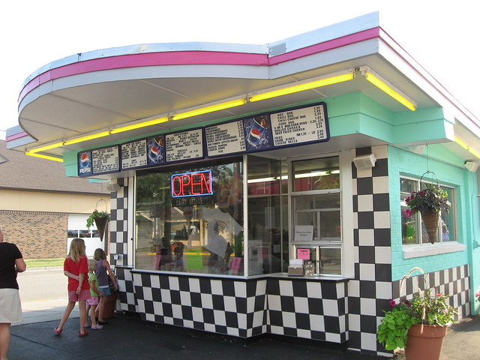

Picture with you, your bike and name of shop

Board member must verify picture and sign book

Call before you go to verify hours of operation

If you complete all stops you may start over for more points

***20 POINTS***

**DARI FAIR**

2813 KILBURN AVE. RKFD IL 61101

**BENNYS DAIRIETTE**

1402 MONTAGUE ST RKFD IL 61102

**ZAMMUTOS**

725 KENT ST RKFD IL 61102

**CREMA ROSA ARTISANAL CREAMERY**

609 KISHWAUKEE ST RKFD IL 61104

**LESSLYS ICE CREAM SHOP**

1710 RURAL ST RKFD IL 61107

**LESSLYS BOTANA**

1522 BROADWAY RKFD IL 61104

**SWEETS N EATS**

7096 WALTON ST RKFD IL 61108

**DAIRY DEPOT**

5413 N SECOND ST LOVES PARK IL 61111

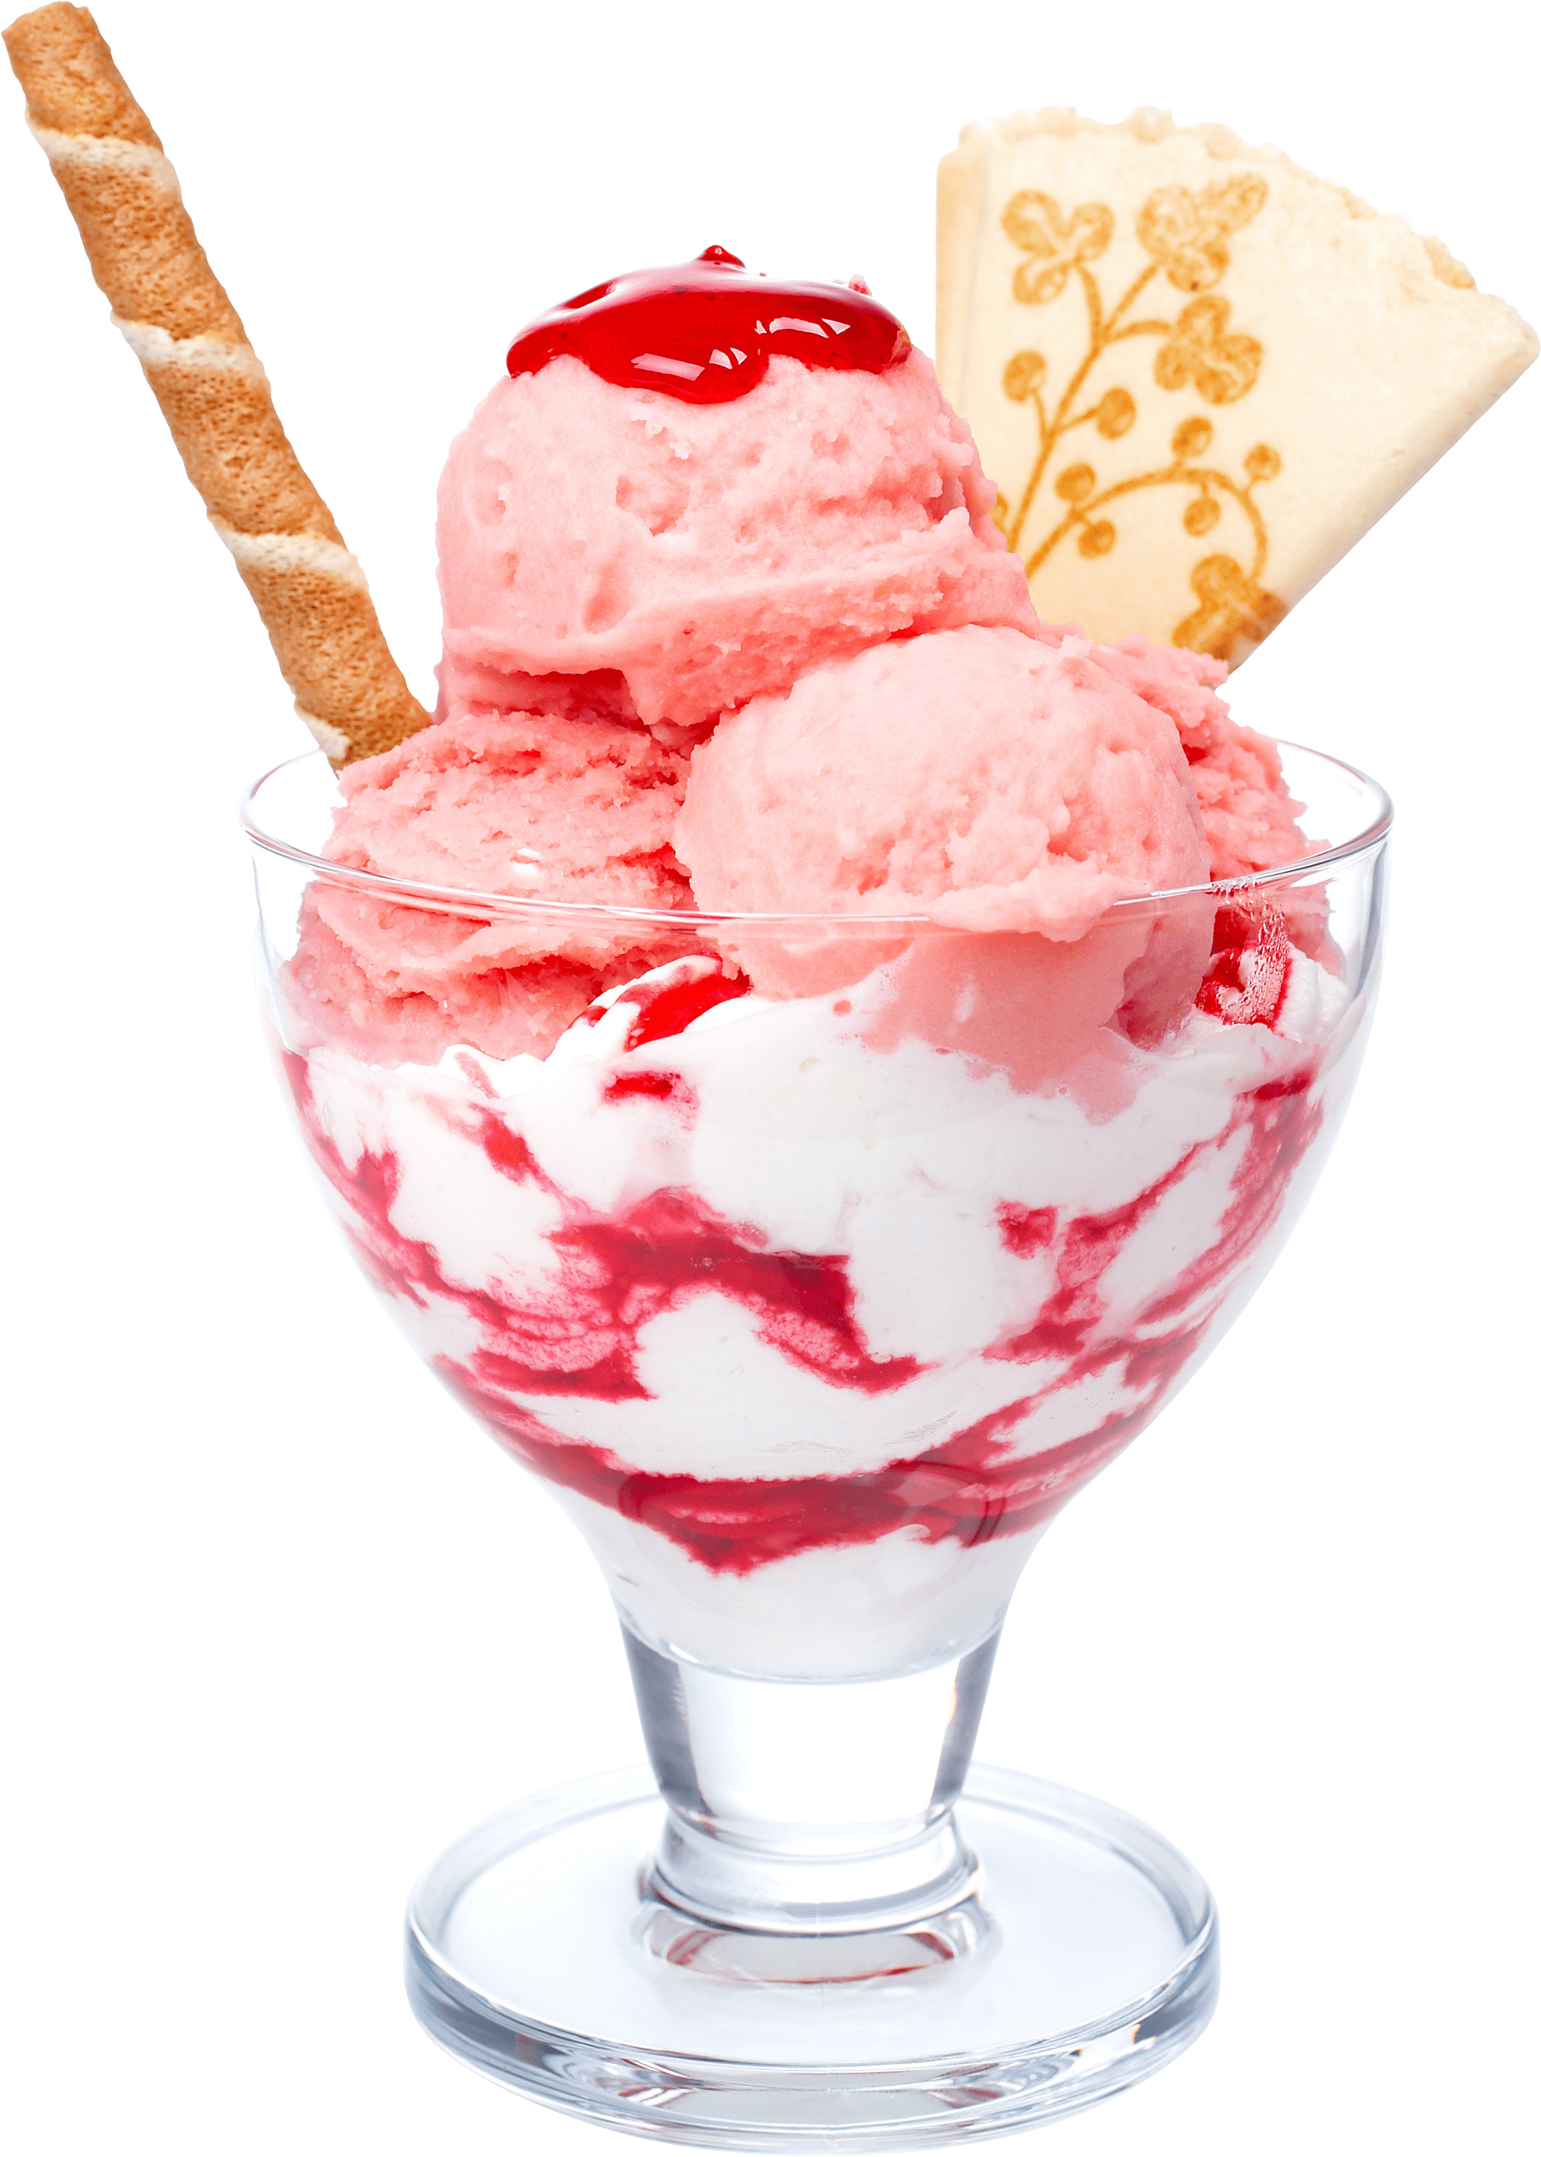

[This Photo](https://freepngimg.com/png/7648-ice-cream-png-image) by Unknown Author is licensed under [CC BY-NC](https://creativecommons.org/licenses/by-nc/3.0/)

**30 POINTS**

**3RD STREET STATION**

102 E 3RD STREET PECATONICA IL 61063

**THE SCOOP**

101 S BENTON ST WINNEBAGO IL 61088

**CENTER STREET CREAMERY**

425 N CENTER ST DURAND IL 61024

**MEGS COUNTRY CHEESE**

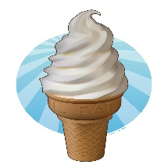

[This Photo](https://www.deviantart.com/jeremymallin/art/Ice-Cream-Cone-271557754) by Unknown Author is licensed under [CC BY-NC-ND](https://creativecommons.org/licenses/by-nc-nd/3.0/)

420 IL ROUTE 75 DAVIS IL 61019

**DAIRY HAUSE**

113 E MAIN ST ROCKTON IL 61072

**UNION DAIRY**

126 E DOUGLAS ST FREEPORT IL 61032

**FLYING PIG TREAT SHOP**

431 E GRAND AVE BELOIT WI 53511

**JAYS DRIVE IN**

107 W WASHINGTON ST OREGON IL 61061

**DARI RIPPLE**

105 S STATE ST BELVEDERE IL 61008

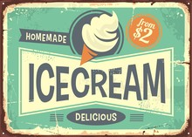 **40 POINTS**

BARREL AND BRIE

7836 US RT 20 W LENA IL 61048

CHOCOLATE TEMPTATION

1004 17TH AVE MONROE WI 53566

RAINBOW CONFECTIONS

1600 11TH ST MONROE WI53566

FLIPPEN FROG ICE CREAM AND TASTEY TREATS

815 ½ S WASHINGTON ST JANESVILLE WI 53548

THE TWISTED KONE

50 N UNION RD EVANSVILLE WI 53536

LA MICHOACANA

343 S DIVISION ST #7 HARVARD IL 60033

DARIEN ICE CREAM SHOP

30 W BELOIT ST DARIEN WI 53114

TROPICAL SNOW

583 N RUSH ST STOCKTON IL 61085

LA MICHOACANA ICE CREAM BAR

162 W LINCOLN HWY DEKALB IL 60115

TINAS ICE CREAM AND ANTIQUES

409 W MAIN ST MT CARROL IL 61053

**50 POINTS**

CAMPBELL BOYS

115 N HENERY ST EDGERTON WI 53534

MEGGY MOOS DAIRY RIPPLE

600 KENOSHA ST WALWORTH WI 53184

KENNEDYS ICE CREAM AND GRILL

400 RAILROSD ST NEW GLARUS WI 53574

MEUSELS DAIRY DELIGHT

303 S MADISON AVE AMBOY IL 61310

ICE CREAM DAYDREAM

124 W MAIN ST STOUGHTON WI 53589

SCREAMERS ICE CREAM

408 E CAMANCHE AVE SHABBONA IL 60550

ZIGGYS BBQ SMOKEHOUSE AND ICE CREAM PARLOR

135 S MAIN ST OREGON WI 53575

FRIENDS ON THE SQUARE

41 N WISCONSIN ST ELKHORN WI 53121

YELLOWSTONE LAKE DAIRY RESTAURANT

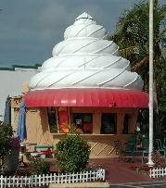

[This Photo](http://www.flickr.com/photos/atelier_tee/3164280102/) by Unknown Author is licensed under [CC BY-NC-ND](https://creativecommons.org/licenses/by-nc-nd/3.0/)

7123 LAKE RD BLANCHARDVILLE WI 5351

THE MILK HOUSE ICE CREAM

230 REINKING RD PINGREE GROVE IL 60140

**60 POINTS**

MALINI BIKINI

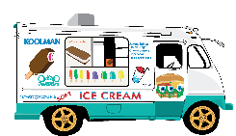

[This Photo](http://www.onyxtruth.com/2014/05/12/the-lyrics-behind-the-ice-cream-truck-song/) by Unknown Author is licensed under [CC BY-NC-ND](https://creativecommons.org/licenses/by-nc-nd/3.0/)

112 WRIGLEY DR LAKE GENEVA WI 53147

SOMETHING SWEET

105 E TOWNLINE RD LAKE GENEVA WI 53147

CHOCOLATE SHOPPE ICE CREAM CO.

2685 RESEARCH PARK DR FITCHBURG WI 53711

DAIRY JOY DRIVE IN

435 E LINCOLN AVE HINKLY IL 60520

IVYS OH SO SWEET ICE CREAM SHOP

10315 MAIN ST RICHMOND IL 60071

COUNTRYTIME CREAMERY

3709 MILLER RD MCHENRY IL 60051

TOMS STRAW HAT

126 S LAKE AVE TWIN LAKES WI 53181

SHEE GOO ROLLED ICE CREAM

1 NIPPERSINK BLVD FOX LAKE IL 60020

ADRANS FROZEN CUSTARD

572 BRIDGE ST BURLINGTON WI 5310

SILVER SPOON ICE CREAM AND TREATS

226 E LAKE ST SILVER LAKE WI 53170

HANSENS ICE CREAM PARLOR

129 E CHESTNUT ST BURLINGTON WI 53105

KRAVINGS

202 E MAIN ST WATERFORD WI 53185

SISLERS ICE CREAM

421 S MAIN ST PRINCETON IL 61356

SYCAMORE DAIRY RIPPLE

675 E STATE ST SYCAMORE IL 60178

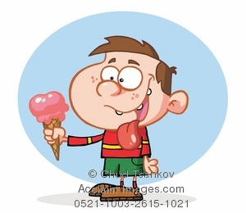

**80 POINTS**

ICE CREAM U SCREAM

198 MAIN ST DUBUQUE IA 52001

GRAB A CONE



[This Photo](https://www.pngall.com/ice-cream-png) by Unknown Author is licensed under [CC BY-NC](https://creativecommons.org/licenses/by-nc/3.0/)

102 US18 MONFORT WI 53569

N7 NITROGEN ICE CREAM

5117 BETTENDORF IA 52722

MINOOKA CREAMERY

111 MCEVILLY RD MINOOKA IL 60447

DELANEYS ICE CREAM

103 1ST AVE E FARLEY IA 52046

SCOOPS ICE CREAM

608 W 31ST ST CHICAGO IL 60616

AMELIAS TREATS AND TREASURES

112 E AMELIA ST CASSEVILLE WI 53806

SCOOPYS ICE CREAM AND CANDY

2466 WISCONSIN DELLS PKWY WIS DELLS 53965

BABES ICE CREAM AND DESSERT

2264 S KINNIKINNIE AVE MILWAUKEE WI 53207

WW HOMESTEAD DAIRY

850 ROSSVILLE RD WAUKON IA 52172

SUPER PREMIUM ICE CREAM

152 W GREENE ST POSTVILLE IA 52162

SWEET DELIGHT ICE CREAM

1901 W 4TH ST DAVENPORT IA 52802

TEES ICE CREAM AND BURGERS

838 PARK AVE MUSCATINE IA 52761

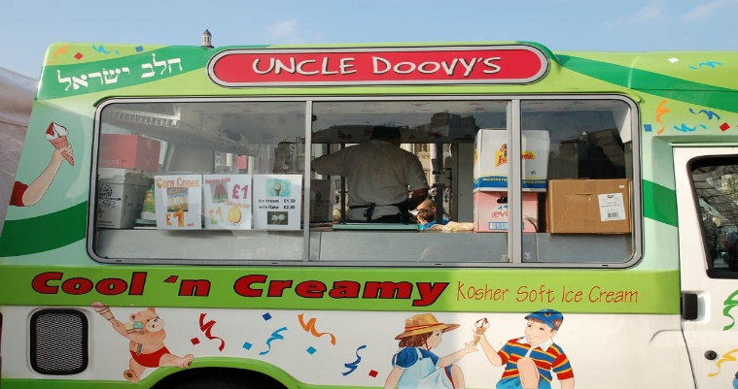

**100 POINTS**

CONE SHOPPE

140 S MAIN ST MONTICELLO IA 52310

ICE CREAM SHACK OF SUNNYLAND

2306 WASHINGTON RD WASHINGTON IL 61571

TWISTEE TREAT

1207 E WASHINGTON ST E PEORIA IL 61611

DOUBLE D’S ICE CRÈME

1434 N 8TH ST PEKIN IL 61554

KOOL MOO

1020 OLD MARION RD NE CEDAR RAPIDS IA 52402

OBERWEIS ICE CREAM AND DAIRY STORE

2105 N VETERANS PKWY BLOOMINGTON IL 61704

OBERWEIS ICE CREAM AND DAIRY STORE

1905 S NEIL ST CHAMPAIGN IL 61820

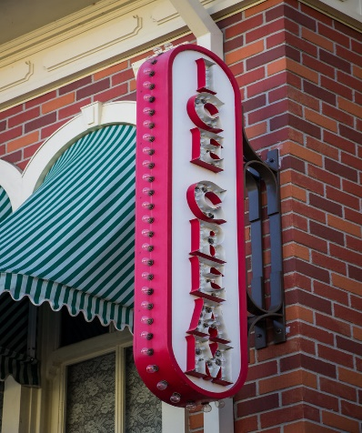

[This Photo](https://www.flickr.com/photos/harshlight/14246746452) by Unknown Author is licensed under [CC BY](https://creativecommons.org/licenses/by/3.0/)

**150 POINTS**

BRIQ’S SOFT SERVE

1605 MORRIS AVE WAUSAU WI 54401

LOVES ICE CREAM AND CHOCOLATE

435 IONIA AVE SW SUITE 106 GRAND RAPIDS MI 49503

OLSONS ICE CREAM

80 S BARSTOW ST EAU CLAIRE WI 54701

SCOOPS ICE CREAM

408 ARROW ST KOKOMO IN 46902

ICE CREAM DREAM

1112 MICHIGAN AVE MARSHALL MI 490

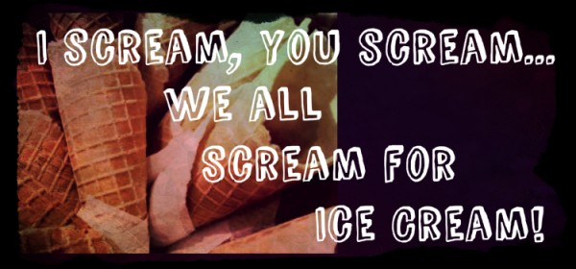

10