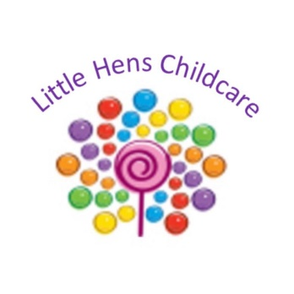

Outgrowing Little Hens Childcare
At Little Hens Childcare we take children up to the age of two and a half. We strive to engage children in age-appropriate activities, encouraging them to learn and develop. As a setting we promote each child’s learning and development to meet their individual needs. We ensure staff observe, assess and plan for individual progress, we do this by giving the children next steps and planning activities that help them develop and learn, following the EYFS. In some instances, a child may outgrow Little Hens Children before they reach the age of two and a half. This means, the child may be ready to move on to a more advanced age-group, the child may have developed skills that suggests they would benefit from a different learning environment. The child’s physical, emotional or social needs may have changed, they may have longer attention span, need more structure or be ready to be in a preschool environment. This can also mean that the space, resources or routine at Little Hens Childcare may no longer meet the needs of the child.
It is really important to us at Little Hens Childcare that we meet the learning needs of all children, if we have assessed that a child may be outgrowing Little Hens Childcare. Management will have a discussion about the child transitioning on to preschool. We will have a discussion with the child’s parents to talk over their child’s development and inform them on our professional opinion as we want the child to be gaining the most from their sessions at Little Hens Childcare. We would give a notice period of one month to the parents and help them with discussions and decisions about next steps and preschool.

