Spotlight March 2025
Valentina

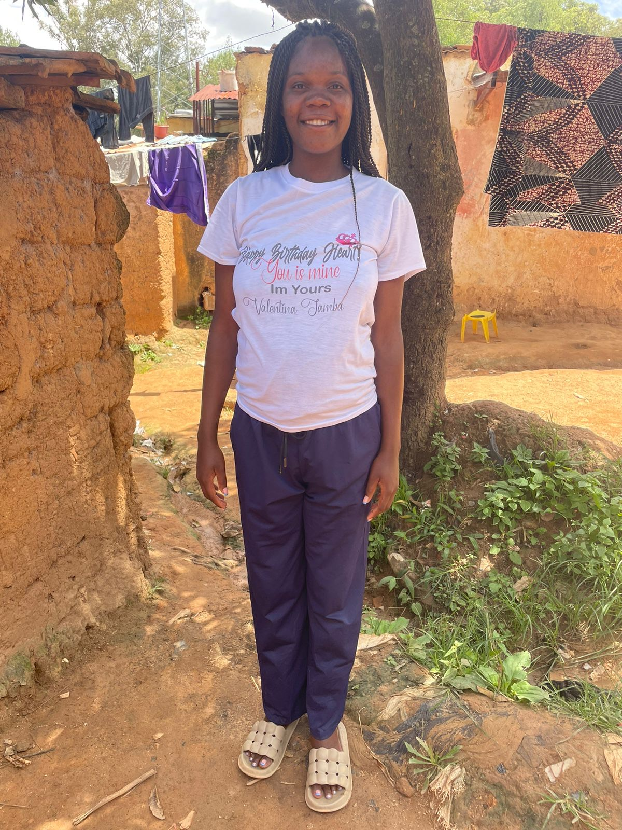

“Cordial greetings to all.

I, Valentina Chiquete Catombela, single, of 24 years of age, born on June 13, 2000, in Huambo, Angola, had the opportunity to complete the high school training for primary school teachers. I was able to attend this program solely based on a AWEF scholarship at Vavayela Magisterium in Huambo. I successfully complete all the requirements and in the same year I got a job as a primary school teacher.

Despite all the difficulties and challenges I faced during my training I thank God for the faith and focus, I thank the supporters of AWEF who made this dream possible, and I thank those who were part of my student journey. I am so grateful. Today I feel proud, because my life has changed. Today I can help my family with the little that I have

I hope that AWEF, a foundation that aims to help the most needy, will continue with this mission, as it has helped many of us fulfill our dreams and those of our families. Thank you very much for everything you have done for us. With best regards and highest esteem, Valentina.”

Valentina has recently lost her only parent, her mother, to breast cancer. Due to the financial security of her current employment she is able to support her younger siblings, and hopes that they will study and have their own careers. She is deeply grateful.

