***[2020 Census: Key Facts for Libraries](http://www.ala.org/advocacy/sites/ala.org.advocacy/files/content/actionareas/v5%20-%20Census%20tip%20sheets.pdf)***

**WHAT IS THE CENSUS? WHY IS IT IMPORTANT?**

* The U.S. Constitution requires a count every 10 years of every person living in the United States.
* Census results determine how the federal government allocates more than $800 billion each year for services that communities rely on, like Head Start, food assistance, and the Library Services and Technology Act.
* Census data also determine representation in Congress and the Electoral College, as well as in state and local governments.
* Historically, certain groups of people have been disproportionately undercounted in the census, including young children, people of color and indigenous people, and people experiencing homelessness.
* If the census misses people, undercounted communities won’t get fair funding for critical programs, and officials won’t have the reliable information they need to make decisions.

**Why is the 2020 Census important to Iowa County Residents?**

* In 2010, 88.4% of Iowa County’s households mailed back their 2010 census questionnaire, requiring more costly and difficult in-person follow up to enumerate the remaining 11.6%. The 11.6% were counted during the Nonresponse Follow-up Operation.
* In 2020 for the first time, the Census Bureau will be urging most households to submit their census responses online. During 2013-17, 20.8% of Iowa County’s households had either no home internet subscription or dial up-only, according to the latest American community Survey estimates. 10.3% of the county’s households had a cellular data plan only.
* In 2020, the all households will receive an invitation letter in the mail with instructions for responding to the census online. The invitation will include a unique identification code called a Census ID or User ID. Respondents can also complete the questionnaire over the phone by contacting Census Questionnaire Assistance. Households will receive several reminder letters form the Census Bureau if they do not self-respond. The final mailed reminder will include a paper questionnaire. After May 2020 if a household has not responded they may receive a phone call or an in-person visit from a Census Bureau employee.

[**How Community Leaders Can Partner with Libraries to Achieve a Complete Count**](http://www.ala.org/advocacy/sites/ala.org.advocacy/files/content/govinfo/CensusDecisionmakers.pdf)

Libraries are essential, trusted partners in achieving a complete count in the 2020 Census.

Libraries:

* Deliver information about the Census and host community outreach activities.
* Provide internet access and enable respondents to complete the Census form online.
* Serve as trusted messengers, including in hard-to-count communities.
* Train data users and provide access to Census statistics for businesses and community members.

[How Can My Library Increase Awareness of 2020 Census Hiring.](http://www.ala.org/advocacy/sites/ala.org.advocacy/files/content/tools/Census%20Tips%2002%20-%20Hiring%20-%20v4%20-%20WEB.pdf)

WHAT SHOULD I KNOW ABOUT CENSUS JOB OPPORTUNITIES?

* Hiring in Every Community: The Census Bureau plans to hire approximately 500,000 temporary workers across the country to help carry out the 2020 Census count, including census takers, office staff, recruiting assistants, and supervisory staff.
* Good Pay: These job opportunities offer excellent pay, flexible hours (for most positions), and, in many cases, paid training.
* Timeline: The Census Bureau is currently accepting applications for 2020 Census jobs and expects to continue hiring through early 2020.
* Eligibility: Candidates must be at least 18 years old, have a valid Social Security number, and be a U.S. citizen. Interested individuals will need to complete an online application.

[***PUBLIC LIBRARIES AND THE 2020 CENSUS***](https://www.gc.cuny.edu/Page-Elements/Academics-Research-Centers-Initiatives/Centers-and-Institutes/Center-for-Urban-Research/CUR-research-initiatives/Public-Libraries-and-the-2020-Census)***.*** *Center for Urban Research »CUR research initiatives. Posted October 23, 2018.*

**KEY FINDINGS:** Public libraries across the United States are planning to play an active role in the 2020 Census, both as sources of information about the importance of participating in the decennial census count, and as local community resources for people who would like to be counted but who may not have adequate internet access, for example.

The 2020 Census will be the first online census, but some parts of the country have poor internet access, raising the concern that it will be harder for households in these areas to be counted. But virtually all public libraries have public access computer terminals and free wi-fi, and can leverage this access for households that do not otherwise have easy access to the internet.

Public libraries are ubiquitous. Close to 100% of the U.S. population lives within 5 miles of at least 1 of almost 17,000 library branches located nationwide, and 73% of the population lives within 1 mile.

Communities that are considered hard-to-count for census purposes and areas that have relatively poor internet access also have libraries nearby. Almost 99% of these neighborhoods (as represented by census tracts) are within 5 miles of a library, and almost three-quarters are within 1 mile of a library.

In large cities, a greater share of neighborhoods with poor internet access than in general nationwide are close to public libraries: 86% of these tracts are within 1 mile of a public library, compared with three-quarters of these tracts near libraries nationwide. And in each of the nation’s 100 largest cities, all hard-to-count neighborhoods are located within 1 mile of a public library.

Public libraries are therefore literally well-positioned to have a major impact on census participation.

[**Libraries’ Guide to the 2020 Census**](http://www.ala.org/advocacy/sites/ala.org.advocacy/files/content/govinfo/LibrariesGuide2020Census.pdf)

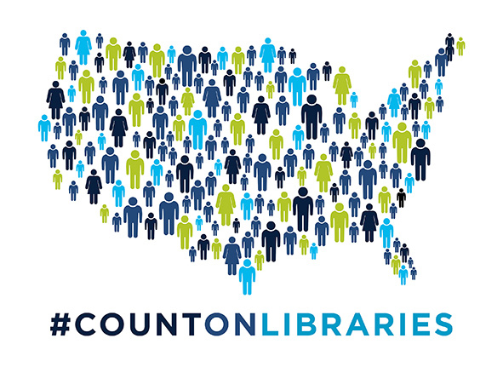

Summary of ALA Census 2020 information from <http://www.ala.org/advocacy/govinfo/census>.