Barneveld Public Library Board of Trustees
Job Responsibilities and Qualifications

What Does a Board Member Do?
- Attend monthly board meetings. Meetings are generally held the fourth Thursday of the month at 6:00 p.m. (No meeting is scheduled in December.)
- Assist in the review and approval of the annual budget and monthly expenditures.
- Participate in the development and review of library policies
- Assist in the hiring, supervising, and evaluating of the library director
- Study and be responsive to the needs and interests of the community
- Plan for the future
- Monitor the library’s effectiveness
- Be an advocate for the library
- Be open to volunteering assistance with library programming, events, and projects

What Are the Qualifications of an Effective Board Member?

- Commit the time that is necessary to carry out the duties of a Trustee. This includes time to become and stay knowledgeable about public library issues, to attend Board meetings, and to carry out Board assignments

- Be genuinely interested in public libraries and understand the importance of public libraries in meeting the educational, recreational, and informational needs of the community

- Understand the local community and its social and cultural needs, and be willing to communicate those needs to the Board

- Be able to work with others to reach a common goal

- Be open-minded, intellectually curious, and respectful of the opinions of others

- Have the courage to plan creatively and direct the effective implementation of those plans

- Be able to withstand pressures and prejudice that would restrict or prevent equal library service to all

Applicant # ________
Barneveld Public Library
Board of Trustees Application

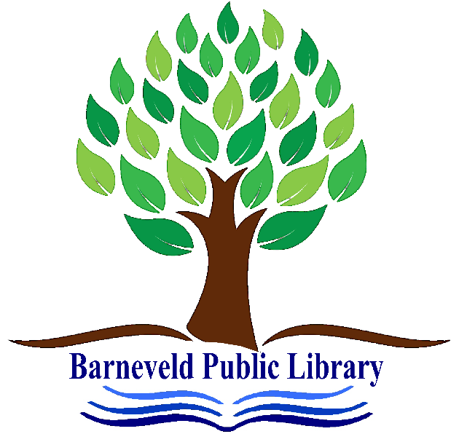

Date:__________________
Name: _________________________________________________
Address_____________________________________________________
_____________________________________________________
Phone (_______)____________________________
Email address____________________________________________________________

Applicant # _______

Board of Trustee Candidate Questionnaire
Thank you for your interest in serving on the Barneveld Library Board of Trustees. Please answer the questions below to help us learn more about you. Feel free to answer on an additional sheet of paper if you need more room.

How long have you lived in the Barneveld area?

Why are you interested in serving on the Library Board of Trustees?

Please describe your use of the materials, resources and programs at the Barneveld Public Library.

What challenges do you think our library faces?

Please describe any experience or expertise you have that you feel would be beneficial to the Board of Trustees.

What segment(s) of the Barneveld community do you feel you represent? (Possible examples: retiree, parent of young children, small business owner, etc.)

Do you have present or previous experience on a Board, Commission or Committee? If yes, what organization and position? If not, please share your experience in other leadership roles.

Please add any other information you would like to share.

Signature _____________________________________________________

