** Barneveld Public Library**



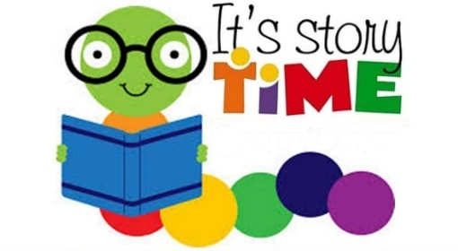

**1st and 3rd Wednesdays 2nd and 4th Wednesdays**

**Wednesdays, 10:30 a.m.**

**Preschool Story Time:** Miss Lynn will share stories and activities directed toward preschoolers ages three through five. Younger children are welcome to attend story time, but stories and activities may not be engaging for children younger than three.

**Preschool Play Time:** A variety of age-appropriate toys and activities will be available to encourage free play, skill development, and socialization.

|  |  |  |
| --- | --- | --- |
| Sept. 13 – Play **2023**  Sept. 20 - Story  Sept. 27 - Play | Dec. 6 - Story  Dec. 13 - Play  Dec. 20 - Story  Dec. 27 - Play | March 6 - Story  March 13 - Play  March 20 -Story  March 27 - Play |
| Oct. 4 - Story  Oct. 11 - Play  Oct 18 - Story  Oct. 25 - Play | Jan. 3 - Story **2024**  Jan. 10 -Play  Jan. 17 - Story  Jan. 24 – Play | April 3 - Story  April 10 - Play  April 17 - Story  April 24 – Play |
| Nov. 1 - Story  Nov. 8 - Play  Nov. 15 - Story  Nov. 22 - Play | Feb. 7 - Story  Feb. 14 - Play  Feb. 21 - Story  Feb. 28 – Play | May 1 - Story  May 8 - Play  May 15 - Story  May 22 - Play |

**Weather Cancellation:** Preschool Story Time and Preschool Play Time will be cancelled if Mount Horeb, Barneveld, or Dodgeville schools are running late or closed for snow or ice related weather conditions