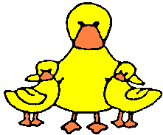
Woodley
Pre-School

15. Animals in the pre-school

Policy Statement

Children learn about the natural world, its animals and other living creatures, as part of the Early Years Foundation Stage curriculum. This may include contact with animals, or other living creatures, either in the pre-school or in visits. We aim to ensure that this is in accordance with sensible hygiene and safety controls.

Procedures

Animals in the pre-school as pets or visits from animals
We do not keep pets at Pre-school but sometimes invite owners and pets in to visit.

- If animals or creatures are brought in by visitors to show the children, they are the responsibility of the owner.
- The owner provides full information about the animal before the visit, detailing how the animal or creature is to be handled and how any safety or hygiene issues will be addressed.
- We carry out a risk assessment with a knowledgeable person accounting for any hygiene or safety risks posed by the animal or creature.
- We request the owner of the animal provide suitable housing for the animal or creature and request that’s this is clean and safe.
- Children are taught correct handling and care of the animal or creature and are supervised when in contact with or near it.
- Children wash their hands after handling the animal or creature and do not have contact with animal soil or soiled bedding.
- Staff wear disposable gloves if required to support the animal’s needs.

