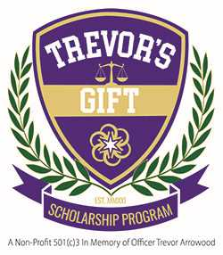
Trevor’s Gift Scholarship Program Application

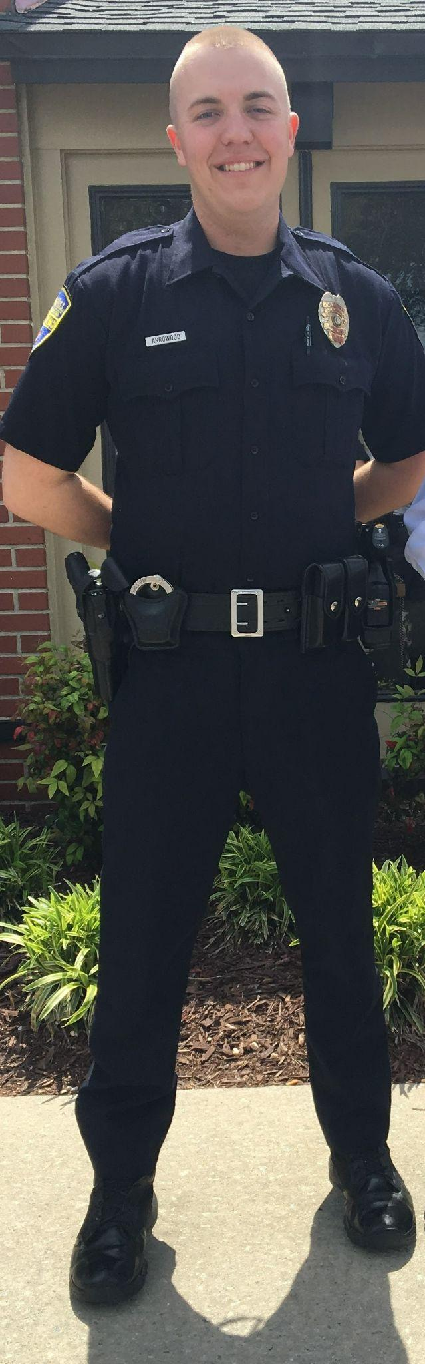
A four-year renewable $1,000 scholarship to Western Carolina University for students pursuing Criminal Justice

Officer Trevor Arrowood was born on November 7, 1995 and grew up in Polk County, N.C. From the time he was a toddler, Trevor dreamed of one day becoming a police officer – and once Trevor set his mind on something, that was it.

Trevor excelled in school and sports, and upon graduation from Polk County High School, he went to Western Carolina University to pursue a degree in Criminal Justice. While at WCU, Trevor found an opportunity to get involved on campus, serve his community and create lasting friendships by joining the fraternity SAE, where he soon earned leadership positions.

After graduating from WCU with honors in 2017, Trevor was proud to begin a career in public service as a Rock Hill, S.C. police officer. He quickly gained notoriety among his fellow officers and his superiors for his tireless work ethic, contagious smile and genuine commitment to the people he served.

In June of 2018, Trevor learned he had a large mass in his heart. After open heart surgery, doctors discovered this mass to be cancer. Though he endured years of chemo, radiation, and multiple surgeries, Trevor never quit fighting and never lost his positive attitude. Trevor insisted on working from home – or from his hospital bed – throughout his treatment. He also continued his habit of making friends wherever he went, and it wasn’t uncommon to see every nurse in the wing stopping by to chat with him during their breaks.

On January 5th, 2021 Trevor won his three-year long battle with cancer and left behind an inspiring legacy. This scholarship was created to honor Trevor’s memory by supporting the education of students who share his passion for service and commitment to justice.

Students must meet the admissions requirements for Western Carolina University to be considered for this scholarship. In order to renew the scholarship, proof of a minimum GPA of 3.0 and good standing with WCU must be provided to the scholarship committee at the end of each spring semester.

The deadline to apply is April 1, 2023. Applications may be emailed to adam12scholarship@gmail.com OR submitted online at trevorsgift.com/apply. Please include both the completed application form and your short essay response.

Two letters of recommendation are also required. Letters must be provided by the recommender directly. These may be emailed to adam12scholarship@gmail.com OR submitted online at trevorsgift.com/recommendations.
Trevor’s Gift Scholarship Program Application

Name: ________________________________________________________________
(First) (Middle) (Last)
Mailing
Address: ______________________________________________________________
(Street) (City) (State) (Zip)

Email: ___________________________________ Phone: _________________________

DOB: ______________________ Last four digits of SSN: _________________

━━━━━━━━━━━━━━━━━━━━━━━━━━━━━━━━━━━━━━

High School: _______________________________ Graduation Date: _____________

Address: ______________________________________________________________
(Street) (City) (State) (Zip)

School Counselor:___________________________________________________

Counselor’s phone: ________________ Counselor’s email: _______________________

━━━━━━━━━━━━━━━━━━━━━━━━━━━━━━━━━━━━━━

Name of Recommender #1: __________________________________________

Relationship to Applicant: ___________________________________________

Phone: ___________________ Email: _______________________________

━━━━━━━━━━━━━━━━━━━━━━━━━━━━━━━━━━━━━━

Name of Recommender #2: __________________________________________

Relationship to Applicant: ___________________________________________

Phone: ___________________ Email: _______________________________

━━━━━━━━━━━━━━━━━━━━━━━━━━━━━━━━━━━━━━

Please list any extracurricular activities you have pursued during your time in high school. You may use the provided space and include additional sheets, if needed.

SCHOOL ACTIVITIES (i.e. sports, clubs, etc.) YEAR(S) POSITIONS HELD/ACCOMPLISHMENTS
___________________________________________________________________________________________________________________________________________________________________________________________________________________________________________________________________________________________________________________________________________________________________________________________________________________________________________________________________________________________________

COMMUNITY/VOLUNTEER ACTIVITIES YEAR(S) TIME SPENT/ACCOMPLISHMENTS
____________________________________________________________________________________________________________________________________________________________________________________________________________________________________________________________________________________
_____________________________________________________________________
_____________________________________________________________________

EMPLOYERS YEAR(S) JOB DESCRIPTION/HOURS
__________________________________________________________________________________________________________________________________________
__________________________________________________________________________________________________________________________________________

You may use this space to list any other achievements, honors, or awards you received during your time in high school.
____________________________________________________________________________________________________________________________________________________________________________________________________________________________________________________________________________________

━━━━━━━━━━━━━━━━━━━━━━━━━━━━━━━━━━━━━━

Please attach your response to the following prompt. Your essay should be no longer than two pages, double spaced.

ESSAY: Why do you want to study Criminal Justice? What kind of career do you hope to pursue with your degree?

━━━━━━━━━━━━━━━━━━━━━━━━━━━━━━━━━━━━━━

