ENCYCLOPEDIA OF SPORTS MANAGEMENT AND MARKETING

MARKET STRUCTURE

The concept of market structure is contained in both of the academic disciplines of Economics and Marketing. Its inclusion in each of these fields is a result of their mutual concern with strategic decision making. Economics has a focus on high level socio-economic issues, while marketing looks to gain understanding of behavioral issues facing both producers/suppliers and consumers. In addition, mmarketing managers seek to define market structure to create competitive strategies as part of an overall marketing plan. In both cases, managers define market structure with the understanding that market structure is fluid. What the market looks like today, and what it looks like tomorrow, may be two completely different pictures. While the approaches in each of these areas tends to take different paths, both have the common concern of understanding the makeup and dynamics of a given environment, and the behavior of the constituents.

In Economics, market structure is most frequently defined by describing the relative strengths of sellers. This is demonstrated by how many firms there are, and how they vary in size. The most familiar categorization yields the following theoretical constructs:

* **Monopoly**: A monopoly exists when one company and one only provides services in a particular industry, or one company dominates and consumers cannot substitute anything that comes close. Today, very few industries are monopolies. Utility companies such as water companies or electric companies may be considered monopolies. Consumers can't easily substitute something else for electricity from the local provider.
* **Oligopoly**: An oligopoly consists of only a handful of companies selling similar products. Consumers can substitute products, but only one company's offerings for another. An example would be the domestic airline industry where the already small number of providers is getting smaller as a result of consolidation through mergers and acquisitions.
* **Monopolistic Competition**: In monopolistic competition, many sellers sell different products. It's very similar to competition, below, with the exception that the products themselves are a bit different from one another, so consumers look for those differences rather than price differences. An example is the restaurant industry. Anyone can obtain the proper permits, licenses and such and open a restaurant offering any cuisine or food in the world. Whether the restaurant is successful or not depends upon whether or not consumers like the food, service, décor, location, and all the other factors that make restaurants successful.
* **Competition**: In markets with perfect competition, there are no barriers to entry, and many companies offering different goods. Consumers often shop on price differences alone. Wal-Mart may be viewed as a purely competitive company within the grocery industry for its super centers that offer lower prices than competing grocery chains.

This broad categorization presents a need for further analysis, prompting several approaches to providing additional insight:

* The N-firm concentration ratio. The five-firm concentration ratio, for example, shows the total market shares of the largest five firms as a proportion of the whole market. This has defects, however; there is a lot of difference between a market in which the largest firm has 80 per cent of all sales and the next four firms have 2 per cent each, and the market in which the largest five firms all have 15 per cent of the market.
* The Herfindahl index, also known as Herfindahl-Hirschman Index or HHI, is a measure of the size of firms in relation to the industry and an indicator of the amount of competition among them. Increases in the Herfindahl index generally indicate a decrease in competition and an increase of market power, whereas decreases indicate the opposite. The major benefit of the Herfindahl index in relationship to such measures as the concentration ratio is that it gives more weight to larger firms.

Marketers view market structure from a different perspective. While knowing if their industry is an oligopoly or a purely competitive environment is important, marketers dig deeper into the industry, searching for the market structure to understand the competition and customer behavior, giving more support to the consumer’s view of market dynamics:

* An operational statement of competition derived from customer perceptions of product substitutability,
* Actual market impact, as measured by cross elasticity

Marketers look across the various companies in the structured categories of competition and examine the goods and services offered. They look at the four P's of marketing among the competitors: product, price, place and promotion. They seek to use this information to help them form their own strategies to drive customer acquisition, retention, and overall profitability. Pertinent dimensions of the analysis include:

* Actual and potential market size
* Market growth
* Market profitability
* Cost structure
* Distribution systems
* Trends and developments
* Key Success Factors

One frequently used, and broadly supported, tool for analysis by marketers is Porter’s Five Forces Model. The five factors are:

* Existing competitive rivalry between suppliers
* Threat of new market entrants
* Bargaining power of buyers
* Power of suppliers
* Threat of substitute products (including technology change)

Figure One

Porter’s Five Forces Model

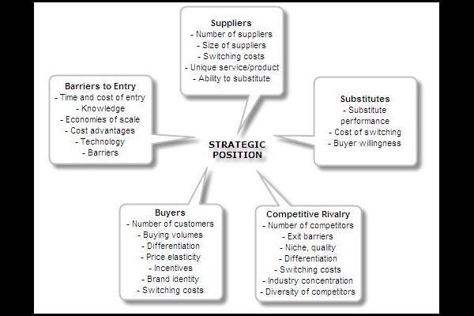

Porter’s model is based on the insight that a corporate strategy should meet the opportunities and threats in the organizations external environment. Especially, competitive strategy should be based on an understanding of industry structures and the way they change.