**INTRODUCTION**

As far back as 1983, with the establishment of the Brundtland Commission, it has been a widely accepted notion that education will play a critical role in advancing the paradigm that future development would incorporate balanced perspectives of human, economic and environmental concerns. Education for sustainable development has natural synergies with the global sector of higher education. In the early part of the 21st century, efforts began to organize and institutionalize this effort. In 2001, the Education for Sustainability Western Network (EFS West), was established by Second Nature, with funding from the Compton Foundation. EFS West served college and university campuses in the western U.S. and Canada, providing resources and support for their sustainability efforts. In 2004, EFS West held the first North American Conference on Sustainability in Higher Education in Portland, Oregon. The success of this conference and increasing demand for EFS West’s resources led it to transition from a regional network to an independent higher education association serving all of North America – the Association for the Advancement of Sustainability in Higher Education. AASHE was officially launched in December 2005, serving as the first professional higher education association for the campus sustainability community in North America. Today, AASHE empowers higher education faculty, administrators, staff and students to be effective change agents and drivers of sustainability innovation, with over 1000 members, across 30 countries. We work with, and for higher education to ensure that our world’s future leaders are motivated and equipped to solve sustainability challenges.

**COLLABORATION WITH OTHER INSTITUTIONS AND EXISTING RELATIONSHIPS**

The AASHE (Association for the Advancement of Sustainability in Higher Education) mission reads as follows:

AASHE empowers higher education faculty, administrators, staff and students to be effective change agents and drivers of sustainability innovation. We work with and for higher education to ensure that our world’s future leaders are motivated and equipped to solve sustainability challenges.

In the United States, and abroad, the organization seeks appropriate partnership opportunities within the higher education arena, as well as with other non-profits and for-profit entities. To that end, we have a substantial network of sustainability-oriented organizations. These partnerships fall into several categories:

**STRATEGIC ALLIANCES**

AASHE enjoys deep and longstanding relationships with a small group of leading organizations. We are working together to increase the number of global sustainability citizens.

[***National Wildlife Federation***](http://www.nwf.org/)

NWF is a voice for wildlife, dedicated to protecting wildlife and habitat and inspiring the future generation of conservationists. Their Campus Ecology program has been working with colleges and universities for more than 25 years to protect wildlife and habitat through campus sustainability efforts.

[***Second Nature***](http://secondnature.org/)

Second Nature strives to help build a sustainable and positive global future through leadership networks in higher education. Their primary tool, the Climate Commitment, integrates a goal of carbon neutrality with climate resilience and provides a systems approach to mitigating and adapting to a changing climate.

[***U.S. Green Building Council***](http://www.usgbc.org/)

USGBC is committed to transforming the way our buildings are designed, constructed and operated through LEED — the top third-party verification system for sustainable structures around the world.

College and university leaders across the US and around the world have stepped up to model sustainability across curricula, operations, management systems, and community relations. In celebration of the bold strides toward sustainability made across US higher education, these organizations pledge to support the next bold leaps with a collective vision that will convey to the world that the US is serious about demonstrating social, economic, and environmental sustainability and is doing so in a way that prepares graduates for 21st century imperatives. We collectively support a vision that:

* By 2025, 20 million graduates across all majors will be global sustainability citizens: learning about relationships between natural, physical, economic, social, and cultural systems
* Promotes understanding of how their personal and professional choices impact these systems
* They have the agency to create solutions that allow people and the environment to thrive.

In order to achieve this vision, AASHE, NWF, Second Nature and USGBC pledge to:

* Expand our collective capacity to convene and empower higher education leaders to deepen climate commitments, share best practices and drive sustainability into their core business.
* Consolidate and leverage our efforts to embolden more students to lead whole-campus sustainability initiatives and prepare them for 21st century careers.
* Cross-promote and increase alignment of our respective rating systems, frameworks and recognition platforms.

**COALITIONS**

AASHE participates in coalitions to magnify our impact and stay informed about issues of interest to the higher education sustainability community:

[**Better Buildings Alliance**](https://betterbuildingsinitiative.energy.gov/alliance)

The Better Buildings Alliance brings together leaders from the nation’s commercial building industry to share and advance solutions in energy efficiency.

[**The Council of Higher Education Management Associations (CHEMA)**](http://www.chemanet.org/)

An informal voluntary assembly of management-oriented higher education associations in the United States and Canada.

[**Disciplinary Associations Network for Sustainability (DANS)**](http://dans.aashe.org/)

An informal network of professional associations working on a number of cross disciplinary projects on education for sustainability.

[**Environmental Paper Network**](http://environmentalpaper.org/)

The Environmental Paper Network shares a common vision of a forest, pulp and paper industry that contributes to a clean, healthy, just and sustainable future for all life on earth.

[**Higher Education Associations Sustainability Consortium (HEASC)**](http://www.aashe.org/partners/heasc/)

HEASC is a network of higher education associations with a commitment to advancing sustainability within their constituencies and within the entire system of higher education.

[**New Economy Coalition (NEC)**](https://neweconomy.net/)

The New Economy Coalition (NEC) is a network of organizations imagining and building a future where people, communities and ecosystems thrive.

## PARTNERSHIPS

With access to over 10,000 professionals from almost 900 institutions, AASHE business partners are well positioned to increase their exposure and business opportunities within the higher education sustainability community. There are several options for these partners to conduct outreach efforts to the AASHE membership:

### AASHE Membership

### Sponsorship

#### AASHE Annual Conference & Expo

#### AASHE Publications

#### AASHE Workshops

#### AASHE Webinars

With the aim of advancing international collaboration and learning to accelerate the campus sustainability movement, AASHE continues to work with our international counterparts, Australasian Campuses Towards Sustainability (ACTS) and the United Kingdom’s Environmental Association for Universities and Colleges (EAUC), as well as continuing to encourage international higher education institutions to be AASHE members.

## Australasian Campuses Towards Sustainability Incorporated Association (ACTS)

ACTS is a nonprofit member-based organization representing higher and further education institutions within Australia and New Zealand. ACTS aims to inspire, promote and support change towards best practice sustainability within the operations, curriculum and research of the tertiary education sector. ACTS seeks to build community and business partnerships at the local, regional and international level, in order to bring together a network of people for positive engagement, capacity building and change.

## The Environmental Association for Universities and Colleges (EAUC)

The EAUC is the environmental and sustainability champion within Further and Higher Education in the U.K. The EAUC is a strong alliance of universities and colleges, sector bodies and commercial organizations that is financed by subscriptions and service generated revenue which funds EAUC’s work of representing and promoting the interests of members and the provision of support services to drive sustainability to the heart of tertiary education across the U.K. and internationally.

As part of our current strategic plan development, priorities for AASHE have been established so as to be in sync with our programs and services and increase value to our members. The plan elements are the voice of our constituency, and are intended to best serve our members and advance our mission over the next three years. This plan will be a guide for the board and staff to continue to improve upon

We will continue to connect members with the programs they need to improve their institution’s sustainability performance. We’ll work to recognize their achievements and celebrate how far higher education has come in advancing sustainability. We’ll provide opportunities to learn from peers, develop your skills, and engage your campus community in sustainability. We’ll also improve and expand upon STARS, our most valued program and an instrument of change that has helped transform so many colleges and universities. Additionally, we will focus on strengthening our organization, fiscally as well as culturally. We’re working to practice our values and model sustainability in every aspect of what we do and how we work. We will embark on a process to identify the future needs of our community in response to the increasing societal and political challenges we’re facing today. Our commitment to the principles of sustainability connects us all and, drawing from one another for support and inspiration will enable our community to be more resilient during these difficult times. Our work is more important today than ever before. This plan provides direction for our future, details on how we’ll accomplish our goals, and strategies for measuring our performance. Perhaps more important, it’s about growing and strengthening our community and bolstering our collective impact.

## Our Mission

To inspire and catalyze higher education to lead the global sustainability transformation.

## Our Vision

AASHE will lead higher education to be a foundation for a thriving, equitable and ecologically healthy world.

## Our Values

Transparency, Collaboration, Hope, Stewardship, Innovation, Courage, Accountability, Diversity & Inclusion.

## Our Strategic Goals (through 2020)

### Goal 1: Empower members to be transformational leaders for sustainability by providing indispensable resources and outstanding professional development

* Develop new and improve existing resources, tools and publications
* Strengthen the annual conference and expo to be the marquee forum for all stakeholders within the higher education sustainability community
* Offer high-value professional development programs
* Expand opportunities for networking and building community

### Goal 2: Catalyze sustainability action and innovation through STARS

* Simplify reporting requirements and reduce barriers to participation in STARS
* Strengthen the value of a STARS rating
* Improve the quality of STARS data
* Increase net income for STARS

### Goal 3: Accelerate higher education’s contributions to global sustainability through increased outreach, communications and advocacy

* Advocate for policies that advance sustainability in higher education
* Champion the value of sustainability in higher education and increase support for sustainability in academics, engagement, operations and administration
* Identify new, high impact strategies to best advance our mission

### Goal 4: Enhance organizational capacity & resilience

* Grow the AASHE member community
* Optimize internal efficiency and improve customer experience
* Strengthen organization leadership and governance
* Create a culture that supports employee well-being and motivation
* Ensure AASHE’s financial health and stability

**IMPORTANCE OF SDG 17 AND PERSPECTIVE ON IMPLEMENTATION**

As a comprehensive list of sustainability goals/targets, SDG 17 represents an opportunity to establish a paradigm which can eliminate or at least minimize the temptation and tendency to view challenges through silos, whether defined by academic expertise, interest area, organizational structure, technology or other. It is an opportune time to address this issue, in a discussion of capacity building in a higher education framework.

“Creating a better world requires teamwork, partnerships, and collaboration, as we need an entire army of companies to work together to build a better world within the next few decades. This means corporations must embrace the benefits of cooperating with one another.”

Simon Mainwaring

As a leader of an organization dedicated to sustainability, and as an individual citizen of the world, I am a firm believer in the benefits of collaboration. In the globally connected world we now live in, developments and decisions no longer occur on a simply local level, but have national, regional and global impact and implications. As global competition intensifies for access to markets, products and technology, strategic alliances are gaining importance worldwide. Whether contemplated as a short-term means of survival, or as an integral part of a carefully considered long-term global strategy, strategic alliances have become familiar as a viable option for firms competing in the global marketplace.

In their book, “Strategic Alliances: An Entrepreneurial Approach to Globalization”, Yoshino and Rangan (1995) state that “Strategic alliances will have the best chance for success if they are treated “comprehensively as instruments of long-term competitive advantage, rather than short-term defensive maneuvers”.

Strategic alliances can be defined as “associations to further the common interests of the members”, with cooperation between two or more independent firms, linking specific facets of their businesses, and involving shared control and continuing contribution by all partners. The ultimate measure of success in any relationship, which will include alliances for business or social reasons, is the ability of the participants to subordinate their personal interests to the interest of the collaboration. Understanding alliances is a critical first step towards their successful management.

Alliance management can and should be actively planned and executed, undertaking the challenge of transforming an agreement into a productive relationship. Elements of that challenge include organizational, managerial, legal and relational ambiguity, balancing of cooperation with competition and ingrained, but usually different (if not outright opposing) managerial mindsets. Distance, language and cultures present new challenges to managing detailed operations, and partners utilize systemic procedures that require reconciliation. A growing network of alliances compound these issues and intensify the uniqueness of the management challenge. Successful alliance management will necessarily entail a widespread understanding of the alliance, protect and augment core competencies, shift the managerial mindset, prepare to expend additional resources, coordinate among varied, often new, functions, and most importantly, anticipate and orchestrate a network of alliances. The most successful organizations will possess the skills to properly manage their array of internal and external networks. It is these organizations that will make the critical transition to a “global network” entity, possessing the capabilities that meet the strategic needs of the environment.

Capacity building is, by definition, a multifaceted initiative, addressing diverse concerns, and best achieved through efficient use of individual talents as shared resources. Adam Smith’s theory of absolute and comparative advantage is relevant here, and the specification of business/corporate social responsibility reflects the importance of a balanced approach, with focus on the three pillars of “People, Planet and Profits”.

It should be recognized that the sustainability movement must be perceived as a specific set of concerns, but yet, is an initiative that encompasses content from across all aspects of an education mission. The inability of an individual (person, institution or other entity, or area of study) to be successful in isolation, requires cooperation across disciplines and organizations. The ultimate achievement of the sustainability movement, is to cease being viewed as a movement separate from discipline specific interests, and become integrated throughout and across all areas of interest – science, business and the arts.

Implications and lessons learned are the recognition that sustainability organizations must resist the inclination and tendency to be highly insular, operating in a “safe” space where everyone agrees. The real upside potential lies in the ability to draft and integrate those currently considered “outsiders” and “contrarians’, which now greatly outnumber the “believers”. The danger lies in the inability to make these conversions in a timely manner, running the risk of gaining a reputation as an effort that failed, described by the phrase “we tried that, but it didn’t work”.

**OBSTACLES AND BARRIERS TO PARTNERSHIPS AND ALLIANCES**

In the workplace, however broadly defined, behavior is driven by measurements. The higher education sector suffers from a silo mentality in both operational and product delivery perspectives. From an operational perspective, Markowitz and Craig (2017) provide evidence of how operational business units fail to demonstrate the appropriate focus on students’ well-being, as reflected by the comparison of existing versus optimal operating paradigms:

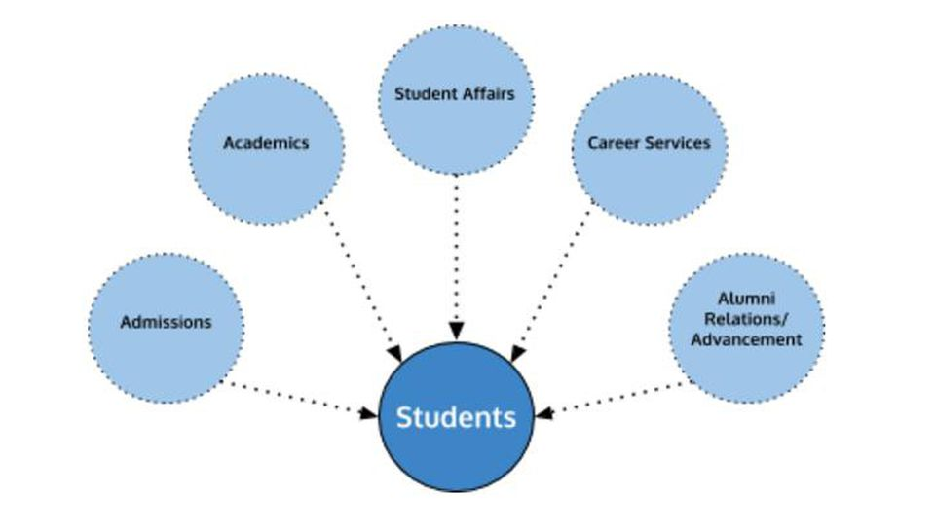

*The siloed university.*

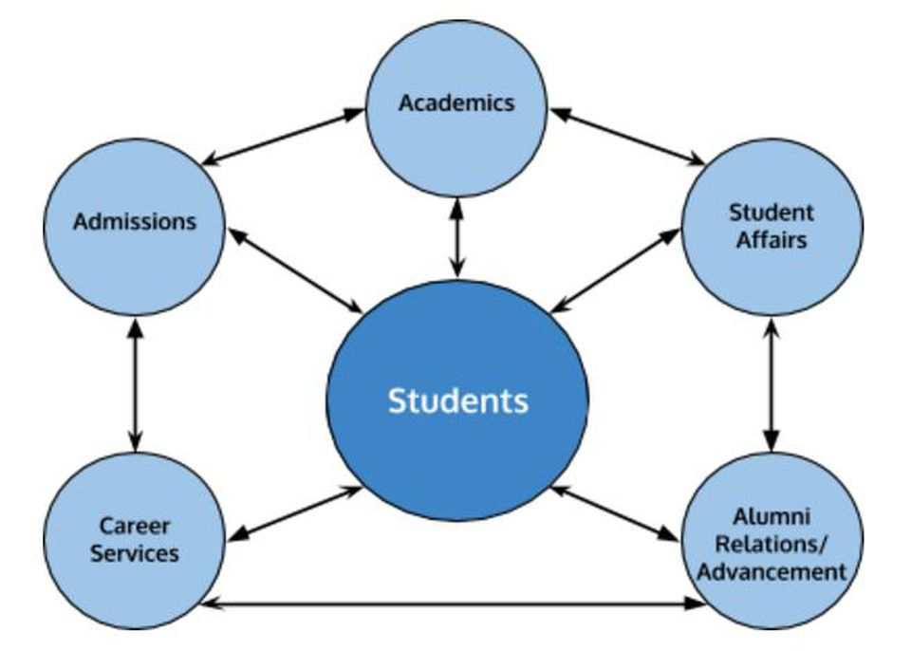

*A better way.*

Interestingly, they take the baseline position that “College graduates realize these benefits as a result of coursework that is not siloed within any one particular major or course of study, but rather the direct result of a learning environment where knowledge is shared and received across conventional disciplines.”

However, in many, if not most, institutions this paradigm of knowledge sharing is scarce, and for good reason. Within higher education, the delivery of the core product/service of knowledge suffers from existing performance evaluation metrics that do not typically reward collaboration. Academic areas are generally defined in narrow ways, and research projects that cross discipline lines are not typically encouraged or rewarded. Highly regarded journals are usually defined by specific, rather than broad academic focus, and less weight is given to research published as other than first author. “Publish or perish” typically dictates that faculty “color within the lines” of their discipline.

**INSTITUTIONAL AND HIGHER EDUCATION SECTOR IMPLICATIONS OF SDG 17**

In a handbook developed at the Asian Development Bank Institute, Tokyo, Terrence Morrison (2001) provided a framework for developing capacity building programs in which the use of experiential learning serves as a fundamental component of teaching pedagogy. The handbook provides “a framework of actionable learning that links three domains of learning: emotion, thought and behavior, and underpins each with a growing capacity to learn how to learn.”

|  |  |  |
| --- | --- | --- |
| LEARNING DOMAIN | | |
| ***FEELING*** | ***THINKING*** | ***ACTING*** |
| LEARNING TO SENSE | LEARNING TO OBSERVE | LEARNING TO ADAPT |
| LEARNING TO EMPATHIZE | LEARNING TO ASSESS | LEARNING TO CHANGE |
| LEARNING TO CARE | LEARNING TO REFLECT | LEARNING TO TRANSFORM |
| LEARNING TO LEARN | | |

Experiential learning is the process whereby knowledge is created through the transformation of experience. Knowledge results from the combinations of grasping and transforming experience.

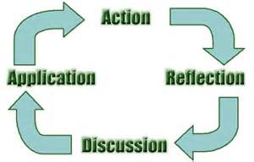

* Set in a paradigm which, at a minimum, implies, and optimally demands, community engagement, experiential learning intersects with service learning. This perspective is reflected by the Carnegie classification of community engagement: the collaboration between institutions of higher education and their larger communities (local, regional/state, national, global) for the mutually beneficial exchange of knowledge and resources in a context of partnership and reciprocity. In practice, experiential learning:
* Connects the campus with the community
* Generates capacity-building partnerships
* Enhances student learning
* Addresses critical community issues
* Encourages student learning and development
* Active participation in thoughtfully organized service that is conducted in, and meets the needs of, a community
* Integrated into, and enhances, the academic curriculum
* Helps foster civic responsibility
* Goes beyond what is learned in the classroom
* A hands-on experience
* Students gain new skills by working directly with the community
* Communication, team-building, and critical thinking; builds their self-esteem; and develops their sense of responsibility for decision-making

The optimal nexus of experiential and service learning is characterized by programs that:

* Must have some academic context and be designed in such a way that ensures that both the service enhances the learning and the learning enhances the service
* Equally benefit the provider and the recipient of the service as well as to ensure equal focus on both the service being provided and the learning that is occurring.

Jeavons (1995) establishes a framework: “Service-learning is a pedagogical strategy that combines meaningful service with academic study in order to 1) teach civic responsibility, 2) strengthen communities, and 3) exchange community- and university-derived resources and expertise. Service-learning is distinct from internship experiences or volunteer work in that it aims to equally benefit both the recipients and the providers of the service, all within a framework that promotes civic engagement and enriches the scholarship of the university. In a service-learning course, students participate in a three-part process. First comes the presentation and analysis of theories or ideas in the classroom. Next is the opportunity to apply or test those theories in a concrete way within a service setting. And third is the chance for students to reflect on and refine what they have learned in light of their experiences. These steps repeat over the course of the semester and are guided by an instructor working in tandem with a community partner.” This framework, to persist, is shaped by participation from the relevant sectors of:

* Government
* Industry
* Community

RECOMMENDATIONS

* Seek out and pursue opportunities for cross-discipline and cross-sector collaboration
* Pursue opportunities to educate the population segments that are not aware or accepting of factual arguments supporting sustainability goals
* Develop messaging targeting emotional responses, and aligned with scientific perspectives
* Establish regional centers, housed by institutions of higher education, as Sustainable Environment Institutes, that will serve as a hub where students, faculty and staff can partner through meaningful collaboration and common goals of advancing the institution and bettering our social well-being, health and prosperity. The SEI will serve as a clearing house of programs and projects, faculty expertise and student involvement for articulating how these goals are supported through sustainability initiatives at the home institution. The Institute will serve as a boundary-spanning entity reaching across Schools, Departments, programs, our community, government agencies, industries and other institutions. It will be a catalyst for economic growth, collaboration, partnership and position each host institution as a leader in this arena beyond the 21st Century.

# REFERENCES

# Jeavons, Thomas, H. (1995), “Service-Learning and Liberal Learning: A Marriage of Convenience”, Michigan Journal of Community Service Learning Volume 2, 1

# Markowitz, Troy. & Craig, Ryan (2017), “College Silos Must Die for Students to Thrive”, Forbes.com

Morrison, Terrance (2001) “Actionable Learning: A Handbook for Capacity Building through Case Based Learning”, Asian Development Bank Institute

Yoshino & Rangan, (1995) “Strategic Alliances: An Entrepreneurial Approach to Globalization”,

Harvard Business School Press