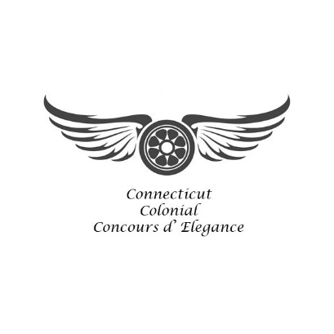
2022 Colonial Concours 30 Under 30 Application

Vehicle Owner : Age:
Note: This is how your names shall appear in Guidebook and Placard)

Address: City: State: Zip: Phone: E-mail Address: Owner’s Representative (if applicable): Representative’s Phone: Representative’s E-mail Address:
Vehicle Information

Year: Make: Model: Body Style: Coachbuilder: Engine, # of cylinders and configuration: Displacement: H.P.: Exterior color(s): Interior color(s): Year obtained: Restored or original: Year when restored : Are the chassis, body and engine original to this car? If not, please explain which parts are
not original and the date(s) added: Will you be bringing your vehicle on a trailer? Length of trailer, in feet: Please include at least 3 recent color photos of your vehicle, two exterior and one interior. Photos may be used for PR. Note: Photos will not be returned. Do not send copyrighted photos.

1

Vehicle Owner:____________________________ Make:_________________ Model: ___________________

Previous shows/awards won

History of the vehicle/special features (Information to be used in Guidebook, Placard and PR):

2

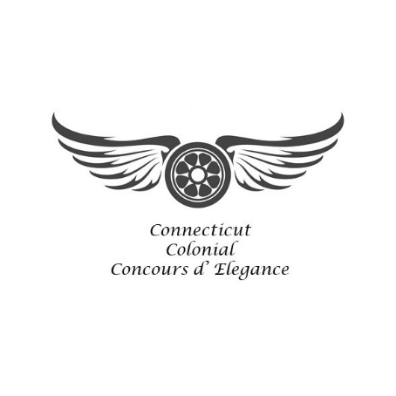
Please Read and Sign This Page

2022 Colonial Concours 30 Under 30 Application

Concours Exhibition Guidelines

The event organizers and their appointed representatives reserve the right to accept only vehicles meeting the standards of the CT Colonial Concours d’ Elegance, as determined by the organizers. Replica vehicles are not eligible. For consideration by the Car/Motorcycle Selection Committee, a vehicle must have its original body on its original chassis. Replacement body used on an original chassis will be considered if it is historically correct in design and materials. To be eligible for the 30 Under 30 category, the owner must be under the age of thirty years old at the time of the Concours.
The Concours will take place rain or shine.
All show vehicles must be on the field, in their appointed locations, no later than 8AM, Saturday and Sunday, July 30 and 31, 2022. Owners agree to leave their vehicles in that location until presentation of the awards, or release from the field by the organizer or an appointed representative.
Participants in the Opening Rally must report to the respective Round Up locations:
Opening Rally: Woodbury Brewery, 738 Main Street South, Woodbury, CT 06798

Vehicles on the show field may not display for-sale signs or advertisements.
All classes for display and judging are determined by the organizer and are subject to combination or addition of classes as deemed necessary by the organizer. The decisions of the judges will be final.

Owner Date ______________
2
Please Read and Sign This Page

2022 Colonial Concours 30 Under 30 Application
Release of Liability

The undersigned, desiring to enter and participate in the Connecticut Colonial Concours d’ Elegance and related activities to be held from July 29 through 31, 2022 does hereby tender his/her application. In consideration of acceptance by the Connecticut Colonial Concours d’ Elegance of this application, the undersigned, on behalf of themselves and all others participating in this entry, does hereby: (1) release the RPM Agency LLC and organizers of the Connecticut Colonial Concours d’ Elegance, their affiliates, representatives, assigns, licensees, employees, and volunteers from any and all liability arising out of said event; (2) release the participating charities identified at the event, their officers, employees, and volunteers from any and all liability arising out of said event; (3) release the Towns of Woodbury and New Milford, their officers, employees, agents, and assigns from any and all liability arising out of said event; (4) release sponsor companies and their employees, vendors, and other exhibitors from any and all liability arising out of said event; (5) release Candlelight Farms, their affiliates, representatives, assigns, licensees, employees, and volunteers from any and all liability arising out of said event; (6) release Woodbury Brewery, their affiliates, representatives, assigns, licensees, employees, and volunteers from any and all liability arising out of said event; (7) give permission to Connecticut Colonial Concours d’ Elegance to use my name, enclosed motorcycle information and histories, as well as any recordings or photographs supplied by me or taken by others (“My Content’) in commercial advertising, educational materials, magazine editorial, brochure, packaging and other promotional material, and to create secondary works derived from My Content, which may be distributed in all media, now or at any time in the future, and throughout the world, without compensation to me and without further authorization by me; (6) declare that the motorcycle is fully insured; (7) warrant that the undersigned has personally read the guidelines and release of liability and will abide by such; and (8) I am at least 18 years of age or older and have the full legal capacity to execute this application, and I acknowledge that this Release of Liability is fully binding upon my heirs and assigns.
I have read the above and accept the terms and conditions:
Owner Date Please return Application, photos, and signed Release of Liability by mail or email to:
Connecticut Colonial Concours d’ Elegance, 24 Depot Street, Watertown, CT 06795
To Email: kara@colonialconcours.com

There is a $45 Application Fee for each vehicle.

Application Deadline July, 25, 2022

www.colonialconcours.com
646.924.8895
3

