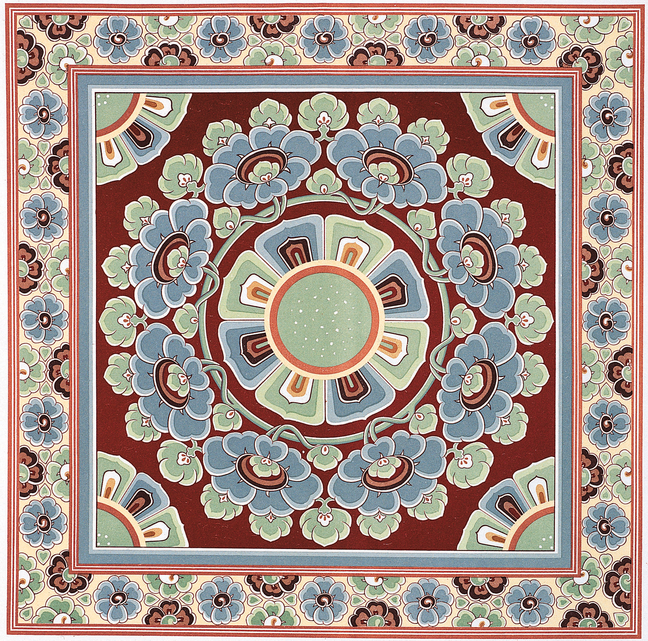

#### IVF Support Program includes Acupuncture and Chinese herbal medicines which help

#### - Harmonizing endocrine system

#### - Increasing local blood circulation

#### - Increasing blood & hormones

#### - Regulating hormones

#### - Relieving stress and anxiety

#### - Increasing basal body temperature

#### - Creating a free flow of Qi, blood, & body fluids

- Stimulating the hypothalamus glands

**There are three stages**

→ **Stage I - Basic Preparation**

This preparation will stimulate the body for hormone

regulation as standard hormone treatment given during IVF

does not stimulate every woman's uterine wall; it also fine

tune the general physical condition, such as back pain,

digestive system problem, of the mother for a healthy

and successful pregnancy preparation.

( Content of program should be in scroll ) 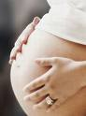

→ **Stage II - Egg Collection Preparation**

Treatment - twice for the first week &

3 times prior to egg collection date.

This preparation will increase the number of follicles on the ovaries and

improve the quality of the embryos.

→ **Stage III - Implant Preparation**

Pro-Implant Treatment - once daily, 24-48 hrs after egg collection

till implant.

Post- Implant Treatment - once, 48 hrs after implant.

Thepro-treatment will thicken the lining of the uterus, increasing blood supply to the uterus, which is the vital properties for a successful implant.

The post-treatment will assist blood circulation in the uterus, maintain the implantation of the embryo and nourish embryo growth.

**After a Positive Pregnancy is achieved …..**

Once pregnant, a woman goes through

dramatic physical and emotional changes.

By preparing her body for the changes and

acquiring the know-how in maximizing her

own health and that of the fetus, a woman

can experience her pregnancy in a

meaningful and enjoyable way.

For centuries, Chinese medicine and acupuncture have been used to relieve many symptoms and complications, manage symptoms ranging from nausea and vomiting to gestational diabetes, preventing pre-eclampsia, common colds, low back pain, low fetal weight , prenatal depression and others.

In short**,**

**Healthy mothers = Healthy babies**

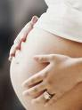

[鍵入文件的引文或重點的摘要。您可以將文字方塊放在文件中的任何位置。使用 [文字方塊工具] 索引標籤以變更重要引述文字方塊的格式。]