**Pain Management**

Dr Chen’s treatment not only brings instant pain-relief, but also long lasting healing as his treatment programs strengthen self-healing power and stimulate the immune system. Thus activate the body’s ability to repair and rejuvenate.

With the pain relief, patients could rest and sleep at night which is the gateway to healing. The ongoing treatment will promote blood circulation and reduce inflammations. This not only helps to improve the symptoms but tackle the underlying reason and prevent same injury and illness from relapsing.

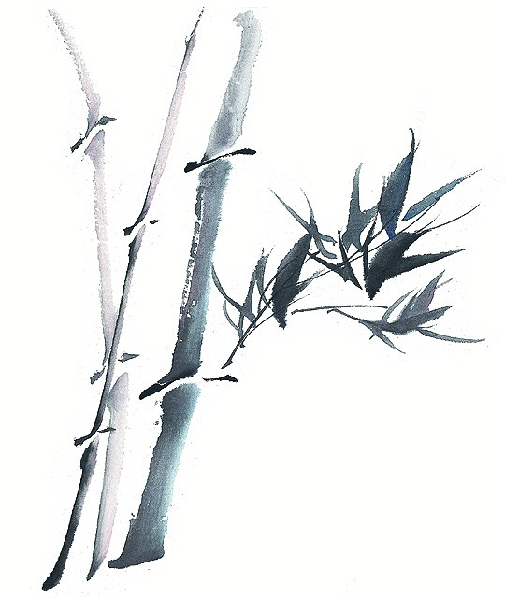

Dr Chen uses different kinds of acupuncture, for example Scalp Acupuncture, and Balance Acupuncture. He also uses Tuina (Chinese massage ), moxibustion, cupping and herbal medicine for best treatment result. His treatment program continues after the patient left the clinic, this is made possible by using Auricular Acupuncture and Kinesio Taping.

Patients are invited to participate in their own healing process by pressing the Auricular acupoints to reinforce the stimulation of their ‘Chi’ (energy) and ‘Xue’ (blood) at times needed. This empowers the patient, allowing them to control and participate in their pain management and ongoing treatment.