Preparation for the Final Crisis - Bible Study Guide
CHAPTER 2 - The Sealing

SYNTHESIS:

When does Fernando explain that the sealing work begins for each Christian? ["As it relates to individuals, the sealing work begins for each Christian on the day of his conversion."-Preparation for the Final Crisis, page 49]

What three (main) objectives does the sealing process accomplish? [1) It immovably fixes in the life the principles of God's law, 2) it prepares them to pass unharmed through the time of trouble and to live above win while they are without a Mediator, 3) it preserves the righteous from the final destruction.]

DESCRIPTION OF THE EVENT:

Is there one sealing event or are there two; a process ending in being sealed and an event to seal a large number at the same time? [The following quotes are designed to help clarify the fact that there are two sealing events:
Revelation 7:4 "And I heard the number of them which were sealed: and there were sealed an hundred and forty and four thousand of all the tribes of the children of Israel."
Revelation 7:9 "After this I beheld, and, lo, a great multitude, which no man could number, of all nations, and kindreds, and people, and tongues, stood before the throne, and before the Lamb, clothed with white robes, and palms in their hands;"
Revelation 7:13-14 "And one of the elders answered, saying unto me, what are these which are arrayed in white robes? And whence came they? And I said unto him, Sir, thou knowest. And he said to me, These are they which came out of great tribulation, and have washed their robes, and made them white in the blood of the Lamb."]

From the above text, what two distinct groups are mentioned? [1) The 144,000, and 2) the great multitude.]

What other evidence do we have that there are two real and distinct groups being sealed? [Ellen White discusses the 144,000 in the following quotations:
"There were all kinds of trees around the temple to beautify the place: the box, the pine, the fir, the oil, the myrtle, the pomegranate, and the fig tree bowed down with the weight of its timely figs--these made the place all over glorious. And as we were about to enter the holy temple, Jesus raised His lovely voice and said, 'Only the 144,000 enter this place,' and we shouted, 'Alleluia.'"-Early Writings, page 18
"In the last solemn work few great men will be engaged…God will work a work in our day that but few anticipate. He will raise up and exalt among us those [the 144,000] who are taught rather by the unction of His Spirit than by the outward training of scientific institutions."-Testimonies for the Church; Volume 5, pages 80 & 82
"To souls that are earnestly seeking for light and that accept with gladness every ray of divine illumination from His holy Word, to such alone light will be given. It is through these souls [the 144,000] that God will reveal that light and power which will lighten the whole earth with His glory."-Testimonies for the Church; Volume 5, pages 729]

What is one key reason that these groups are separate and/or distinct? [One group is given the specific task to form and teach the other group. Team 144K (the 144,000) spread the 3rd angel's message to the entire world. They assist in the formation of the great multitude.]

Will all of God's righteous be protected during the time of trouble? ["I saw a covering that God was drawing over His people to protect them in the time of trouble; and every soul that was decided on the truth and was pure in heart was to be covered with the covering of the Almighty."-Early Writings, page 43]

When, in the sequence of events, does the shaking begin? ["Just as soon as the people of God [144,000] are sealed in their foreheads--it is not any seal or mark that can be seen, but a settling into the truth [each valid candidate for Team 144K is sealed when they are settled into the truth, when they are ready], both intellectually and spiritually, so they cannot be moved--just as soon as God's people are sealed and prepared for the shaking, it will come."-S. D. A. Bible Commentary; Volume 4, page 1161]

NOTE: Important sequencing points are made here:
1.) There are two groups of people that are sealed (Team 144K & great multitude),
2.) There are two separate times that these groups are sealed (Team 144K before, and the great multitude after the shaking),
3.) The shaking is for the great multitude and not the 144,000,
4.) The 144,000 are sealed before the great multitude,
5.) The 144,000 are sealed before the shaking.

WHAT IS THE SEAL OF GOD?

What two things may be called a "seal"? [1) The instrument that is used for stamping a mark, and 2) the mark itself.-Preparation for the Final Crisis, page 51]

Is there biblical evidence that shows what the seal of God is? [Ezekiel 20:12 "I give them my Sabbaths, to be a sign between me and them, that they might know that I am the Lord that sanctify them." Exodus 31:17 "It is a sign between me and the children of Israel for ever: for in six days the Lord made heaven and earth."
From the above texts, God is letting us know that He gave us His Sabbath as a glorious sign of His power to create and His power to sanctify (convert and save) us. In the Bible, the words seal, sign, mark, and token are used interchangeably. God's sign, the Sabbath, represents His holy power to rule as Creator and savior. Revelation 7:1-3 says it will be written upon the foreheads (minds--Hebrews 10:16) of His people. It will signify that they are owned by Him and have His character. Hebrews 4:4-10 confirms this by saying that when we enter His rest (receive salvation), we should keep His seventh-day Sabbath holy as a symbol, or mark; of salvation. True Sabbathkeeping signifies that a person has surrendered his life to Jesus Christ and is willing to follow wherever Jesus leads.
"The fourth commandment is the only one of all the ten in which are found both the name and the title of the Lawgiver. It is the only one that shows by whose authority the law is given. Thus it contains the seal of God, affixed to His law as evidence of its authenticity and binding force."-Patriarchs and Prophets, page 307]

WHEN THE SEALING OCCURS: TIME AND DURATION:

Does the time of trouble, the seven last plagues, occur before OR after the close of probation? [Revelation 7:1-3 "And after these things I saw four angels standing on the four corners of the earth, holding the four winds of the earth, that the wind should not blow on the earth, nor on the sea, nor on any tree. And I saw another angel ascending from the east, having the seal of the living God: and he cried with a loud voice to the four angels, to whom it was given to hurt the earth and the sea. Saying [the decree to seal the great multitude, after the shaking], hurt not the earth, neither the sea, nor the trees, till we have sealed the servants of our God in their foreheads." This quote, as well as the next, clearly shows that the great multitude is sealed when the decree to seal them is made. "The sealing time is very short, and will soon be over. Now is the time, while the four angels are holding the four winds, to make our calling and election sure."-Early Writings, page 58]

Is there a point in time when all cases have been decided? ["When this time of trouble comes, every case is decided; there is no longer probation, no longer mercy for the impenitent. The seal of the living God is upon His people."-Testimonies for the Church; Volume 5, page 213]

CONDITIONS IN ORDER TO BE SEALED:

What can we do right now to better prepare for this? ["Now is the time to prepare. The seal of God will never be placed upon the forehead of an impure man or woman."-Testimonies for the Church; Volume 5, page 216
"The Lord will not excuse those who know the truth if they do not in word and deed obey His commands."-Maranatha, page 243
"Satan could find nothing in the Son of God that would enable him to gain the victory. He had kept His Father's commandments, and there was no sin in Him that Satan could use to his advantage. This is the condition on which those must be found who shall stand in the time of trouble.
It is in this life that we are to separate sin from us, through faith in the atoning blood of Christ. Our precious Savior invites us to join ourselves to Him, to unite our weakness to His strength, our ignorance to His wisdom, our unworthiness to His merits. God's providence is the school in which we are to learn the meekness and lowliness of Jesus. The Lord is ever setting before us, not the way we would choose, which seems easier and pleasanter to us, but the true aims of life. It rests with us to co-operate with the agencies which Heaven employs in the work of conforming our characters to the divine model. None can neglect or defer this work but at the most fearful peril to their souls. [emphasis added]"-The Great Controversy, Page 623]

What (SPECIFICALLY) must we do to receive the seal of the living God? ["Those who receive the seal of the living God and are protected in the time of trouble must reflect the image of Jesus fully."--Early Writings, page 71 "Not one of us will ever receive the seal of God while our characters have one spot or stain upon them."--Testimonies for the Church; Volume 5, page 214 "Only those who, in their attitude before God, are filling the position of those who are repenting and confessing their sins in the great antitypical day of atonement, will be recognized and marked as worthy of God's protection."-Testimonies to Ministers and Gospel Workers, page 445]

Please see the presentation entitled; "Angels Will Keep You" for additional information on the sealing process (source of chart). It is available online at http://www.bellresearchlab.com/

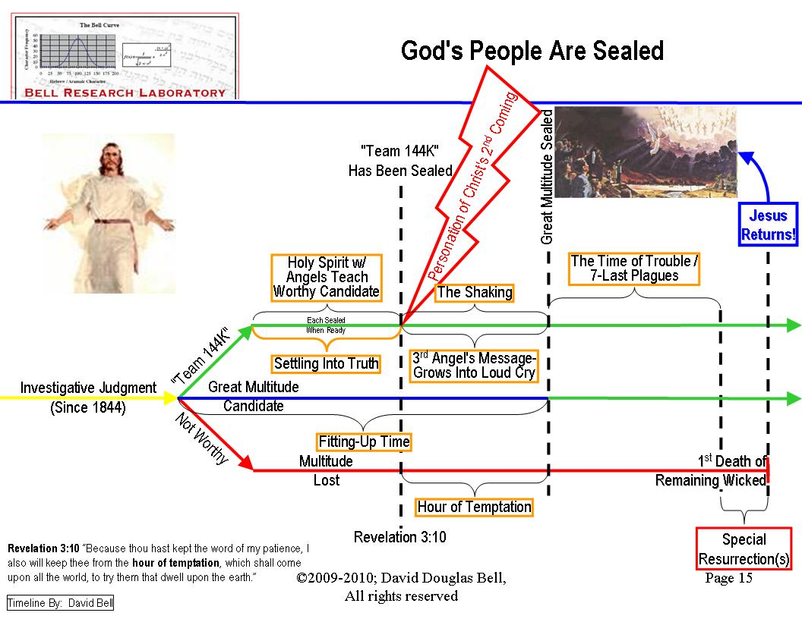
NOTE: If evidence can be brought to view that the 144,000 lived before the seventh plague, then we have positive proof that the 144,000 never died and must be sealed and given special protection prior to the great multitude. [They never died during, and went through the seven last plagues, therefore they existed before the seven last plagues. Since the group is formed before the seven last plagues and go out to spread the third angel's message that swells into the loud cry during the hour of temptation; and since they are kept from the hour of temptation (Revelation 3:10) they must be sealed before receiving this protection.] Great Controversy, page 649: "And they sing 'a new song' before the throne, a song which no man can learn save the 144,000. It is the song of Moses and the Lamb,--a song of deliverance. None but the 144,000 can learn that song; for it is the song of their experience,--an experience such as no other company have ever had…They have seen the earth wasted with famine and pestilence, the sun having power to scorch men with great heat, and they themselves have endured suffering, hunger, and thirst." Here is a positive statement that the 144,000 lived in the time of the fourth plague, the sun having power to scorch men with great heat."

ALSO NOTE: How can a number that is made up of spiritual pieces / parts sum to equal a real (physical) / exact number? The 144,000 is made up of 12,000 from each "tribe"; this is described in Revelation 7:5-8 (Juda, Reuben, Gad, Aser, Nepthalim, Manasses, Simeon, Levi, Issachar, Zabulon, Joseph, and Benjamin). Note that these are slightly different than those of Genesis. The reason the tribes do not match is they are spiritual in the Revelation pertaining to the 144,000. For example the tribe of Dan is not listed in Revelation because they spiritually fell away from God by worshiping graven images. Therefore; I believe that the 144,000 is a spiritual number that represents God's chosen / elite that will begin the loud cry to generate (shake out) the "great multitude".

