Preparation for the Final Crisis - Bible Study Guide
CHAPTERS 12 and 13: Preparation For The Crisis

FROM THE LIBERATION TO THE SECOND COMING OF CHRIST:

Where, in the spirit of prophecy, can the sequence of events from deliverance to the second coming be found? [1) The Great Controversy pages 635-661, and 2) Early Writings pages 285-291.]

INTRODUCTORY NOTE:

Where does the teaching and / or preparation come from for the saints to pass through the time of trouble? ["We pray that the Holy Spirit may move each one to take the steps that will draw him closer to heaven and fit him to receive the seal of the living God. This alone can prepare one to pass unharmed through the terrible time of trouble and at last to meet Christ in peace at His second coming."-Preparation for the Final Crisis, page 162]

SERIOUSNESS OF THE TIME AND NECESSITY FOR A PREPARATION:

In the parable of the 10 virgins; did ALL of them sleep? [Matthew 25:5 "While the bridegroom tarried, they all slumbered and slept."]

What does Fernando say that the ten virgins represent? ["The ten virgins represent the church of the last days. All members believe the same truths and wait for the same Lord. But not all are preparing themselves for this most glorious event. Those who will not prepare, will not receive the latter rain. They will be like the foolish virgins."-Preparation for the Final Crisis, page 163]

NOTE: Even though there are virgins in the church, there are also non-virgins that are not in the church. These are they that are not concerned with the soon coming of our Lord. I have heard this group of last day wise virgins described as "a remnant within a remnant".

Will the training that we need be obtained by: studying, reading, and / or searching the scriptures? ["…we shall need an experience which we do not now possess and which many are too indolent to obtain."-The Great Controversy, page 622]

Breaking down the statement above: [Checking Webster's on-line dictionary we find the definition of: shall = used in laws, regulations, or directives to express what is mandatory; and indolent = 1) averse to activity, effort, or movement or habitually lazy or 2) conducive to or encouraging laziness]

From the quote featured above, what does the phrase "… need an experience…" imply about how we obtain the required training? [The training will require the righteous to experience it. We can not obtain all of it through studying, reading and prayer. "Those who come up to every point, and stand every test, and overcome, be the price what it may, have heeded the counsel of the True Witness, and they will receive the latter rain, and thus be fitted for translation."-Maranatha, page 43

Summing all of this up, what are the facts regarding the saints training? [1) The training must be given by real experiences of the trainee, 2) the training is a requirement and MUST occur, 3) the training includes action on the trainee's part, 4) everyone has access to the training.]

How serious is this? Are the destiny of other souls, dependant upon our own preparation? ["My brethren, do you realize that your own salvation, as well as the destiny of other souls, depends upon the preparation you now make for the trial before us? Have you that intensity of zeal, that piety and devotion, which will enable you to stand when opposition shall be brought against you? If God has ever spoken by me, the time will come when you will be brought before councils, and every position of truth which you hold will be severely criticized. The time that so many are now allowing to go to waste should be devoted to the charge that God has given us of preparing for the approaching crisis."-Testimonies for the Church Volume Five, page 716 & 717]

If we neglect to prepare, will we not be able to receive the latter rain when it is poured out on everyone? ["Oh, how many I saw in the time of trouble without a shelter! They had neglected the needful preparation; therefore they could not receive the refreshing that all must have to fit them to live in the sight of a holy God…I saw that none could share the 'refreshing' unless they obtain the victory over every besetment, over pride, selfishness, love of the world, and over every wrong word and action."-Early Writings, page 71]

FACTORS IN THE PREPARATION:

What are six points that Fernando makes that are factors in the preparation to receive the outpouring of the Holy Spirit? [1) Study of the Bible and the spirit of prophecy, 2) communion with God; fervent prayer, 3) cleansing from sin and victory over weaknesses, 4) a complete surrender to God, 5) a diligent work for Christ, and 6) activity on behalf of religious liberty.]

1) Study of the Bible and the spirit of prophecy: ["…there are men now preaching to others who will find, upon examining the positions they hold, that there are many things for which they can give no satisfactory reason. Until thus tested they knew not their great ignorance…When separated from those of like faith and compelled to stand singly and alone to explain their belief, they will be surprised to see how confused are their ideas of what they had accepted as truth."-Testimonies for the Church Volume Five, page 707

"Only those who had been diligent students of the Scriptures and who have received the love of the truth will be shielded from the powerful delusion that takes the world captive."-The Great Controversy, page 625 "None but those who have fortified the mind with the truths of the Bible will stand through the last great conflict..."-The Great Controversy, page 593 & 594]

What will God's spirit do to bring attention to the Bible? ["God's Spirit has illuminated every page of the Holy Writ, but there are those upon whom it makes little impression, because it is imperfectly understood."-Testimonies to Ministers and Gospel Workers, page 112]

What category of information is important to study at the end of earth's history? ["As we near the close of this world's history, the prophecies relating to the last days especially demand our study."-Christ's Object Lessons, page 133]

Will other works of writing be useful to the righteous other than the Bible? ["Many are going directly contrary to the light which God has given to His people, because they do not read the books which contain the light and knowledge in cautions, reproofs, and warnings."-Testimonies for the Church Volume Four, page 391]

2) Communion with God; fervent prayer: ["As the praying ones continued their earnest cries, at times a ray of light from Jesus came to them, to encourage their hearts and light up their countenances. Some, I saw, did not participate in this work of agonizing and pleading. They seemed indifferent and careless. They were not resisting the darkness around them, and it shut them in like a thick cloud. The angels of God left these and went to the aid of the earnest, praying ones. I saw angels of God hasten to the assistance of all who were struggling with all their power to resist the evil angels and trying to help themselves by calling upon God with perseverance. But His angels left those who made no effort to help themselves, and I lost sight of them."-Early Writings, page 270]

3) Cleansing from sin and victory over weaknesses: ["Satan leads many to believe that God will overlook their unfaithfulness in the minor affairs of life; but the Lord shows in His dealings with Jacob that He will in no wise sanction or tolerate evil. All who endeavor to excuse or conceal their sins, and permit them to remain upon the books of heaven, unconfessed and unforgiven, will be overcome by Satan."-The Great Controversy, page 620 And we read in Joel 2:12 "Therefore also now, saith the Lord, turn ye even to me with all your heart, and with fasting, and with weeping, and with mourning:"]

4) A complete surrender to God: ["Consecrate yourself to God in the morning; make this your very first work. Let your prayer be, 'Take me, O Lord, as wholly Thine. I lay all my plans at Thy feet. Use me today in Thy service. Abide with me, and let all my work be wrought in Thee.' This is a daily matter. Each morning consecrate yourself to God for that day. Surrender all your plans to Him, to be carried out or given up as His providence shall indicate. Thus day by day you may be giving your life into the hands of God, and thus your life will be molded more and more after the life of Christ."-Steps to Christ, page 70]

5) A diligent work for Christ: ["The work which the church has failed to do in a time of peace and prosperity she will have to do in a terrible crisis under most discouraging, forbidding circumstances. The warnings that worldly conformity has silenced or withheld must be given under the fiercest opposition from enemies of the faith."-Testimonies for the Church Volume Five, page 463]

6) Activity on behalf of religious liberty: ["We should search the Scriptures and be able to give the reason for our faith. Says the prophet: 'The wicked shall do wickedly: and none of the wicked shall understand; but the wise shall understand.'"-Testimonies for the Church Volume Five, page 452 "Not all our ministers who are giving the third angel's message really understand what constitutes that message."-Testimonies for the Church Volume Five, page 715]

Are some not prepared to co-operate with God when the time comes? ["If our people continue in the listless attitude in which they have been, God cannot pour upon them His Spirit. They are unprepared to co-operate with Him. They are not awake to the situation and do not realize the threatened danger. They should feel now, as never before, their need of vigilance and concerted action.
The peculiar work of the third angel has not been seen in its importance. God meant that His people should be far in advance of the position which they occupy today. But now, when the time has come for them to spring into action, they have the preparation to make."-Testimonies for the Church Volume Five, page 714 & 715]

Should we be afraid of making mistakes in our haste? ["But too often the leader has stood hesitating, seeming to say: "Let us not be in too great haste. There may be a mistake. We must be careful not to raise a false alarm." The very hesitancy and uncertainty on his part is crying: "'Peace and safety.' Do not get excited. Be not alarmed. There is a great deal more made of this religious amendment question than is demanded. This agitation will all die down." Thus he virtually denies the message sent from God, and the warning which was designed to stir the churches fails to do its work. The trumpet of the watchman gives no certain sound, and the people do not prepare for the battle. Let the watchman beware lest, through his hesitancy and delay, souls shall be left to perish, and their blood shall be required at his hand.-Testimonies for the Church Volume Five, page 715 & 716]

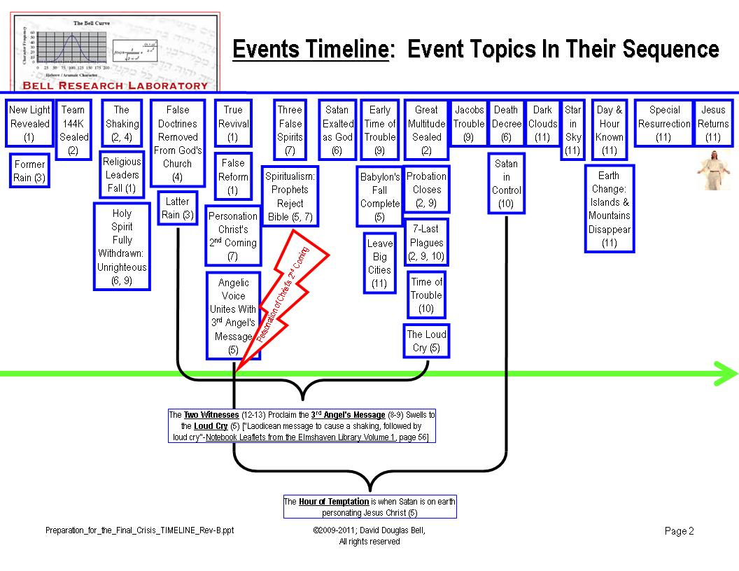
Regarding the chart above, who/what are the two witnesses? ["Concerning the two witnesses the prophet declares further: 'These are the two olive trees, and the two candlesticks standing before the God of the earth.' 'Thy word,' said the psalmist, 'is a lamp unto my feet, and a light unto my path.' Revelation 11:4; Psalm 119:105. The two witnesses represent the Scriptures of the Old and the New Testament."-The Great Controversy, page 267]

NOTE: For more information, please visit http://www.bellresearchlab.com/.

