Rebuttal To: "Be Ready vs. Get Ready"
(Article published in a local church's newsletter.)

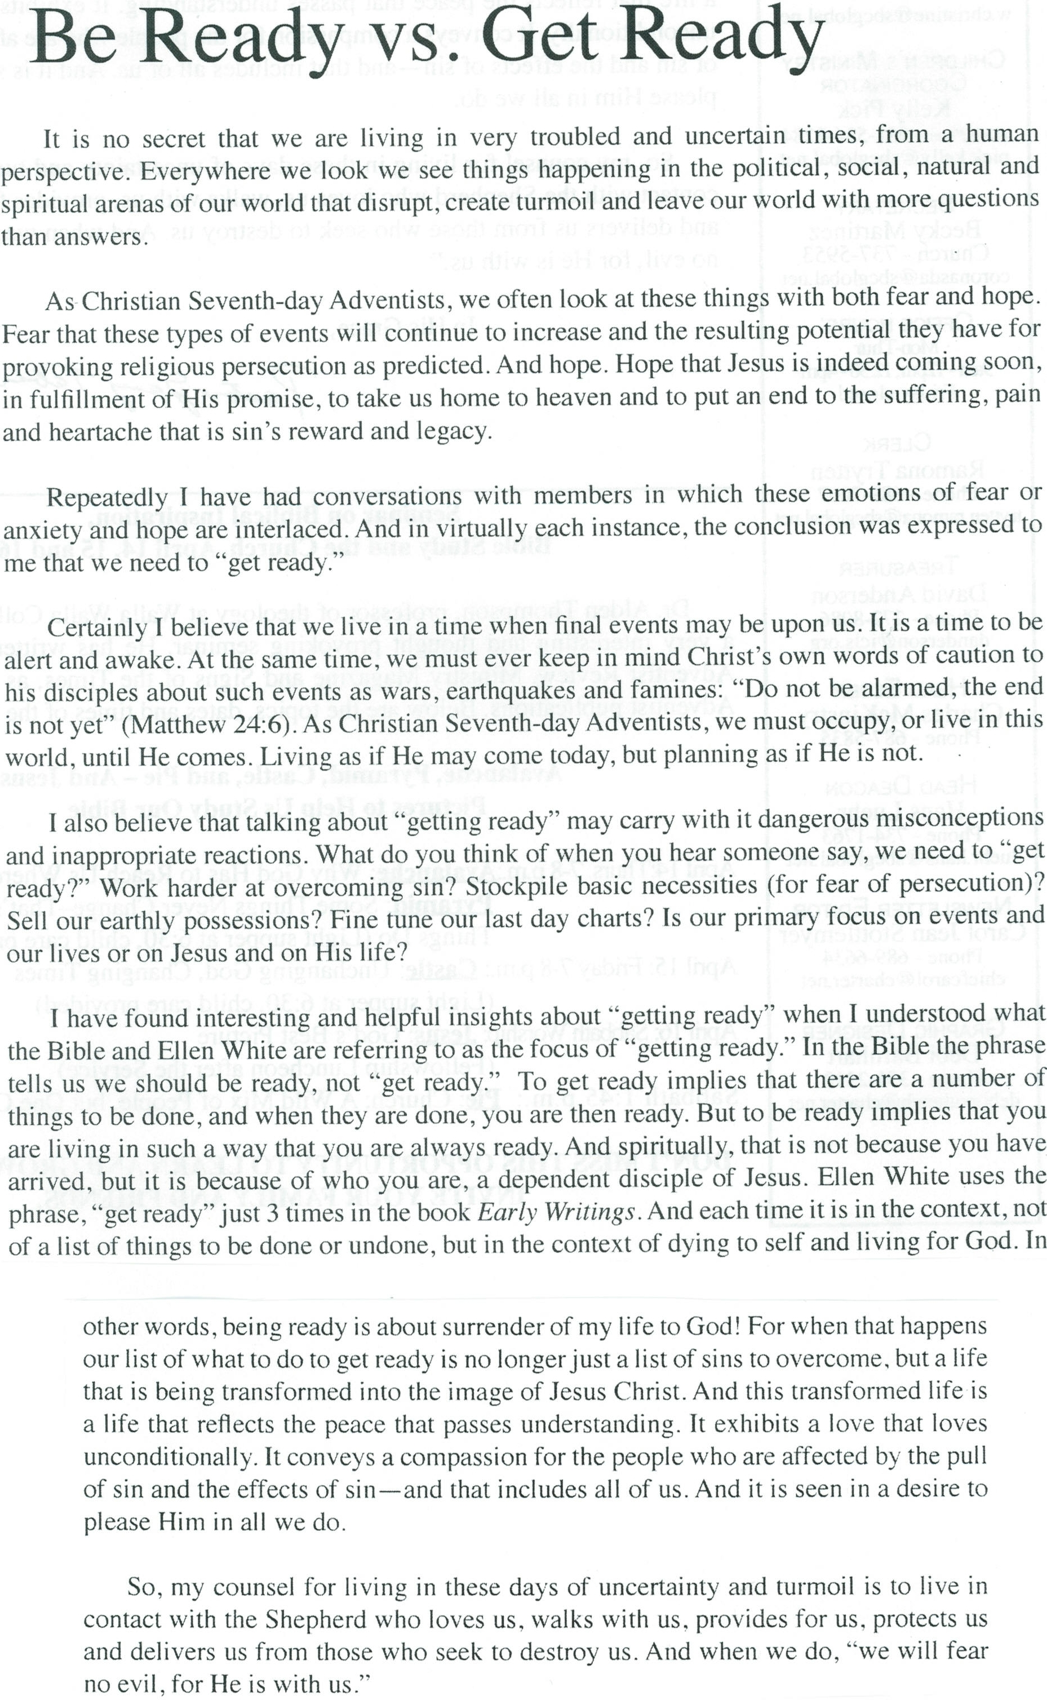
It was mentioned in the newsletter (select article shown above) that the phrase "get ready" is used three times in the book Early Writings, written by Ellen G. White in 1882. Actually, it is used four separate times, and 117 times total in her writings. Below is one of the quotes from Early Writings that shows, in the true non-biased context, what "get ready" means. Let's look:

"Then my eyes were taken from the glory, and I was pointed to the remnant on the earth. The angel said to them, 'Will ye shun the seven last plagues? Will ye go to glory and enjoy all that God has prepared for those who love Him and are willing to suffer for His sake? If so, ye must die that ye may live. Get ready, get ready, get ready. Ye must have a greater preparation than ye now have, for the day of the Lord cometh, cruel both with wrath and fierce anger, to lay the land desolate and to destroy the sinners thereof out of it. Sacrifice all to God. Lay all upon His altar--self, property, and all, a living sacrifice. It will take all to enter glory. Lay up for yourselves treasure in heaven, where no thief can approach or rust corrupt. Ye must be partakers of Christ's sufferings here if ye would be partakers with Him of His glory hereafter.'
Heaven will be cheap enough, if we obtain it through suffering. We must deny self all along the way, die to self daily, let Jesus alone appear, and keep His glory continually in view. I saw that those who of late have embraced the truth would have to know what it is to suffer for Christ's sake, that they would have trials to pass through that would be keen and cutting, in order that they may be purified and fitted through suffering to receive the seal of the living God, pass through the time of trouble, see the King in His beauty, and dwell in the presence of God and of pure, holy angels. As I saw what we must be in order to inherit glory, and then saw how much Jesus had suffered to obtain for us so rich an inheritance, I prayed that we might be baptized into Christ's sufferings, that we might not shrink at trials, but bear them with patience and joy, knowing what Jesus had suffered that we through His poverty and sufferings might be made rich. Said the angel, 'Deny self; ye must step fast.' Some of us have had time to get the truth and to advance step by step, and every step we have taken has given us strength to take the next. But now time is almost finished, and what we have been years learning, they will have to learn in a few months. They will also have much to unlearn and much to learn again. Those who would not receive the mark of the beast and his image when the decree goes forth, must have decision now to say, Nay, we will not regard the institution of the beast."-Early Writings, pages 66 and 67.

FIRST: God's forgiveness is not unconditional.

Later, the statement is made that "It exhibits a love that loves unconditionally". This statement is VERY deceiving! It is implying (very strongly) that God gives unconditional forgiveness. This is not true. This is precisely why there is something called the "unpardonable sin". If the forgiveness is truly unconditional, why is there a sin that can NOT be pardoned? If God's forgiveness is unconditional, there would be universal salvation; even for Satan.
Note the following: "Satan deceives many with the plausible theory that God's love for His people is so great that He will excuse sin in them; he represents that while the threatenings of God's word are to serve a certain purpose in His moral government, they are never to be literally fulfilled. But in all His dealings with his creatures God has maintained the principles of righteousness by revealing sin in its true character--by demonstrating that its sure result is misery and death. The unconditional pardon of sin never has been, and never will be. Such pardon would show the abandonment of the principles of righteousness, which are the very foundation of the government of God. It would fill the unfallen universe with consternation. God has faithfully pointed out the results of sin, and if these warnings were not true, how could we be sure that His promises would be fulfilled? That so-called benevolence which would set aside justice is not benevolence but weakness."-Patriarchs and Prophets, (1890), page 522.

SECOND: Obedience to God is a requirement to enter heaven and enter into eternal life.

"'If thou wilt enter into life,' He added, 'keep the commandments.' The character of God is expressed in His law; and in order for you to be in harmony with God, the principles of His law must be the spring of your every action.
Christ does not lessen the claims of the law. In unmistakable language He presents obedience to it as the condition of eternal life--the same condition that was required of Adam before his fall. The Lord expects no less of the soul now than He expected of man in Paradise, perfect obedience, unblemished righteousness. The requirement under the covenant of grace is just as broad as the requirement made in Eden--harmony with God's law, which is holy, just, and good."-Christ's Object Lessons, page 391.
I have seen it stated on a T-shirt, "Who would Jesus deport?" The answer is; those who do not keep His commandments! Would it surprise you to learn that the opportunity for angels to fall still exists; and that there is a tree in heaven similar to the tree of life to facilitate this? "The Lord has given me a view of other worlds. Wings were given me, and an angel attended me from the city to a place that was bright and glorious. The grass of the place was living green, and the birds there warbled a sweet song. The inhabitants of the place were of all sizes, they were noble, majestic and lovely. They bore the express image of Jesus, and their countenances beamed with holy joy, expressive of the freedom and happiness of the place. I asked one of them why they were so much more lovely than those on the earth. The reply was--"we have lived in strict obedience to the commandments of God, and have not fallen by disobedience, like those on the earth." Then I saw two trees, one looked much like the tree of life in the city. The fruit of both looked beautiful; but of one they could not eat. They had power to eat of both, but were forbidden to eat of one. Then my attending angel said to me--'none in this place have tasted of the forbidden tree; but if they should eat they would fall.'"-Broadside2, January 31, 1849 paragraph 8.

THIRD: We are to bring our characters into alignment with the heavenly community:

"Our faith is that if we perfect a Christian character we shall be numbered as the family of God in the mansions that He has gone to prepare for us. Now, our heavenly father brings us together in church capacity that we may gain in knowledge and be fitting up for the community of heaven. 'Well,' some may say, 'All I want is that everyone should see eye to eye.' But there are those who want everyone to see just as they do. They do not consider that they have traits of character that must be changed. Then, what is the work before us in order to be ready to be among those who are waiting for their Lord to come in the clouds of heaven? It is for us to be in a position of humility before God. 'Gird up the loins of your mind, be sober, and hope to the end for the grace that is to be brought unto you at the revelation of Jesus Christ.'"-Sermons and Talks Volume One, (1990), page 39.

FOURTH: Breaking God's commandments occurs by some because they are ignorant of the truth that you should keep God's law.

"The minds of all who embrace this message are directed to the most holy place, where Jesus stands before the ark, making His final intercession for all those for whom mercy still lingers and for those who have ignorantly broken the law of God. This atonement is made for the righteous dead as well as for the righteous living. It includes all who died trusting in Christ, but who, not having received the light upon God's commandments, had sinned ignorantly in transgressing its precepts.
After Jesus opened the door of the most holy, the light of the Sabbath was seen, and the people of God were tested, as the children of Israel were tested anciently, to see if they would keep God's law."-Early Writings, page 254
Now having read this, you are no longer ignorant of this fact regarding point number four.

FIFTH: The implication is made that making charts and/or presentations to teach others is a bad thing:

"By the use of charts, symbols, and representations of various kinds the minister can make the truth stand out clearly and distinctly. This is a help, and in harmony with the word of God; but when the worker makes his labors so expensive that others are unable to secure from the treasury sufficient means to support them in the field, he is not working in harmony with God's plan. The work in the large cities is to be done after Christ's order, not after the order of a theatrical performance. It is not a theatrical performance that glorifies God, but the presentation of the truth in the love of Christ."-Testimonies for the Church Volume Nine, (1909), page 142.

