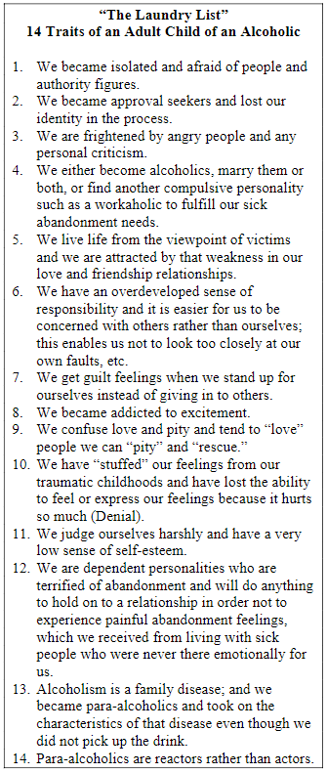
Fellow Travelers
Names & Numbers
_____________________
_____________________
_____________________
_____________________
_____________________
_____________________
_____________________
_____________________
_____________________
_____________________
_____________________
_____________________
_____________________
_____________________
_____________________
_____________________
_____________________
_____________________
_____________________
_____________________

Adult Children
of Alcoholics
and
Dysfunctional Families
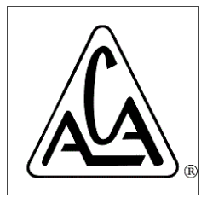

NW Arkansas
Meeting Directory

Web: acanorthwestarkansas.com
Facebook: Adult Children of Alcoholics Northwest Arkansas
Global & Resources: adultchildren.org

January 2026
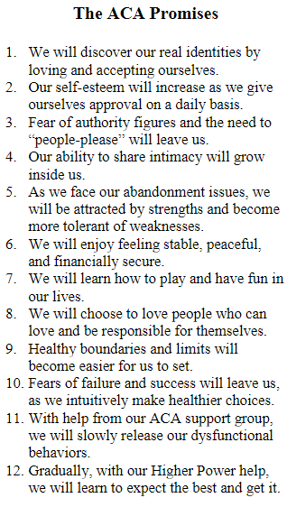
NW Arkansas Area Meetings

Monday – 2 Meetings
6:00-7:00pm – Rogers
Rogers ACA Group
Fellowship Hall
217 W. Cypress, 72756

6:30-7:30pm – Fayetteville
Take Back Our Lives Group
St. Paul’s Episcopal Church LIBRARY
224 N. East Avenue / Fayetteville, AR 72701

Tuesday
6:00-7:00pm – North Bentonville/Bella Vista
We Are Worth It! Group
Bella Vista Church of Christ
989 NW McNelly Rd. AR, 72712

Wednesday
6:00 - 7:00pm – Rogers
Rogers ACA Group
Fellowship Hall / 217 W. Cypress, 72756

Thursday
6:00-7:00pm – North Bentonville/Bella Vista
Hurting to Helping to Healing Group
Bella Vista Church of Christ
989 NW McNelly Rd. AR, 72712

Friday – 2 Meetings
12noon - 1:00pm - Rogers
Rogers ACA Group
Fellowship Hall / 217 W. Cypress, 72756

6:00pm - 7:00pm - Joplin
Joplin ACA Group
Fellowship Hall / 1800 East 30th St, Joplin 64804

Global ACA + Online Meetings: Adultchildren.org
What are ACA Meeting Like?
We meet to share our experience and recovery in an atmosphere of mutual respect. We discover how alcoholism and other family dysfunction affected us in the past and how it influences us in the present. We begin to see the unhealthy elements of our childhood. By practicing the 12 Steps, focusing on the ACA Solution, accepting a loving Higher Power of our own understanding, we find freedom.

What is ACA?
Adult Children of Alcoholics (ACA) is a 12 Step, 12 Tradition program of men and women who grew up in dysfunctional homes. We meet to share our experience of growing up in an environment where abuse, neglect and trauma infected us. This affects us today and influences how we deal with all aspects of our lives.
ACA provides a safe, nonjudgmental environment that allows us to grieve our childhoods and conduct an honest inventory of ourselves and our family—so we may:
- Identify and heal core trauma
- Experience freedom from shame and abandonment
- Become our own loving parents

Why We First Came to ACA
Our decisions and answers to life did not seem to work. Our lives had become unmanageable. We exhausted all the ways we thought we could become happy. We often lost our creativity, our flexibility, and our sense of humor. Continuing the same existence was no longer an option. Nevertheless, we found it almost impossible to abandon the thought of being able to fix ourselves. Exhausted, we held out hope that a new relationship, a new job, or a move would be the cure, but it never was. We made the decision to seek help.

