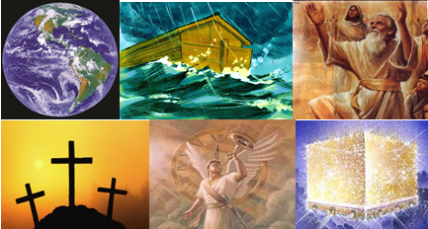

The Bible – Beginning to End

Restart - Introduction –

Gene Dahler – August 11, 2020

STARTING THE GREAT ADVENTURE

We are gathered here to initiate an exploration of God’s Word, a search for the truth, an adventure of a life time.

We are going to discover what believers are here on earth for, what is the purpose of God in what is going on in the world and what part should we play. If there is more to life than our short stay here on earth, what is it? What is the master plan (perhaps we should say Master’s plan) and where are we at in that plan? That information sets apart a knowledgeable born again Christian from the rest of the world!!!
___________________________________________________________________________________________________________________________________________________________________________________________________________________________________________________________________________________

Why have a Bible study like this, looking at the interventions of God here on Earth?

First, to answer those last two questions. What is the Master’s plan and where are we at in the plan?

Second, because knowing and understanding God’s plan is a gift from God.

Ephesians 1:16-19
16 - - - while making mention of you in my prayers;
17 that the God of our Lord Jesus Christ, the Father of glory, may give to you a spirit of wisdom and of revelation in the knowledge of Him.
18 I pray that the eyes of your heart may be enlightened, so that you will know what is the hope of His calling, what are the riches of the glory of His inheritance in the saints,
19 and what is the surpassing greatness of His power toward us who believe. NASU

Problem – almost no one teaches/preaches what the Bible says about God’s master plan for the earth and those on it. 90+% of the sermons in the protestant churches today focus on salvation and conduct. The result is that those attending those churches keep asking “why” the things that are happening today are occurring when the answer to the question is in the book that we all have.

God has the following master plan for planet earth and those on it and it is all documented in the Bible. The major themes are:

  - ________ – Creation to destruction
  - _________ – From Adam & Eve to the last person born on earth
  - Groups of people -
    - ________ –Gen 35 – Rev 20
    - ________ – John 12 – Rev 22
  - __________ – The nations of the world, but primarily those involved with Israel, from 2,500 BC to the end.
  - _______ – His involvement in things on earth and in heaven
  - _______ – His attempts to cause God’s master plan to fail on earth, beginning to end

- Scripture defines God’s involvement in all of this from creation to at least 1,007 years into the future.

So, what is important?

Believe and have the right perspective
Why? Because nothing enhances the life of a saved person more than having a complete perspective based on the truth, a perspective of the past, present and especially the future.

Today, many say they “believe in Jesus”, but most have barely begun to “know Him.” Our promise is that you will know Him come next November.

Understanding and believing God’s message is a key to life on earth as a saved person. It is important we get it right! The good news is; it is not difficult to get it right!!!!!

INDIVIDUALS -
God wants each of His children to understand His master plan. He wants us to join His team and be participating in His will. In fact, we cannot have the life that He wants us to have without understanding it.

NATIONS -
Likewise, nations will receive His blessings or curses based on their blessing Israel and following the commandments of His Son. Remember, if a nation receives blessings or curses, everyone in the nation is blessed or cursed. Believers must do all they can to influence their nation to conform to the positive side of God’s master plan.

Remember the incredible price that the prophets and apostles paid so we could have the knowledge in regard to all this.
____________________________________________________________________________________________________________________________________________________________________________________________________________________________

Third, it is an essential for a believer in order to receive the rest, peace, freedom and power that God wants to give you.

Bible study goal –To complete what you already know. Perhaps fill in some blanks in your understanding that you didn’t know you had in covering these 20 interventions.

The Apostle Paul said it this way.

Ephesians 4:11-15
11 And He gave some as apostles, and some as prophets, and some as evangelists, and some as pastors and teachers,
12 for the equipping of the saints for the work of service, to the building up of the body of Christ;
13 until we all attain to the unity of the faith, and of the knowledge of the Son of God, to a mature man, to the measure of the stature which belongs to the fullness of Christ.
____________________________________________________________________________________________________________________________________________________________________________________________________________________________

Rom 12:2
2 And do not be conformed to this world, but be transformed by the renewing of your mind, so that you may prove what the will of God is, that which is good and acceptable and perfect. NASU
____________________________________________________________________________________________________________________________________________________________________________________________________________________________________________________________________________________________________________________________________________________________________________________________________________________________________________________________________________________________________________________________________________________________________________________________________________________________________________________________________________________

The New Covenant is all about believers knowing the truth. Satan has done and is doing many things to keep us from the truth. So, what do we do?

2 Cor 10:3-5
3 For though we walk in the flesh, we do not war according to the flesh,
4 for the weapons of our warfare are not of the flesh, but divinely powerful for the destruction of fortresses.
5 We are destroying speculations and every lofty thing raised up against the knowledge of God, NASU
______________________________________________________________________________________________________________

Summary of events we will be studying.

- History – 10 events. What has He done? How does Jesus fit into it? Impact then? Significance now?

- Present – 3 events. What happened 2000 years ago? How does it change the way people relate to Him today? How did it impact the world? When does the Old Covenant end and the New Covenant really begin? How is the church different from Israel? What is going on with Israel?

- Future – 7 events. For the last 6,000 years, God has provided information to His people about the future. We will look into our awesome future. Although we are not individually mentioned, our group is specifically mentioned. What will be the next intervention by God for our group here on earth? What follows after that? Are you ready? God gave us His Word so we can be!
_____________________________________________________________________________________________________________________________________________________________________

Can we really know and understand these things? YES. That is why God gave us the truth, teachers of the truth and, most important, the Holy Spirit.

John 16:13
13 "But when He, the Spirit of truth, comes, He will guide you into all the truth; for He will not speak on His own initiative, but whatever He hears, He will speak; and He will disclose to you what is to come. NASU
______________________________________________________________________________________________________________

Rom 12:2
2 And do not be conformed to this world, but be transformed by the renewing of your mind, so that you may prove what the will of God is, that which is good and acceptable and perfect. NASU
_______________________________________________________________________________________________________________________________________________________________________________________

KEY POINT – We can fully understand God’s will for our group!!

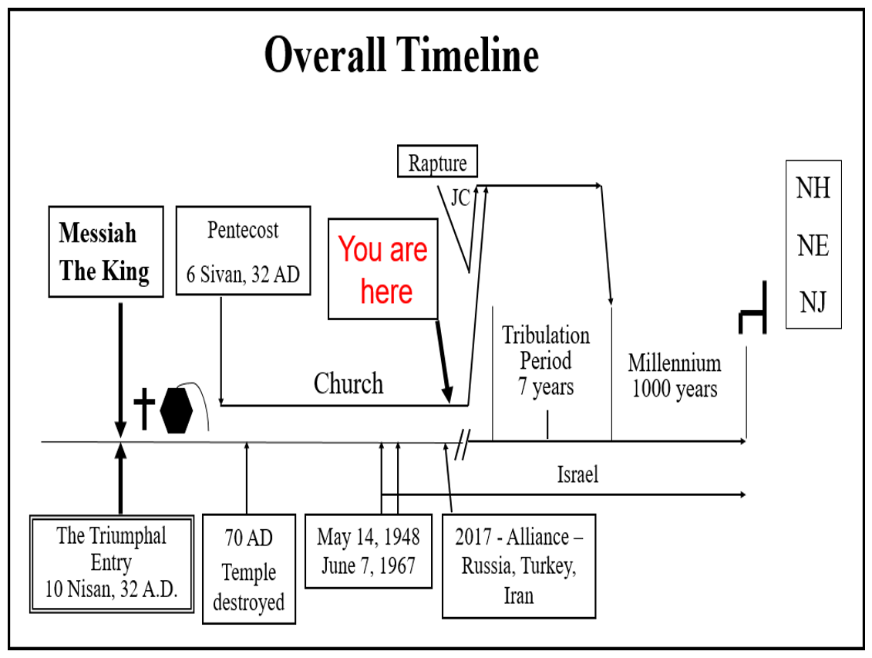
_____________________________________________________________________________________________________________________________________________________________________

No one has been this far down this time line before. We are temporarily entering unknown territory. The only advice for us at this time is in God’s Word. We know that changes will be coming more rapidly (birth pangs). This is going to be exciting.

FINAL PERSPECTIVE –

This book is not just a place to get a glimpse of history or to get good ideas and principles for life on any number of topics. This is a living book. This is the 7,000-year book of planet earth and the people on it.

It is the greatest novel ever written. It is different than all other novels as it is not fiction, it is reality.

MILESTONE KEY POINT OF UNDERSTANDING – We are actually living this book.

- Today, it appears the world is falling apart, but it isn’t. The pieces are just falling into place.
- We will be including current events in this study when we get there.

The mission of the Verse-by-Verse Bible Study Ministry is to bring Biblical truth to believers.

I hope you will stay with as we do our very best to do that.

Christian Prophetic Perspective News Sources
Rapture Ready News - http://www.raptureready.com/rapnews_db.php
Koenig World Watch Daily - http://www.watch.org/
His channel - http://www.hischannel.com/ – World News Briefing & Breaking News
Jan Markel’s website - https://olivetreeviews.org/ - Check the News and Radio Archives for specific topics
Israeli Middle East Conflict News - https://www.debka.com/

