The Bible – Beginning to End

Restart Summary
Moses – Passover, Exodus and Freedom

Clifford Phipps – August 25, 2020

- Fulfillment of the prophetic promise God gave to Abraham.

Gen 15:13-14
God said to Abram, "Know for certain that your descendants will be strangers in a land that is not theirs, where they will be enslaved and oppressed four hundred years. 14 "But I will also judge the nation whom they will serve, and afterward they will come out with many possessions.
NASU

Moses tells us that the Israelites left Egypt on the very day that the 400 years of oppression were concluded.

- Come out with many possessions Ex 12:35-36

- Enslaved and oppressed for 400 years. Ex 12:40-41

- Did God judge the Egyptians?

God devastated Egypt with the 10 plagues. The nation is in ruins.

- The crops have been destroyed
- The animals are dead
- The first born males, females and even the first born of the animals have all been killed.
- The heir to the throne of Pharaoh is now dead.

The intervention of God

God gave a dream to the Pharaoh of Egypt and he also gave the interpretation to Joseph.

This allowed The 70 people that would make up the entire nation of Israel to enter into Egypt where they would be safe to grow into a 2-million-person nation during the next 400 years.

Once the 400 years were up the Israelites didn’t want to leave Egypt

God intervened by allowing the Pharaoh to put the Nation of Israel under hard labor to make them uncomfortable, and He used 10 plagues to force the hand of the Pharaoh to make him release the Children of Israel.

God used Moses to lead the children of Israel into the Promised Land and he parted the Red Sea allowing them to walk on dry ground to safety.

God destroyed the Pharaoh and his entire army when they entered those same waters that God was holding back for the Children of Israel.

- God provided a guide (10 Commandments), for those that have a relationship with Him, to remain in fellowship with Him
- This also provided a guide on how to relate to one another.
- God wrote this document with His own finger and He wrote it in stone.
- The 10 Commandments were written specifically for the Nation of Israel. The Gentile nations were not held accountable to follow the 10 Commandments.
- God did not provide a plan of Salvation for the Gentile nations.

Originally taught on 2/18/20

The Bible – Beginning to End

Restart Summary – Israel in the Land – Promises & Problems

Gene Dahler – August 25, 2020

THE PROPHET – Jeremiah (52 Chapters) (640-570 BC)

Jeremiah 1:4-10
4 Now the word of the Lord came to me saying,
5 "Before I formed you in the womb I knew you,
And before you were born I consecrated you;
I have appointed you a prophet to the nations."

9 Then the Lord stretched out His hand and touched my mouth, and the Lord said to me,
"Behold, I have put My words in your mouth.
10 "See, I have appointed you this day over the nations and over the kingdoms,
To pluck up and to break down,
To destroy and to overthrow,
To build and to plant." NASU

Did they listen?

Jeremiah 7:25-28
25 "Since the day that your fathers came out of the land of Egypt until this day, I have sent you all My servants the prophets, daily rising early and sending them.
26 "Yet they did not listen to Me or incline their ear, but stiffened their neck; they did more evil than their fathers.
27 "You shall speak all these words to them, but they will not listen to you; and you shall call to them, but they will not answer you.

What had God previously given them?

THE LAW

God’s commandments from Moses to the nation of Israel before entering the land. (Deuteronomy 5-25)

Deuteronomy 4:1-2
1 "Now, O Israel, listen to the statutes and the judgments which I am teaching you to perform, so that you may live and go in and take possession of the land which the Lord, the God of your fathers, is giving you. 2 "You shall not add to the word which I am commanding you, nor take away from it, that you may keep the commandments of the Lord your God which I command you. NASU

Promises for obedience

Deuteronomy 28:1-7
1 "Now it shall be, if you diligently obey the Lord your God, being careful to do all His commandments which I command you today, the Lord your God will set you high above all the nations of the earth.
2 "All these blessings will come upon you and overtake you if you obey the Lord your God:
3 "Blessed shall you be in the city, and blessed shall you be in the country.
4 "Blessed shall be the offspring of your body and the produce of your ground and the offspring of your beasts, the increase of your herd and the young of your flock.
5 "Blessed shall be your basket and your kneading bowl.
6 "Blessed shall you be when you come in, and blessed shall you be when you go out.
7 "The Lord shall cause your enemies who rise up against you to be defeated before you; they will come out against you one way and will flee before you seven ways.

KEY POINT FOR ISRAEL – If you want the ______________ of God, you must obey the ___________________ of God.

Consequences of Disobedience

Deuteronomy 28:15-25
15 "But it shall come about, if you do not obey the Lord your God, to observe to do all His commandments and His statutes with which I charge you today, that all these curses will come upon you and overtake you:
16 "Cursed shall you be in the city, and cursed shall you be in the country.
17 "Cursed shall be your basket and your kneading bowl.
18 "Cursed shall be the offspring of your body and the produce of your ground, the increase of your herd and the young of your flock.
19 "Cursed shall you be when you come in, and cursed shall you be when you go out.

25 "The Lord shall cause you to be defeated before your enemies; you will go out one way against them, but you will flee seven ways before them, and you will be an example of terror to all the kingdoms of the earth.

HOW FAR FROM THE LAW DID THEY STRAY?

2 Kings 22:8-13
8 Then Hilkiah the high priest said to Shaphan the scribe, "I have found the book of the law in the house of the Lord." And Hilkiah gave the book to Shaphan who read it. NASU

10 Shaphan the scribe told the king (Josiah) saying, "Hilkiah the priest has given me a book." And Shaphan read it in the presence of the king.
11 When the king heard the words of the book of the law, he tore his clothes.

Jeremiah 25:1-11
1 The word that came to Jeremiah concerning all the people of Judah, in the fourth year of Jehoiakim the son of Josiah, king of Judah (that was the first year of Nebuchadnezzar king of Babylon),
2 which Jeremiah the prophet spoke to all the people of Judah and to all the inhabitants of Jerusalem, saying,
3 "From the thirteenth year of Josiah the son of Amon, king of Judah, even to this day, these twenty-three years the word of the Lord has come to me, and I have spoken to you again and again, but you have not listened.

8 "Therefore thus says the Lord of hosts, 'Because you have not obeyed My words,
9 behold, I will send and take all the families of the north,' declares the Lord, 'and I will send to Nebuchadnezzar king of Babylon, My servant, and will bring them against this land and against its inhabitants and against all these nations round about; and I will utterly destroy them and make them a horror and a hissing, and an everlasting desolation.
10 'Moreover, I will take from them the voice of joy and the voice of gladness, the voice of the bridegroom and the voice of the bride, the sound of the millstones and the light of the lamp.
11 ' This whole land will be a desolation and a horror, and these nations will serve the king of Babylon seventy years. NASU

Would God use a pagan nation to deliver the consequences of disobedience?

2 Chronicles 36:15-21
15 The Lord, the God of their fathers, sent word to them again and again by His messengers, because He had compassion on His people and on His dwelling place;
16 but they continually mocked the messengers of God, despised His words and scoffed at His prophets, until the wrath of the Lord arose against His people, until there was no remedy.
17 Therefore He brought up against them the king of the Chaldeans who slew their young men with the sword in the house of their sanctuary, and had no compassion on young man or virgin, old man or infirm; He gave them all into his hand.

20 Those who had escaped from the sword he carried away to Babylon; and they were servants to him and to his sons until the rule of the kingdom of Persia,
21 to fulfill the word of the Lord by the mouth of Jeremiah, until the land had enjoyed its sabbaths. All the days of its desolation it kept sabbath until seventy years were complete. NASU

HOW LONG WILL THE EXILE LAST?

The previous set of verses told us – 70 years.

Why 70 years?
Leviticus 25:1-4
1 The Lord then spoke to Moses at Mount Sinai, saying,
2 "Speak to the sons of Israel and say to them, 'When you come into the land which I shall give you, then the land shall have a sabbath to the Lord.
3 ' Six years you shall sow your field, and six years you shall prune your vineyard and gather in its crop,
4 but during the seventh year the land shall have a sabbath rest, a sabbath to the Lord; you shall not sow your field nor prune your vineyard. NASU

How does that explain it?

They had been settled in the promise land 490 years and never gave the land a Sabbath!!!!

The number of Sabbaths that the nation owes God’s land is 70. (490/7=70)

THE RETURN

Jeremiah sent a letter to the exiles in Babylon encouraging them with the Lord’s promise of their return.

Jeremiah 29:1-14
1 Now these are the words of the letter which Jeremiah the prophet sent from Jerusalem to the rest of the elders of the exile, the priests, the prophets and all the people whom Nebuchadnezzar had taken into exile from Jerusalem to Babylon.

10 "For thus says the Lord, 'When seventy years have been completed for Babylon, I will visit you and fulfill My good word to you, to bring you back to this place.
11 'For I know the plans that I have for you,' declares the Lord, 'plans for welfare and not for calamity to give you a future and a hope.
12 'Then you will call upon Me and come and pray to Me, and I will listen to you.
13 'You will seek Me and find Me when you search for Me with all your heart.
14 'I will be found by you,' declares the Lord, 'and I will restore your fortunes and will gather you from all the nations and from all the places where I have driven you,' declares the Lord, 'and I will bring you back to the place from where I sent you into exile.' NASU
Who releases them?

Ezra 1:1-4
1 Now in the first year of Cyrus king of Persia, in order to fulfill the word of the Lord by the mouth of Jeremiah, the Lord stirred up the spirit of Cyrus king of Persia, so that he sent a proclamation throughout all his kingdom, and also put it in writing, saying:
2 "Thus says Cyrus king of Persia, 'The Lord, the God of heaven, has given me all the kingdoms of the earth and He has appointed me to build Him a house in Jerusalem, which is in Judah.
3 'Whoever there is among you of all His people, may his God be with him! Let him go up to Jerusalem which is in Judah and rebuild the house of the Lord, the God of Israel; He is the God who is in Jerusalem.
4 'Every survivor, at whatever place he may live, let the men of that place support him with silver and gold, with goods and cattle, together with a freewill offering for the house of God which is in Jerusalem.'"
NASU

Isaiah prophesied even before Cyrus was born this would happen!

Isaiah 44:28
28 "It is I who says of Cyrus, 'He is My shepherd!
And he will perform all My desire.'
And he declares of Jerusalem, ' She will be built,'
And of the temple, ' Your foundation will be laid.' "NASU

Closing perspective -

Remember, just as in these times, everyone is subject to God’s intervention to the nation where they live.
Originally taught on 2/25/20

The Bible – Beginning to End

Restart Summary
Jesus – The Messiah – Birth and Ministry

Clifford Phipps – August 25, 2020

The Messiah was promised by God throughout all of the Old Testament Scriptures.

- He was the promised Seed of the Woman (Gen. 3:15)
- He would be a descendant of Abraham (Gen. 12:3)
- He would be a descendant of Isaac (Gen. 17:19)
- He would be a descendant of Jacob (Num. 24:17)
- He would be from the Tribe of Judah (Gen. 49:10)
- He would be a descendant of Jesse (Isa. 11:10)
- He would be a descendant of David (Jer. 23:5-6)
- He would shepherd His people Israel (Ezek. 37:24)
- He would be an heir to the throne of King David (Isa. 9:7)
- He would be anointed and eternal (Psalm 45:6-7, Psalm 102:25-27)
- He would be born in Bethlehem (Micah 5:2)
- He would be born to virgin (Isa. 7:14)
- He would be worshipped by shepherds (Psalm 72:9)
- Honored by great kings (Psalm 72:10,15; Isa. 60:3)
- The slaughter of Jewish children would be associated with His birth (Jer. 31:15)
- He would have flight to Egypt (Hosea 11:1)
- The way for Him would be prepared (Isa. 40:3-5)
- Preceded by a forerunner (Mal. 3:1)
- He would be preceded by Elijah (Mal. 4:5-6) – (Matt11:14, Mark 9:12-13)
- He would be declared to be the Son of God (Psalm 2:7, Prov.30:4)
- He would have a ministry in Galilee (Isa. 9:1-2)
- He would speak in parables (Psalm 78:2-4)
- He would heal the blind, deaf and lame (Isa. 29:18, Isa.35:5-6)
- He would be meek and mild (Isa. 42:2-3, Isa. 53:7)
- He would be a priest after the order of Melchizedek (Psalm 110:4)

The birth of the Messiah – God intervenes

The Announcement

He gave us some information about the birth of the Messiah.

- The child would be conceived by the Holy Spirit
- She would bear a Son
- She was to name Him Jesus
- He would save His people from their sins.

Matthew tells us that all of this was to fulfill what was said by the Lord through the prophet…………..

23 "BEHOLD, THE VIRGIN SHALL BE WITH CHILD AND SHALL BEAR A SON, AND THEY SHALL CALL HIS NAME IMMANUEL," which translated means, "GOD WITH US."
________________________________________________________________________________________________________________________

The Birth

An angel said to them,

"Do not be afraid; for behold, I bring you good news of great joy which will be for all the people;
11 for today in the city of David there has been born for you a Savior, who is Christ the Lord.
12 "This will be a sign for you: you will find a baby wrapped in cloths and lying in a manger."
________________________________________________________________________________________________________________________

The Magi

About 2 years after Jesus was born, Magi from the East came to worship the Jewish Messiah. They came to King Herod and asked “Where is He who is born King of the Jews”. This was actually an insult to Herod since he was not a Jew and was simply an installed king of the region and was ruling over the Jews.
_____________________________________________________________________________________________________________________________________________________________________

The beginning of Jesus’ Ministry

Jesus began His ministry when He was baptized by John the Baptist in the Jordan River.

How did the baptism of Jesus change Judaism?

Previously, to be saved, you had to believe that God would send a Messiah.

Following the baptism of Jesus, to be saved, you had to believe that Jesus was that Messiah.

Satan’s Response

Now that the Seed of the Woman had indeed come to the earth, we see that Satan has to come up with a new strategy to foil the promise of God that the Messiah would crush the head of Satan.

Satan attempts to keep Jesus from redeeming mankind and the earth back to the Father.

Satan offers all of the kingdoms of the world to Jesus if Jesus will simply bow down and worship Satan.

What was the purpose of Jesus’ ministry?

The purpose of Jesus’ ministry was to prove to the Nation of Israel that He was their Messiah.

Israel’s Problem with Recognizing Jesus as Their Messiah.

Did they have any excuse for not recognizing Him as their promised Messiah?

God gave Moses the Law.

But it appears that they didn’t even believe the words of Moses.

(John 5:46-47)

What happened?

The Scribes and the Pharisees had not done their job to preserve the integrity of God’s Word to the Nation of Israel.

The Nation of Israel was led astray by the false teachings of the scribes and Pharisees.

Mark 7:1-13
The Pharisees and some of the scribes gathered around Him when they had come from Jerusalem,
2 and had seen that some of His disciples were eating their bread with impure hands, that is, unwashed.
3 (For the Pharisees and all the Jews do not eat unless they carefully wash their hands, thus observing the traditions of the elders;
4 and when they come from the market place, they do not eat unless they cleanse themselves; and there are many other things which they have received in order to observe, such as the washing of cups and pitchers and copper pots.) 5 The Pharisees and the scribes asked Him, "Why do Your disciples not walk according to the tradition of the elders, but eat their bread with impure hands?"
6 And He said to them, "Rightly did Isaiah prophesy of you hypocrites, as it is written:

'THIS PEOPLE HONORS ME WITH THEIR LIPS,
BUT THEIR HEART IS FAR AWAY FROM ME.
7 'BUT IN VAIN DO THEY WORSHIP ME,
TEACHING AS DOCTRINES THE PRECEPTS OF MEN.'

(Precept is a general rule to regulate the behavior or thoughts of men)

8 "Neglecting the commandment of God, you hold to the tradition of men."

9 He was also saying to them, "You are experts at setting aside the commandment of God in order to keep your tradition.
10 "For Moses said, 'HONOR YOUR FATHER AND YOUR MOTHER'; and, 'HE WHO SPEAKS EVIL OF FATHER OR MOTHER, IS TO BE PUT TO DEATH';
11 but you say, 'If a man says to his father or his mother, whatever I have that would help you is Corban (that is to say, given to God),'
12 you no longer permit him to do anything for his father or his mother;
13 thus invalidating the word of God by your tradition which you have handed down; and you do many things such as that."
NASU

The Result of Missing Their Messiah.

(Matt 21:43)
____________________________________________________________________________________________________________________________________________________________________________________________________________________________________________________________________________________________________________________________________________________________________________________________________________________________________________________________________________________________________________________________________________________________

Originally taught 3/3/2020

The Bible – Beginning to End

Restart Summary – When Will The Messiah Come To Israel

Gene Dahler – August 25, 2020

THE PROPHECY

Daniel 9:25
25 "So you are to know and discern that from the issuing of a decree to restore and rebuild Jerusalem until Messiah the Prince there will be seven weeks and sixty-two weeks

9:25 A Biblical year is 360 days. All references to the timing of a calendar in the Bible (Gen 7:11, 7:24, 8:3,4, Rev 11:2, 12:6, 13:3,5) define a 360-day year.

INITIATION OF THE 69 WEEKS.

93 years after Daniel receives the prophecy, Nehemiah receives the decree "in the month of Nisan in the twentieth year of King Artaxerxes." (Neh 2:1-10) (445 BC)

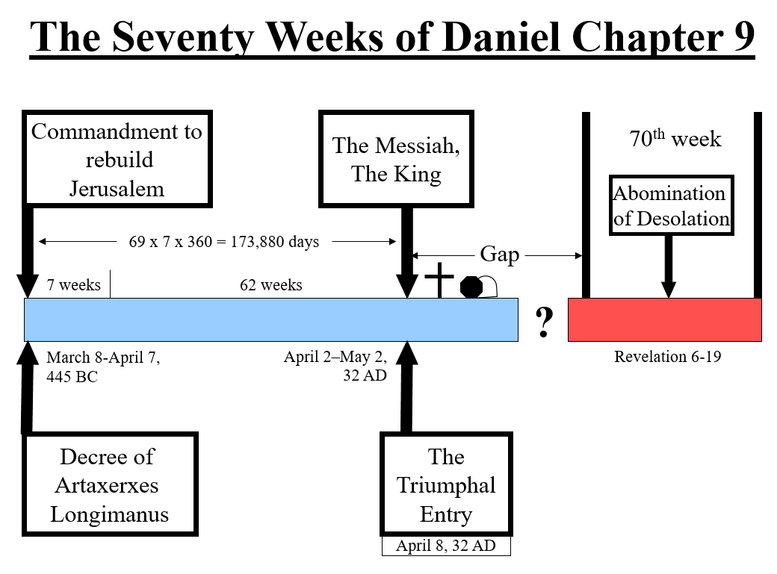
Prior to that day Jesus declines to be proclaimed the king saying "My hour is not yet come" (Jn 6:15, 7:6, 8, 30, 44, 8:20) (Jn 12:23, 27, 13:1, 17:1).

The year of the triumphal entry is defined by the Bible (Lk 3:1) as the year of 32 AD.
The date of the Triumphal entry is April 8th, 32 AD.
________________________________________________________________________________________________________________________________________________________________________________________________________________________________________________

KEY POINTS:

What is the significance of this event?

- Confirms that the author is not a man since no man could know this.
- Confirms that God keeps His Word.
- Confirms that Jesus is who He claimed to be.
- The Bible is unique amongst all printed documents on earth.

The question is: WILL YOU BELIEVE????
____________________________________________________________________________________________________________________________________________________________________________________

Originally taught on 3/10/20

Dan 9:25 from the issuing of a decree to restore and rebuild Jerusalem until Messiah the Prince there will be seven weeks and sixty-two weeks.

Basic mathematics of this prophecy.

Weeks (seven Biblical years) of the prophecy

7 + 62 = 69 seven Biblical years (360 day) periods

Days of the prophecy

69 X 7 X 360 = 173,880 days

Date of the decree (Nisan, 445 BC)

Nisan, 445 BC = March 8 - April 7, 445 BC

Prophesied date of the coming of the Messiah

March 8, 445 BC + 173,880 days = April 2, 32 AD
April 7, 445 BC + 173,880 days = May 2, 32 AD

Moving forward in time from March 8, 445 BC by 173,880 days brings us to April 2, 32 AD. The prophecy states that the Messiah will come within a 30-day period (the length of the month of Nisan) starting on the day of April 2 and ending May 2, 32 AD.

