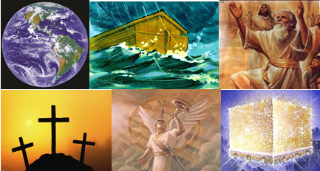

The Bible – Beginning to End

Olivet Discourse (part 1)

Gene Dahler – September 8, 2020

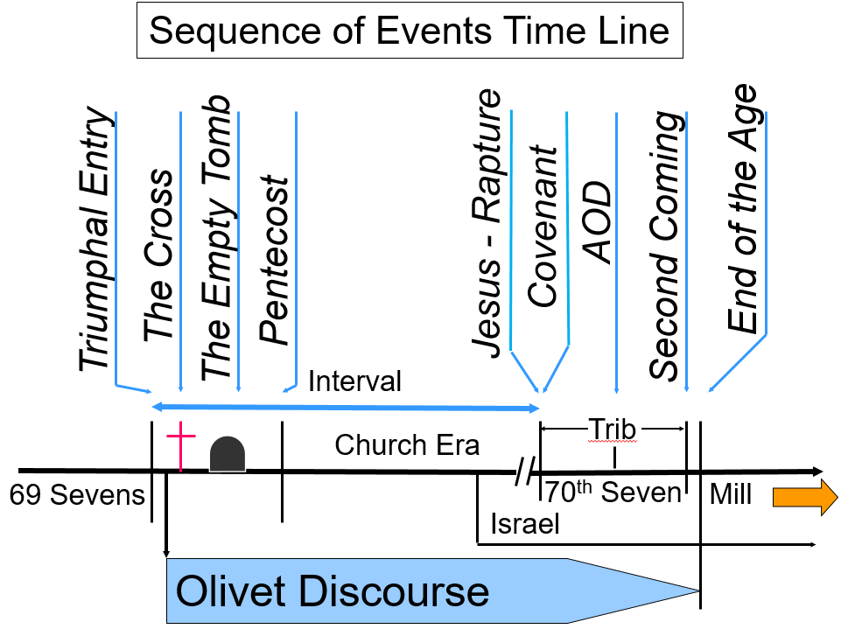
PERSPECTIVE – The Olivet Discourse is the bridge from Daniel’s prophecies to the Apostle John’s prophecies in Revelation. Here, while answering the question posed by the apostles, Jesus gives us the key to understanding.

OD:1-4 The questions.

OD:1 The temple was the pride of every Israeli and was massive in size. The Apostles probably perceived the possibility that its destruction would ever occur as near impossible.

OD:4 The questions. The answer is the remainder of Mt 24 and 25, Mk 13:1-37 and Lk 21:5-36.

The questions:
- When will these things happen?
- What will be the sign of Your coming?
- What will be the sign of the end of the age?

OD:5-10 General Overview – Apostles/Church

Who is speaking? Jesus Who is being spoken to?___________________
Who/what about?________________________________________
When does it apply?______________________________________

OD:5-6 Key point – do not be deceived

- Deception has a special power – it is very difficult for the deceived person to __________________________.

OD:8 Kingdoms are groups of nations

OD:8-9 This verses indicate that deception, war, earthquakes, plagues, famines, terror and great signs from heaven are events that will be continuously increasing trends for the entire period.

OD:10 These are just the beginning of the birth pains!
What happens when the birth pains are over?

OD:11-20 The Apostles Future.

Who/what about?____________When does it apply?_________________

OD:20 When does the Bible tell us the gospel of the kingdom is preached in the whole world? ____________________

OD:21-25 The destruction of Jerusalem.

Who/what about? ________________________ __ When? ________

Destruction of the Jerusalem and the Temple by Titus and the 5th, 10th and 12th Roman legions occur in 70AD. Josephus records that over one million were killed and over 100,000 taken captive.

Thus far Jesus has covered what conditions would exist in the near future for the apostles and when the destruction of the temple would occur.

OD:26-31 Tribulation Period - Abomination of Desolation

Who/what about? _________________ When? _____________________

OD:26 The abomination of desolation is the worshiping of the pseudo-Christ in the temple. The abomination is further defined in Dan 9:27, 11:31-39, 12:11, 2Ths 2:3-4, 8-12, Rev 13:1-18.

OD:28-29 When should they flee? ____________________

OD:32-39 After the Abomination

Who/what about? _________________ When? _____________________

OD:32 Why should the Judeans flee? To physically escape the distress unequaled from the beginning of the world.

OD:33 Who are the elect – survivors going into the millennium

OD:34-35 False Christ’s will appear doing miracles.

OD:35-39 What would be the purpose of a false Christ at this time. To ________________ them with a deception of His returning.

OD:39 What are the vultures all about? What would probably happen to those that go out to the wilderness (OD:37)? They will be _____________. Who is this about? _______________ in the tribulation period.

OD:38 This verse is stating that when the Son of Man returns, it will be a readily visible event. The whole world will know. (Mt 24:30-31 (OD:42-43); Rev 1:7)

OD:40-46 The Second Coming

Who/what about? ___________________________
When? ____________________________________

Additional references about “the Second Coming” are: Dan 2:44-45, 7:9-14; Zech 14:1-15; Mt 13:27-30, 41-43, 48-50, 16:28, 25:30, 31-46; Mk 13:14-27; Lk 21:27-28; Acts 1:9-11, 3:19-21; 1 Ths 3:13; 2 Ths 1:6-10; 2 Ths 2:8; Jude 14-15; Rev 1:7; 19:11-20:6.

These signs are also described in Isa 13:10, 24:23; Ezek 32:7-8; Joel 2:10-11, 2:30-32, 3:15-16; Amos 5:20, 8:9; Zeph 1:14-15; Acts 2:19-21; Rev 6:12-17.

OD: 26-46 – These verses are Jesus response for what will be the sign of your coming and of the end of the age.
OD:47-65 Church Era - As the End Approaches.

Who/what about?_____________________________________

When?_____________________________________________

OD:47 Whose redemption? The _____________________.

OD:48 The fig tree symbolizes Israel. The other trees symbolize the rest of the world (prophecies of).

OD:51 What is the generation that will not pass away?

OD:48-51 When the stage is being set (leaves sprout), believers know the time is near (summer). This will not take long, the survivors of the generation that sees the leaves sprouting (preparation for the beginning) will see the summer (the end). The emphasis here is on surviving (not passing away), not the length of a generation. Remember, if the time was not short, there would be no survivors. (Mt 24:22)

- How about the Church? There will be signs that the time is near. We do not know the day or the hour (Matt 24:36, 25:13; Mark 13:32; Luke 12:46), but we are to know the season (1Th 5:1-11).

- Jesus made another remarkable statement about those that know the Master’s business (plans), that He has called you “___________.” (Jn 15:15)

OD:52 Jesus way of saying the Truth will stand forever.

OD:53 No one knows the day or hour, not even the angels or the Son. Why? ___________________________________________

OD:54 The days will be like the days of Noah. It will be like watching Noah ________________________.

OD:55 Is there anything wrong with eating, drinking, marrying? The emphasis here is on the ______ ________ _______ the ____.
OD:56 It is like today - "those being left behind knew nothing about what is about to happen."

OD:57-58 They will be caught up to meet the Lord in the air. (1Th 4:15-18)

OD:59-65 Be ready! Watch!

OD:66-69 Jesus says pray that you will be able to escape

Who/what about?________________________________________

When?_________________________________________________

OD:69 "PRAY THAT YOU MAY BE ABLE TO ESCAPE "ALL" THAT IS ABOUT TO HAPPEN, AND THAT YOU MAY BE ABLE TO STAND BEFORE THE SON OF MAN."

OD: 51-69 – These verses are Jesus statement for believers in regard to what will be the sign of His coming (rapture) and of the end of the church era.

SUMMARY:

- Do not be deceived.

- The purpose of all these end of the age events is to bring everyone into the Kingdom that would come.

- Perspective # 1 - Today – The schedule is dependent on the people.

- Perspective # 2 - Be ready! Watch!

- Perspective # 3 - PRAY THAT YOU MAY BE ABLE TO ESCAPE "ALL" THAT IS ABOUT TO HAPPEN, AND THAT YOU MAY BE ABLE TO STAND BEFORE THE SON OF MAN. (OD:69; Lk 21:36)

filename: 200908-OD – HB – The Signs rev b a3.doc 7/31/2026

