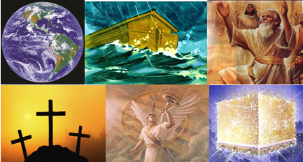

The Bible – Beginning to End

Olivet Discourse (part 2)

Gene Dahler – Sept 15, 2020

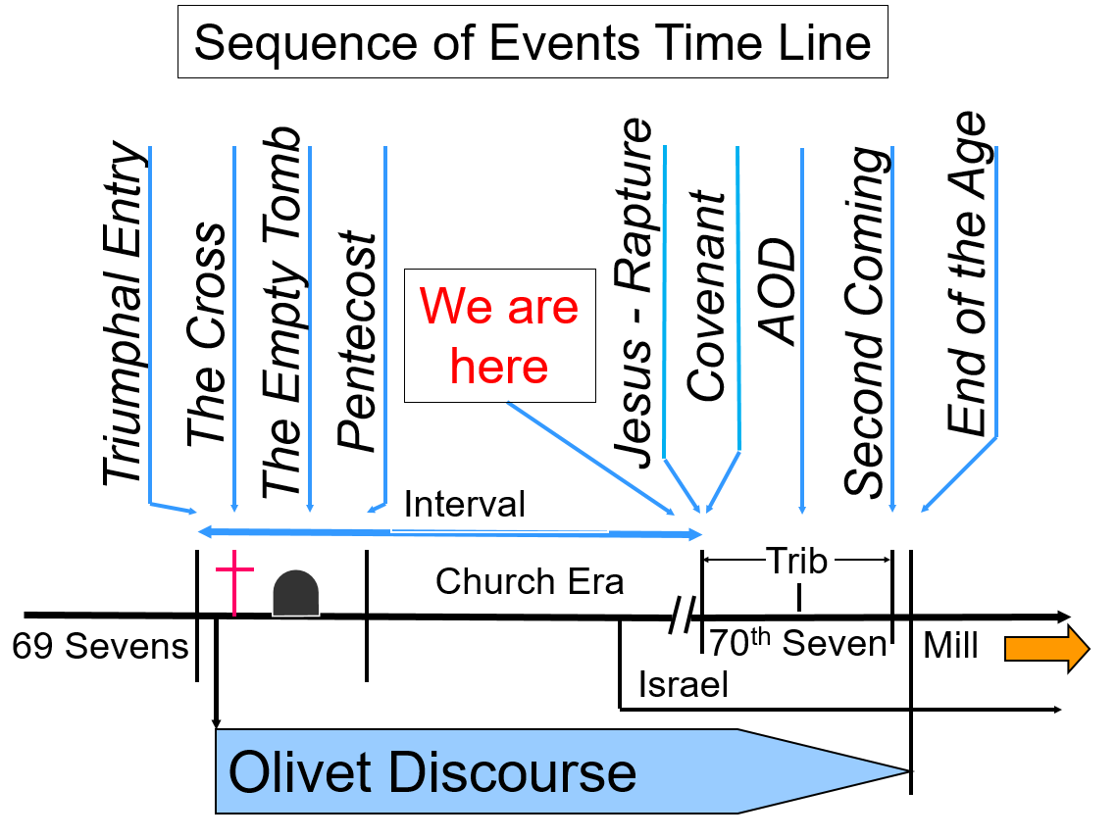
OVERVIEW – Purpose of chapter 25 – Identify the groups of people in existence at the end of the age, where they will go, when they will go and why.

25:1-13 – Parable of the Ten Virgins

Matt 25:1-13
1 "Then the kingdom of heaven will be comparable to ten virgins, who took their lamps and went out to meet the bridegroom.
2 "Five of them were foolish, and five were prudent.
3 "For when the foolish took their lamps, they took no oil with them,
4 but the prudent took oil in flasks along with their lamps.
5 "Now while the bridegroom was delaying, they all got drowsy and began to sleep.
6 "But at midnight there was a shout, 'Behold, the bridegroom! Come out to meet him.'
7 "Then all those virgins rose and trimmed their lamps.
8 "The foolish said to the prudent, 'Give us some of your oil, for our lamps are going out.'
9 "But the prudent answered, 'No, there will not be enough for us and you too; go instead to the dealers and buy some for yourselves.'
10 "And while they were going away to make the purchase, the bridegroom came, and those who were ready went in with him to the wedding feast; and the door was shut.
11 "Later the other virgins also came, saying, 'Lord, lord, open up for us.'
12 "But he answered, 'Truly I say to you, I do not know you.'
13 "Be on the alert then, for you do not know the day nor the hour. NASU

Who/what is being spoken about? ______________________
When does it apply? ___________________________________

This parable is about the event that precedes the 70th 7, _______________________________________.

:8 Oil is symbolic of the Holy Spirit. The lamp is symbolic of the Word or the Truth. It is capable of giving light, but not without oil. (Matt 5:14-16, Luke 12:35-36)

How does a person receive the original oil for his/her lamp?
Ans – By believing the gospel!!!!
How does a person keep oil in the lamp?
Ans – By abiding in the Word and establishing understanding of the truth which gives a person the assurance needed to not be deceived and to be an overcomer believing the truth to the end.

:12 “I don’t know you.” These virgins are trying to be included in the group that is the bride and it is too late. He already has appeared for His bride and it happened quickly. There is no second chance to be the bride of Christ. (1Th 4:13-18; 1Cor 15:50-54)

The Bride is the church and once the church is taken to heaven, there is no longer an opportunity to be part of the bride. However, it is still possible to be a guest at the wedding.

:13 We do not know the day or the hour.
____________________________________________________________________________________________________________________________________________________________________________________

NOTE: The next two judgments happen in the 75-day gap between the tribulation period and the millennium

25:14-30 – Judgment of the Talents

The talents are money, estimated to be approximately one worker’s annual income.

Matt 25:14-30
14 "For it is just like a man about to go on a journey, who called his own slaves and entrusted his possessions to them.
15 "To one he gave five talents, to another, two, and to another, one, each according to his own ability; and he went on his journey.
16 "Immediately the one who had received the five talents went and traded with them, and gained five more talents.
17 "In the same manner the one who had received the two talents gained two more.
18 "But he who received the one talent went away, and dug a hole in the ground and hid his master's money.
19 "Now after a long time the master of those slaves came and settled accounts with them.
20 "The one who had received the five talents came up and brought five more talents, saying, 'Master, you entrusted five talents to me. See, I have gained five more talents.'
21 "His master said to him, 'Well done, good and faithful slave. You were faithful with a few things; I will put you in charge of many things; enter into the joy of your master.'
22 "Also the one who had received the two talents came up and said, 'Master, you entrusted two talents to me. See, I have gained two more talents.'
23 "His master said to him, 'Well done, good and faithful slave. You were faithful with a few things; I will put you in charge of many things; enter into the joy of your master.'
24 "And the one also who had received the one talent came up and said, 'Master, I knew you to be a hard man, reaping where you did not sow and gathering where you scattered no seed.
25 'And I was afraid, and went away and hid your talent in the ground. See, you have what is yours.'
26 "But his master answered and said to him, 'You wicked, lazy slave, you knew that I reap where I did not sow and gather where I scattered no seed.
27 'Then you ought to have put my money in the bank, and on my arrival I would have received my money back with interest.
28 'Therefore take away the talent from him, and give it to the one who has the ten talents.'
29 "For to everyone who has, more shall be given, and he will have an abundance; but from the one who does not have, even what he does have shall be taken away.
30 "Throw out the worthless slave into the outer darkness; in that place there will be weeping and gnashing of teeth. NASU

Who/what is being spoken about? ______________________
When does it apply? ___________________________________

The talents are symbolic of resources and/or opportunities.

:15 – Human skill is the contribution of the slaves – “to his own ability.”

:21 & 23 – The ones who do well get to enter into the joy of your master.

:29 – This is not about heaven, but about entering the promise land in the Millennium.

:30 - The slave that didn’t apply his ability is cast into ________________.

We have something very significant to be thankful for and that is that this judgment does _________________________________.
____________________________________________________________________________________________________________________________________________________________________________________

25:31-46 – The Sheep and the Goat Judgment

Matt 25:31-46
31 "But when the Son of Man comes in His glory, and all the angels with Him, then He will sit on His glorious throne.
32 "All the nations will be gathered before Him; and He will separate them from one another, as the shepherd separates the sheep from the goats;
33 and He will put the sheep on His right, and the goats on the left.
34 "Then the King will say to those on His right, 'Come, you who are blessed of My Father, inherit the kingdom prepared for you from the foundation of the world. 35 'For I was hungry, and you gave Me something to eat; I was thirsty, and you gave Me something to drink; I was a stranger, and you invited Me in;
36 naked, and you clothed Me; I was sick, and you visited Me; I was in prison, and you came to Me.'
37 "Then the righteous will answer Him, 'Lord, when did we see You hungry, and feed You, or thirsty, and give You something to drink?
38 'And when did we see You a stranger, and invite You in, or naked, and clothe You?
39 'When did we see You sick, or in prison, and come to You?'
40 "The King will answer and say to them, 'Truly I say to you, to the extent that you did it to one of these brothers of Mine, even the least of them, you did it to Me.'
41 "Then He will also say to those on His left, 'Depart from Me, accursed ones, into the eternal fire which has been prepared for the devil and his angels;
42 for I was hungry, and you gave Me nothing to eat; I was thirsty, and you gave Me nothing to drink;
43 I was a stranger, and you did not invite Me in; naked, and you did not clothe Me; sick, and in prison, and you did not visit Me.'
44 "Then they themselves also will answer, 'Lord, when did we see You hungry, or thirsty, or a stranger, or naked, or sick, or in prison, and did not take care of You?' 45 "Then He will answer them, 'Truly I say to you, to the extent that you did not do it to one of the least of these, you did not do it to Me.'
46 "These will go away into eternal punishment, but the righteous into eternal life." NASU

Who/what is being spoken about? ________________________________
When does it apply? __________________________________________

:34-40 – The sheep

:34 Those who are blessed are to inherit the kingdom prepared from the foundations of the world. It is a _____________ kingdom.

:35 Those receiving the inheritance gave to the brothers of the King. Who is the King? _____________

Who are the brothers? __________________________

41-46 – The goats

:41 – The accursed ones receive eternal fire.

:42-43 – Why did they receive eternal fire? They did not help the brothers of the King.
____________________________________________________________________________________________________________________________________________________________________________________

SUMMARY –

This is an incredible plan to bring people into the kingdom without violating their personal sovereignty of choice as time expires at the end of the age and to fulfill all the promises made to Israel. Remember, the end of the age is a period of time for all those that refused to accept Jesus during the church era. Wonderful eras follow for all those who are in the kingdom; the Millennium and then a new Heaven, new Earth and new Jerusalem and you will be there. We need to be incredibly thankful to be alive now and have chosen to be a member of this unique group that has never existed before called the virgin bride of Christ, the Church.

What should we do? Bring everybody into the kingdom now that we can.

Why? Because the facts are that this is not _________, it is ________.

Key Points in these verses:

- _____________ times we are told not to be ________________.

- __________________ times we are told to be ________________.

