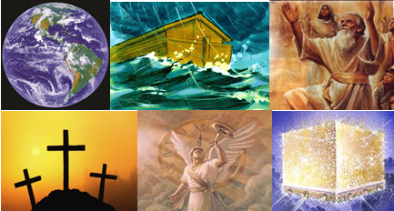

The Bible – Beginning to End

The Holy Spirit and the Believer

Gene Dahler – October 6, 2020

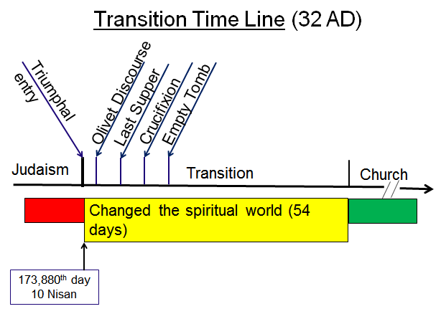

REVIEW
________________________________________________________________________________________________________________________________________________________________________________________________________________________________________________
What is God going to do now?

THE GREAT COMMISSION

Matt 28:16-20
16 But the eleven disciples proceeded to Galilee, to the mountain which Jesus had designated.
17 When they saw Him, they worshiped Him; but some were doubtful.
18 And Jesus came up and spoke to them, saying, "All authority has been given to Me in heaven and on earth.
19 "Go therefore and make disciples of all the nations, baptizing them in the name of the Father and the Son and the Holy Spirit,
20 teaching them to observe all that I commanded you; and lo, I am with you always, even to the end of the age." NASU
____________________________________________________________________________________________________________________________________________________________________________________

THE ASCENSION

Luke 24:44-51
44 Now He said to them, "These are My words which I spoke to you while I was still with you, that all things which are written about Me in the Law of Moses and the Prophets and the Psalms must be fulfilled."
45 Then He opened their minds to understand the Scriptures,
46 and He said to them, "Thus it is written, that the Christ would suffer and rise again from the dead the third day,
47 and that repentance for forgiveness of sins would be proclaimed in His name to all the nations, beginning from Jerusalem.
48 "You are witnesses of these things.
49 "And behold, I am sending forth the promise of My Father upon you; but you are to stay in the city until you are clothed with power from on high."
50 And He led them out as far as Bethany, and He lifted up His hands and blessed them.
51 While He was blessing them, He parted from them and was carried up into heaven. NASU
____________________________________________________________________________________________________________________________________________________________________________________
Luke reported it this way in his letter to Theophilus -

Acts 1:5, 8-11
5 - - - you will be baptized with the Holy Spirit not many days from now."
8 - - - you will receive power when the Holy Spirit has come upon you; and you shall be My witnesses both in Jerusalem, and in all Judea and Samaria, and even to the remotest part of the earth."
9 And after He had said these things, He was lifted up while they were looking on, and a cloud received Him out of their sight.
10 And as they were gazing intently into the sky while He was going, behold, two men in white clothing stood beside them.
11 They also said, "Men of Galilee, why do you stand looking into the sky? This Jesus, who has been taken up from you into heaven, will come in just the same way as you have watched Him go into heaven." NASU
____________________________________________________________________________________________________________________________________________________________________________________

THE BEGINNING OF THE CHURCH – (Pentecost, 6 Sivan (June 2, 32AD))

Acts 2:1-15
1 When the day of Pentecost had come, they were all together in one place.
2 And suddenly there came from heaven a noise like a violent rushing wind, and it filled the whole house where they were sitting.
3 And there appeared to them tongues as of fire distributing themselves, and they rested on each one of them.
4 And they were all filled with the Holy Spirit and began to speak with other tongues, as the Spirit was giving them utterance.
________________________________________________________________________________________________________________________

5 Now there were Jews living in Jerusalem, devout men from every nation under heaven.
6 And when this sound occurred, the crowd came together, and were bewildered because each one of them was hearing them speak in his own language.
7 They were amazed and astonished, saying, "Why, are not all these who are speaking Galileans?
8 "And how is it that we each hear them in our own language to which we were born?
9 "Parthians and Medes and Elamites, and residents of Mesopotamia, Judea and Cappadocia, Pontus and Asia,
10 Phrygia and Pamphylia, Egypt and the districts of Libya around Cyrene, and visitors from Rome, both Jews and proselytes,
11 Cretans and Arabs — we hear them in our own tongues speaking of the mighty deeds of God."
12 And they all continued in amazement and great perplexity, saying to one another, "What does this mean?"
________________________________________________________________________________________________________________________

13 But others were mocking and saying, "They are full of sweet wine."
________________________________________________________________________________________________________________________

14 But Peter, taking his stand with the eleven, raised his voice and declared to them: "Men of Judea and all you who live in Jerusalem, let this be known to you and give heed to my words.
15 "For these men are not drunk, as you suppose, for it is only the third hour of the day;
________________________________________________________________________________________________________________________

22 "Men of Israel, listen to these words: Jesus the Nazarene, a man attested to you by God with miracles and wonders and signs which God performed through Him in your midst, just as you yourselves know —
23 this Man, delivered over by the predetermined plan and foreknowledge of God, you nailed to a cross by the hands of godless men and put Him to death.
24 "But God raised Him up again, putting an end to the agony of death, since it was impossible for Him to be held in its power.
________________________________________________________________________________________________________________________

32 "This Jesus God raised up again, to which we are all witnesses.
33 "Therefore having been exalted to the right hand of God, and having received from the Father the promise of the Holy Spirit, He has poured forth this which you both see and hear.
34 "For it was not David who ascended into heaven, but he himself says: 'THE LORD SAID TO MY LORD, "SIT AT MY RIGHT HAND,
35 UNTIL I MAKE YOUR ENEMIES A FOOTSTOOL FOR YOUR FEET."'
36 "Therefore let all the house of Israel know for certain that God has made Him both Lord and Christ — this Jesus whom you crucified."
________________________________________________________________________________________________________________________

37 Now when they heard this, they were pierced to the heart, and said to Peter and the rest of the apostles, "Brethren, what shall we do?"
38 Peter said to them, "Repent, and each of you be baptized in the name of Jesus Christ for the forgiveness of your sins; and you will receive the gift of the Holy Spirit.
________________________________________________________________________________________________________________________

39 "For the promise is for you and your children and for all who are far off, as many as the Lord our God will call to Himself."
40 And with many other words he solemnly testified and kept on exhorting them, saying, "Be saved from this perverse generation!"
________________________________________________________________________________________________________________________

41 So then, those who had received his word were baptized; and that day there were added about three thousand souls. NASU
____________________________________________________________
____________________________________________________________

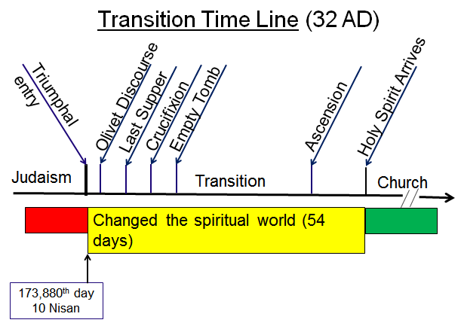

Jesus just fulfilled what he told the chief priests and elders in Judaism what He was going to do!!

Matt 21:43 (after the Triumphal Entry - to the chief priests and elders in Judaism)
43 "Therefore I say to you, the kingdom of God will be taken away from you and given to a people, producing the fruit of it. NASU

What has happened? Where has God’s relationship to man come from and where has it gone?

What was it?

54 days ago - Judaism

- Law
- Works for salvation
- Animal sacrifices for sin
- Mandatory pilgrimages to Jerusalem
- Destination of Abraham’s bosom upon departure from earth
- Never be confident of their personal salvation

What is God’s relationship with man now?

What was promised?

Remember Jesus’ statements at the Last Supper?

Luke 22:20
20 And in the same way He took the cup after they had eaten, saying, "This cup which is poured out for you is the new covenant in My blood. NASU

John 14:16
16 "I will ask the Father, and He will give you another Helper, that He may be with you forever; NASU

John 16:7
7 "But I tell you the truth, it is to your advantage that I go away; for if I do not go away, the Helper will not come to you; but if I go, I will send Him to you. NASU

John 16:13
13 "But when He, the Spirit of truth, comes, He will guide you into all the truth; for He will not speak on His own initiative, but whatever He hears, He will speak; and He will disclose to you what is to come. NASU

Jesus said later -

Luke 24:49
- - - you are to stay in the city until you are clothed with power from on high."

Paul wrote of the results of all this:

2 Cor 5:17
17 Therefore, if anyone is in Christ, he is a new creation; old things have passed away; behold, all things have become new. NKJV

Rom 8:1-16
1 Therefore there is now no condemnation for those who are in Christ Jesus.
2 For the law of the Spirit of life in Christ Jesus has set you free from the law of sin and of death.
3 For what the Law could not do, weak as it was through the flesh, God did: sending His own Son in the likeness of sinful flesh and as an offering for sin, He condemned sin in the flesh,
4 so that the requirement of the Law might be fulfilled in us, who do not walk according to the flesh but according to the Spirit.
________________________________________________________________________________________________________________________

5 For those who are according to the flesh set their minds on the things of the flesh, but those who are according to the Spirit, the things of the Spirit.
6 For the mind set on the flesh is death, but the mind set on the Spirit is life and peace,
7 because the mind set on the flesh is hostile toward God; for it does not subject itself to the law of God, for it is not even able to do so,
8 and those who are in the flesh cannot please God.

9 However, you are not in the flesh but in the Spirit, if indeed the Spirit of God dwells in you. But if anyone does not have the Spirit of Christ, he does not belong to Him.
10 If Christ is in you, though the body is dead because of sin, yet the spirit is alive because of righteousness.
________________________________________________________________________________________________________________________

11 But if the Spirit of Him who raised Jesus from the dead dwells in you, He who raised Christ Jesus from the dead will also give life to your mortal bodies through His Spirit who dwells in you.

12 So then, brethren, we are under obligation, not to the flesh, to live according to the flesh —
13 for if you are living according to the flesh, you must die; but if by the Spirit you are putting to death the deeds of the body, you will live.
14 For all who are being led by the Spirit of God, these are sons of God.
________________________________________________________________________________________________________________________

15 For you have not received a spirit of slavery leading to fear again, but you have received a spirit of adoption as sons by which we cry out, "Abba! Father!"
16 The Spirit Himself testifies with our spirit that we are children of God,
17 and if children, heirs also, heirs of God and fellow heirs with Christ, if indeed we suffer with Him so that we may also be glorified with Him.
________________________________________________________________________________________________________________________

18 For I consider that the sufferings of this present time are not worthy to be compared with the glory that is to be revealed to us.
19 For the anxious longing of the creation waits eagerly for the revealing of the sons of God.

20 For the creation was subjected to futility, not willingly, but because of Him who subjected it, in hope
21 that the creation itself also will be set free from its slavery to corruption into the freedom of the glory of the children of God.
22 For we know that the whole creation groans and suffers the pains of childbirth together until now.
23 And not only this, but also we ourselves, having the first fruits of the Spirit, even we ourselves groan within ourselves, waiting eagerly for our adoption as sons, the redemption of our body.
________________________________________________________________________________________________________________________

24 For in hope we have been saved, but hope that is seen is not hope; for who hopes for what he already sees?
25 But if we hope for what we do not see, with perseverance we wait eagerly for it.
26 In the same way the Spirit also helps our weakness; for we do not know how to pray as we should, but the Spirit Himself intercedes for us with groanings too deep for words;
27 and He who searches the hearts knows what the mind of the Spirit is, because He intercedes for the saints according to the will of God. NASU
________________________________________________________________________________________________________________________

The Church – Initiated 54 days after the triumphal entry

Those born again believers receive -

1. The Holy Spirit – a new creation (Jn 16:17; 2Cor 5:17)
2. Guide into the truth (Jn 16:13)
3. Forgiveness without animal sacrifice (Rom 8:1, Heb 10:14)
4. Departure destination from earth is now heaven (Jn 14:1-3)
5. The promise of the rapture (1Cor 15:51-58; 1Thess 4:14-18)
6. Exclusion from the tribulation period (Rev 4-6; 2Thess 2:1-4)
7. Free from the law of sin and death (Rom 8:2, 7:6)
8. Received a spirit of adoption (Rom 8:15)
9. The Holy Spirit testifies with our spirit (Rom 8:16)
10. Heirs of God and fellow heirs with Christ (Rom 8:17)
11. Have an intercessor in heaven (Rom 8:27)
12. The Holy Spirit will be with you forever (Jn 14:16)
13. Receive power (Lk 24:49; Acts 1:8)
14. Eternal security (Heb 10:14; 1Pet 1:3-5; 1Jn 5:10-13)
15. We will be like Jesus (1Jn 3:2, Rom 8:28; Phil 3:21)

Did Jesus provide these 15 items in the church list to the Jewish people before the last supper?

Remember Jesus’ statement at the last supper?

John 14:12
12 "Truly, truly, I say to you, he who believes in Me, the works that I do, he will do also; and greater works than these he will do; because I go to the Father. NASU

____________________________________________________________________________________________________________________________________________________________________________________________________________________________________________________________________________________________________________________________________________________________________________________________________________________________________

Understand this; you have the power of the Holy Spirit. A major part of that power is that your works can play a part in instilling the power of the Holy Spirit in others bringing the blessings of these 15 items. That is the thing that Jesus says you can do that is greater than what He had done prior to the last supper.
________________________________________________________________________________________________________________________________________________________________________________________________________________________________________________________________________________________________________________________________________________________________________

Always remember who you are, that you are loved and that what you are doing for the Lord for the rest of your time here on earth is significant to our Lord and Savior, Jesus Christ.

File: 201006- HS – believer HO a7

