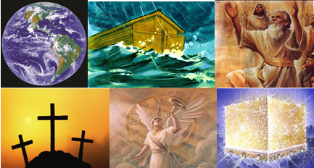

The Bible – Beginning to End

Israel – Past and Present

Gene Dahler – October 13, 2020

REVIEW -
____________________________________________________________________________________________________________________________________________________________________________________________________________________________________________________________________________________________________________________________________________________________________________________________________________________________________

The Prophecy of the Servitude of the Nation-

Ezekiel 4:1-8
1 "Now you son of man, get yourself a brick, place it before you and inscribe a city on it, Jerusalem.
2 "Then lay siege against it, build a siege wall, raise up a ramp, pitch camps and place battering rams against it all around.
3 "Then get yourself an iron plate and set it up as an iron wall between you and the city, and set your face toward it so that it is under siege, and besiege it. This is a sign to the house of Israel.
4 "As for you, lie down on your left side and lay the iniquity of the house of Israel on it; you shall bear their iniquity for the number of days that you lie on it.
5 "For I have assigned you a number of days corresponding to the years of their iniquity, three hundred and ninety days; thus you shall bear the iniquity of the house of Israel.
6 "When you have completed these, you shall lie down a second time, but on your right side and bear the iniquity of the house of Judah; I have assigned it to you for forty days, a day for each year.
7 "Then you shall set your face toward the siege of Jerusalem with your arm bared and prophesy against it.
8 "Now behold, I will put ropes on you so that you cannot turn from one side to the other until you have completed the days of your siege. NASU

The first 70 years of the 430-year prophecy is obviously the Babylonian captivity which commenced in 606 BC. The remaining 360 years does not fit the historical record.

A Modification of the Term -

The Levitical Law states that if Israel does not listen and remains hostile to God, then God will multiply their punishment seven times.

Note: Not listening to God has consequences from the Garden of Eden to the end of the Millennium.

Lev 26:18, 21, 24, 28

18 'If also after these things you do not obey Me, then I will punish you seven times more for your sins. NASU

21 'If then, you act with hostility against Me and are unwilling to obey Me, I will increase the plague on you seven times according to your sins. NASU

24 then I will act with hostility against you; and I, even I, will strike you seven times for your sins. NASU

28 then I will act with wrathful hostility against you, and I, even I, will punish you seven times for your sins. NASU
__________________________________________________________________________________________________________________________________________________________________
Prophecy of Ezekiel 4:1-8

Term modified by Lev 26:18, 21, 24 & 28

Constants:

1. 70 prophetic years = 69 Gregorian calendar years (Babylonian captivity)
2. 360 x 7 = 2520 prophetic years = 2484 Gregorian calendar years

606 BC
I948 AD

1948 AD

69 years
2484 years

On May 14, 1948, David Ben Gurion, citing the book of Ezekiel as his authority, proclaimed Israel as the new Jewish homeland.

____________________________________________________________________________________________________________________________________________________________________________________________________________________________________________________________________________________________________________________________________

The same mathematics applied to 9 AB, 587 BC, the date of the third siege that historians have discovered was the day that the Babylonians destroyed Jerusalem and ended the rule of Jerusalem by Israelis.

Prophecy of Ezekiel 4:1-8
as applied to the final destruction and dispersion of the Jews from Jerusalem.
Term modified by Lev 26:18, 21, 24 & 28

Constants:

- 70 prophetic years = Babylonian servitude
- 70 prophetic years = 25,200 days)
(70 x 360 = 25,200)
- 360 prophetic years x 7 = 2520 prophetic years
(360 x 7 x 360 = 907,200)

9 Ab, 587 BC
June 7, 1967 AD

1948 AD

25,200 days
907,200 days

June 7, 1967 was the first day the city of Jerusalem fell under Jewish control since 587 BC.

____________________________________________________________________________________________________________________________________________________________________________________________________________________________________________________________________________________________________________________________________

WHAT IS THE PROPHESIED SPIRITUALITY OF THE ISRAEL OF TODAY?

Israel today appears to represent the gathering in _____________ that is prophesied. (Ezk 20:33-38, 22:17-12, 36:22-24; Isa 11:11-12; Zeph 2:1-2) (FYI – before the Millennium in belief; Deut 4:29-31, 30:1-10; Isa 27:12-13; 43:5-7; Jer 16:14-15, 31:7-10, Ezk 11:14-18; Amos 9:14-15; Zech 10:8-12; Mt 24:31)

Ezek 36:22-24
22 "Therefore say to the house of Israel, 'Thus says the Lord GOD, "It is not for your sake, O house of Israel, that I am about to act, but for My holy name, which you have profaned among the nations where you went.
23 "I will vindicate the holiness of My great name which has been profaned among the nations, which you have profaned in their midst. Then the nations will know that I am the LORD," declares the Lord GOD, "when I prove Myself holy among you in their sight.
24 "For I will take you from the nations, gather you from all the lands and bring you into your own land. NASU

Ezek 22:17-19
17 And the word of the LORD came to me, saying,
18 "Son of man, the house of Israel has become dross to Me; all of them are bronze and tin and iron and lead in the furnace; they are the dross of silver.
19 "Therefore, thus says the Lord GOD, 'Because all of you have become dross, therefore, behold, I am going to gather you into the midst of Jerusalem. NASU

Israel has not recognized their Messiah. It appears they are, as prophecied, gathered in unbelief.

________________________________________________________________________________________________________________________________________________________________________________________________________________________

WHAT IS THIS GOD GATHERED ISRAEL PROPHESIED TO BE?

- a _________________________ unto all the people

- a ________________________ for all people

Zech 12:1-3
12:1 The burden of the word of the LORD for Israel, saith the LORD, which stretcheth forth the heavens, and layeth the foundation of the earth, and formeth the spirit of man within him.
2 Behold, I will make Jerusalem a cup of trembling unto all the people round about, when they shall be in the siege both against Judah and against Jerusalem.
3 And in that day will I make Jerusalem a burdensome stone for all people: all that burden themselves with it shall be cut in pieces, though all the people of the earth be gathered together against it. KJV

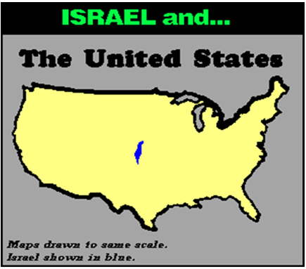

Every major nation in the world has a council or representatives chartered to influence and exercise control, if possible, in the national relationship of Israel and its neighbors. Israel is a topic of significant focus for these nations. What is their perspective? The United Nations (UN) is the central meeting place for the nations. It is one of the best indicators of world attitude towards Israel. How do the nations vote?

SUMMARY:

UN Security Council: Resolutions condemning Israel: 45 (half of all the resolutions applied to countries)
Resolutions condemning Palestinians: 0
UN Human Rights Council: From its creation in June 2006 through June 2016, the UN Human Rights Council over one decade adopted 135 resolutions criticizing countries; 68 out of those 135 resolutions have been against Israel (more than 50%).
UN Nations General Assembly: From 2012 through 2015, the United Nations General Assembly has adopted 97 resolutions criticizing countries; 83 out of those 97 have been against Israel (86%).
UNESCO: Each year, the United Nations Educational, Scientific and Cultural Organization (UNESCO) adopts around 10 resolutions a year criticizing only Israel. UNESCO does not criticize any other member state in a country-specific resolution (100%). An exception occurred in 2013, when, under pressure from UN Watch, UNESCO adopted one resolution on Syria.
World Health Organization: For one week every year, the UN World Health Assembly, the decision-making body of the World Health Organization (WHO), meets to formulate global health policy. Resolutions are adopted to address global health issues. There is one exception: the annual resolution entitled “Health conditions in the occupied Palestinian territory, including east Jerusalem, and in the occupied Syrian Golan,” which singles out Israel for condemnation; no other country in the world is condemned by the WHO.
______________________________________________________________________________________________________________________________________________________________________________________________________________________________________________________________________________

WHAT IS ISRAEL TO ISLAM?

CURRENT EVENTS – Israel is facing overwhelming odds.

We now have Israel in the land, however all of the surrounding nations are in opposition.

What is the problem?
- Israel is small – about the size of New Jersey.
- Many say the unrest is all about oil, but Israel has almost none, although recently they discovered a large natural gas reserve.

So, what is the problem? ______________ Why does that exist from such a small country? The population and landmass is overwhelmed by the surrounding Muslim nations by 200 to 1, population 600+ to 1. What is the source of the fear?

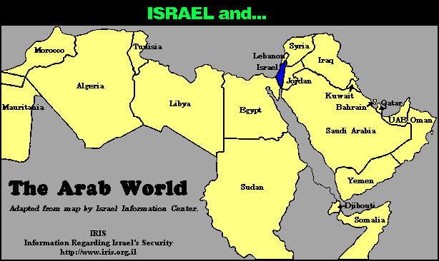

Consider –
- Moses (Exodus 14)
- Jericho (Joshua 2-6)
- Gideon (Judg 6-7)
- Angel of the Lord (2Kings 19:32-37; Is 37:33-38)

- 5 wars since 1948
  - 1948-49 – Egypt, Syria, Jordan, Lebanon, Iraq
  - 1956 – Egypt
  - 1967 (6 day war) – Egypt, Syria, Jordan
  - 1973-74 (Yom Kippur war) – Egypt, Syria, Jordan, Libya, Iraq
  - 1982 - Lebanon

The Muslim perspective is; it doesn’t matter if Israel is well armed, has nuclear weapons, has the USA for an ally, or is from a worldly view defenseless, history has proven that when they are in God’s favor, they are dangerous and capable of victory against overwhelming odds and therefore must be eliminated.

From the spiritual perspective to a Muslim; the evidence of Israel’s military victories against overwhelming odds is a statement that Israel’s God is greater than the Muslim god. To a fundamental Muslim, this is an unacceptable situation and cannot be allowed to continue to exist.

PERSPECTIVE – These 5 wars, were they with terrorists groups (Al Qaida, etc.)? NO – nations – Egypt (4), Syria (3), Jordan (3), Lebanon (2), Iraq (1) and Libya (1). What have we been told about Muslims for the last 10+ years? 90% are not aggressive fundamentalist terrorist, but peace loving people. If 90% of the people in these nations are peace loving, how is it that these nation’s governments ordered their army’s to start wars with Israel????

WHAT IS THE LAND OF ISRAEL TO GOD?

Israel is a special place to our God. Even though he made the galaxies and this entire planet, he calls Israel “_______________.” (Jer 2:7, 16:18; Ezek 36:5, 38:16; Joel 3:2)

Jer 2:7 "I brought you into the fruitful land
To eat its fruit and its good things.
But you came and defiled My land,
And My inheritance you made an abomination.
NASU

Ezek 36:5
5 therefore thus says the Lord GOD, "Surely in the fire of My jealousy I have spoken against the rest of the nations, and against all Edom, who appropriated My land for themselves as a possession with wholehearted joy and with scorn of soul, to drive it out for a prey."
NASU

KEY POINT: WILL ISRAEL BE DESTROYED?

God says that there are a few things that would have to happen before Israel could be destroyed. (Jer 31:35-36)

Jer 31:35-36
35 Thus says the LORD,
Who gives the sun for light by day
And the fixed order of the moon and the stars for light by night,
Who stirs up the sea so that its waves roar;
The LORD of hosts is His name:
36 " If this fixed order departs
From before Me," declares the LORD,
"Then the offspring of Israel also will cease
From being a nation before Me forever." NASU

At the end of the age, God will set up a victorious kingdom on Earth. Where will He do that? ________________
DOES THE LEADERSHIP OF THE WORLD UNDERSTAND THIS?

Jesus described the condition of the worlds understanding at the time when the world is near the end of the age. (Mt 24:37-39)

Matt 24:37-39
37 "For the coming of the Son of Man will be just like the days of Noah. 38 "For as in those days before the flood they were eating and drinking, marrying and giving in marriage, until the day that Noah entered the ark, 39 and they did not understand until the flood came and took them all away; so will the coming of the Son of Man be. NASU

Gen 12:3
3 And I will bless those who bless you, And the one who curses you I will curse. NASU

What do we know with absolute certainty about the future?
Answer - _____________________________________

When these things are known and understood, it becomes obvious there is only one remedy for a nation and that is to be on God’s side.

"- - - - for I know the Lord is always on the side of the right. But, it is my constant anxiety and prayer that I and this nation should be on the Lord's side."
Abraham Lincoln

That needs to be our prayer today.

