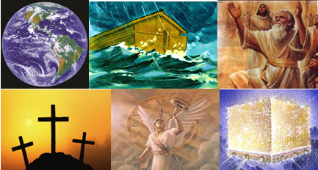

The Bible – Beginning to End

The Tribulation Period

Gene Dahler – October 20, 2020

Tonight, we are transitioning from the church era to the Tribulation period.

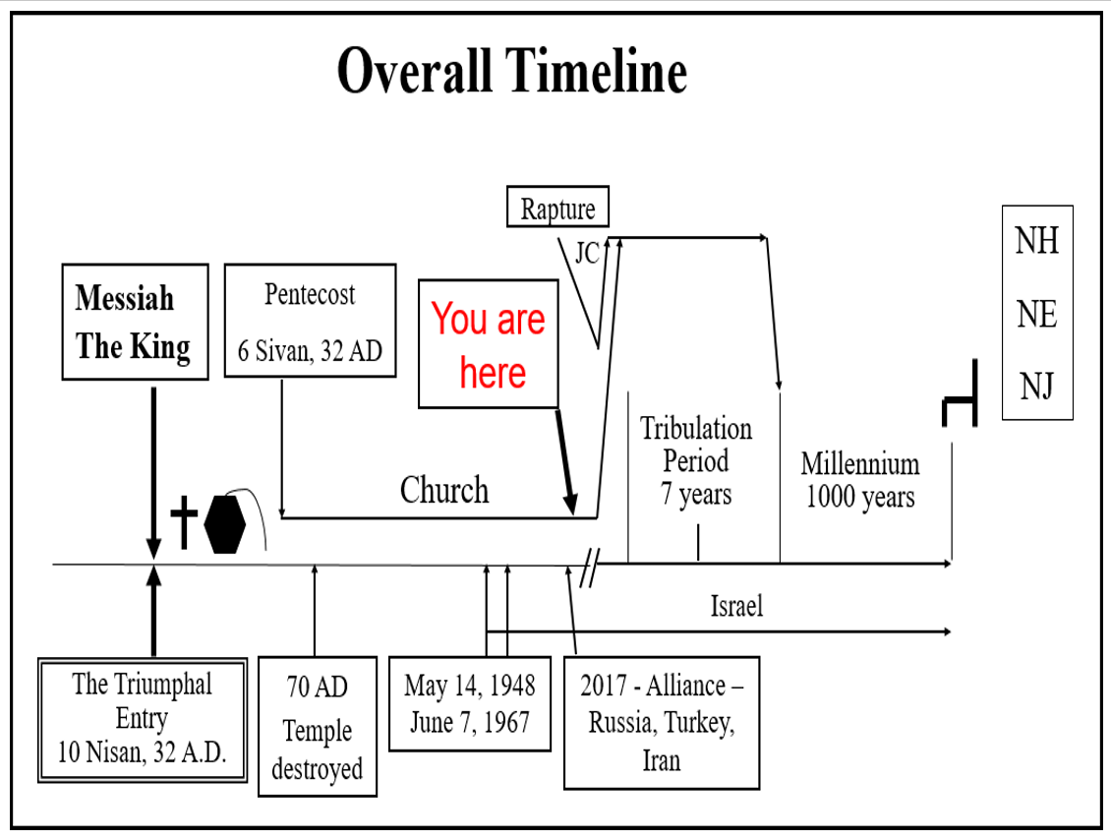The transition is described in 2Thess 2.

2 Thess 2:1-5
1 Now we request you, brethren, with regard to the coming of our Lord Jesus Christ and our gathering together to Him,
2 that you not be quickly shaken from your composure or be disturbed either by a spirit or a message or a letter as if from us, to the effect that the day of the Lord has come.
3 Let no one in any way deceive you, for it will not come unless the apostasy comes first, and the man of lawlessness is revealed, the son of destruction,
4 who opposes and exalts himself above every so-called god or object of worship, so that he takes his seat in the temple of God, displaying himself as being God.
5 Do you not remember that while I was still with you, I was telling you these things? NASU

:2 The Day of the Lord is the tribulation period.
:3 Apostasy means departure. In this case the departure of the church.
:3 The “man of lawlessness” is the Anti-Christ.
________________________________________________________________________________________________________________________

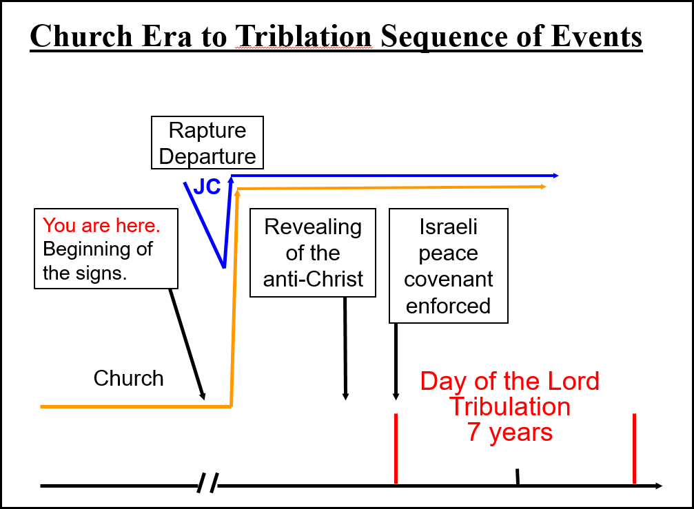
2 Thess 2:6-10
6 And you know what restrains him now, so that in his time he will be revealed.
7 For the mystery of lawlessness is already at work; only he who now restrains will do so until he is taken out of the way.
8 Then that lawless one will be revealed whom the Lord will slay with the breath of His mouth and bring to an end by the appearance of His coming;
9 that is, the one whose coming is in accord with the activity of Satan, with all power and signs and false wonders,
10 and with all the deception of wickedness for those who perish, because they did not receive the love of the truth so as to be saved. NASU

What is restraining him now??
What event starts the Day of the Lord?

Daniel 9:27
27 "And he will make a firm covenant with the many for one week,

Revelation spiritually sees his arrival this way.

Rev 13:1-7
1 And the dragon (Satan) stood on the sand of the seashore. Then I saw a beast coming up out of the sea, having ten horns and seven heads, and on his horns were ten diadems, and on his heads were blasphemous names.
2 And the beast (anti-Christ) which I saw was like a leopard, and his feet were like those of a bear, and his mouth like the mouth of a lion. And the dragon gave him his power and his throne and great authority.
________________________________________________________________________________________________________________________

3 I saw one of his heads as if it had been slain, and his fatal wound was healed. And the whole earth was amazed and followed after the beast;
4 they worshiped the dragon because he gave his authority to the beast; and they worshiped the beast, saying, "Who is like the beast, and who is able to wage war with him?"
5 There was given to him a mouth speaking arrogant words and blasphemies, and authority to act for forty-two months was given to him.
6 And he opened his mouth in blasphemies against God, to blaspheme His name and His tabernacle, that is, those who dwell in heaven.
7 It was also given to him to make war with the saints and to overcome them, and authority over every tribe and people and tongue and nation was given to him. NASU

Now that the day of the Lord has started, what does God do next to insure Israel will make it through it?

Revelation 7:4
4 And I heard the number of those who were sealed, one hundred and forty-four thousand sealed from every tribe of the sons of Israel:

12,000 from each tribe (Rev 7:5-8)

These are sealed for survival in the day of the Lord, the tribulation period.
________________________________________________________________________________________________________________________

Since the overall Jewish population is not believers, He sends two witnesses for them.

Revelation 11:1-13
1 Then there was given me a measuring rod like a staff; and someone said, "Get up and measure the temple of God and the altar, and those who worship in it.
2 "Leave out the court which is outside the temple and do not measure it, for it has been given to the nations; and they will tread under foot the holy city for forty-two months.
3 "And I will grant authority to my two witnesses, and they will prophesy for twelve hundred and sixty days, clothed in sackcloth."

Definition of witness – martus (mar'-toos); a witness; by analogy, a "martyr":

4 These are the two olive trees and the two lampstands that stand before the Lord of the earth.
5 And if anyone wants to harm them, fire flows out of their mouth and devours their enemies; so if anyone wants to harm them, he must be killed in this way.
________________________________________________________________________________________________________________________

6 These have the power to shut up the sky, so that rain will not fall during the days of their prophesying; and they have power over the waters to turn them into blood, and to strike the earth with every plague, as often as they desire.
7 When they have finished their testimony, the beast that comes up out of the abyss will make war with them, and overcome them and kill them.
8 And their dead bodies will lie in the street of the great city which mystically is called Sodom and Egypt, where also their Lord was crucified.

9 Those from the peoples and tribes and tongues and nations will look at their dead bodies for three and a half days, and will not permit their dead bodies to be laid in a tomb.
10 And those who dwell on the earth will rejoice over them and celebrate; and they will send gifts to one another, because these two prophets tormented those who dwell on the earth.

11 But after the three and a half days, the breath of life from God came into them, and they stood on their feet; and great fear fell upon those who were watching them.

12 And they heard a loud voice from heaven saying to them, "Come up here." Then they went up into heaven in the cloud, and their enemies watched them. 13 And in that hour there was a great earthquake, and a tenth of the city fell; seven thousand people were killed in the earthquake, and the rest were terrified and gave glory to the God of heaven. NASU
________________________________________________________________________________________________________________________

At the midpoint of the day of the Lord, the abomination of desolation.

Daniel 9:27
27 "And he will make a firm covenant with the many for one week, but in the middle of the week he will put a stop to sacrifice and grain offering; and on the wing of abominations will come one who makes desolate, even until a complete destruction, one that is decreed, is poured out on the one who makes desolate." NASU

What does he (anti-Christ) do?

The anti-Christ has a partner, the false prophet.

Rev 13:11-14
11 Then I saw another beast coming up out of the earth; and he had two horns like a lamb and he spoke as a dragon.
12 He exercises all the authority of the first beast in his presence. And he makes the earth and those who dwell in it to worship the first beast, whose fatal wound was healed.
13 He performs great signs, so that he even makes fire come down out of heaven to the earth in the presence of men.
14 And he deceives those who dwell on the earth because of the signs which it was given him to perform in the presence of the beast, telling those who dwell on the earth to make an image to the beast who had the wound of the sword and has come to life.

What has Jesus said to do at this time?

Matt 24:15-22
15 "Therefore when you see the ABOMINATION OF DESOLATION which was spoken of through Daniel the prophet, standing in the holy place (let the reader understand),
16 then those who are in Judea must flee to the mountains.
17 "Whoever is on the housetop must not go down to get the things out that are in his house.
18 "Whoever is in the field must not turn back to get his cloak.
19 "But woe to those who are pregnant and to those who are nursing babies in those days!
20 "But pray that your flight will not be in the winter, or on a Sabbath.
21 "For then there will be a great tribulation, such as has not occurred since the beginning of the world until now, nor ever will.
22 "Unless those days had been cut short, no life would have been saved; but for the sake of the elect those days will be cut short. NASU
________________________________________________________________________________________________________________________

The anti-Christ becomes more determined to destroy any that are not following him.

Rev 13:15-17
15 And it was given to him to give breath to the image of the beast, so that the image of the beast would even speak and cause as many as do not worship the image of the beast to be killed.

16 And he causes all, the small and the great, and the rich and the poor, and the free men and the slaves, to be given a mark on their right hand or on their forehead,
17 and he provides that no one will be able to buy or to sell, except the one who has the mark, either the name of the beast or the number of his name.
NASU

The anti-Christ’s incentive program –
- Worship my image or die
- Take the mark of the beast or the number of my name or starve

What is the impact on life on earth because of what the anti-Christ is doing?

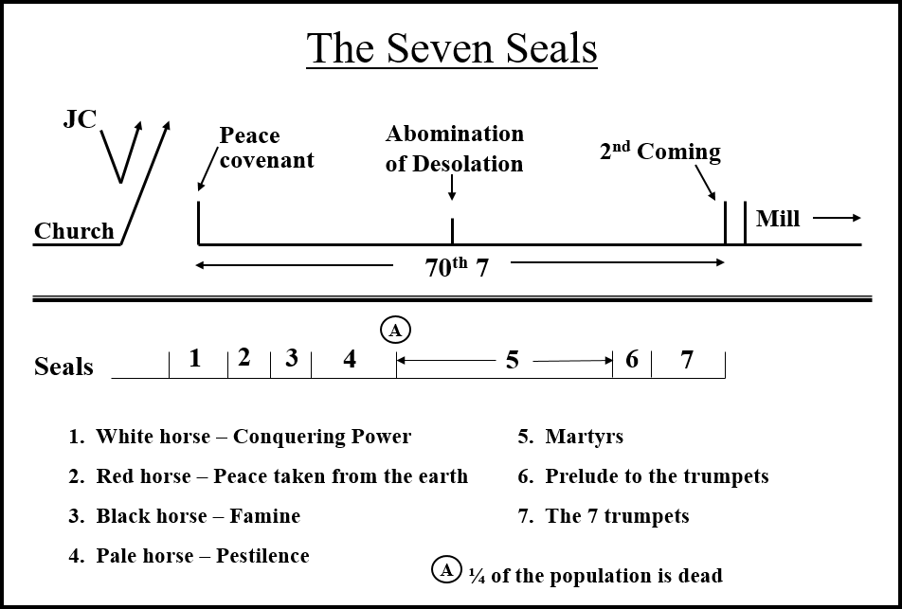Revelation 6:9-11
9 When the Lamb broke the fifth seal, I saw underneath the altar the souls of those who had been slain because of the word of God, and because of the testimony which they had maintained;
10 and they cried out with a loud voice, saying, "How long, O Lord, holy and true, will You refrain from judging and avenging our blood on those who dwell on the earth?"
11 And there was given to each of them a white robe; and they were told that they should rest for a little while longer, until the number of their fellow servants and their brethren who were to be killed even as they had been, would be completed also. NASU
________________________________________________________________________________________________________________________

What else is happening in the second half of the 70th week, the Great Tribulation? There are 7 trumpets.

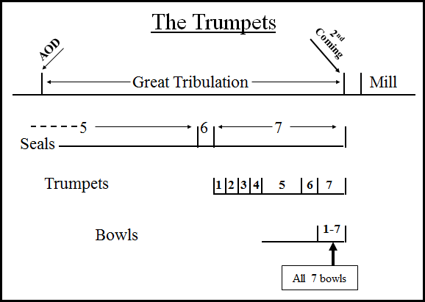

Rev 8 & 9

1st Trumpet affects the earth (1/3 earth, 1/3 trees all green grass burned)
2nd Trumpet affects the sea (1/3 sea creatures die, 1/3 sea turns to blood, 1/3 ships are destroyed)
3rd Trumpet affects the fresh water (1/3 of the rivers and springs of fresh water became poisonous)
4th Trumpet affects the sun, moon and stars (1/3 of the sun, stars and moon will not shine)
5th Trumpet – affects people; locusts from the abyss, people are stung but cannot die for 5 months
6th Trumpet – affects people; demon army, 1/3 of mankind is killed.

The combination of the 4th seal and 6th trumpet bring about the death of ½ of mankind

The 5th trumpet provides a special real life illustration for the earth dwellers (non-believers – Israelis and gentiles).

Rev 9:1-11
9 Then the fifth angel sounded, and I saw a star from heaven which had fallen to the earth; and the key of the bottomless pit was given to him.
2 He opened the bottomless pit, and smoke went up out of the pit, like the smoke of a great furnace; and the sun and the air were darkened by the smoke of the pit.
3 Then out of the smoke came locusts upon the earth, and power was given them, as the scorpions of the earth have power.
4 They were told not to hurt the grass of the earth, nor any green thing, nor any tree, but only the men who do not have the seal of God on their foreheads.
5 And they were not permitted to kill anyone, but to torment for five months; and their torment was like the torment of a scorpion when it stings a man.
6 And in those days men will seek death and will not find it; they will long to die, and death flees from them.
7 The appearance of the locusts was like horses prepared for battle; and on their heads appeared to be crowns like gold, and their faces were like the faces of men.
8 They had hair like the hair of women, and their teeth were like the teeth of lions.
9 They had breastplates like breastplates of iron; and the sound of their wings was like the sound of chariots, of many horses rushing to battle.
10 They have tails like scorpions, and stings; and in their tails is their power to hurt men for five months.
11 They have as king over them, the angel of the abyss; his name in Hebrew is Abaddon, and in the Greek he has the name Apollyon. NASU

What is this an illustration of?
________________________________________________________________________________________________________________________

Revelation 14:6-7
6 And I saw another angel flying in midheaven, having an eternal gospel to preach to those who live on the earth, and to every nation and tribe and tongue and people; 7 and he said with a loud voice, "Fear God, and give Him glory, because the hour of His judgment has come; worship Him who made the heaven and the earth and sea and springs of waters." NASU

First, God gives them an illustration of hell (Rev 9:1-11), then a last chance not to go there (Rev 14:6-7).

The action of this angel is the fulfillment of Mt 24:14

Matthew 24:14
14 "This gospel of the kingdom shall be preached in the whole world as a testimony to all the nations, and then the end will come. NASU
____________________________________________________________________________________________________________________________________

And now, at the end of the Day of the Lord, God’s wrath falls upon the world of earth dwellers that have persecuted the Israelis and the tribulation saints.

Revelation 16:1-12
1 Then I heard a loud voice from the temple, saying to the seven angels, "Go and pour out on the earth the seven bowls of the wrath of God."
2 So the first angel went and poured out his bowl on the earth; and it became a loathsome and malignant sore on the people who had the mark of the beast and who worshiped his image.
3 The second angel poured out his bowl into the sea, and it became blood like that of a dead man; and every living thing in the sea died.

4 Then the third angel poured out his bowl into the rivers and the springs of waters; and they became blood.
5 And I heard the angel of the waters saying, "Righteous are You, who are and who were, O Holy One, because You judged these things;
6 for they poured out the blood of saints and prophets, and You have given them blood to drink. They deserve it."
7 And I heard the altar saying, "Yes, O Lord God, the Almighty, true and righteous are Your judgments."
8 The fourth angel poured out his bowl upon the sun, and it was given to it to scorch men with fire.
9 Men were scorched with fierce heat; and they blasphemed the name of God who has the power over these plagues, and they did not repent so as to give Him glory.
10 Then the fifth angel poured out his bowl on the throne of the beast, and his kingdom became darkened; and they gnawed their tongues because of pain, 11 and they blasphemed the God of heaven because of their pains and their sores; and they did not repent of their deeds.

And they still would not repent!!!

12 The sixth angel poured out his bowl on the great river, the Euphrates; and its water was dried up, so that the way would be prepared for the kings from the east. NASU
________________________________________________________________________________________________________________________

Rev 16:17-21
17 Then the seventh angel poured out his bowl upon the air, and a loud voice came out of the temple from the throne, saying, "It is done."
18 And there were flashes of lightning and sounds and peals of thunder; and there was a great earthquake, such as there had not been since man came to be upon the earth, so great an earthquake was it, and so mighty.
19 The great city was split into three parts, and the cities of the nations fell. Babylon the great was remembered before God, to give her the cup of the wine of His fierce wrath.

Babylon was the origination point of all false religions.

20 And every island fled away, and the mountains were not found.
21 And huge hailstones, about one hundred pounds each, came down from heaven upon men; and men blasphemed God because of the plague of the hail, because its plague was extremely severe. NASU

There is no doubt that they know who is doing this!!!

The surviving earth dwellers that are following the anti-Christ start gathering for their last attack. The anti-Christs last hope and only remaining strategy now is to completely destroy the Jews.

Revelation 16:13-16
13 And I saw coming out of the mouth of the dragon and out of the mouth of the beast and out of the mouth of the false prophet, three unclean spirits like frogs;
14 for they are spirits of demons, performing signs, which go out to the kings of the whole world, to gather them together for the war of the great day of God, the Almighty.

Spirits go out to the kings of the whole world!

16 And they gathered them together to the place which in Hebrew is called Har-Magedon. NASU
________________________________________________________________________________________________________________________

Zechariah 12:2-3
2 "Behold, I am going to make Jerusalem a cup that causes reeling to all the peoples around; and when the siege is against Jerusalem, it will also be against Judah. 3 "It will come about in that day that I will make Jerusalem a heavy stone for all the peoples; all who lift it will be severely injured. And all the nations of the earth will be gathered against it. NASU

Key Points. Remember -

- - The 70th 7 is about Daniel’s people, the Jews, not the church.
- - Although the devastation in physical lives lost due to these events is large, we are near the end of the age and the people that are going to hell have very little time left on earth any way.
- - As we approach the end of the age, not a single nation will be in favor of this little Jewish country called Israel surviving or even the existence of Israelis.
- - Belief in the gospel is the way to salvation all the way to the end of the age.

Summary:

Those that refuse to repent are still on earth with a few surviving tribulation saints, the Church is in heaven, the Jews are in the wilderness and the anti-Christ’s army is gathering at Megiddo to wipe them out. We are coming to the end of the age; how will it end? What will we learn by understanding it?

What is the reason for everything starting all the way back in Gen 3?

I think you will be surprised.

Be here next week.

