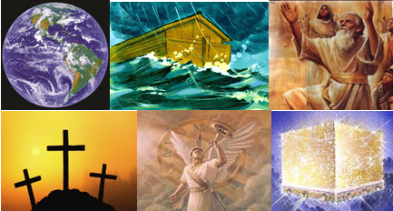

The Bible – Beginning to End

Part 2 - End of the Age - New Beginning

Gene Dahler – November 10, 2020

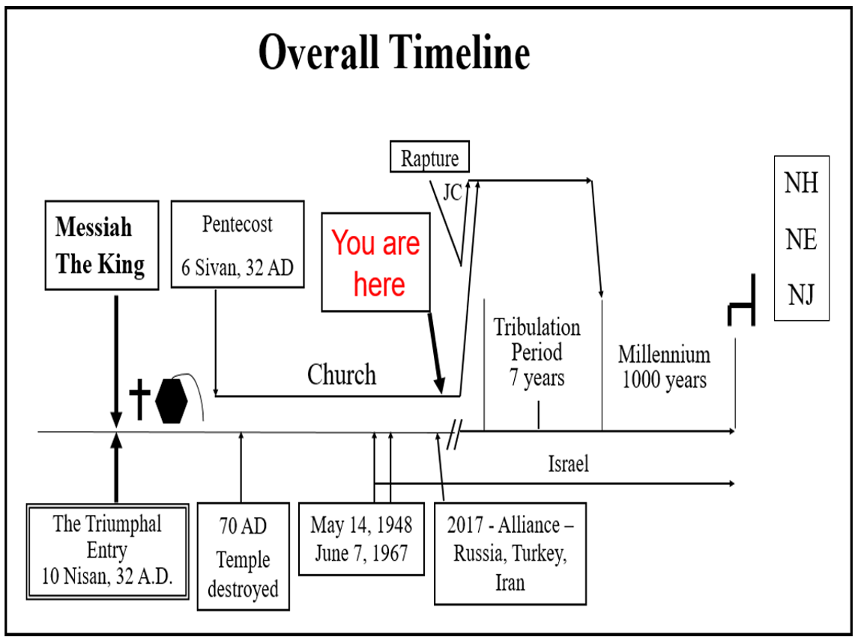
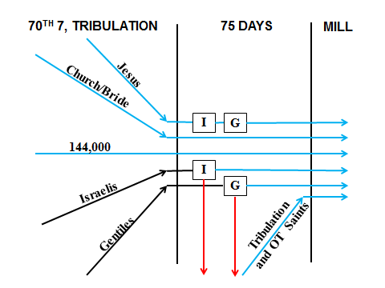

Jesus – Rev 19

Church/Bride – Rev 19

144,000 – Israelis sealed and set aside for the Millennium – Rev 7:4-8, 14:1-5

Israelis – All Israelis that are alive at the end of the tribulation are brought together for the judgment of the talents – Mt 25:14-30
I
Israel – Judgment of the talents – Mt 25:14-30

Gentiles – All gentiles that are alive at the end of the tribulation are brought together for the judgment of the nations – Mt 25:31-46
G
Gentiles – Judgment of the nations (sheep & goats) – Mt 25:31-46

Tribulation and Old Testament Saints – Resurrected to receive the promises of Abraham, Isaac, Jacob and the prophets. - Dan 12:1-3; Jn 6:39-40, 44, 54.

This is the biggest event since the flood. A milestone for all time. The end of an age.

EVERY GOOD ETERNAL THING ON THIS PLANET HAS BEEN MOVING TOWARDS THIS 75 DAY PERIOD SINCE THE FALL OF MAN.

God has a plan and each of us has a part in it. Our joining the predestined body, the church, now is just the beginning. We have an exciting future and great things to look forward to.

Think about this - What is your part in the grand finale we have been studying today and what might be your role in reigning with Him in His kingdom?

