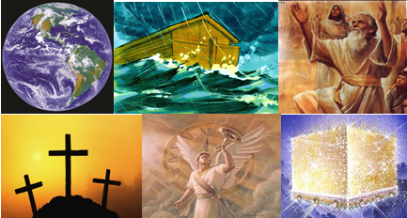

The Bible – Beginning to End

Perspective & Summary

Cliff Phipps & Gene Dahler – December 8, 2020

Perspective

1 Peter 1:3-5
3 Blessed be the God and Father of our Lord Jesus Christ, who according to His great mercy has caused us to be born again to a living hope through the resurrection of Jesus Christ from the dead,
4 to obtain an inheritance which is imperishable and undefiled and will not fade away, reserved in heaven for you,
5 who are protected by the power of God through faith for a salvation ready to be revealed in the last time.
NASU
____________________________________________________________________________________________________________________________________________________________________________________________________________________________________________________________________________________________________________________________________________________________________________________________________________________________________________________________________________________________________________________________________________________________
Summary

Tonight we want to focus on what we have learned and how it has impacted our perspective on life. Specifically, we're going to be focusing on how what we have learned has impacted our thinking on what we call the four W's,

1. - Who God is,
2. - Who We Are,
3. - Where We Are In Time
4. - What's The Plan.

Who God Is -

The traditional definitions include God Is Spirit. changeless. all powerful, all knowing. eternal, holy. righteous. love, truth and wisdom.
(from Nelson's Illustrated Bible Dictionary)

These are all important, wonderful and true things, however I’m not sure those are the items that really matter the most to those of us today who believe God's Word and are desiring to be part of His plans.

Because of where we are in time and desiring to be part of His plan, these additional God characteristics are probably high on our list of importance:

- Trustworthy. From Genesis to Revelation, He never failed to keep His word.

- Faithful. He wants His children to succeed and even puts special conditions into His plans to insure it.

- Cares about individuals. That is all the way through to the end. He even gave us prophets, apostles and His Son so we as individuals could know the truth and be blessed.

- Since no man could keep the law and live a sinless life, He sent His Son to become a man so that salvation could occur by grace and the book of seven seals could be opened initiating the end of Satan’s reign on earth. He and His Son are totally committed to His plans.

- He wants us to make it through to the end. He provided seven personal epistles to help us overcome the obstacles of Satan and this world. He obviously cares about us.

- He is called Love and it is obvious through all of the past that He loves us and wants to have a relationship with us.

- He has even reserved the very best destination, the New Jerusalem, for us alone, the believers during the church era.

- In addition, He gave us His Word so we could know Him and His Son and know who we are, where we are in time and what the plan is.

Who You Are -

How are we fundamentally like Him?

Gen 1:26-27
26 Then God said, "Let Us make man in Our image, according to Our likeness; and let them rule over the fish of the sea and over the birds of the sky and over the cattle and over all the earth, and over every creeping thing that creeps on the earth."
27 God created man in His own image, in the image of God He created him; male and female He created them. NASU

How is every human being like God?
- __________________________
- __________________________

What do you become when you become a member of God’s family?

- Answer - We become a new creation

2Cor 5:17
17 Therefore if anyone is in Christ, he is a new creature; the old things passed away; behold, new things have come.
21 He made Him who knew no sin to be sin on our behalf, so that we might become the righteousness of God in Him.
20 - - - - we are ambassadors for Christ, as though God were making an appeal through us; we beg you on behalf of Christ, be reconciled to God. NASU

We have become righteous, ambassadors for Christ.

Remember the one-word message to be used by the bride from Rev 22 – “Come”.

- We receive the Holy Spirit that guides us into the truth and tells us what is to come.

John 16:13
13 "But when He, the Spirit of truth, comes, He will guide you into all the truth; for He will not speak on His own initiative, but whatever He hears, He will speak; and He will disclose to you what is to come. NASU

Where does the Spirit of Truth abide when He comes?

John 14:16-17
16 "I will ask the Father, and He will give you another Helper, that He may be with you forever;
17 that is the Spirit of truth, whom the world cannot receive, because it does not see Him or know Him, but you know Him because He abides with you and will be in you. NASU

Some say these verses apply only to the Apostles, not believers today. However, Jesus in the real Lord’s prayer said this:

John 17:13-17, 20-21
"But now I come to You; and these things I speak in the world so that they may have My joy made full in themselves.
14 "I have given them Your word; and the world has hated them, because they are not of the world, even as I am not of the world.
15 "I do not ask You to take them out of the world, but to keep them from the evil one.
16 "They are not of the world, even as I am not of the world.
17 "Sanctify them in the truth; Your word is truth.

20 "I do not ask on behalf of these alone, but for those also who believe in Me through their word;
21 that they may all be one; even as You, Father, are in Me and I in You, that they also may be in Us, so that the world may believe that You sent Me. NASU

:20 Who is that?

We have the Spirit of Truth. A guide into the truth.

Don’t let anyone tell you this book is hard to understand. It is not.
Also, don’t let anyone tell you it is alright to have multiple views.

Truth is a major theme in the New Covenant. The word is used 131 times in the New Covenant.

There is one more way we are like God.

- As a John 16:13 saved person you are even more like God as you have ________________.

Just how different are you as a righteous ambassador with the indwelling Spirit of Truth, knowledge of the truth and foreknowledge?

1 Peter 1:1-2
1 Peter, an apostle of Jesus Christ, To those who reside as aliens, scattered throughout Pontus, Galatia, Cappadocia, Asia, and Bithynia, who are chosen
2 according to the foreknowledge of God the Father, by the sanctifying work of the Spirit, to obey Jesus Christ and be sprinkled with His blood: May grace and peace be yours in the fullest measure. NASU

Alien - parepidemos (par-ep-id'-ay-mos); an alien alongside, a resident foreigner:

Where we are in time and what is the plan? -

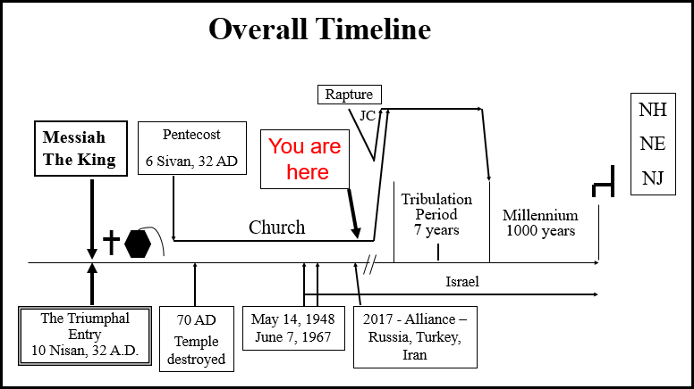

We will receive or we will be present at -

- A glorified body
- The Rapture of the believers
- In heaven when Jesus Takes the scroll from the Father, and participate in the biggest celebration of all time
- Then the wedding of the believers to Jesus
- The second coming
- We received no judgement getting into the millennium,
- Then we reign on Earth with our Lord and Savior Jesus Christ for a thousand years
- Then we bypass the Great White Throne judgement
- Our final destination, the New Jerusalem, the most incredible place created by God for Himself, His Son and those from the church era to dwell.

So, what are you to do?

First, stay in the word in particular the New Covenant. We will have for you a list of reading in the New Testament that covers the New Covenant. We recommend that for your vacation reading. It is not lengthy.

Second, share what you have learned with the people you know that claim to be Christians to make disciples.

Matt 28:19-20
19 "Go therefore and make disciples of all the nations, baptizing them in the name of the Father and the Son and the Holy Spirit,
20 teaching them to observe all that I commanded you; and lo, I am with you always, even to the end of the age." NASU

When it comes to making disciples, you do not have to go to Africa to find a mission field. You are most likely surrounded by it every Sunday morning.

Third, exercise discernment anytime you hear a message that claims to be Christian whether it's on radio, TV or perhaps sermons that you may hear at your church. There is much teaching today from Bible distortions and there's also a significant emphasis now on doing philosophical messages. These philosophical messages may be quite beneficial for people in a worldly sense, however, do not forget that they have no eternal value.

Colossians 2:8
8 See to it that no one takes you captive through philosophy and empty deception, according to the tradition of men, according to the elementary principles of the world, rather than according to Christ. NASU

2 Peter 3:15-18
15 - - -our beloved brother Paul, according to the wisdom given him, wrote to you,
16 as also in all his letters, speaking in them of these things, in which are some things hard to understand, which the untaught and unstable distort, as they do also the rest of the Scriptures, to their own destruction.
17 You therefore, beloved, knowing this beforehand, be on your guard so that you are not carried away by the error of unprincipled men and fall from your own steadfastness,
18 but grow in the grace and knowledge of our Lord and Savior Jesus Christ. To Him be the glory, both now and to the day of eternity. Amen. NASU

What specifically do we do for these people that have heard or believed false teaching?

2Cor 10:3-5
3 For though we walk in the flesh, we do not war according to the flesh,
4 for the weapons of our warfare are not of the flesh, but divinely powerful for the destruction of fortresses.
5 We are destroying speculations and every lofty thing raised up against the knowledge of God, and we are taking every thought captive to the obedience of Christ, NASU

Remember, very few professing Christians have accurate Biblical understanding. These people are now in your mission field.

So, what is important?

Believe and have the right perspective.
Believe what? Ans – The truth
Why? Because nothing enhances the life of a saved person more than having a complete perspective based on the truth, a perspective of the past, present and especially the future. Remember, we have been given a Spirit of Truth.

When it comes to conduct, keep it simple. Remember the ten commandments of Jesus Christ. We also have a copy of those for you at the end of the Bible study.

Pray every day this fundamental prayer that you would live the day in full recognition of:

- Who God is
- Who You Are
- Where You Are In Time
- What's The Plan

It has been awesome to have you folks in this Bible study. You have been one of the best groups we have ever had. Thank you for your attendance and participation, especially through all the distractions we have had this year.

