PPE For The Church – Introduction
Philippians 1:1-10
January 12, 2021

Presented by Gene Dahler
Verse-by-Verse Bible Studies

We will be studying, Philippians, then Peter 1 & 2 and Ephesians.

General perspective –

For all these books, we need to know:

- Who is writing – Apostle Paul - Philippians
- Who is being written to – Church _____________________
- What is the subject - Truth
- When does it apply – The church era

Example:

2 Thess 2:1-5
1 Now we request you, brethren, with regard to the coming of our Lord Jesus Christ and our gathering together to Him,
2 that you not be quickly shaken from your composure or be disturbed either by a spirit or a message or a letter as if from us, to the effect that the day of the Lord has come.
3 Let no one in any way deceive you, for it will not come unless the apostasy comes first, and the man of lawlessness is revealed, the son of destruction,
4 who opposes and exalts himself above every so-called god or object of worship, so that he takes his seat in the temple of God, displaying himself as being God.
5 Do you not remember that while I was still with you, I was telling you these things? NASU
__________________________________________________________________________________________________________________________________________________________________
Worldly examples of the value of knowing the future: ______________________________________________________________________________________________________________________________________________________________________________________________________________________________________________________________________________________________________________________________________________________________________________________________________________________________________________________________________________________________________

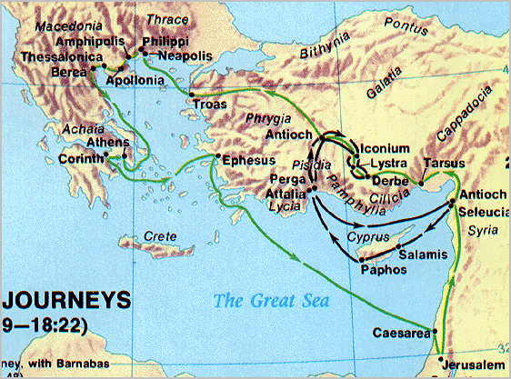

Phil 1:1-11
1 Paul and Timothy, bond-servants of Christ Jesus, To all the saints in Christ Jesus who are in Philippi, including the overseers and deacons:
________________________________________________________________________________________________________________________________________________________________________________________________________________________________________________

2 Grace to you and peace from God our Father and the Lord Jesus Christ.
__________________________________________________________________________________________________________________________________________________________________
3 I thank my God in all my remembrance of you,
4 always offering prayer with joy in my every prayer for you all,
5 in view of your participation in the gospel from the first day until now. (3 Jn 2-4)
____________________________________________________________________________________________________________________________________________________________________________________

6 For I am confident of this very thing, that He who began a good work in you will perfect it until the day of Christ Jesus.
________________________________________________________________________________________________________________________

7 For it is only right for me to feel this way about you all, because I have you in my heart, since both in my imprisonment and in the defense and confirmation of the gospel, you all are partakers of grace with me. (2 Cor 10:3-5; Jude 20-23)
________________________________________________________________________________________________________________________________________________________________________________________________________________________________________________

2 Corinthians 10:3-5
3 For though we walk in the flesh, we do not war according to the flesh, 4 for the weapons of our warfare are not of the flesh, but divinely powerful for the destruction of fortresses. 5 We are destroying speculations and every lofty thing raised up against the knowledge of God, NASU

The ______________ is for the _______________.

________________________________________________________________________________________________________________________

8 For God is my witness, how I long for you all with the affection of Christ Jesus.
9 And this I pray, that your love may abound still more and more in real knowledge and all discernment, (Acts 20:29-31; Col 2:6-8; 2Pet 2:1)
________________________________________________________________________________________________________________________________________________________________________________________________________________________________________________

10 so that you may approve the things that are excellent, in order to be sincere and blameless until the day of Christ; (Heb 6:19)
________________________________________________________________________________________________________________________

11 having been filled with the fruit of righteousness which comes through Jesus Christ, to the glory and praise of God. NASU
____________________________________________________________

Therefore, now move forward by:

- The obtaining of knowledge (truth) and the exercising of discernment
- Which results in the ability to approve (test) everything to confirm the truth
- Which results in a conviction that will make you sincere and blameless until the day of Christ.

What is he mission of a scripturally mature Christian?
- ______________________
- ______________________
Leading to –
- _____________
- _____________
- _____________
In the _____________
- Then, ______________ it with fellow believers

filename: 210112 – PPE Intro HO rev e.doc

