

END TIMES PROPHECIES

INTRODUCTION – 9/14/2021

Presented by Gene Dahler

**OVERVIEW OF PROPHECY**

GOD IS IN CONTROL

What does that mean? A lot of things going on that we all know God can’t be endorsing.

________________________________________________________________________________________________________________________________________________________________________________________________________________________________________________

What is Biblical prophecy?

God’s factual description of the future.

Prophecy Study Purpose Statement:

To acquire a Biblical prophetic perspective in order to receive the belief, hope and faith that comes from knowing the unique miraculous truth of the Bible and knowing it truly is the Word of God. To believe without any doubts that He really is in control; that you have joined the team that wins and reigns; to understand who you are and the awesome journey you have just begun.

Finally, to fully understand where we are in time and what our purpose is here on earth until our departure.

How important is it to have true knowledge? What are the benefits?

Is it worth the effort?

Theme verses:

**2 Peter 1:2-4**

**2 Grace and peace be multiplied to you in the knowledge of God and of Jesus our Lord;**

**3 seeing that His divine power has granted to us everything pertaining to life and godliness, through the true knowledge of Him who called us by His own glory and excellence.**

**4 For by these He has granted to us His precious and magnificent promises, so that by them you may become partakers of the divine nature, having escaped the corruption that is in the world by lust. NASU**

____________________________________________________________________________________________________________________________________________________________________________________________________________________________________________________________________________________________________________

The New testament epistle writers were focused on bringing these incredible blessing to those that were in the first century church. We are going to give it our best effort to do the same for all of you in this Bible study. To receive these blessing is a goal that we all should have had from the time we got saved, but like me, I suspect that many of us didn’t understand these blessing even existed for us!

There is a battle going on here on earth. It is for the minds of people. Satan is always involved in trying to deceive us by distracting our thoughts and manipulating what we think is true.

Barna Research conducted a poll of main line Protestants a few years ago. Here are some of the questions and the responses.

Question - Do You strongly agree that the Bible is totally accurate in all that it teaches? _____%

Question – Do you strongly believe that Satan is real? ______%

Question – Do you strongly agree that good works will not earn a place in heaven? ______%

Remember, the first casualty of war is always the same – The Truth.

**STARTING THE GREAT ADVENTURE**

We are gathered here to initiate an exploration of God’s Word, a search for the truth, an adventure of a life time.

We are going to discover what we are here for, what is the purpose of God in what is going on in the world and what part should we play. If there is more to life than our short stay here on earth, what is it? What is the plan and where are we at in that plan? This information sets apart a knowledgeable born-again spirit filled pre-tribulation rapture Christian from the rest of the world!!!

________________________________________________________________________________________________________________________

**What is the Bible about?**

* + ____________ – Creation to destruction (Gen 2 – Rev 21)
  + __________ – From Adam & Eve to the last person born on earth
  + Groups of people -
    - _____–Gen 35 – Rev 20 (mentioned in the Bible 3407 times)
    - ________ – John 13 – Rev 22
  + ______ – What nations will survive and which one wins in the end
  + ________ – He is in there from beginning to the end.
  + ________ – His involvement on earth, beginning to end

Scripture defines God’s involvement in all of this from creation to at least 1007 years into the future.

The majority of the corporate church today is disregarding prophecy like the Jews 2,000 years ago.

From studying Thessalonians, we know that the 1st century church was focused on understanding the prophetic truth. This church with only 3 weeks of training knew their future.

* 1Thess & 2Thess
  + - Rapture (1Thess 4:13-18; 2Thess 2:1,3)
  + - Anti-Christ (2Thess 2:3-12)
  + - Tribulation (1Thess 5:1-11; 2Thess 2:2)
  + - Holy Spirit – Restrainer of the appearing of the anti-Christ (2Thess 2:6-7)
* In the first century the church members knew of their future
* Most professing Christians today don’t know

How can that be? It was ___________________!!!!!

Mt 24:37-39 – Today the leaders and the people in general will not know what is coming.

**Matt 24:37-39**

**37 "For the coming of the Son of Man will be just like the days of Noah.**

**38 "For as in those days before the flood they were eating and drinking, marrying and giving in marriage, until the day that Noah entered the ark,**

**39 and they did not understand until the flood came and took them all away; so will the coming of the Son of Man be. NASU**

________________________________________________________________________________________________________________________________________________________________________________________________________________________________________________

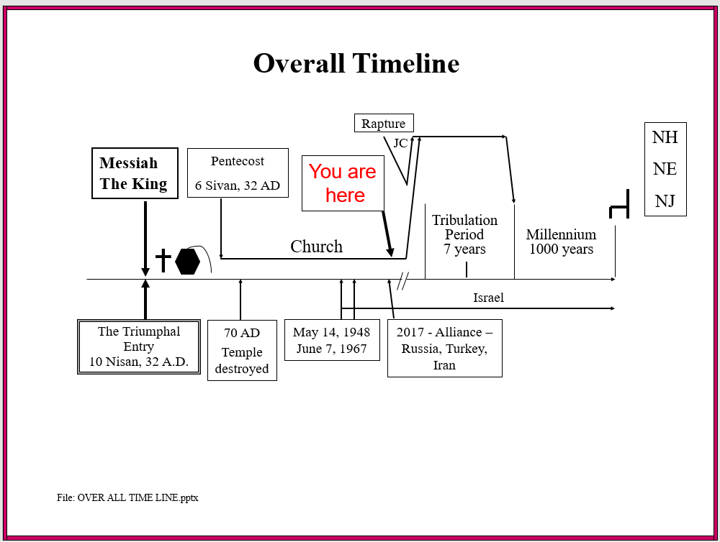

____________________________________________________________________________________________________________________________________________________________________________________

What else did Jesus say about today?

**Luke 21:28**

**28 "But when these things begin to take place, straighten up and lift up your heads, because your redemption is drawing near." NASU**

KEY POINT – Previous wisdom principles do not exclusively apply now. No one has ever been here before.

KEY POINT – There is no going back. This is a one-way time line.

KEY POINT – Knowing your past, present and FUTURE is the only way you can fully understand who you are as a child of God. Adding knowledge of your future to your understanding of who you are is the way to develop a Biblical perspective for the remainder of your life here on earth. Knowledge of the future is how we grow in faith and our relationship with our heavenly Father and His Son.

Just like the facts of the things that happened in the past, you can know the facts of many of the things that will happen in the future.

Question? – Would you rather know the truth about the past or the future????

Is there any personal significance in this kind of perspective? What is the significance if there is some? The following verses are an example for today.

**2 Peter 1:16-21**

**16 For we did not follow cleverly devised tales when we made known to you the power and coming of our Lord Jesus Christ, but we were eyewitnesses of His majesty.**

**17 For when He received honor and glory from God the Father, such an utterance as this was made to Him by the Majestic Glory, "This is My beloved Son with whom I am well-pleased" — 18 and we ourselves heard this utterance made from heaven when we were with Him on the holy mountain.**

____________________________________________________________________________________________________________________________________________________________________________________

**19 So we have the prophetic word made more sure, to which you do well to pay attention as to a lamp shining in a dark place, until the day dawns and the morning star arises in your hearts.**

**20 But know this first of all, that no prophecy of Scripture is a matter of one's own interpretation, 21 for no prophecy was ever made by an act of human will, but men moved by the Holy Spirit spoke from God. NASU**

__________________________________________________________________________________________________________________________________________________________________________________________________________________

Knowledge of the future is what faith is built on. What we are talking about is faith.

What is the definition of faith?

Merriam Webster definition:

Firm belief in something for which there is no proof

Biblical definition:

**Hebrews 11:1**

**1 Now faith is the assurance of things hoped (confident expectation) for, the conviction of things not seen. NASU**

________________________________________________________________________________________________________________________

Remember the question the 4 apostles, Peter, James, John and Andrew asked Jesus –

**Matthew 24:3**

**3 As He was sitting on the Mount of Olives, the disciples came to Him privately, saying, "Tell us, when will these things happen, and what will be the sign of Your coming, and of the end of the age?" NASU**

What was His response – Mt 24 & 25, Mark 13, Luke 21:6-36

Why such a lengthy detailed response? Because He wants us to know His plans in order for us to have a relationship with Him and He wants us to be on His side, the side that leads to victory and brings grace, peace and partaking in the divine nature.

It really isn’t religion, it truly is a relationship based on the true knowledge of Him and the incredible things He wants to do together with us!!! It is about love.

KEY POINT – God never controls individual people.

____________________________________________________________________________________________________________________________________________________________________________________

KEY POINT – What do we need to know to have the faith-based inheritance foundation.

* Who Jesus Is –

Past – Savior

Present – Savior & Intercessor

Future – King

* Who you are –

Past – you already know

Present – you already know

Future – you will know. It will give you a new perspective on life.

* Where you are in time –
* What the plan is –

____________________________________________________________________________________________________________________________________________________________________________________

KEY POINT - Anyone that knows and believes Jesus and God’s plans will not be deceived into departing the love and inheritance They have for us. You will not be deceivable when you know your future.

____________________________________________________________________________________________________________________________________________________________________________________

Prophetic Perspective News Sources

Rapture Ready News - <http://www.raptureready.com/rapnews_db.php>

Koenig World Watch Daily - <http://www.watch.org/>

His Channel – World News Briefing - <http://www.hischannel.com/>

Israeli Middle East Conflict News - <https://www.debka.com/>

Olive Tree Views – Jan Markell – News Headlines and Radio Complete Archives - <https://olivetreeviews.org/>