END TIMES PROPHECIES
Propecies of the Rapture of the Church 11/2/2021
Presented by Clifford Phipps
____________________________________________________________________________________________________________________________________________________________________________________

(Matt 21:43)

Matt 21:18-21
18 Now in the morning, when He was returning to the city, He became hungry.
19 Seeing a lone fig tree by the road, He came to it and found nothing on it except leaves only; and He said to it, "No longer shall there ever be any fruit from you." And at once the fig tree withered.
20 Seeing this, the disciples were amazed and asked, "How did the fig tree wither all at once?"
21 And Jesus answered and said to them, "Truly I say to you, if you have faith and do not doubt, you will not only do what was done to the fig tree, but even if you say to this mountain, 'Be taken up and cast into the sea,' it will happen. NASU
____________________________________________________________________________________________________________________________________________________________________________________

(Luke 22:20)
________________________________________________________________________________________________________________________
Jesus gave the church 10 commands before He departed the earth. Those commands are all found in His teachings to the disciples and recorded in the gospels in the chapters following the Triumphal Entry.

1. Love the Lord your God with all your heart, and with all your soul, and with all your mind

2. Love your neighbor as yourself

3. Serve one another (feet washing)

4. Communion (Do this in remembrance of Me)

5. Take heed that no one deceives you

6. Go and make disciples

7. Abide in Me (2)

8. Do not let your heart be troubled (2)

9. Love one another (4)

10. Watch for my return (10)
____________________________________________________________________________________________________________________________________________________________________________________

(Acts 1:6-8)
____________________________________________________________________________________________________________________________________________________________________________________________________________________________________________________________________________________________________________

Matt 6:9-14
9 "Pray, then, in this way:
'Our Father who is in heaven,
Hallowed be Your name.
10 'Your kingdom come.
Your will be done,
On earth as it is in heaven.
____________________________________________________________________________________________________________________________________________________________________________________

What we instructed to pray for?

Our prayer comes from the 2nd to the last verse in the Book of Revelation.

(Rev 22:20)

Matt 6:11-15
11 'Give us this day our daily bread.
12 'And forgive us our debts, as we also have forgiven our debtors.
13 'And do not lead us into temptation, but deliver us from evil. [For Yours is the kingdom and the power and the glory forever. Amen.']
14 "For if you forgive others for their transgressions, your heavenly Father will also forgive you.
15 "But if you do not forgive others, then your Father will not forgive your transgressions. NASU
________________________________________________________________________________________________________________________________________________________________________________________________________________________________________________

What is the Rapture of the Church?

The rapture is an event described in the bible when Jesus personally appears in the clouds to gather His church together to give them their glorified bodies and to take them to heaven to be with Him.

When will the Rapture occur?

The timing of the Rapture is unknown.

What causes the Rapture to occur?

According to Rom. 11:25, the Rapture of the Church can occur when the last Gentile is added to the Church.

Who is the Rapture for?

The Rapture is promised only to the true believers in the Church Era. Only those people that have believed the gospel from the time of Pentecost until the moment of the Rapture will take part in the Rapture of the Church.

Will some “Christians” miss the rapture? Yes, due to unbelief.

Matt 25:1-13
1 "Then the kingdom of heaven will be comparable to ten virgins, who took their lamps and went out to meet the bridegroom.
2 "Five of them were foolish, and five were prudent.
3 "For when the foolish took their lamps, they took no oil with them,
4 but the prudent took oil in flasks along with their lamps.
5 "Now while the bridegroom was delaying, they all got drowsy and began to sleep.
6 "But at midnight there was a shout, 'Behold, the bridegroom! Come out to meet him.' 7 "Then all those virgins rose and trimmed their lamps.
8 "The foolish said to the prudent, 'Give us some of your oil, for our lamps are going out.'
9 "But the prudent answered, 'No, there will not be enough for us and you too; go instead to the dealers and buy some for yourselves.'
10 "And while they were going away to make the purchase, the bridegroom came, and those who were ready went in with him to the wedding feast; and the door was shut. 11 "Later the other virgins also came, saying, 'Lord, lord, open up for us.'
12 "But he answered, 'Truly I say to you, I do not know you.'
13 "Be on the alert then, for you do not know the day nor the hour. NASU

(Eph 1:13)

What is the purpose of the Rapture of the Church?

- For God to protect His bride from the wrath that is to come.

(1 Thess 5:9-10, 1 Thess 1:6, Rev 3:10)

- To provide the church with Glorified Bodies

(Phil 3:20-21, 1 Cor 15:51-53)

- But the word “Rapture” does not occur in the bible.

(1 Thess 4:17)

The Rapture and the 2nd Coming are two completely separate events separated by at least 7 years.
________________________________________________________________________________________________________________________________________________________________________________________________________________________________________________

Timing of the Rapture

• The coming of Jesus for His Church is imminent. Scripture does not place any major events between the rapture and today in the bible.

• How could the Rapture of the Church occur during the middle or the end of the Tribulation Period if the Tribulation Period or the 70th 7 of Daniel is a Jewish Era? The Rapture is specifically a Church Age event.

• Daniel was told that the 70 7’s were determined for his people (the Jews) and his Holy City (Jerusalem). The 70th 7 is that 7-year period of time we call the tribulation period. If this period of time is specified for Israel, the church is not going to be part of it.

• How could the church be present during the Tribulation Period if Jesus promised to keep us from it? Hard to imagine that the church would be present during the tribulation period in order to participate in a mid or post tribulational rapture
• Paul described a Pre-Tribulational Rapture.

2 Thess 2:1-4
1 Now we request you, brethren, with regard to the coming of our Lord Jesus Christ and our gathering together to Him,
2 that you not be quickly shaken from your composure or be disturbed either by a spirit or a message or a letter as if from us, to the effect that the day of the Lord has come.
3 Let no one in any way deceive you, for it will not come unless the apostasy (departure) comes first, and the man of lawlessness is revealed, the son of destruction,
4 who opposes and exalts himself above every so-called god or object of worship, so that he takes his seat in the temple of God, displaying himself as being God.

• John describes a Pre-Tribulational Rapture

(Rev 4:1-2)

3 Rapture passages.

John 14:1-3
14 "Do not let your heart be troubled; believe in God, believe also in Me. 2 "In My Father's house are many dwelling places; if it were not so, I would have told you; for I go to prepare a place for you. 3 "If I go and prepare a place for you, I will come again and receive you to Myself, that where I am, there you may be also.

1 Thess 4:13-18
13 But we do not want you to be uninformed, brethren, about those who are asleep, so that you will not grieve as do the rest who have no hope.
14 For if we believe that Jesus died and rose again, even so God will bring with Him those who have fallen asleep in Jesus.
15 For this we say to you by the word of the Lord, that we who are alive and remain until the coming of the Lord, will not precede those who have fallen asleep.
16 For the Lord Himself will descend from heaven with a shout, with the voice of the archangel and with the trumpet of God, and the dead in Christ will rise first.
17 Then we who are alive and remain will be caught up together with them in the clouds to meet the Lord in the air, and so we shall always be with the Lord.
18 Therefore comfort one another with these words. NASU

(2 Tim 2:15-16, 1 Peter 1:13-14, John 14:18-19)

1 Cor 15:51-52
51 Behold, I tell you a mystery; we will not all sleep, but we will all be changed,
52 in a moment, in the twinkling of an eye, at the last trumpet; for the trumpet will sound, and the dead will be raised imperishable, and we will be changed. NASU

So, what do we do until the rapture?

• Realize that we don’t belong here.

(Phil 3:20)

• Be on alert. (Lk. 21:25-36; Mt. 24:36-44) Don’t know the day or the hour, watch for the signs.

• Tell as many people that you can about Jesus. Especially those that think they are saved in the church. Make sure they understand the Gospel and make sure that their faith is a genuine faith, based on God’s word.

(1 Peter 3:15)

• Continue to increase your faith.

Why?

(1 Peter 1:7-8)
____________________________________________________________________________________________________________________________________________________________________________________________________________________________________________________________________________________________________________________________________________________________________________________________________________________________________________________________________________________________________________________________________________________________________________________________________________________________________________________________________________________

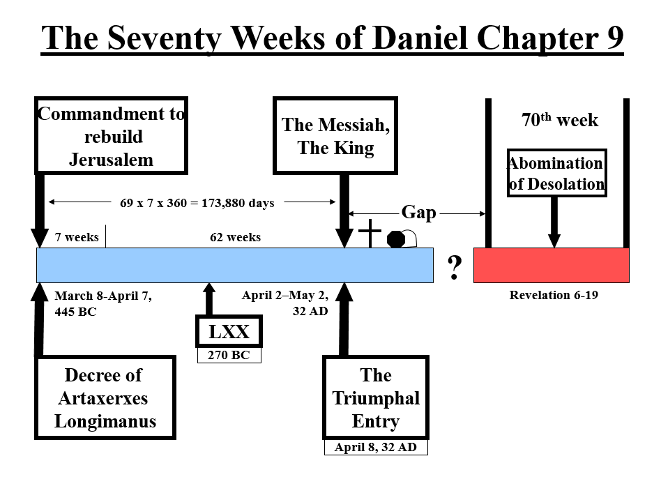

The Rapture & The Second Coming

Truth Perspective –11/4/18
Gene Dahler – Verse-by-Verse Bible Study

2nd Coming
Rapture

70th Seven
Millennium
Church

7 Years 1000 Years

PERSPECTIVE

Rapture Second Coming

1. Translation of all believers Translation of non-believers

2. Translated saints go to heaven Raptured saints return to earth

3. Earth not judged Earth judged; righteousness established

4. Imminent, any moment, signless Follows definite predicted signs, including the tribulation

5. No reference to Satan Satan is bound

6. Christ comes for His own Christ comes with His own

7. Descends with a shout (command) Comes with an army on white horses

8. He appears in the air He comes to the Earth (Mt. of Olives)

9. Appears as a bride groom Comes as a king

10. He claims His bride He comes with His bride

11. Hope of the Church Hope of Israel

12. Comes secretly, only His own see Comes openly, every eye shall see him

13. Rewards the saints Judges the nations

14. Many (hopefully) resurrected Many die

15. Pseudo-christ is revealed Pseudo-christ defeated

16. Tribulation follows Tribulation ends, millennium follows

17. Day of rejoicing Day of wrath

18. Encourage believers Warn unbelievers
PASSAGES -

Rapture Second Coming

Mt 24:37-41 Dan 2:44-45
Mt 24:42-44 Dan 7:9-14
Mt 25:1-10, 13 Zech 14:1-15
Mk 13:33-36 Mt 13:27-30, 41, 48-50
Lk 21:28 Mt 24:30-31
Lk 21:34-36 Mt 25:30, 31-46
Jn 14:1-3 Mk 13:14-27
Rom 8:17-19, 23, 29 Lk 21:27-28
1 Cor 1:7-8 Acts 1:9-11
1 Cor 15:1-58 Acts 3:19-21
1 Cor 16:22 2 Ths 2:8
Phil 3:20-21 2 Pet 3:1-14
Col 3:4 Jude 14-15
1 Ths 1:10 Rev 1:7
1 Ths 2:19 Rev 19:11-20:6
1 Ths 3:13
1 Ths 4:13-18 Total of 18
1 Ths 5:9
2 Ths 1:6-10
2 Ths 2:1
1 Tim 6:14
2 Tim 4:1
Titus 2:13
Heb 9:28
Jas 5:7-9
1 Pet 1:5, 7, 9, 13
1 Pet 2:12
1 Jn 2:28-3:2
Jude 21
Rev 2:25
Rev 3:10

Total of 37

Why learn about the Rapture? Because it is the greatest day of the Earthbound Church.

This topic is demanding only because it requires the integration of many portions of Scripture. Remember 1Th 5:21 - "Test everything." and 1Cor 4:6 "Do not go beyond what is written."

181104 file: Rap18 HO.DOC

