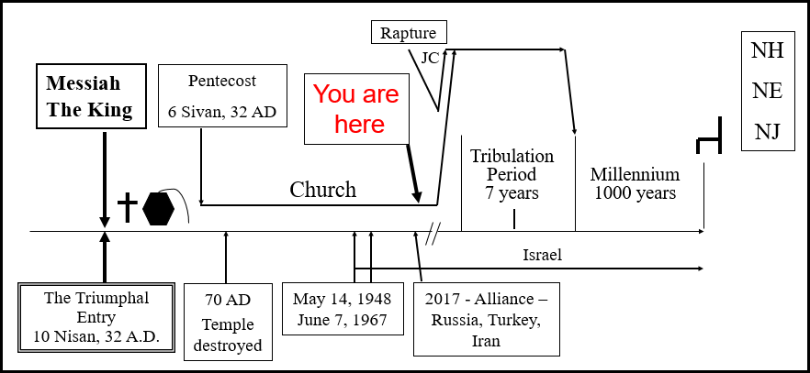
The Significance of Prophecy
1/11/2022
Presented by Gene Dahler
________________________________________________________________________________________________________________________________________________________________________________________________________________________________________________________________________________________________________________________________________________________________________________________________________________________________________________________________________________________________

OVERVIEW OF PROPHECY

What is Biblical prophecy?
God’s factual description of the future.

GOD IS IN CONTROL
What does that mean?
________________________________________________________________________________________________________________________
Prophecy Study Purpose Statement:

To acquire a Biblical prophetic perspective in order to receive the belief, hope and faith that comes from knowing the unique miraculous truth of the Bible and knowing it truly is the Word of God. To believe without any doubts that He really is in control; that you have joined the team that wins and reigns; to understand who you are and the awesome journey you have just begun.
Finally, to fully understand where we are in time and what our purpose is here on earth until our departure.

How important is it to have true knowledge? What are the benefits?
Is it worth the effort?

Theme verses:
2 Peter 1:2-4

2 Grace and peace be multiplied to you in the knowledge of God and of Jesus our Lord;
3 seeing that His divine power has granted to us everything pertaining to life and godliness, through the true knowledge of Him who called us by His own glory and excellence.
4 For by these He has granted to us His precious and magnificent promises, so that by them you may become partakers of the divine nature, having escaped the corruption that is in the world by lust. NASU
____________________________________________________________________________________________________________________________________________________________________________________________________________________________________________________________________________________________________________________________________________________________________________________________________________________________________________________________________________________________________________________________________________________________
2Peter 1:2-4 Seven earthly blessings for believers
- Grace is multiplied to you (:2)
- Peace is multiplied to you (:2)
- Divine (god like) power is granted to you (:3)
- Precious promises are granted to you (:4)
- Magnificent promises are granted to you (:4)
- Become partakers of the divine nature (:4)
- Escape the corruption that is in the world (:4)
____________________________________________________________________________________________________________________________________________________________________________________

The New testament epistle writers were focused on bringing these incredible blessing to those that were in the first century church. We are going to give it our best effort to do the same for all of you in this Bible study. To receive these blessing is a goal that we all should have had from the time we got saved, but like me, I suspect that many of us didn’t understand these blessing even existed for us!

There is a battle going on here on earth. It is for the minds of people. Satan is always involved in trying to deceive us by distracting our thoughts and manipulating what we think is true.

1 Peter 5:8
8 - - - be on the alert. Your adversary, the devil, prowls around like a roaring lion, seeking someone to devour. NASU
________________________________________________________________________________________________________________________________________________________________________________________________________________________________________________

Barna Research conducted a poll of main line Protestants a few years ago. Here are some of the questions and the responses.
Question - Do You strongly agree that the Bible is totally accurate in all that it teaches? _______%

Question – Do you strongly believe that Satan is real? __________%

Question – Do you strongly agree that good works will not earn a place in heaven? _________%

Question – Do you strongly believe people must believe in God to go to heaven? _________%
________________________________________________________________________________________________________________________________________________________________________________________________________________________________________________

Remember, the first casualty of war, spiritual or worldly, is always the same – The Truth.

SIGNIFICANCE PERSPECTIVE #1 – Knowledge of God’s Word is the only way to escape the corruption that is in the world.
____________________________________________________________________________________________________________________________________________________________________________________________________________________________________________________________________________________________________________

STARTING THE GREAT ADVENTURE

We are gathered here to initiate an exploration of God’s Word, a search for the truth, an adventure of a life time.

We are going to discover what we are here for, what is the purpose of God in what is going on in the world and what part we should play. If there is more to life than our short stay here on earth, what is it? What is the plan and where are we at in that plan? This information sets apart a knowledgeable born-again spirit filled pre-tribulation rapture Christian from the rest of the world!!!
________________________________________________________________________________________________________________________________________________________________________________________________________________________________________________________________________________________________________________________________________________________________________

What is the Bible about?

  - Planet – Creation to destruction (Gen 1 – Rev 21)
  - People – From Adam & Eve to the last person born on earth
  - Groups of people -
    - Israel –Gen 35 – Rev 20
    - Church – John 13 – Rev 22
  - Nations – What nations will survive and which one wins in the end
  - Jesus – He is in there from beginning to the end.
  - Satan – His involvement on earth, beginning to end

Scripture defines God’s involvement in all of this from creation to at least 1007 years into the future.
________________________________________________________________________________________________________________________________________________________________________________________________________________________________________________________________________________________________________________________________________________________________________
From studying Thessalonians, we know that the 1st century church was focused on understanding the prophetic truth about the future. This church with only 3 weeks of training by the Apostle Paul knew their future.

- 1Thess & 2Thess
  - - Rapture (1Thess 4:13-18; 2Thess 2:1-3)
  - - Anti-Christ (2Thess 2:3-12)
  - - Tribulation (1Thess 5:1-11; 2Thess 2:2)
  - - Holy Spirit – Restrainer of the appearing of the anti-Christ (2Thess 2:6-7)
- In the first century the church members knew of their future. It was apparently one of the first thing they were taught.
- Most professing Christians today don’t know
____________________________________________________________________________________________________________________________________________________________________________________

How can that be? It was ___________________!!!!!

Mt 24:37-39 – Today the leaders and the people in general will not know what is coming.

Matt 24:37-39
37 "For the coming of the Son of Man will be just like the days of Noah.
38 "For as in those days before the flood they were eating and drinking, marrying and giving in marriage, until the day that Noah entered the ark,
39 and they did not understand until the flood came and took them all away; so will the coming of the Son of Man be. NASU
____________________________________________________________________________________________________________________________________________________________________________________________________________________________________________________________________________________________________________

Today, in addition to the application of past experience and education to obtain wisdom, we also need to know where we are in time.

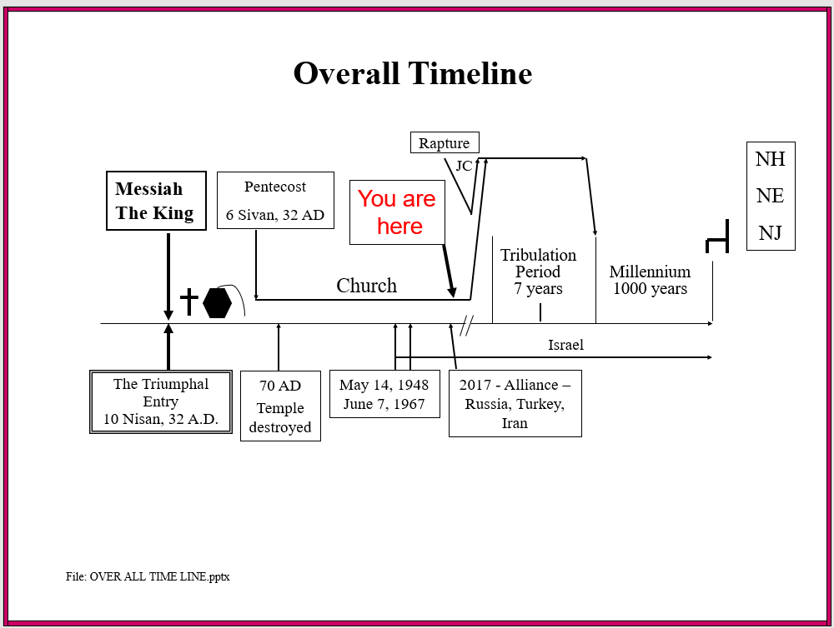
____________________________________________________________________________________________________________________________________________________________________________________

What else did Jesus say about today?

Luke 21:28
28 "But when these things begin to take place, straighten up and lift up your heads, because your redemption is drawing near." NASU

Today, it is essential for a believer to know where we are in time and the future.
____________________________________________________________________________________________________________________________________________________________________________________
KEY POINT – Previous wisdom principles do not exclusively apply now. No one has ever been here before. This is different, the future is now impacting the present.

KEY POINT – There is no going back. This is a one-way time line.

KEY POINT – Knowing your past, present and FUTURE is the only way you can fully understand who you are as a child of God. Adding knowledge of your future to your understanding of who you are is the way to develop a Biblical perspective for the remainder of your life here on earth. Knowledge of the future is how we grow in faith and our relationship with our heavenly Father and His Son.

Just like the facts of the things that happened in the past, you can know the facts of many of the things that will happen in the future.

Question? – Would you rather know the truth about the past or the future????

Is there any personal significance in this kind of perspective? What is the significance if there is some?
________________________________________________________________________________________________________________________________________________________________________________________________________________________________________________

SIGNIFICANCE PERSPECTIVE #2 – The only way to understand what is happening in this world is to have knowledge, understanding, hope & faith in where we are in time and in God’s plans for the present and the future.
____________________________________________________________________________________________________________________________________________________________________________________________________________________________________________________________________________________________________________

Rev 1:3
Blessed is he who reads and those who hear the words of the prophecy, and heed the things which are written in it. NASU

KEY POINT – What do we need to know to have a faith-based inheritance foundation.

Four W’s -
- Who Jesus Is –
Past – Savior
Present – Savior & Intercessor
Future – King
- Who you are –
Past – you already know
Present – you already know
Future – you will know. It will give you a new perspective on life.
- Where you are in time –
- What the plan is -
____________________________________________________________________________________________________________________________________________________________________________________

KEY POINT - Anyone that knows and believes Jesus and God’s plans will understand what is happening on earth and will not be deceived into departing the love and inheritance They have for us. Then you will have rest, peace, freedom and power and will not be deceivable when you know you have been blessed by the most wonderful future any person on earth has ever received.
________________________________________________________________________________________________________________________________________________________________________________________________________________________________________________

WHY STUDY REVELATION?

- You will get to know Jesus better because you will know about Him in the present and the future, not just in the past.
- It is the only book in the Bible with a blessing for those who read and heed it.
- It reveals God’s plans for the planet, nations, Israel, church and people.
- You will know where you are in time.
- It enables us to understand the first 65 books which were all written in anticipation of the 66th (Revelation).
- It will answer most of the “Why” questions you have about the Bible
- This book informs us of our awesome inheritance as a child of God.
- It is the only book in the Bible you are in!

1 Peter 1:3-5
3 Blessed be the God and Father of our Lord Jesus Christ, who according to His great mercy has caused us to be born again to a living hope through the resurrection of Jesus Christ from the dead,
4 to obtain an inheritance which is imperishable and undefiled and will not fade away, reserved in heaven for you,
5 who are protected by the power of God through faith for a salvation ready to be revealed in the last time. NASU

SIGNIFICANCE PERSPECTIVE #3 – The only way you will ever discover who you are as a child of God is by understanding your imperishable inheritance.
____________________________________________________________________________________________________________________________________________________________________________________________________________________________________________________________________________________________________________
Prophetic Perspective News Sources
Rapture Ready News - http://www.raptureready.com/rapnews_db.php
Koenig World Watch Daily - http://www.watch.org/
His Channel – World News Briefing - http://www.hischannel.com/
Israeli Middle East Conflict News - https://www.debka.com/
Olive Tree Views – Jan Markell – News Headlines and Radio Complete Archives - https://olivetreeviews.org/

