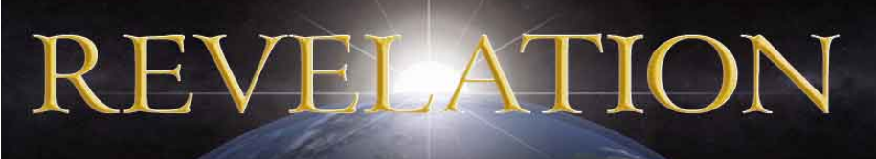

Redeeming The World
Revelation 5 – 3/8/2022
Presented by Gene Dahler

REVIEW -

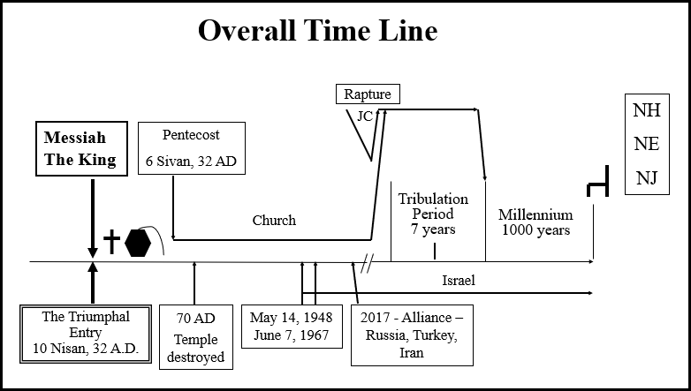

Review notes: __________________________________________
________________________________________________________________________________________________________________________________________________________________________________________________________________________________________________________________________________________________________________________________________________________________________________________________________________________________________________________
(Rom 8:19-23) (Rom 11:25)

KEY POINT – You are _________in your new _________________.

Rev 5:1 I saw in the right hand of Him who sat on the throne a book written inside and on the back, sealed up with seven seals.
____________________________________________________________________________________________________________________________________________________________________________________________________________________________

2 And I saw a strong angel proclaiming with a loud voice, "Who is worthy to open the book and to break its seals?"
_____________________________________________________________________________________________________________________________________________________________________

3 And no one in heaven or on the earth or under the earth was able to open the book or to look into it.
_______________________________________________________________________________________________________________________________________________________________________________________

4 Then I began to weep greatly because no one was found worthy to open the book or to look into it;
____________________________________________________________________________________________________________________________________________________________________________________________________________________________

5 and one of the elders said to me, "Stop weeping; behold, the Lion that is from the tribe of Judah, the Root of David, has overcome so as to open the book and its seven seals."
_____________________________________________________________________________________________________________________________________________________________________

6 And I saw between the throne (with the four living creatures) and the elders a Lamb standing, as if slain, having seven horns and seven eyes, which are the seven Spirits of God, sent out into all the earth.
_______________________________________________________________________________________________________________________________________________________________________________________
_____________________________________________________________

7 And He came and took the book out of the right hand of Him who sat on the throne.
______________________________________________________________________________________________________________

8 When He had taken the book, the four living creatures and the twenty-four elders fell down before the Lamb, each one holding a harp and golden bowls full of incense, which are the prayers of the saints.
______________________________________________________________________________________________________________

9 And they sang a new song, saying, "Worthy are You to take the book and to break its seals; for You were slain, and purchased for God with Your blood men from every tribe and tongue and people and nation.
10 "You have made them to be a kingdom and priests to our God; and they will reign upon the earth."
__________________________________________________________________________________________________________________________________________________________________________________________________________________________________________________________________________________________________________________________________________

11 Then I looked, and I heard the voice of many angels around the throne and the living creatures and the elders; and the number of them was myriads of myriads, and thousands of thousands,
12 saying with a loud voice, "Worthy is the Lamb that was slain to receive power and riches and wisdom and might and honor and glory and blessing."
_____________________________________________________________________________________________________________________________________________________________________

13 And every created thing which is in heaven and on the earth and under the earth and on the sea, and all things in them, I heard saying, "To Him who sits on the throne, and to the Lamb, be blessing and honor and glory and dominion forever and ever."
__________________________________________________________________________________________________________________________

KEY POINT – This is the biggest celebration recorded in heaven!!

Why is this such a big deal?

This is the redemption deed that redeems the active deed given to Adam at the creation of the earth. This is the recovery from Genesis 3 when Adam and Eve ate of the forbidden fruit and turned over the active deed and the earth to Satan. This is the beginning of the end of Satan’s authority on Earth.

THE EXERCISING OF THE REDEMPTION DEED HAS BEEN A PRIMARY GOAL OF THE _______________________.

14 And the four living creatures kept saying, "Amen." And the elders fell down and worshiped. NASU
_______________________________________________________________________________________________________________________________________________________________________________________

PERSPECTIVES FROM REV 5

PERSPECTIVE #1 - Rev 5:1

What is God waiting on to make the call for someone to open the book? Answer – He is waiting on __________.

PERSPECTIVE # 2 – Rev 5

Why did Jesus have to become a man? There are four reasons.

- To fulfill the ________ (Mt 5:17)
- To fulfill ____________ (Lk 19)
- To _______________of the sins for all those that would __________ (Jn 3:16-18; 1Cor 6:20; 1Pet 2:24, 3:18; 1Jn 4:10)

Tonight we studied one reason that most overlook, the big picture reason.

Jesus had to become a man because only a man could ____________________from our heavenly Father ____________. (Rev 5:3-4, Rev 6)

PERSPECTIVE # 3 – Rev 5

How soon could Jesus take the book from His Father happen? ______________

Notes and additional thoughts:
__________________________________________________________________________________________________________________________________________________________________________________________________________________________________________________________________________________________________________________________________________

file: 220408 - Rev–chap-5 GD HB rev g.doc

