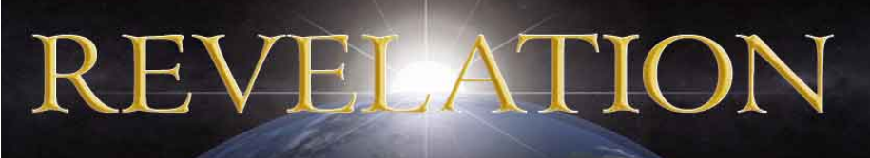
The 144,000 & Tribulation Saints
3/22/2022
Presented by Gene Dahler

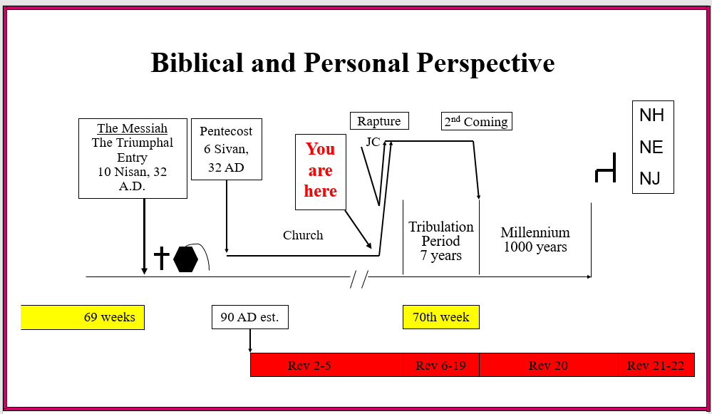

Review notes: ___________________________________________
______________________________________________________________________________________________________________
____________________________________________________________________________________________________________________________________________________________________________________________________________________________

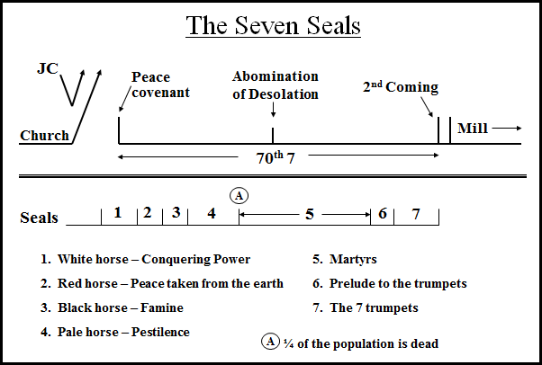

Review notes: ___________________________________________
_________________________________________________________________________________________________________________________________________________________________________________________________________________________________________________________________________________________________________________________________________________________________________________________________________________________________________________________________________________________________________________________________________________________________________________________________________________________________________________________________________________________________________________________________________________________________________________________________________________________________________________________

Revelation 7:1-8 – THE 144,000

1 After this I saw four angels standing at the four corners of the earth, holding back the four winds of the earth, so that no wind would blow on the earth or on the sea or on any tree.
2 And I saw another angel ascending from the rising of the sun, having the seal of the living God; and he cried out with a loud voice to the four angels to whom it was granted to harm the earth and the sea,
3 saying, "Do not harm the earth or the sea or the trees until we have sealed the bond-servants of our God on their foreheads."
4 And I heard the number of those who were sealed, one hundred and forty-four thousand sealed from every tribe of the sons of Israel:
____________________________________________________________________________________________________________________________________________________________________________________________________________________________

5 from the tribe of Judah, twelve thousand were sealed, from the tribe of Reuben twelve thousand, from the tribe of Gad twelve thousand,
6 from the tribe of Asher twelve thousand, from the tribe of Naphtali twelve thousand, from the tribe of Manasseh twelve thousand,
7 from the tribe of Simeon twelve thousand, from the tribe of Levi twelve thousand, from the tribe of Issachar twelve thousand,
8 from the tribe of Zebulun twelve thousand, from the tribe of Joseph twelve thousand, from the tribe of Benjamin, twelve thousand were sealed.
_____________________________________________________________________________________________________________________________________________________________________

Rev 14:1 & 4
1 Then I looked, and behold, the Lamb was standing on Mount Zion, and with Him one hundred and forty-four thousand, having His name and the name of His Father written on their foreheads.
4 These are the ones who have not been defiled with women, for they have kept themselves chaste. These are the ones who follow the Lamb wherever He goes. These have been purchased from among men as first fruits to God and to the Lamb.
______________________________________________________________________________________________________________

Revelation 7:9-17 – THE TRIBULATION SAINTS

9 After these things I looked, and behold, a great multitude which no one could count, from every nation and all tribes and peoples and tongues, standing before the throne and before the Lamb, clothed in white robes, and palm branches were in their hands;
10 and they cry out with a loud voice, saying, "Salvation to our God who sits on the throne, and to the Lamb."
11 And all the angels were standing around the throne and around the elders and the four living creatures; and they fell on their faces before the throne and worshiped God,
12 saying, "Amen, blessing and glory and wisdom and thanksgiving and honor and power and might, be to our God forever and ever. Amen."
13 Then one of the elders answered, saying to me, "These who are clothed in the white robes, who are they, and where have they come from?"
14 I said to him, "My lord, you know." And he said to me, "These are the ones who come out of the great tribulation, and they have washed their robes and made them white in the blood of the Lamb.
______________________________________________________________________________________________________________

Same group as Rev 6:9-11, but more of them now.

Rev 6:9-11
9 When the Lamb broke the fifth seal, I saw underneath the altar the souls of those who had been slain because of the word of God, and because of the testimony which they had maintained;
10 and they cried out with a loud voice, saying, "How long, O Lord, holy and true, will You refrain from judging and avenging our blood on those who dwell on the earth?"
11 And there was given to each of them a white robe; and they were told that they should rest for a little while longer, until the number of their fellow servants and their brethren who were to be killed even as they had been, would be completed also. NASU
__________________________________________________________________________________________________________________________
_______________________________________________________________________________________________________________________________________________________________________________________

15 "For this reason, they are before the throne of God; and they serve Him day and night in His temple; and He who sits on the throne will spread His tabernacle over them.
16 "They will hunger no longer, nor thirst anymore; nor will the sun beat down on them, nor any heat;
17 for the Lamb in the center of the throne will be their shepherd, and will guide them to springs of the water of life; and God will wipe every tear from their eyes." NASU
___________________________________________________________________________________________________________________________________________________________________________________________________________________________________________________________________________________

PERSPECTIVES FOR REVELATION CHAPTERS 6 & 7

- Sequence of events;
First seal – Antichrist
Second seal – Peace taken from the earth
Third seal – Famine
Fourth seal – One fourth of the earth physically dies
Angel – Do no harm to the earth
Israeli’s - 144,000 sealed
In heaven – A multitude of tribulation saints

- The 144,000 – What do they do? ______________

- How soon from now could the events of chapter 7 occur? ________

PERSPECTIVE FOR TODAY

Prepare for the coming rapture with the thought of saving those going into the tribulation period. DO IT NOW.

Key Point – TIME IS NOT ON OUR SIDE!!!

file: 220322 - Rev–chap-7 GD HB rev f.doc

