
The Angel & Book & The Two Witnesses
Chapters 10 & 11 – 4/5/22
Presented by Gene Dahler

Review Notes: ___________________________________________ _____________________________________________________________________________________________________________________________________________________________________

Revelation 10:1 – 11:19
Rev 10:1-19
1 I saw another strong angel coming down out of heaven, clothed with a cloud; and the rainbow was upon his head, and his face was like the sun, and his feet like pillars of fire;
2 and he had in his hand a little book which was open. He placed his right foot on the sea and his left on the land;

3 and he cried out with a loud voice, as when a lion roars; and when he had cried out, the seven peals of thunder uttered their voices.
4 When the seven peals of thunder had spoken, I was about to write; and I heard a voice from heaven saying, "Seal up the things which the seven peals of thunder have spoken and do not write them."

5 Then the angel whom I saw standing on the sea and on the land lifted up his right hand to heaven,
6 and swore by Him who lives forever and ever, WHO CREATED HEAVEN AND THE THINGS IN IT, AND THE EARTH AND THE THINGS IN IT, AND THE SEA AND THE THINGS IN IT, that there will be delay no longer,
______________________________________________________________________________________________________________

7 but in the days of the voice of the seventh angel, when he is about to sound, then the mystery of God is finished, as He preached to His servants the prophets.
_____________________________________________________________________________________________________________________________________________________________________

8 Then the voice which I heard from heaven, I heard again speaking with me, and saying, "Go, take the book which is open in the hand of the angel who stands on the sea and on the land."
9 So I went to the angel, telling him to give me the little book. And he said to me, "Take it and eat it; it will make your stomach bitter, but in your mouth it will be sweet as honey."
10 I took the little book out of the angel's hand and ate it, and in my mouth it was sweet as honey; and when I had eaten it, my stomach was made bitter.
______________________________________________________________________________________________________________

11 And they said to me, "You must prophesy again concerning many peoples and nations and tongues and kings." NASU
____________________________________________________________________________________________________________________________________________________________________________________________________________________________

Rev 11:1-2
1 Then there was given me a measuring rod like a staff; and someone said, "Get up and measure the temple of God and the altar, and those who worship in it.
2 "Leave out the court which is outside the temple and do not measure it, for it has been given to the nations; and they will tread under foot the holy city for forty-two months.
____________________________________________________________________________________________________________________________________________________________________________________________________________________________

Rev 11:3-13
3 "And I will grant authority to my two witnesses, and they will prophesy for twelve hundred and sixty days, clothed in sackcloth."

How did Israel get here and why?

Who is writing? ____________________________
Who is being written to? ________________________
What is it about? _________________________________________
When does it apply? ______________________________________

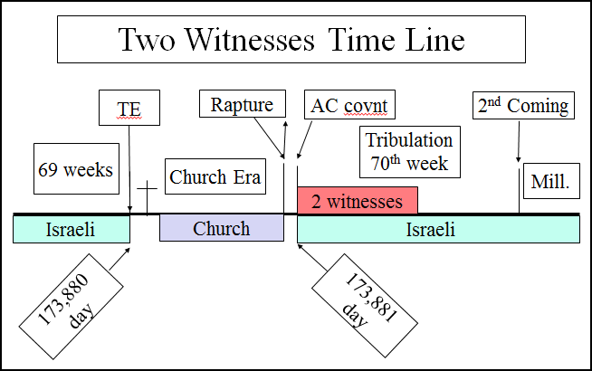

Ref: Dan 9:24-27; John 5:43; Luke 19:41-44; Matt 23:37-39, Rev 6:1-2
_________________________________________________________________________________________________________________________________________________________________________________________________________________________________________________________________________________________________________________________________________________________________________________________________

3 "And I will grant authority to my two witnesses, and they will prophesy for twelve hundred and sixty days, clothed in sackcloth."
______________________________________________________________________________________________________________

4 These are the two olive trees and the two lampstands that stand before the Lord of the earth.
5 And if anyone wants to harm them, fire flows out of their mouth and devours their enemies; so if anyone wants to harm them, he must be killed in this way.

6 These have the power to shut up the sky, so that rain will not fall during the days of their prophesying; and they have power over the waters to turn them into blood, and to strike the earth with every plague, as often as they desire.
_____________________________________________________________________________________________________________________________________________________________________

7 When they have finished their testimony, the beast that comes up out of the abyss will make war with them, and overcome them and kill them.
8 And their dead bodies will lie in the street of the great city which mystically is called Sodom and Egypt, where also their Lord was crucified.
9 Those from the peoples and tribes and tongues and nations will look at their dead bodies for three and a half days, and will not permit their dead bodies to be laid in a tomb.
10 And those who dwell on the earth will rejoice over them and celebrate; and they will send gifts to one another, because these two prophets tormented those who dwell on the earth.
_____________________________________________________________________________________________________________________________________________________________________

11 But after the three and a half days, the breath of life from God came into them, and they stood on their feet; and great fear fell upon those who were watching them.
12 And they heard a loud voice from heaven saying to them, "Come up here." Then they went up into heaven in the cloud, and their enemies watched them.
_____________________________________________________________________________________________________________________________________________________________________

13 And in that hour there was a great earthquake, and a tenth of the city fell; seven thousand people were killed in the earthquake, and the rest were terrified and gave glory to the God of heaven. NASU

Ref: Rev 12:13-16; Zec 13:8-9;
____________________________________________________________________________________________________________________________________________________________________________________________________________________________

Rev 11:14-19
14 The second woe is past; behold, the third woe is coming quickly.

15 Then the seventh angel sounded; and there were loud voices in heaven, saying, "The kingdom of the world has become the kingdom of our Lord and of His Christ; and He will reign forever and ever."
16 And the twenty-four elders, who sit on their thrones before God, fell on their faces and worshiped God,
17 saying, "We give You thanks, O Lord God, the Almighty, who are and who were, because You have taken Your great power and have begun to reign.
___________________________________________________________________________________________________________________________________________________________________________________________________________________________________________________________________________________

18 "And the nations were enraged, and Your wrath came, and the time came for the dead to be judged, and the time to reward Your bond-servants the prophets and the saints and those who fear Your name, the small and the great, and to destroy those who destroy the earth."
______________________________________________________________________________________________________________

19 And the temple of God which is in heaven was opened; and the ark of His covenant appeared in His temple, and there were flashes of lightning and sounds and peals of thunder and an earthquake and a great hailstorm. NASU
______________________________________________________________________________________________________________

PERSPECTIVE – Rev 10 & 11

The Angel has sounded the 7th trumpet.

Why is the final tribulation wrath starting now?
Answer – All those that will be _______ have been _________.
The time is up for the __________.

Who is going through the judgment process?
Answer – All those _______on earth at the end of the tribulation period.
Except who? Ans – _______________

Who is being rewarded?
Answer – Bond servants, prophets, saints and those who fear God’s name.
From what period of time? Ans – ________________

When does the judging and rewarding happen?
Answer – In the ___________ between the tribulation and millennium

Note: Wailing Wall camera website
http://english.thekotel.org/camera.asp

file: 220405 - Rev–chap-10-11 GD HB rev c.doc

