

The Fall of Babylon Revelation 18 – 5/24/2022
Presented by Gene Dahler

Review Notes: ________________________________________________ ____________________________________________________________________________________________________________________________________________________________________________________


________________________________________________________________________________________________________________________________________________________________________________________________________________________________________________
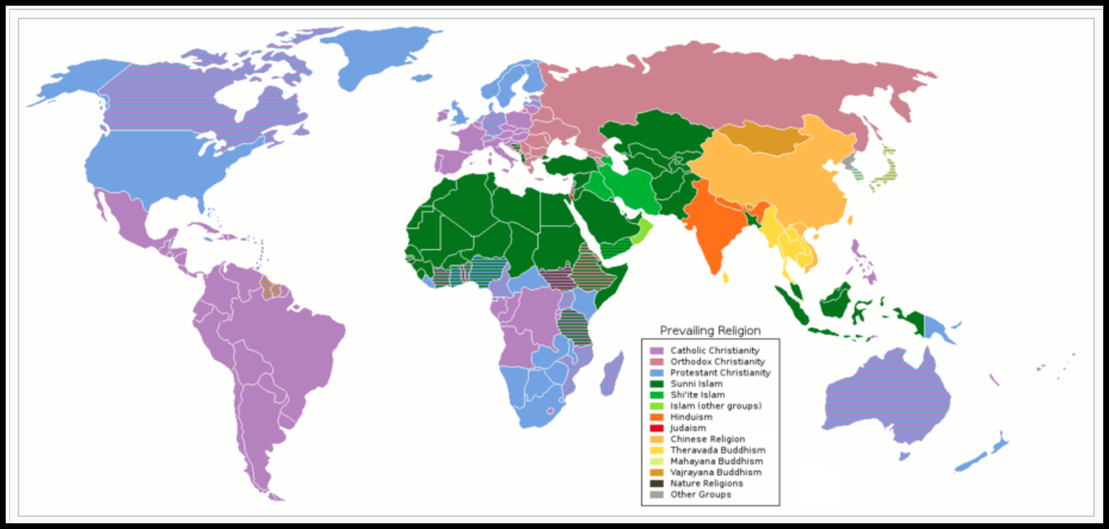

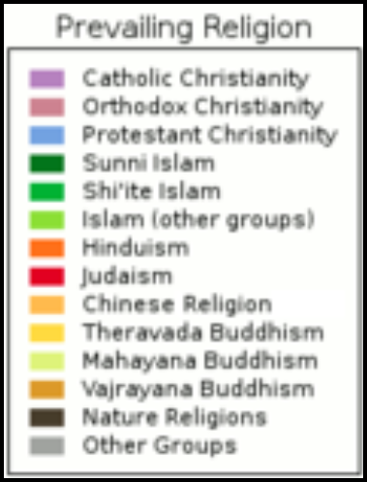Wikipedia- 2022
________________________________________________________________________________________________________________________________________________________________________________________________________________________________________________________________________________________________________________________________________________________________________________________________________________________________________________________________________________________________

Revelation 17:18
18 "The woman whom you saw is the great city, which reigns over the kings of the earth."

Revelation 18:1-24
1 After these things I saw another angel coming down from heaven, having great authority, and the earth was illumined with his glory.
________________________________________________________________________________________________________________________
2 And he cried out with a mighty voice, saying, " Fallen, fallen is Babylon the great! She has become a dwelling place of demons and a prison of every unclean spirit, and a prison of every unclean and hateful bird.
________________________________________________________________________________________________________________________

3 "For all the nations have drunk of the wine of the passion of her immorality, and the kings of the earth have committed acts of immorality with her, and the merchants of the earth have become rich by the wealth of her sensuality."
________________________________________________________________________________________________________________________

4 I heard another voice from heaven, saying, "Come out of her, my people, so that you will not participate in her sins and receive of her plagues;
5 for her sins have piled up as high as heaven, and God has remembered her iniquities.
________________________________________________________________________________________________________________________

6 " Pay her back even as she has paid, and give back to her double according to her deeds; in the cup which she has mixed, mix twice as much for her.
7 " To the degree that she glorified herself and lived sensuously, to the same degree give her torment and mourning; for she says in her heart, ' I SIT as A QUEEN AND I AM NOT A WIDOW, and will never see mourning.'

8 "For this reason in one day her plagues will come, pestilence and mourning and famine, and she will be burned up with fire; for the Lord God who judges her is strong.
______________________________________________________________________________________________________________________________________________________________________________________________________
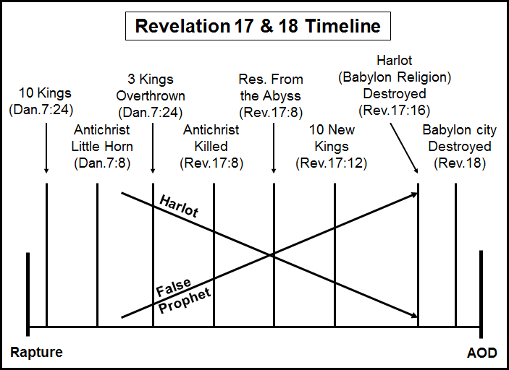

Three groups of people will bemoan the passing of the city of Babylon

- Group 1 - Kings

9 "And the kings of the earth, who committed acts of immorality and lived sensuously with her, will weep and lament over her when they see the smoke of her burning,
10 standing at a distance because of the fear of her torment, saying, ' Woe, woe, the great city, Babylon, the strong city! For in one hour your judgment has come.'
________________________________________________________________________________________________________________________

- Group 2 – Merchants

11 "And the merchants of the earth weep and mourn over her, because no one buys their cargoes any more—
12 cargoes of gold and silver and precious stones and pearls and fine linen and purple and silk and scarlet, and every kind of citron wood and every article of ivory and every article made from very costly wood and bronze and iron and marble,
13 and cinnamon and spice and incense and perfume and frankincense and wine and olive oil and fine flour and wheat and cattle and sheep, and cargoes of horses and chariots and slaves and human lives.
________________________________________________________________________________________________________________________

14 "The fruit you long for has gone from you, and all things that were luxurious and splendid have passed away from you and men will no longer find them.
15 "The merchants of these things, who became rich from her, will stand at a distance because of the fear of her torment, weeping and mourning,
16 saying, ' Woe, woe, the great city, she who was clothed in fine linen and purple and scarlet, and adorned with gold and precious stones and pearls;
________________________________________________________________________________________________________________________

- Group 3 – Those that trade by sea

17 for in one hour such great wealth has been laid waste!' And every shipmaster and every passenger and sailor, and as many as make their living by the sea, stood at a distance,
18 and were crying out as they saw the smoke of her burning, saying, ' What city is like the great city?'
19 "And they threw dust on their heads and were crying out, weeping and mourning, saying, ' Woe, woe, the great city, in which all who had ships at sea became rich by her wealth, for in one hour she has been laid waste!'
________________________________________________________________________________________________________________________

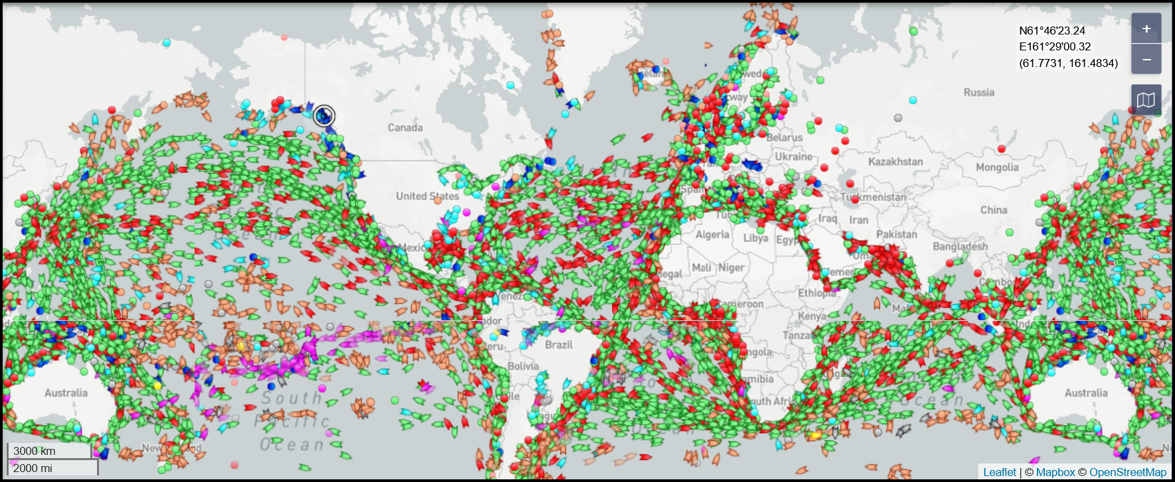
marinetraffic.com
Green – Cargo
Red – Tanker
Brown – Fishing
Blue – Cruise
Purple – Pleasure, war, unspecified

20 " Rejoice over her, O heaven, and you saints and apostles and prophets, because God has pronounced judgment for you against her."
________________________________________________________________________________________________________________________

21 Then a strong angel took up a stone like a great millstone and threw it into the sea, saying, "So will Babylon, the great city, be thrown down with violence, and will not be found any longer.
22 "And the sound of harpists and musicians and flute-players and trumpeters will not be heard in you any longer; and no craftsman of any craft will be found in you any longer; and the sound of a mill will not be heard in you any longer;
23 and the light of a lamp will not shine in you any longer; and the voice of the bridegroom and bride will not be heard in you any longer; for your merchants were the great men of the earth, because all the nations were deceived by your sorcery.
________________________________________________________________________________________________________________________

24 "And in her was found the blood of prophets and of saints and of all who have been slain on the earth." NASU
________________________________________________________________________________________________________________________

What city is the most likely candidate for the city of the harlot today?

Ans - _________________________

What city will be the city of the harlot at the time of her judgement?

Ans - Whatever city emerges as the center of world trade for luxurious items during the first half of the tribulation period.

PERSPECTIVE FOR TODAY – Rev 18 – 5/24/22

What is the harlot’s name – Babylon the great, the mother of harlots and of the abominations of the earth.

What has she done in the past (including the church era) and what are the results -
17:2 The kings of the earth commit immoral acts with her
17:2 The earth dwellers are made drunk with the wine of her immorality
17:6 She is drunk with the blood of the saints
17:6 And with the blood of the witnesses of Jesus
17:15 She sits on the peoples, multitudes, nations and tongues
18:3 All nations have drunk of the wine of the passion of her immorality
18:3 The merchants of the earth have become rich by the wealth of her sensuality.
18:5 Her sins have piled up as high as heaven
18:23 Her merchants were the great men of the earth, because all the nations were deceived by her sorcery.
18:24 In her was found the blood of prophets and of saints and of all who have been slain on the earth.

What area did her activities take place in? Ans - _______________ (18:23)
Where and when did she start doing the things that brought her to this title and definition? Ans – ____________ (Gen 11 – Est _____________).
________________________________________________________________________________________________________________________

Remember what Paul wrote to the Ephesians to prepare believers for this period of time.

Ephesians 6:10-12
10 Finally, be strong in the Lord and in the strength of His might.
11 Put on the full armor of God, so that you will be able to stand firm against the schemes of the devil.
12 For our struggle is not against flesh and blood, but against the rulers, against the powers, against the world forces of this darkness, against the spiritual forces of wickedness in the heavenly places.

Who are the leaders of the world forces of this darkness and the spiritual forces of wickedness in the heavenly places?
- ___________________
- ___________________

The influence of these two plus the activity of rulers and powers results in methods and programs that deny or distort the truth promoted by organizations of every type in this world. These are the world forces.

- Governments - Religions
- Academia - World trade / commerce
- Media - Entertainment industry

The influence by subject includes:

- Creation by evolution. Man is not made in God’s image.
- Antisemitism
- LGBTTQQIAAP (lesbian, gay, bisexual, transgender, transsexual, queer, questioning, intersex, asexual, ally, pansexual) acceptance
- Socialism
- Bible distortion – transliterations, paraphrases
- Acceptance of drug use – legal and illegal
- Acceptance of abortion
- The belief that Islam is a religion
- Climate change conspiracy
- Fear of nuclear proliferation
- Promotion of the new world order – no borders – theory, no wars
- Covid 19 pandemic conspiracy

SUMMARY

Do we understand that the tentacles of evil are everywhere and are against us as Bible Believers? Their weapons – SCHEMES (Eph 6:11).

But, two spiritual, yet practical miracles happen every day.

1. People get saved

2. Saved people overcome and go to heaven

Despite Satan and the Harlot of Babylon, it still happens.

How? - Because we have access to a greater power. God’s power working through us is how eternal differences are made in people’s lives.

Imagine this. The majority of the governments, corporations, organizations and all false religions of the world are attempting to influence everyone in the world. But God’s power penetrates straight through all of that to every member of His family. We have His power working through us. Let it have an impact with everyone you meet.

What is your mission?

2 Corinthians 10:3-5
3 - - - though we walk in the flesh, we do not war according to the flesh,
4 for the weapons of our warfare are not of the flesh, but divinely powerful for the destruction of fortresses.
5 We are destroying speculations and every lofty thing raised up against the knowledge of God, NASU

This is exciting and the most rewarding thing that an individual on earth can do. Be part of it.

