

Directions To Life In A Lost World

- Introduction – 1Pet 1:1-12

Gene Dahler & Cliff Phipps - Sept. 20, 2022

KEY POINTS -

- It is the opinion of many that these two letters are the best consolidated advice to the church today in the Bible.

- Prepare to be amazed by the large scope of the thinking of this Apostle and the accuracy of his description of today. He will expand our understanding and will provide incredible truth that can enlighten your heart and change your life.
_____________________________________________________________________________________________________________________________________________________________________

The date of the writing of these letters is believed to have been between 60 AD and 68 AD. That is primarily because Peter refers to Paul’s prison letters, which are dated no earlier than 60 AD, and Peter was martyred during Nero’s reign, which ended in 68AD. This would be 28 – 36 years after the crucifixion of Jesus Christ.
Introductory verse:

1 Peter 1:13
13 Therefore, prepare your minds for action, keep sober in spirit, fix your hope completely on the grace to be brought to you at the revelation of Jesus Christ. NASU

1 Peter, an apostle of Jesus Christ, To those who reside as aliens, scattered throughout Pontus, Galatia, Cappadocia, Asia, and Bithynia, who are chosen
2 according to the foreknowledge of God the Father, by the sanctifying work of the Spirit, to obey Jesus Christ and be sprinkled with His blood: May grace and peace be yours in the fullest measure.
3 Blessed be the God and Father of our Lord Jesus Christ, who according to His great mercy has caused us to be born again to a living hope through the resurrection of Jesus Christ from the dead,
4 to obtain an inheritance which is imperishable and undefiled and will not fade away, reserved in heaven for you,
5 who are protected by the power of God through faith for a salvation ready to be revealed in the last time.

1 Peter 1:1-12
1 Peter, an apostle of Jesus Christ, To those who reside as aliens, scattered throughout Pontus, Galatia, Cappadocia, Asia, and Bithynia, who are chosen

- Definition – apostle - a delegate, messenger, one sent forth with orders
- Definition - aliens – Born again believers, who have in this world only a passing dwelling place, but not their actual home.

Who is speaking/writing? ___________________________________

Who is being spoken/written to? _____________________________
___________________________________________________________________________________________________________________________________________________________________________________________________________________________________________________________________________________
2 according to the foreknowledge of God the Father, by the sanctifying work of the Spirit, to obey Jesus Christ and be sprinkled with His blood: May grace and peace be yours in the fullest measure.

- Definition – foreknowledge – to know in advance
- Definition – sanctifying – to be set apart, purification
- Definition – grace – to receive good things you do not deserve
___________________________________________________________________________________________________________________________________________________________________________________________________________________________________________________________________________________

3 Blessed be the God and Father of our Lord Jesus Christ, who according to His great mercy has caused us to be born again to a living hope through the resurrection of Jesus Christ from the dead,

- Definition – Mercy – not receiving what you do deserve
- Definition – Hope – ____________________________________
_______________________________________________________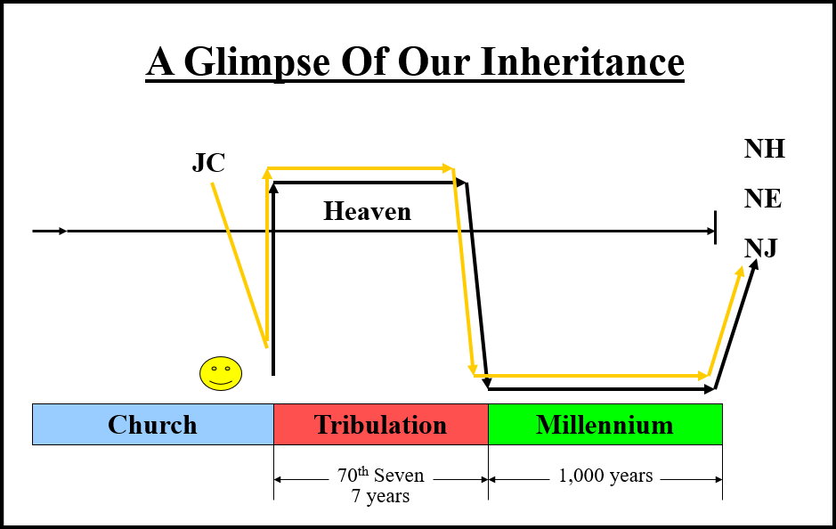
_____________________________________________________________________________________________________________________________________________________________________
4 to obtain an inheritance which is imperishable and undefiled and will not fade away, reserved in heaven for you,
__________________________________________________________________________________________________________________________________________________________________________________________________________________________________________________________________________________________________________________________________________

PERSPECTIVE – If you don’t get anything else from this first half of tonight’s message, get this:

For the earth dweller (unbeliever), their time here on earth is as _______ as it gets.

For the alien (born-again believer), our time here on earth is as _______ as it gets.

5 who are protected by the power of God through faith for a salvation ready to be revealed in the last time.

What does faith protect you from? How does it protect you?

Eph 6:10-11
10 Finally, be strong in the Lord and in the strength of His might.
11 Put on the full armor of God, so that you will be able to stand firm against the schemes of the devil. NASU

Eph 6:16
16 in addition to all, taking up the shield of faith with which you will be able to extinguish all the flaming arrows of the evil one. NASU

What are the flaming arrows? Schemes, false teaching, statements of mockers, distractions to worldly items, lies, etc.
______________________________________________________________________________________________________________

- Definition – faith - Hebrews 11:1 Now faith is the assurance of things hoped for, the conviction of things not seen. NASU

How do we get faith? It is based on hearing, knowing and understanding the truth.

Hearing > Knowing > Understanding > Believing > Holy Spirit > Hope > Assurance (which is Faith)

- Definition – salvation – rescue, deliverance
- Definition – last time – latter time for believers on earth
____________________________________________________________________________________________________________________________________________________________________________________________________________________________

6 In this you greatly rejoice, even though now for a little while, if necessary, you have been distressed by various trials,

Let’s look back at the previous verses.

1 Peter 1:3-6
3 Blessed be the God and Father of our Lord Jesus Christ, who according to His great mercy has caused us to be born again to a living hope through the resurrection of Jesus Christ from the dead, 4 to obtain an inheritance which is imperishable and undefiled and will not fade away, reserved in heaven for you, 5 who are protected by the power of God through faith for a salvation ready to be revealed in the last time.

Peter says that it is in your salvation that you greatly rejoice.

(Phil 4:6, Jer 29:11, Matt 6:33,, Matt 6:34)

6 In this you greatly rejoice, even though now for a little while, if necessary, you have been distressed by various trials,

(1 Peter 4:12-14, Rom 8:18)

7 so that the proof of your faith, being more precious than gold which is perishable, even though tested by fire, may be found to result in praise and glory and honor at the revelation of Jesus Christ;
_____________________________________________________________________________________________________________________________________________________________________

8 and though you have not seen Him, you love Him, and though you do not see Him now, but believe in Him, you greatly rejoice with joy inexpressible and full of glory,
9 obtaining as the outcome of your faith the salvation of your souls.
_____________________________________________________________________________________________________________________________________________________________________

Salvation means deliverance or rescue from danger.

(Acts 4:12, Rom 1:16, Rom 10:9-10, Eph 1:13-14, 1 Peter 1:9, 2 Tim 3:13-15)
____________________________________________________________________________________________________________________________________________________________________________________________________________________________

4 Steps Paul gave to Timothy

- The Word

- Wisdom.

- Faith

- Salvation.

10 As to this salvation, the prophets who prophesied of the grace that would come to you made careful searches and inquiries,
11 seeking to know what person or time the Spirit of Christ within them was indicating as He predicted the sufferings of Christ and the glories to follow.
12 It was revealed to them that they were not serving themselves, but you, in these things which now have been announced to you through those who preached the gospel to you by the Holy Spirit sent from heaven — things into which angels long to look.
_____________________________________________________________________________________________________________________________________________________________________

(Matt 23:37-39, Rom 11:11)

Summary – What have we learned so far from this letter?

Peter is writing to believers that know that they live as aliens here on the earth.

Their focus is no longer this planet. Their focus is on their citizenship in heaven.

They have been set apart by the Holy Spirit to obey Jesus and His commands.

They have been born again to a living hope by the resurrection of Jesus from the dead.

They know they have an incredible inheritance reserved in heaven.

They know they are protected by the power of God because of their faith for a salvation that will keep them from going to hell or entering into the Tribulation Period.

Even though they are facing trials, they rejoice more in their salvation.

They know that the trials they face just allow them to prove that their faith is genuine.

They know that the prophets that gave their lives to deliver the message of God’s salvation were not serving themselves but those prophets were actually serving the believers.

