

First Thessalonians – Chapter Five
February 7, 2023

Presented by Gene Dahler

Chapter 3 Summary –
- Where does faith come from?
- Where is your personal faith?
- The battle is for your mind.
- What part of our spiritual armor is faith?
- How to add to or complete someone’s faith.
- Specifically defined what we can have faith in.
- What it will take to stand to the end.
________________________________________________________________________________________________________________________________________________________________________________________________________________________

Chapter 4 Summary –
- How to walk as a saved person
- Rapture details, awake or asleep – our greatest day on earth
- Spiritual make up of a person
______________________________________________________________________________________________________________________________________________________________________________________________________________________________________________________________________________
Chapter 4 for context

1 Thessalonians 4:1
1 Finally then, brethren, we request and exhort you in the Lord Jesus, that as you received from us instruction as to how you ought to walk and please God (just as you actually do walk), that you excel still more. NASU

1 Thessalonians 4:13-18
13 But we do not want you to be uninformed, brethren, about those who are asleep, so that you will not grieve as do the rest who have no hope.
14 For if we believe that Jesus died and rose again, even so God will bring with Him those who have fallen asleep in Jesus.
15 For this we say to you by the word of the Lord, that we who are alive and remain until the coming of the Lord, will not precede those who have fallen asleep.
16 For the Lord Himself will descend from heaven with a shout, with the voice of the archangel and with the trumpet of God, and the dead in Christ will rise first.
17 Then we who are alive and remain will be caught up together with them in the clouds to meet the Lord in the air, and so we shall always be with the Lord.

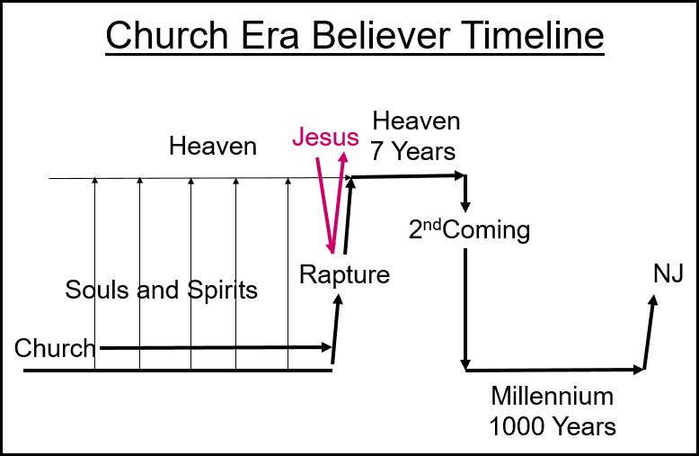

18 Therefore comfort one another with these words. NASU
1 THESSALONIANS 5:1-28

1 Now as to the times and the epochs, brethren, you have no need of anything to be written to you.
2 For you yourselves know full well that the day of the Lord will come just like a thief in the night.
3 While they are saying, " Peace and safety!" then destruction will come upon them suddenly like labor pains upon a woman with child, and they will not escape.
Matt 24:37-39
________________________________________________________________________________________________________________________________________________________________________________________________________________________

4 But you, brethren, are not in darkness, that the day would overtake you like a thief;
5 for you are all sons of light and sons of day. We are not of night nor of darkness;
6 so then let us not sleep as others do, but let us be alert and sober.
7 For those who sleep do their sleeping at night, and those who get drunk get drunk at night.
2Peter 3:3-4, John 12:46, Eph 5:6-8, 1Peter 2:9-10, Prov 31:6-7
__________________________________________________________________________________________________________________________________________________________________

8 But since we are of the day, let us be sober, having put on the breastplate of faith and love, and as a helmet, the hope of salvation.
9 For God has not destined us for wrath, but for obtaining salvation through our Lord Jesus Christ,
10 who died for us, so that whether we are awake or asleep, we will live together with Him.
________________________________________________________________________________________________________________________________________________________________________________________________________________________

11 Therefore encourage one another and build up one another, just as you also are doing.
________________________________________________________________________________________________________________________

12 But we request of you, brethren, that you appreciate those who diligently labor among you, and have charge over you in the Lord and give you instruction,
13 and that you esteem them very highly in love because of their work. Live in peace with one another.
________________________________________________________________________________________________________________________________________________________________________________________________________________________

14 We urge you, brethren, admonish the unruly, encourage the fainthearted, help the weak, be patient with everyone.
15 See that no one repays another with evil for evil, but always seek after that which is good for one another and for all people.
Matt 7:1-2, 1Cor 6:2-3
________________________________________________________________________________________________________________________________________________________________________________________________________________________

16 Rejoice always;
____________________________________________________________________________________________________________

17 pray without ceasing;
____________________________________________________________________________________________________________

18 in everything give thanks; for this is God's will for you in Christ Jesus.
Romans 8:28
____________________________________________________________________________________________________________

19 Do not quench the Spirit;
John 16:13

3 Reasons Saved People Quench The Holy Spirit –
- They don’t spend time in God’s Word
- They know too much that isn’t true
- They believe that it is not possible to know the truth.
____________________________________________________________________________________________________________

KEY POINT – A believer must be willing to set aside anything that he ever thought was true when confronted with a Biblical contradicting fact.

20 do not despise prophetic utterances.
2Peter 1:19, Rev 19:10
____________________________________________________________________________________________________________

21 But examine everything carefully; hold fast to that which is good;
2Peter 2:1, 1 Tim 4:1-2, Heb 5:11-14,
__________________________________________________________________________________________________________________________________________________________________

22 abstain from every form of evil.
____________________________________________________________________________________________________________

23 Now may the God of peace Himself sanctify you entirely; and may your spirit and soul and body be preserved complete, without blame at the coming of our Lord Jesus Christ.
John 17:17
____________________________________________________________________________________________________________

24 Faithful is He who calls you, and He also will bring it to pass.

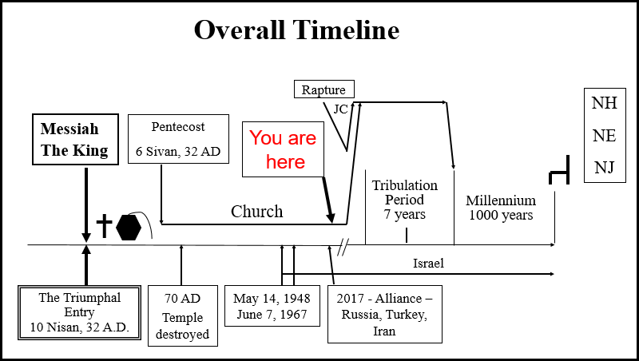

________________________________________________________________________________________________________________________________________________________________________________________________________________________________________________

25 Brethren, pray for us.
26 Greet all the brethren with a holy kiss.
27 I adjure you by the Lord to have this letter read to all the brethren.
28 The grace of our Lord Jesus Christ be with you. NASU

Key Point for this letter: You don’t have to be a Christian a long time to be mature, you just need knowledge and understanding.

Key Point for this chapter: Our Lord’s coming will not be like a thief in the night for those who are not in darkness, but are looking for Him. He will not surprise us, for we are expecting Him.

Filename: 230207 – 1Thess5 HB GD b.doc

