

Ephesians – Chapter 3:14-21
April 18, 2023

Presented by Clifford Phipps

Questions for tonight

- What causes Christ to dwell in your heart?
- What is necessary for you to comprehend and know the love of Christ?

Review
______________________________________________________________________________________________________________________________________________________________________________________________________________________________________________________________________________________________________________________

(Eph 3:4, Eph 3:5-6, Eph 2:18-20, Eph 2:4-8, Eph 2:8-9, Gal 3:13-14, Eph 1:7-8, Luke 22:41-45, Heb 12:2)

14 For this reason I bow my knees before the Father,
____________________________________________________________________________________________________________________________________________________________________________________________________________________________________________________________________________________________________________________________________________________________________________________

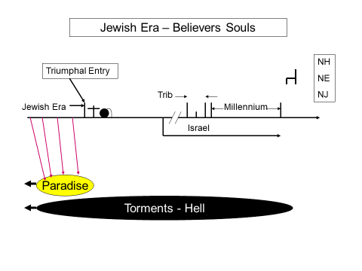
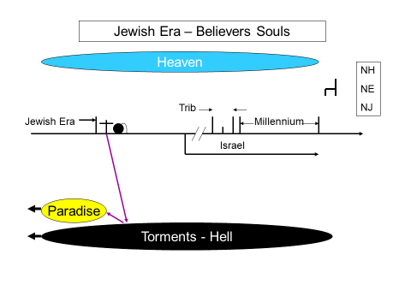

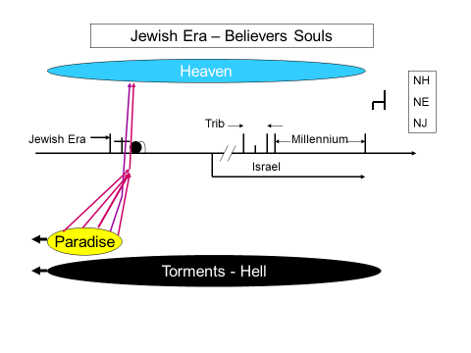

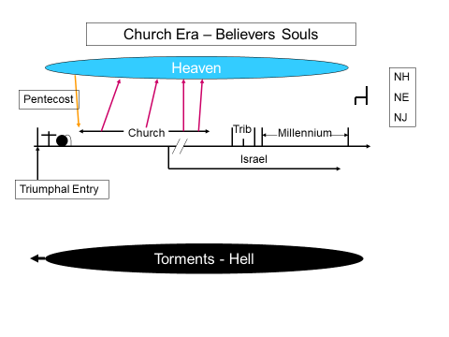

______________________________________________________________________________________________________________________________________________________________________________________________________________________________________________________________________________________________________________________

(Eph 3:8-11, Eph 3:11-12)

14 For this reason I bow my knees before the Father,
15 from whom every family in heaven and on earth derives its name,
16 that He would grant you, according to the riches of His glory, to be strengthened with power through His Spirit in the inner man,
17 so that Christ may dwell in your hearts through faith; and that you, being rooted and grounded in love,
18 may be able to comprehend with all the saints what is the breadth and length and height and depth,
19 and to know the love of Christ which surpasses knowledge, that you may be filled up to all the fullness of God.
NASU
____________________________________________________________________________________________________________________________________________________________________________________________________________________________________________________________________________________________________________________________________________________________________________________________________________________________________________________________________________________________________________________________________________________________________________________________________________________________________________

14 For this reason I bow my knees before the Father,
15 from whom every family in heaven and on earth derives its name,
16 that He would grant you, according to the riches of His glory,
______________________________________________________________________________________________________________________________________________________________________________________________________________________________________________________________________________________________________________________
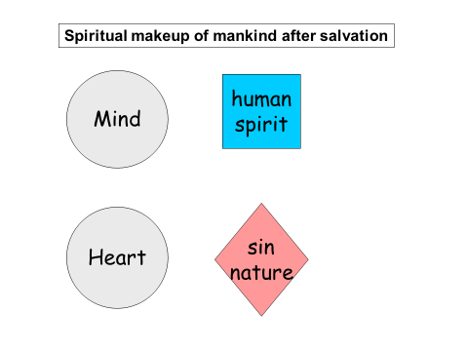

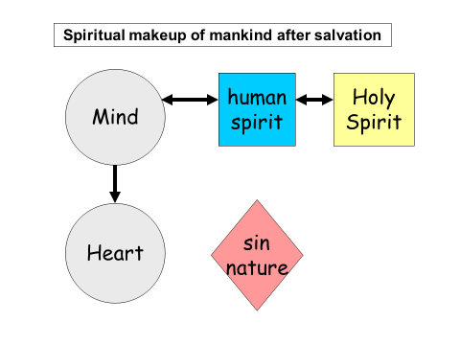

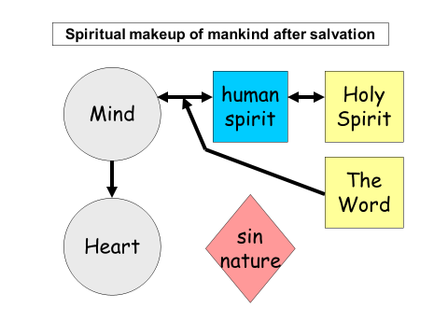

____________________________________________________________________________________________________________________________________________________________________________________________________________________________________________________________________________________________________________________________________________________________________________________

16 that He would grant you, according to the riches of His glory, to be strengthened with power through His Spirit in the inner man,
17 so that Christ may dwell in your hearts through faith;
______________________________________________________________________________________________________________________________________________________________________________________________________________________________________________________________________________________________________________________________________________________________________________________________________________________________________________________

18 may be able to comprehend with all the saints what is the breadth and length and height and depth,
19 and to know the love of Christ which surpasses knowledge, that you may be filled up to all the fullness of God.
______________________________________________________________________________________________________________________________________________________________________________________________________________________________________________________________________________________________________________________

John 15:12-13

20 Now to Him who is able to do far more abundantly beyond all that we ask or think,
21 to Him be the glory in the church and in Christ Jesus to all generations forever and ever. Amen.
________________________________________________________________________________________________________________________________________________________________________________________________________________________________________________________

Review of our questions

- What causes Christ to dwell in your heart? _____________

- What is necessary for you to comprehend and know the love of Christ? _________________________________________

