

Ephesians 4:1-16
April 25, 2023

Presented by Gene Dahler

REVIEW
Ephesians 3:20-21
20 Now to Him who is able to do far more abundantly beyond all that we ask or think, according to the power that works within us,
21 to Him be the glory in the church and in Christ Jesus to all generations forever and ever. Amen.
____________________________________________________________________________________________________________________________________________________________________________________

Eph 4:1-16
1 Therefore I, the prisoner of the Lord, implore you to walk in a manner worthy of the calling with which you have been called,
2 with all humility and gentleness, with patience, showing tolerance for one another in love,
____________________________________________________________________________________________________________________________________________________________________________________

3 being diligent to preserve the unity of the Spirit in the bond of peace.
____________________________________________________________________________________________________________________________________________________________________________________________________________________________________________________________________________________________________________
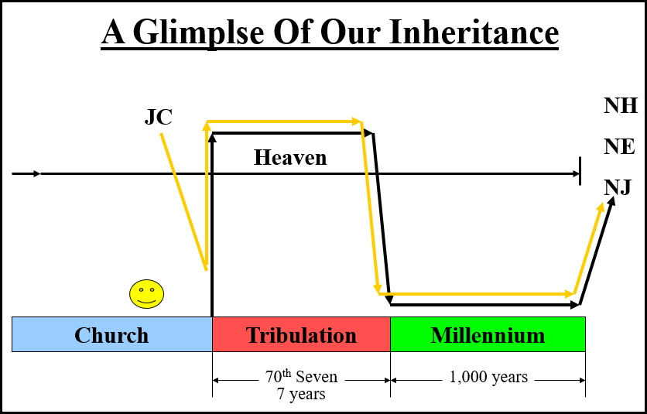
_________________________________________________________________________________________________________________________________________________________________

KEY POINT - We can walk in this manner for three reasons.

1. We have a Biblical perspective (past, present & future) of the current issues concerning the world, nations and people of today.

2. We know the reality of who we are!

3. We know the reality of ________________________!!

4 There is one body and one Spirit, just as also you were called in one hope of your calling;
5 one Lord, one faith, one baptism,
6 one God and Father of all who is over all and through all and in all.
__________________________________________________________________________________________________________________________________________________________________________________________________________________________________________________________________________________________________________________________________________________________________________________________
____________________________________________________________________________________________________________________________________________________________________________________
7 But to each one of us grace was given according to the measure of Christ's gift.
____________________________________________________________________________________________________________________________________________________________________________________

8 Therefore it says, "WHEN HE ASCENDED ON HIGH, HE LED CAPTIVE A HOST OF CAPTIVES, AND HE GAVE GIFTS TO MEN."
9 (Now this expression, "He ascended," what does it mean except that He also had descended into the lower parts of the earth?
10 He who descended is Himself also He who ascended far above all the heavens, so that He might fill all things.)
____________________________________________________________________________________________________________________________________________________________________________________

11 And He gave some as apostles, and some as prophets, and some as evangelists, and some as pastors and teachers,
12 for the equipping of the saints for the work of service, to the building up of the body of Christ;
____________________________________________________________________________________________________________________________________________________________________________________

13 until we all attain to the unity of the faith, and of the knowledge of the Son of God, to a mature man, to the measure of the stature which belongs to the fullness of Christ.
________________________________________________________________________________________________________________________

QUESTION – What are we to be united in? FAITH BASED ON TRUTH.
____________________________________________________________________________________________________________________________________________________________________________________

14 As a result, we are no longer to be children, tossed here and there by waves and carried about by every wind of doctrine, by the trickery of men, by craftiness in deceitful scheming;
________________________________________________________________________________________________________________________

What is? –
- Doctrine – That which claims to be taught directly from Scripture
- Trickery – Defrauding or gambling
- Scheming – Deceiving, delusional
____________________________________________________________
____________________________________________________________

15 but speaking the truth in love, we are to grow up in all aspects into Him who is the head, even Christ,
16 from whom the whole body, being fitted and held together by what every joint supplies, according to the proper working of each individual part, causes the growth of the body for the building up of itself in love. NASU
____________________________________________________________________________________________________________________________________________________________________________________

Additional notes and comments:
___________________________________________________________________________________________________________________________________________ _________________________________________________________________________________________________________________________________________________________________________________________________________________________________________________________________________________________________________________________________________________________________________________________________________________________________________________________________________________________________________________________________________

Filename: 230425 – Ephesians 4:1-16 HB GD b1.doc

