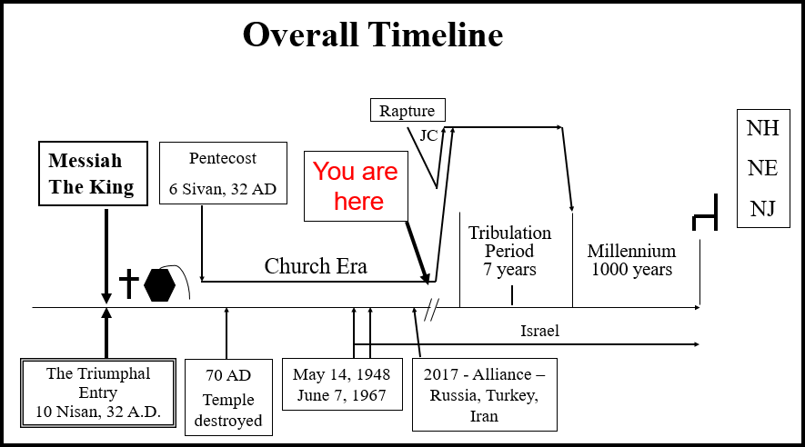
UNDERSTANDING THE END TIMES
Jesus First Coming – 69 Weeks – 10/10/2023
Presented by Gene Dahler

KEY POINT - The 70 weeks’ prophecy of Daniel is a key to understanding all end time prophecy about Jesus, the nations, the world and you!

Dan 9:20-23 Gabriel brings Daniel a prophecy

Daniel 9:20-23
20 Now while I was speaking and praying, and confessing my sin and the sin of my people Israel, and presenting my supplication before the Lord my God in behalf of the holy mountain of my God,
21 while I was still speaking in prayer, then the man Gabriel, whom I had seen in the vision previously, came to me in my extreme weariness about the time of the evening offering.
22 He gave me instruction and talked with me and said, "O Daniel, I have now come forth to give you insight with understanding.
23 "At the beginning of your supplications the command was issued, and I have come to tell you, for you are highly esteemed; so give heed to the message and gain understanding of the vision. NASU
____________________________________________________________________________________________________________________________________________________________________________________

Dan 9:24-25a The prophecy of the coming of the Messiah

Daniel 9:24-25a
24 "Seventy weeks have been decreed for your people and your holy city, to finish the transgression, to make an end of sin, to make atonement for iniquity, to bring in everlasting righteousness, to seal up vision and prophecy and to anoint the most holy place.
25 "So you are to know and discern that from the issuing of a decree to restore and rebuild Jerusalem until Messiah the Prince there will be seven weeks and sixty-two weeks; NASU

9:24 "Seventy weeks are decreed for your people and your holy city" - This prophecy is decreed for Israel, not the gentile world. However, Israel appears to be God's clock for the world and consequently this prophecy therefore affects everyone on Earth.

- The "weeks" are seven year periods. (Gen 29:27)
________________________________________________________________________________________________________________________________________________________________________________________________________________________________________________

9:25 A prophetic year is 360 days. All references to the timing of a calendar in the Bible (Gen 7:11, 7:24, 8:3,4, Rev 11:2, 12:6, 13:3,5) define a 360-day year.
____________________________________________________________________________________________________________________________________________________________________________________

Daniel 9:25a
25 "So you are to know and discern that from the issuing of a decree to restore and rebuild Jerusalem until Messiah the Prince there will be seven weeks and sixty-two weeks; NASU
____________________________________________________________________________________________________________________________________________________________________________________
INITIATION OF THE 69 WEEKS.

93 years after Daniel receives the prophecy, Nehemiah receives the decree "in the month of Nisan in the twentieth year of King Artaxerxes." (Neh 2:1-9) (445 BC)
________________________________________________________________________________________________________________________________________________________________________________________________________________________________________________

Remember what God said. How will we know the message is from Him??

Isa 46:9-10
9 "Remember the former things long past, For I am God, and there is no other; I am God, and there is no one like Me,
10 Declaring the end from the beginning, And from ancient times things which have not been done, Saying, 'My purpose will be established, And I will accomplish all My good pleasure'; NASU

CONCLUSION OF THE 69 WEEKS.

What happened between April 2 and May 2, 32AD?

Jesus rode into Jerusalem on a donkey exactly as prophecied by Zechariah 9:9 creating the first Palm Sunday (Mt 21:1-9, Mk 11:1-10, Lk 19:29-39, Jn 12:12-16). Prior to that day Jesus declines to be proclaimed the king saying "My hour is not yet come" (Jn 6:15, 7:6, 8, 30, 44, 8:20). After that day, He proclaims His hour has come (Jn 12:23, 27, 13:1, 17:1).

The year of the triumphal entry is defined by the Bible (Lk 3:1) as the year of 32 AD. The date of Passover that year was April 12th. The date of the Triumphal entry is fixed at four days before Passover, (Jn 11:55 - 12:12) which means it happened on April 8th, 32 AD.
____________________________________________________________________________________________________________________________________________________________________________________________________________________________________________________________________________________________________________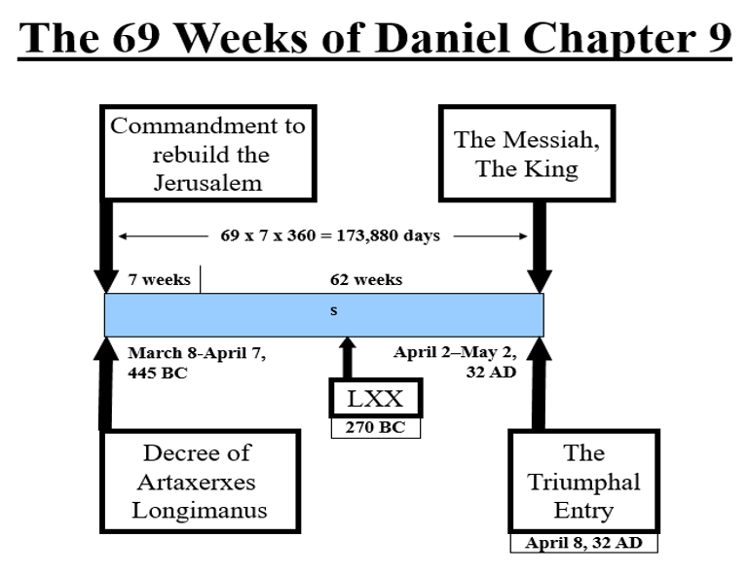________________________________________________________________________________________________________________________________________________________________________________________________________________________________________________________________________________________________________________________________________________________________________

Luke 19:37-44 The triumphal entry

Luke 19:37-44
37 As soon as He was approaching, near the descent of the Mount of Olives, the whole crowd of the disciples began to praise God joyfully with a loud voice for all the miracles which they had seen,
38 shouting:
"BLESSED IS THE KING WHO COMES IN THE NAME OF THE LORD;
Peace in heaven and glory in the highest!"
39 Some of the Pharisees in the crowd said to Him, "Teacher, rebuke Your disciples."
40 But Jesus answered, "I tell you, if these become silent, the stones will cry out!" NASU
________________________________________________________________________________________________________________________
Luke 19:41-44
41 When He approached Jerusalem, He saw the city and wept over it,
42 saying, "If you had known in this day, even you, the things which make for peace! But now they have been hidden from your eyes.
43 "For the days will come upon you when your enemies will throw up a barricade against you, and surround you and hem you in on every side,
44 and they will level you to the ground and your children within you, and they will not leave in you one stone upon another, because you did not recognize the time of your visitation." NASU
________________________________________________________________________________________________________________________________________________________________________________________________________________________________________________

(Mt 23:37, Rom 10:21, Jn 1:11, Mt 27:25)

We now have almost 2,000 years of devastating history for the Jews. Why? “because you did not recognize the time of “your visitation." (Lk 19:44b)
________________________________________________________________________________________________________________________________________________________________________________________________________________________________________________

Why is the nation of Israel unable to recognize the Messiah? They did not pay attention when God said "know and understand." (Lk 19:42, 44; Dan 9:23 ,25; Mt 24:15)

National Israel is temporarily set aside; "it is hidden from your eyes". (Lk 19:42; Is 8:14-15; Rom 11:7-8)
____________________________________________________________________________________________________________________________________________________________________________________________________________________________________________________________________________________________________________

Principle - We can be harmed as much by failing to believe something that is true as we can by believing something that is fa lse.
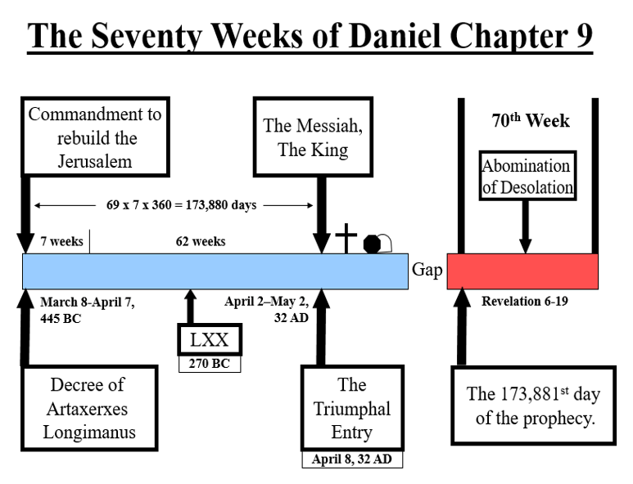

KEY POINTS:

- What is the significance of this prophecy and this event?

1. It is proof that the Bible is God’s Word

2. It is proof that Jesus is who He claimed to be.

3. It is more evidence that God always keeps His Word.

4. It is confirmation that we have found the truth and that we are not deceived.

5. It is the beginning of a period of servitude for Israel that continues unto this today.

6. God loves Israel and the Israelis. He even set aside a 7 year period for them to fulfill the requirements he gave them knowing that they would fail at the end of the 483 years.

The question is: WILL YOU BELIEVE IT????
________________________________________________________________________________________________________________________
Dan 9:25 from the issuing of a decree to restore and rebuild Jerusalem until Messiah the Prince there will be seven weeks and sixty-two weeks

Basic mathematics of this prophecy.

Weeks (seven prophetic years) of the prophecy

7 + 62 = 69 seven prophetic year (360 day) periods

Days of the prophecy

69 X 7 X 360 = 173,880 days

Gregorian calendar years of the prophecy

173,880 / 365.24219 = 476 years 25 days

Date of the decree (Nisan, 445 BC)

Nisan, 445 BC = March 8 - April 7, 445 BC

Prophesied date of the coming of the Messiah

March 8, 445 BC + 476 years 25 days = April 2, 32 AD
April 7, 445 BC + 476 years 25 days = May 2, 32 AD

Moving forward in time from March 8, 445 BC by 476 years 25 days brings us to April 2, 32 AD. The prophecy states that the Messiah will come within a 30-day period (the length of the month of Nisan) starting on the day of April 2 and ending May 2, 32 AD. Jesus fulfilled the prophecy on April 8, 32 AD.

