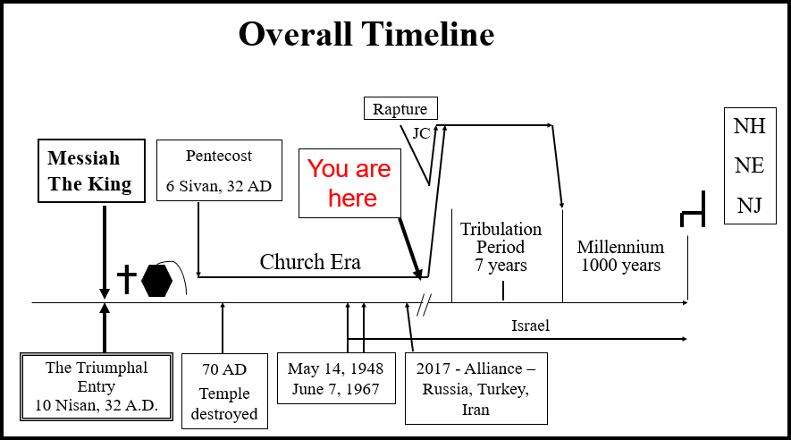

END TIMES PROPHECIES

Daniel 9 – 70th 7 Prophecy

10/24/2023

Presented by Clifford Phipps

____________________________________________________________________________________________________________________________________________________________________________________________________________________________________________________________________________________________________________

(Jer 29:1, Jer 29:10)

Dan 9:1-6

1 In the first year of Darius the son of Ahasuerus, of Median descent, who was made king over the kingdom of the Chaldeans —

2 in the first year of his reign, I, Daniel, observed in the books the number of the years which was revealed as the word of the Lord to Jeremiah the prophet for the completion of the desolations of Jerusalem, namely, seventy years.

3 So I gave my attention to the Lord God to seek Him by prayer and supplications, with fasting, sackcloth and ashes.

4 I prayed to the Lord my God and confessed and said, "Alas, O Lord, the great and awesome God, who keeps His covenant and lovingkindness for those who love Him and keep His commandments,

5 we have sinned, committed iniquity, acted wickedly and rebelled, even turning aside from Your commandments and ordinances.

6 "Moreover, we have not listened to Your servants the prophets, who spoke in Your name to our kings, our princes, our fathers and all the people of the land.

________________________________________________________________________________________________________________________________________________________________________________________________________________________________________________

Dan 9:26b

26b and the people of the prince who is to come will destroy the city and the sanctuary. And its end will come with a flood; even to the end there will be war; desolations are determined.

________________________________________________________________________________________________________________________

27 "And he will make a firm covenant with the many for one week, but in the middle of the week he will put a stop to sacrifice and grain offering; and on the wing of abominations will come one who makes desolate, even until a complete destruction, one that is decreed, is poured out on the one who makes desolate."

____________________________________________________________________________________________________________________________________________________________________________________

________________________________________________________________________________________________________________________________________________________________________________________________________________________________________________

(Matt 23:32)

________________________________________________________________________________________________________________________________________________________________________________________________________________________________________________________________________________________________________________________________________________________________________

Faith is both **developed** and **demonstrated**.

1. **How do You Develop Faith?**

____________________________________________________________________________________________________________________________________________________________________________________

To **develop** faith……

1. You know what God has done in the past
2. You know what He plans to do in the future.

(Rom 10:17)

1. **How do You Demonstrate Faith?**

________________________________________________________________________________________________________________________

1. **First you have to have faith. You have to have the assurance of those things that God has done in the past and you have to know what His plans are for the future.**

____________________________________________________________________________________________________________________________________________________________________________________

(Heb 11:7, Josh 6:1-2)

1. **Is God Able – Is God Faithful?**

(Heb 11:11, Heb 11:17-19, Rom 1:20)

____________________________________________________________________________________________________________________________________________________________________________________

1. **We need to understand that God will not necessarily do those things that He has not promised to do.**

____________________________________________________________________________________________________________________________________________________________________________________

1. **Obedience is Easy When You Have Faith.**

**________________________________________________________________________________________________________________________**

**Obedience is difficult, if not impossible. without faith.**

**____________________________________________________________________________________________________________________________________________________________________________________**

(Heb 1:1-2, Matt 28:18-20)

____________________________________________________________________________________________________________________________________________________________________________________

