INTRODUCTION &

SETTING THE STAGE– Sept. 9, 2025

Presented by Gene Dahler

INTRODUCTIION

____________________________________________________________________________________________________________________________________________________________________________________________________________________________________________________________________________________________________________

JESUS loves you and He and His heavenly Father want you to love Him as well. The good news is, it is easy to love JESUS once you get to know Him.

If you are not sure if you really love the person JESUS, then this is your Bible study. We are going to introduce you to JESUS. You will know what He has done in the past and, most importantly, what He will do with you in the future. You will know more about JESUS than any other person. You will not only love Him, He will be your best friend. Many say they are following JESUS, but they don’t know where He is going. JESUS wants you to know. Knowing where He is going provides the key ingredient for a believer’s salvation – Faith!

**The Significance of FAITH -**

1 Peter 1:3-6

Blessed be the God and Father of our Lord Jesus Christ, who according to His great mercy has caused us to be born again to a living hope through the resurrection of Jesus Christ from the dead, 4 to obtain an inheritance which is imperishable and undefiled and will not fade away, reserved in heaven for you, 5 **who are protected by the power of God through faith** for a salvation ready to be revealed in the last time. NASU

Eph 2:8 **For by grace you have been saved through faith**; and that not of yourselves, it is the gift of God;

9 not as a result of works, so that no one may boast. NASU

What is faith?

Heb 11:1

1 Now faith is the assurance of things hoped for, the conviction of things not seen.

Heb 11:6

6 And without faith it is impossible to please Him, for he who comes to God must believe that He is and that He is a rewarder of those who seek Him. NASU

The key is the conviction that He is a rewarder of those who seek Him. Our goal is, that in getting to know JESUS really well, that you will know and believe the reward God has for us.

After covering the key events of the past, we will be stepping through what He will be doing with you in the future. JESUS is at the heart of the significant communication and the major events from 32 AD forward. By the time we finish this study, you will know JESUS better than anyone else. You will not be able to resist loving Him and you will also have a comprehensive understanding of the Bible because every major event starting in 32 AD involves JESUS.

What are the events / communication?

FOUNDATIONAL EVENTS –

Triumphal Entry (32 AD)

Olivet Discourse (32 AD)

Last Supper (32 AD)

Cross to the resurrection (32 AD)

Birthday of the church (32 AD)

**FUTURE EVENTS –**

**Rapture of the believers**

**Receiving the Scroll from the Father**

**The greatest celebration in the Bible**

**Releasing of the anti-Christ**

**2nd coming**

**Armageddon**

**Millennium judgements**

**Reign during the millennium**

**Great White Throne judgement**

**New Jerusalem**

* **Bold – you are there**

____________________________________________________________________________________________________________________________________________________________________________________

JESUS is at the heart of every major future event and you will be there with Him for all of those. To know what JESUS will be doing with you in the future establishes a relationship of faith and love that cannot be found anywhere else. That relationship separates you in a magnificent way from the rest of humanity. It is obvious, a relationship based on knowledge of the future is special and not available with anyone else!!!

________________________________________________________________________________________________________________________

Why did God do all this – create heaven, earth, people and everything else? Why did God send His Son to earth? The Bible doesn’t specifically tell us. All that anyone has is theories. But, there is one thing we absolutely know for certain, we know what He is going to accomplish by doing it all. He is going to create the most amazing place for people to live, the New Jerusalem, and He wants a family for His Son and Him living there together forever. He is going to make that family from those that love His Son in the church era, the era we are living in now. We know that is the end result of it all (Rev 21 & 22).

____________________________________________________________________________________________________________________________________________________________________________________

There is one thing every believer on earth should have as their most important goal – To make absolutely certain that they will be part of that family. Reality is, there is nothing more important. That is God’s reward for those that love His Son.

It is time to stop speaking about what we hope to accomplish in this JESUS Bible study and actually get started.

We are going to start with JESUS terminating the Old Covenant. The New Covenant does not begin until the Old Covenant is finished. That will be our first lesson starting now.

THE FIRST EVENT – The Setting of the Stage for Everything to Come

538 BC – The angel Gabriel is dispatched to the Prophet Daniel with a message of a future event, perhaps the most significant of all the events.  
  
**Dan 9:24-25a The prophecy of the coming of the Messiah**

**Daniel 9:24**

**24 "Seventy weeks (490 years) have been decreed for your people and your holy city, to finish the transgression, to make an end of sin, to make atonement for iniquity, to bring in everlasting righteousness, to seal up vision and prophecy and to anoint the most holy place.**

**25 "So you are to know and discern that from the issuing of a decree to restore and rebuild Jerusalem until Messiah the Prince there will be seven weeks and sixty-two weeks (69 weeks – 483 years)**

INITIATION OF THE 69 WEEKS AND CONCLUSION

93 years after Daniel receives the prophecy, Nehemiah receives the decree "in the month of Nisan in the twentieth year of King Artaxerxes" initiating the 483 year clock for the arrival of the Messiah. (Neh 2:1) (445 BC) The conclusion of the 483 year clock translated to today’s calendar would be April 2 to May 2, 32 AD.

JESUS FULFILLS THE PROPHECY

When does JESUS enter Jerusalem riding on a donkey (Zech 9:9) with the followers proclaiming Him to be the Messiah. The date of that event is April 8, 32 AD, the first Palm Sunday (Mt 21:1-9, Mk 11:1-10, Lk 19:29-39, Jn 12:12-16).

____________________________________________________________________________________________________________________________________________________________________________________

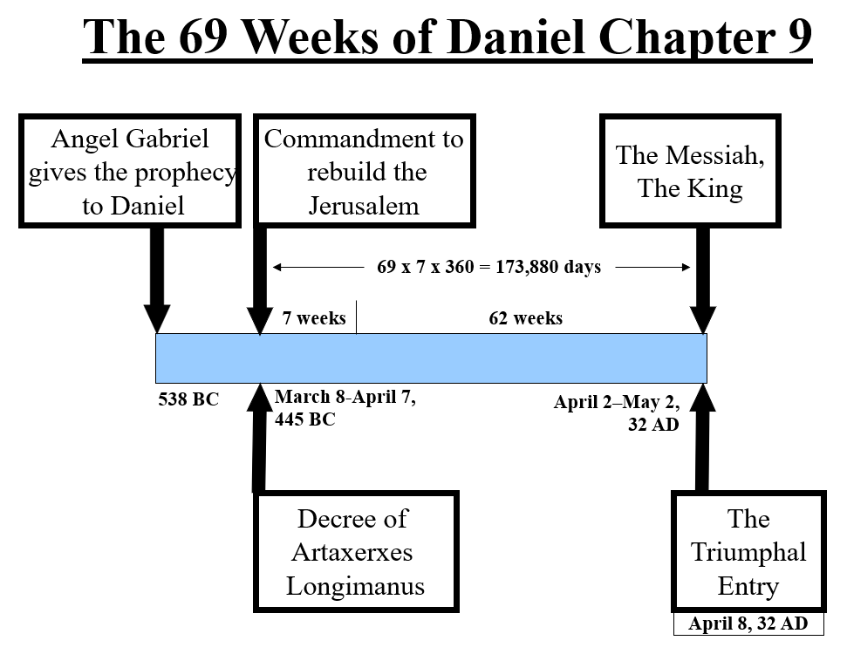

________________________________________________________________________________________________________________________________________________________________________________________________________________________________________________

Understand that this is absolute proof that JESUS is who He claimed to be? This should eliminate any and all doubts that anyone might possibly have. Remember what JESUS said, “Do not be deceived.” This is absolute evidence that we have not been deceived!!!

**KEY POINTS:**

What is the significance of this event?

1. Confirms the Bible is the Word of God since no man could possibly know this 570 years in advance.
2. Confirms the Bible is true.
3. Confirms that God keeps His Word. In this case to the nation of Israel.
4. Confirms that JESUS is who He claimed to be. The Messiah, the Son of God.
5. Ends Judaism. Judaism is no longer the way for a person to have a relationship with God.
6. The Bible is unique amongst all printed documents on earth providing inerrant detailed predefined information of the future.
7. This is an act of Love. There can be no other purpose. Why else would the Father want His Son to come to earth and why else would the Son agree to do it?

This is the day that God came to Israel. All of Israel should have been waiting.

____________________________________________________________________________________________________________________________________________________________________________________________________________________________________________________________________________________________________________

What happened on that day, April 8, 32 AD? This event sets the stage for the coming 2,000 years.

**Luke 19:35-44**

**35 They brought it to Jesus, and they threw their coats on the colt and put Jesus on it.**

**36 As He was going, they were spreading their coats on the road.**

**37 As soon as He was approaching, near the descent of the Mount of Olives, the whole crowd of the disciples began to praise God joyfully with a loud voice for all the miracles which they had seen,**

**38 shouting: "BLESSED IS THE KING WHO COMES IN THE NAME OF THE LORD; Peace in heaven and glory in the highest!"**

**39 Some of the Pharisees in the crowd said to Him, "Teacher, rebuke Your disciples."**

**40 But Jesus answered, "I tell you, if these become silent, the stones will cry out!"**

**41 When He approached Jerusalem, He saw the city and wept over it,**

**42 saying, "If you had known in this day, even you, the things which make for peace! But now they have been hidden from your eyes.**

**43 "For the days will come upon you when your enemies will throw up a barricade against you, and surround you and hem you in on every side,**

**44 and they will level you to the ground and your children within you, and they will not leave in you one stone upon another, because you did not recognize the time of your visitation." NASU**

Remember, this is the day of Gabriels prophecy. The prophecy of the promised Messiah.

________________________________________________________________________________________________________________________________________________________________________________________________________________________________________________

**Review -**

**39 Some of the Pharisees in the crowd said to Him, "Teacher, rebuke Your disciples."**

**40 But Jesus answered, "I tell you, if these become silent, the stones will cry out!"**

Interesting response. He could of just said “No”.

39 – Why upset? Halel Psalm 118.

40 - Why this statement? –

Because this is the day. It is the 173,880 day of Gabriels prophecy. It is one of the most significant days since the beginning. It is important that not just the Israelis, but people everywhere must know about this day. The significance of this day is hard to comprehend (more to come about that).

**41 When He approached Jerusalem, He saw the city and wept over it,**

Why weeping?

He knows what is going to happen to the city and most of the Israelis living there. It is estimated over a million will be killed.

**42 saying, "If you had known in this day, even you, the things which make for peace! But now they have been hidden from your eyes.**

What is the “they”. History since 32 AD would tend to cause us to think that it is anything, anything at all, that would lead to peace.

This may be the most devastating verse in the entire Bible. Think about this:

* 70 AD – Destruction of the temple and the city. Estimated 1 M lost.
* 73 AD – Masada – Suicide devastation - hundreds
* Dispersion – persecuted everywhere they go. Why? Because they are Israelis.
* Conflicts and wars everywhere they go
* Holocaust – 1935-1945 – 6 M died
* Persecution in their own land from 1948. Constant attack.
* 2005 to present, rocket and terrorist attacks
* Oct 7, 2023 – Gaza Hamas genecide
* 2023 to present – War with Hamas, Hezbollah, Houties, Iran, etc.
* Future – Tribulation – 2/3 lost

**43 "For the days will come upon you when your enemies will throw up a barricade against you, and surround you and hem you in on every side,**

**44 and they will level you to the ground and your children within you, and they will not leave in you one stone upon another,**

70 AD – The Romans destroyed the city and the temple

Why did all this happen?

**44 because you did not recognize the time of your visitation." NASU**

Can we grasp the scope of this event?

This event sets the stage for the next 2,000 years. From this day forward, Satan and the Harlot will be out to destroy the Israeli’s and deceive the gentiles.