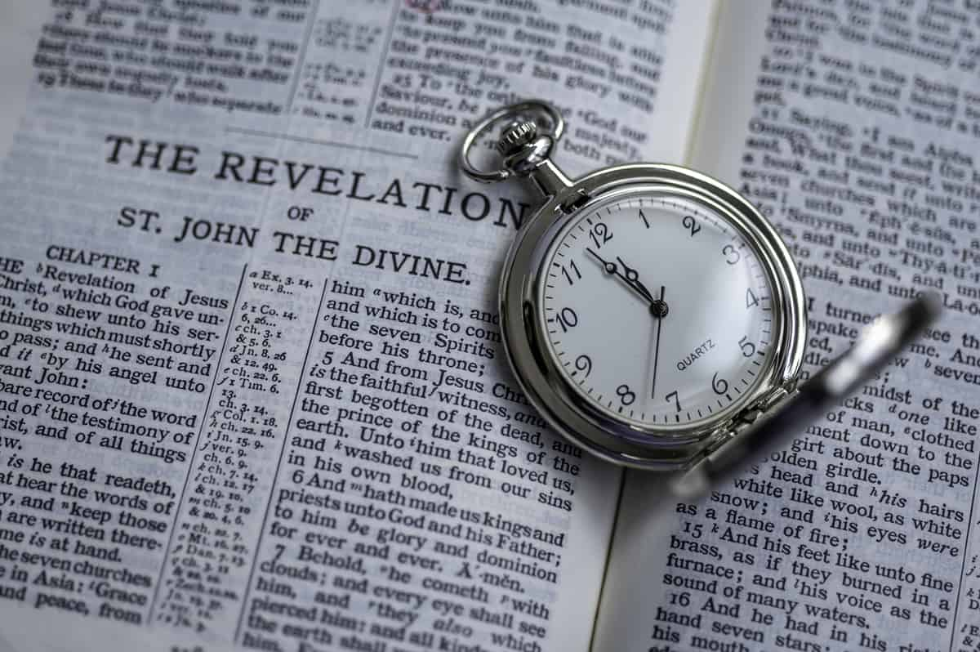

The Millennium - Rev 20
Gene Dahler - 6/17/2025

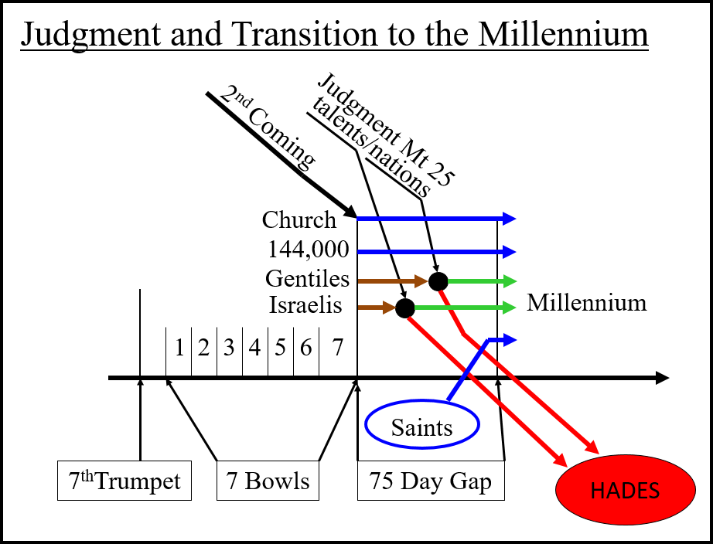

SUMMARY OF RECENT EVENTS

Judgment of the Bowls
Marriage
Armies gathering
2nd Coming
Anti-Christ army destroyed
Church is passing through
144,000 is passing through
Anti-Christ and False Prophet are cast into the LOF
Judgment of the talents (Israel)
Judgment of the nations (sheep and goats)
______________________________________________________________________________________________________________

Revelation 20:1-15
1 Then I saw an angel coming down from heaven, holding the key of the abyss and a great chain in his hand.
2 And he laid hold of the dragon, the serpent of old, who is the devil and Satan, and bound him for a thousand years;
3 and he threw him into the abyss, and shut it and sealed it over him, so that he would not deceive the nations any longer, until the thousand years were completed; after these things he must be released for a short time.
_____________________________________________________________________________________________________________________________________________________________________

4 Then I saw thrones, and they sat on them, and judgment was given to them. (Ref Mt 19:27-28)
______________________________________________________________________________________________________________

4 (cont) And I saw the souls of those who had been beheaded because of their testimony of Jesus and because of the word of God, and those who had not worshiped the beast or his image, and had not received the mark on their forehead and on their hand; and they came to life and reigned with Christ for a thousand years.

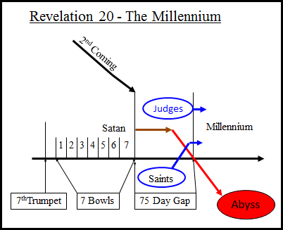

John 5:28-29
28 "Do not marvel at this; for an hour is coming, in which all who are in the tombs will hear His voice,
29 and will come forth; those who did the good deeds to a resurrection of life,
______________________________________________________________________________________________________________

29b those who committed the evil deeds to a resurrection of judgment.

Rev 20
5a The rest of the dead did not come to life until the thousand years were completed.
______________________________________________________________________________________________________________

5b This is the first resurrection.
6 Blessed and holy is the one who has a part in the first resurrection; over these the second death has no power, but they will be priests of God and of Christ and will reign with Him for a thousand years.
_____________________________________________________________________________________________________________________________________________________________________

7 When the thousand years are completed,
_____________________________________________________________________________________________________________________________________________________________________

PERSPECTIVE

First, what just happened through verse :6? ____________________

Let’s look at a few end of the age verses. Dan 12:13, Mt 13:47-50)
___________________________________________________________________________________________________________________________________________________________________________________________________________________________________________________________________________________

Let’s think about the world today and all that is going on. The major nations are all desiring to be powerful militarily. Nations like America, Russia, China and now the European Union desiring to make a joint powerful military. The question is, in the end, who wins?
Answer - _________________________

Why? They have the most powerful weapon!! What is it? _________
____________________________________________________________________________________________________________________________________________________________________________________________________________________________________________________

Today, the world continues to organize against Israel in numerous ways. A recent organization is the BDS movement (2001). BDS means Boycott, Divest from and Sanction Israel. Goal is to participate in the elimination of Israel.
- America has 250 participating organizations including the Episcopal Church, Presbyterian Church (USA), United Church of Christ and the Evangelical Lutheran Church.
- BDS boycott list includes a large list of companies including these well-known firms: Caterpillar, Stanley Black & Decker, Hewlett Packard, Victoria’s Secret, Gap, J.C. Penny, Calvin Klein and Motorola.

Despite everything being done in opposition to Israel, remember in the end, Israel wins.

Also remember, we are living this book!!! Not just a book to find some good conduct ideas, it is a biography of the earth and the people on it, even those that are reading it.

How will life change in the millennium compared to now?

Next week, Cliff is going to take you through verses that describe life in the Millennium. However, we can have a practical look from what we know today.

Think about life today and life at the beginning of the millennium.

What is going on today that will be different.
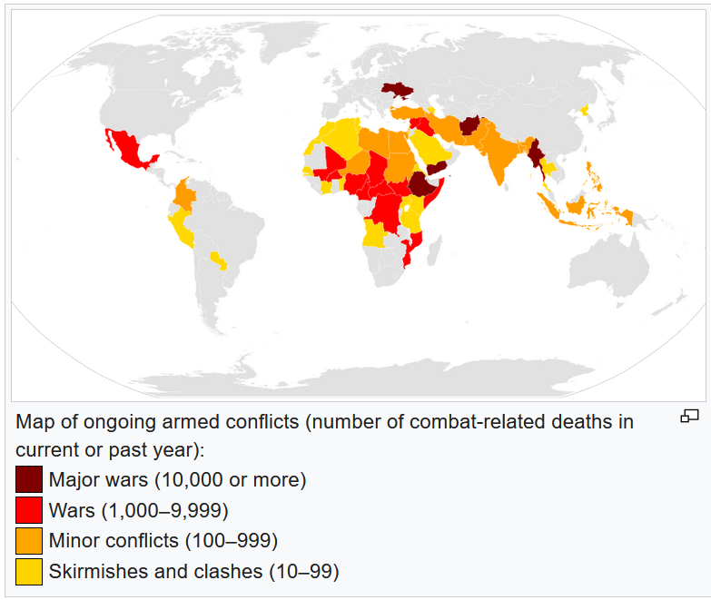
__________________________________________________________________________________________________________________________________________________________________________________________________________________________________________________________________________________

THE MILLENNIUM

The big picture -

Daniel 2:35 (Daniel was given a vision of Nebuchadnezzar’s statue)
35 "Then the iron, the clay, the bronze, the silver and the gold were crushed all at the same time and became like chaff from the summer threshing floors; and the wind carried them away so that not a trace of them was found. But the stone that struck the statue became a great mountain and filled the whole earth. NASU
______________________________________________________________________________________________________________

VERSES ABOUT ISRAEL

Zephaniah 3:9-12, 15 - Israelis that made it into the millennium
9 "For then I will give to the peoples purified lips,
That all of them may call on the name of the Lord,
To serve Him shoulder to shoulder.
10 "From beyond the rivers of Ethiopia
My worshipers, My dispersed ones,
Will bring My offerings.
11 "In that day you will feel no shame
Because of all your deeds
By which you have rebelled against Me;
For then I will remove from your midst
Your proud, exulting ones,
And you will never again be haughty
On My holy mountain.
12 "But I will leave among you
A humble and lowly people,
And they will take refuge in the name of the Lord.
15 The Lord has taken away His judgments against you,
He has cleared away your enemies.
The King of Israel, the Lord, is in your midst;
You will fear disaster no more.
______________________________________________________________________________________________________________

7 When the thousand years are completed, Satan will be released from his prison,
8 and will come out to deceive the nations which are in the four corners of the earth, Gog and Magog, to gather them together for the war; the number of them is like the sand of the seashore.
_____________________________________________________________________________________________________________________________________________________________________

9 And they came up on the broad plain of the earth and surrounded the camp of the saints and the beloved city, and fire came down from heaven and devoured them.
_____________________________________________________________________________________________________________________________________________________________________

10 And the devil who deceived them was thrown into the lake of fire and brimstone, where the beast and the false prophet are also; and they will be tormented day and night forever and ever.
_____________________________________________________________________________________________________________________________________________________________________

THE GREAT WHITE THRONE JUDGMENT

11 Then I saw a great white throne and Him who sat upon it, from whose presence earth and heaven fled away, and no place was found for them.
______________________________________________________________________________________________________________

12 And I saw the dead, the great and the small, standing before the throne, and books were opened; and another book was opened, which is the book of life; and the dead were judged from the things which were written in the books, according to their deeds.
13 And the sea gave up the dead which were in it, and death and Hades gave up the dead which were in them; and they were judged, every one of them according to their deeds.
_____________________________________________________________________________________________________________________________________________________________________

14 Then death and Hades were thrown into the lake of fire. This is the second death, the lake of fire.
_____________________________________________________________________________________________________________________________________________________________________

15 And if anyone's name was not found written in the book of life, he was thrown into the lake of fire. NASU
_____________________________________________________________________________________________________________________________________________________________________

PERSPECTIVE FOR REV 20 – 6/7/2022

What is the difference between the tribulation to millennium transition judgments and the Great White Throne Judgment?

Transition (Judgment of the talents; judgment of the nations)
Ans – People go into the millennium or hades. Their judgment is based on ____________.

Great White Throne –
Ans – People go into the New Heaven/New Earth or the lake of fire. Judgment is based on their name being in the ______________________.

Books?

What is the most important book for the world in general?
Ans – _________________________
What is most important book for unsaved individuals?
Ans – _________________________
What is the most important book for the saved?
Ans - _________________________

What has ended in Revelation chapter 20?
1. _______________
2. _____________
3. Rule on earth by ________________________

What is the most important thing for a saved person to have today?
Ans – An accurate and clear _______________________.

What is at least part of our vision?

- Departing earth to heaven
- Opening of the book of the 7 seals
- Heavenly events
- Seeing the OT and tribulation saints
- Our marriage
- Second coming on white horses
- Be here on earth with Jesus to insure Israel gets all of the promises His Father gave them
- Then, off to the New Jerusalem, the most fantastic place ever created for man
MILLENNIAL VERSES

There are many verses about the millennium. For added research, check the list below. The ones marked with an asterisk were used in this Bible study.

Psalm 2:6-9
* Isaiah 2:2-4
Isaiah 9:6-7
* Isaiah 11:4-10
Isaiah 35:1-2
Isaiah 35:5-10
* Isaiah 65:18-23
Jeremiah 3:17-19
Jeremiah 23:5-8
Jeremiah chapters 31-37
* Ezekiel 34:25-29
Ezekiel 37:1-6
Ezekiel 40-48
* Daniel 2:35
Daniel 7:13-14
Joel 2:21-27
* Zech 14:16-21
Amos 9:13-14
Micah 4:1-7
Zephaniah 3:9-20
Matthew 19:27-30
* Matthew 26:27-29
Mark 14:25
Luke 22:18
* 1 Cor 6:2&3
1Cor 6:9-11
* 2Tim 2:11&12
* Rev 2:26&27
* Rev 20

